**Question 1** – Functional Requirements & Non-Functional Requirements

**Answer**:

Requirements analysis is an essential process that enables the success of a system or software project to be assessed. Requirements are generally split into two types: Functional and Non-functional requirements.

Functional requirements define the specific behaviour or functions of a system like what the system should do to meet user needs. These include features like data processing, authentication, and user interactions.

In contrast, non-functional requirements specify how the system performs its tasks, focusing on attributes like performance, security, scalability, and usability.

|  |  |  |
| --- | --- | --- |
| **Req Id** | **Req Name** | **Req Description** |
| FR0001 | Registration | User should be able to create an account with his basic details and valid authentication |
| FR0002 | Login | The user should be able to login through the credentials generated in the registration process |
| FR0003 | Product Catlog | The application should be able to display a comprehensive list of all available products including fertilizers, seeds and pesticides with detailed information |
| FR0004 | Search of Products | Users should be able to search for products based on various criteria like name, type, brand, price range, etc |
| FR0005 | Adding to cart | The user should be able to select the product and add it to a cart |
| FR0006 | Making Payment | User should be able to make payment for their orders using various modes of payment |
| FR0007 | Check Out | The user should be able to check out and complete the process by entering delivery address etc |
| FR0008 | Tracking Order | User should be able to track the order placed |
| FR0009 | Order Cancellation | The user should be able to cancel the order (Based on the pre-defined conditions) |
| FR0010 | User Profile & History | The user should be able to manage their profile and view past orders |
| NFR001 | User friendliness | The user should find the system to be very intuitive and friendly to adapt |
| NFR002 | Browser Compatibility | The system should be compatible with the latest versions of popular web browsers |
| NFR003 | Scalability | The system should be able to handle large volume of data and transactions happening at a real time basis |
| NFR004 | Data Security | The data in motion and rest has to be end to end encrypted for user security |
| NFR005 | Maintenance | Software annual maintenance |
| NFR006 | Reliability | How often we see Software failure and the strategies for detecting such errors with the plans for error correction |
| NFR007 | Modifiability | The flexibility of the system to be modified at any point of time based on the new requirements |
| NFR008 | Performance | The system performance of the process for which it was created like the speed and access |
| NFR009 | Traceability | Changes made to the system's configuration or code should be logged and traceable to specific users or processes like an audit trail |
| NFR010 | Consistency | The graphical user interface should have a consistent layout and design across all pages. |

**Question 2** – Minimum 5-page designs

**Answer**:

1. User Registration

1. User Login

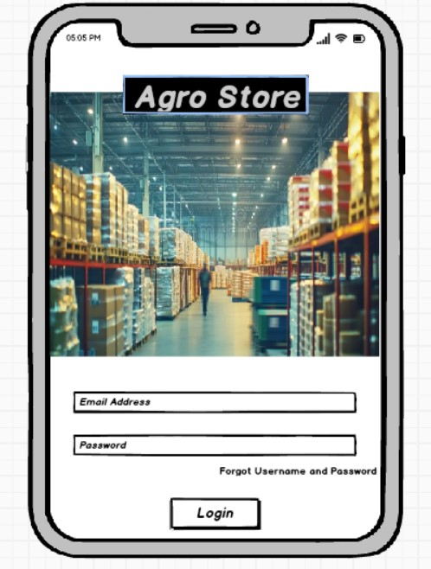

1. Search of Products

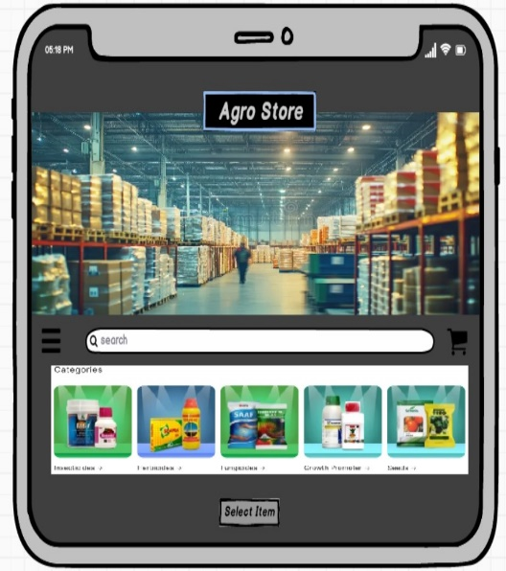

1. Add to Cart

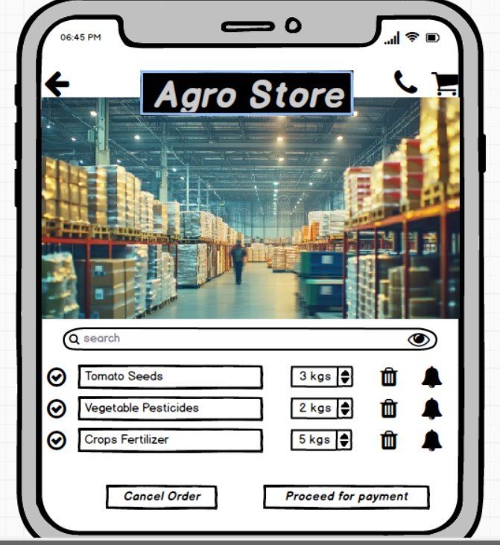

1. Making Payment

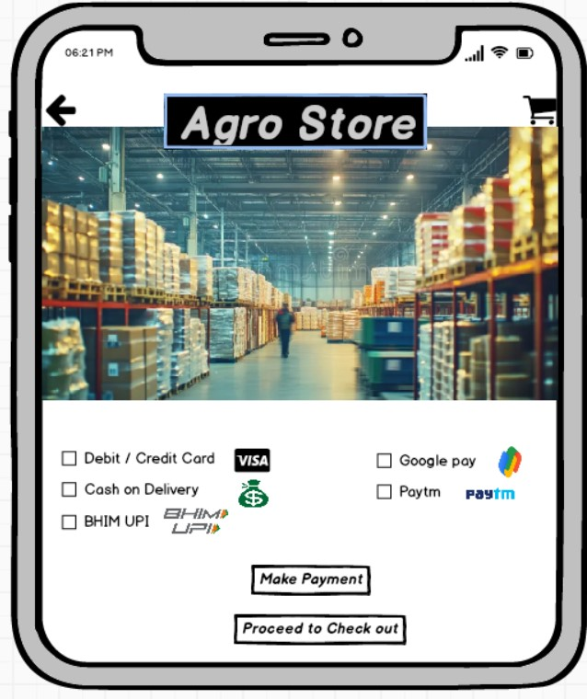

**Question 3** – Tools (Visio, Balsamiq)

**Answer**:

- **Microsoft Visio**:

Microsoft Visio is a versatile diagramming tool that allows users to create a wide range of diagrams, including flowcharts, organizational charts, and network diagrams. With its extensive library of shapes and customization options, Visio enables users to visually represent complex information and processes. It offers collaboration features, data linking capabilities, and seamless integration with other Microsoft Office applications.

* Integration with Other Microsoft Products:

Visio integrates seamlessly with other Microsoft Office applications such as Word, Excel, PowerPoint, and SharePoint. Users can embed Visio diagrams into Office documents or publish them to SharePoint for easy access and sharing.

**- Axure:**

Axure is a powerful prototyping tool that enables the creation of interactive and high-fidelity prototypes. It offers a wide range of dynamic and interactive elements, such as animations, conditional logic, and data-driven interactions. Axure allows designers to simulate user flows and test complex interactions before the actual development phase, aiding in user testing and stakeholder communication.

**- Balsamiq**:

Balsamiq is a popular wireframing tool used for creating low-fidelity prototypes. It focuses on simplicity and sketch-like designs to quickly visualize and communicate design ideas. With its drag-and-drop interface and pre-built UI elements, Balsamiq allows users to rapidly iterate and gather feedback on the basic structure and layout of a digital product.

* Linking and Interactivity:

Balsamiq allows users to create clickable prototypes by linking mock-up screens together to simulate user interactions and navigation flows. This feature enables stakeholders to experience the user interface firsthand and provide feedback on usability and functionality.

**Question 4** – RTM

**Answer**: <https://docs.google.com/spreadsheets/d/1iZQ1XpqJGxS_5VvM9pGh1ACHL0p-M9d2YgLjsOAwOic/edit?gid=0#gid=0>

**Question 5** – 10 Test Case Documents

**Answer**:

|  |  |  |  |
| --- | --- | --- | --- |
|  | **TEST CASE 1** | |  |
| Test Case | TC _ 0001 | Test Case Name | User Login |
| Project ID | PRJ _ 0001 | Project Name | Online Agriculture Product Store |
| PM ID | PM _ 0001 | Tester ID | T0001 |
| Test Strategy ID | TS _ 0001 | Tester Name | Mr Jason |
| Test Plan ID | TP _ 0001 | Date of Test | 03-01-2025 |
| Test Schedule ID | TSH _ 0001 |  |  |
| Scenario | The user enters valid credentials to login the account created |  |  |
| Inputs | Username: peter@agristore.com Password: Password@123 |  |  |
| Expected Output | User logs in successfully and lands on the home page |  |  |
| Actual Output | User logs in successfully and lands on the home page |  |  |
| Comments | Successful Login with Valid credentials |  |  |
| Test Result | Pass |  |  |

|  |  |  |  |
| --- | --- | --- | --- |
|  | **TEST CASE 2** | |  |
| Test Case | TC _ 0002 | Test Case Name | User Login (Invalid Credentials) |
| Project ID | PRJ _ 0001 | Project Name | Online Agriculture Product Store |
| PM ID | PM _ 0001 | Tester ID | T0001 |
| Test Strategy ID | TS _ 0001 | Tester Name | Mr Jason |
| Test Plan ID | TP _ 0001 | Date of Test | 03-01-2025 |
| Test Schedule ID | TSH _ 0001 |  |  |
| Scenario | The user enters invalid credentials to login the account created |  |  |
| Inputs | Username: peter@agristore.com Password: 1234 (Invalid) |  |  |
| Expected Output | System displays an error of invalid password and the user lands on the login page |  |  |
| Actual Output | System is restricting the user to login but not displaying the error code as invalid password |  |  |
| Comments | The system should display an error code specifying what field is invalid for the user to enter valid details |  |  |
| Test Result | Fail |  |  |

|  |  |  |  |
| --- | --- | --- | --- |
|  | **TEST CASE 3** | |  |
| Test Case | TC _ 0003 | Test Case Name | Browsing Products |
| Project ID | PRJ _ 0001 | Project Name | Online Agriculture Product Store |
| PM ID | PM _ 0001 | Tester ID | T0001 |
| Test Strategy ID | TS _ 0001 | Tester Name | Mr Jason |
| Test Plan ID | TP _ 0001 | Date of Test | 02-01-2025 |
| Test Schedule ID | TSH _ 0001 |  |  |
| Scenario | The user selects the product from the range of options available with detailed description |  |  |
| Inputs | The user searches for "Pesticides for Vegetables". |  |  |
| Expected Output | The user can browse and select through all the pesticides available for vegetables |  |  |
| Actual Output | The user is able to browse and select through all the pesticides available for vegetables |  |  |
| Comments | Detailed summary with ingredients of the pesticides is being displayed |  |  |
| Test Result | Pass |  |  |

|  |  |  |  |
| --- | --- | --- | --- |
|  | **TEST CASE 4** | |  |
| Test Case | TC _ 0004 | Test Case Name | Adding to Cart |
| Project ID | PRJ _ 0001 | Project Name | Online Agriculture Product Store |
| PM ID | PM _ 0001 | Tester ID | T0001 |
| Test Strategy ID | TS _ 0001 | Tester Name | Mr Jason |
| Test Plan ID | TP _ 0001 | Date of Test | 02-01-2025 |
| Test Schedule ID | TSH _ 0001 |  |  |
| Scenario | The user selects the required product from the range of options available with detailed description and adds to cart |  |  |
| Inputs | The user selects the specific product of interest and adds to the cart |  |  |
| Expected Output | The user should be able to select the required product and add to cart |  |  |
| Actual Output | The user is able to select the required product and add to cart |  |  |
| Comments | Successful adding of the product in the cart |  |  |
| Test Result | Pass |  |  |

|  |  |  |  |
| --- | --- | --- | --- |
|  | **TEST CASE 5** | |  |
| Test Case | TC _ 0005 | Test Case Name | Adding to Wishlist |
| Project ID | PRJ _ 0001 | Project Name | Online Agriculture Product Store |
| PM ID | PM _ 0001 | Tester ID | T0001 |
| Test Strategy ID | TS _ 0001 | Tester Name | Mr Jason |
| Test Plan ID | TP _ 0001 | Date of Test | 04-01-2025 |
| Test Schedule ID | TSH _ 0001 |  |  |
| Scenario | The user wants to order it post it is available for delivery and currently wants to add in Wishlist |  |  |
| Inputs | The user selects the specific product of interest and adds to the Wishlist |  |  |
| Expected Output | The user should be able to select the required product and add it to the Wishlist |  |  |
| Actual Output | The user is able to select the required product and add it to the Wishlist |  |  |
| Comments | Successful adding of the product to the Wishlist |  |  |
| Test Result | Pass |  |  |

|  |  |  |  |
| --- | --- | --- | --- |
|  | **TEST CASE 6** | |  |
| Test Case | TC _ 0006 | Test Case Name | Selecting Delivery Address & Quantity |
| Project ID | PRJ _ 0001 | Project Name | Online Agriculture Product Store |
| PM ID | PM _ 0001 | Tester ID | T0001 |
| Test Strategy ID | TS _ 0001 | Tester Name | Mr Jason |
| Test Plan ID | TP _ 0001 | Date of Test | 04-01-2025 |
| Test Schedule ID | TSH _ 0001 |  |  |
| Scenario | The user is wants to select the delivery address and quantity of the product for placing an order |  |  |
| Inputs | The user has selected the product as "Seeds for Tomato" with 2 as quantity and the delivery address as "Mahuva". |  |  |
| Expected Output | The user should be able to add a valid delivery address and select the required quantity for placing and order |  |  |
| Actual Output | The user is able to add a valid delivery address and select the required quantity for placing and order |  |  |
| Comments | Successful addition of delivery address and quantity for placing the order |  |  |
| Test Result | Pass |  |  |

|  |  |  |  |
| --- | --- | --- | --- |
|  | **TEST CASE 7** | |  |
| Test Case | TC _ 0007 | Test Case Name | Making Payment and Check out |
| Project ID | PRJ _ 0001 | Project Name | Online Agriculture Product Store |
| PM ID | PM _ 0001 | Tester ID | T0001 |
| Test Strategy ID | TS _ 0001 | Tester Name | Mr Jason |
| Test Plan ID | TP _ 0001 | Date of Test | 04-01-2025 |
| Test Schedule ID | TSH _ 0001 |  |  |
| Scenario | The user wants to make payment from various payment options and checkout |  |  |
| Inputs | The user has selected "UPI" as the payment option and makes payment to check out |  |  |
| Expected Output | The user should be able to select "UPI" as the payment option and view invoice |  |  |
| Actual Output | The user is able to select "UPI" as the payment option and view invoice pdf |  |  |
| Comments | Payment made successfully and the user is able to download the invoice |  |  |
| Test Result | Pass |  |  |

|  |  |  |  |
| --- | --- | --- | --- |
|  | **TEST CASE 8** | |  |
| Test Case | TC _ 0008 | Test Case Name | Tracking Order |
| Project ID | PRJ _ 0001 | Project Name | Online Agriculture Product Store |
| PM ID | PM _ 0001 | Tester ID | T0002 |
| Test Strategy ID | TS _ 0001 | Tester Name | Mr Alekya |
| Test Plan ID | TP _ 0001 | Date of Test | 04-01-2025 |
| Test Schedule ID | TSH _ 0001 |  |  |
| Scenario | The user wants to track the order placed |  |  |
| Inputs | The user is selecting the product that is ordered and is checking the date and time of delivery |  |  |
| Expected Output | The user should be able to view the accurate date and time of delivery |  |  |
| Actual Output | The system is only showing that the order is placed with the delivery address, but no data is being displayed for delivery |  |  |
| Comments | System to be fixed by displaying the approx. date and time of delivery post placing an order |  |  |
| Test Result | Fail |  |  |

|  |  |  |  |
| --- | --- | --- | --- |
|  | **TEST CASE 9** | |  |
| Test Case | TC _ 0009 | Test Case Name | Cancelling the Order |
| Project ID | PRJ _ 0001 | Project Name | Online Agriculture Product Store |
| PM ID | PM _ 0001 | Tester ID | T0002 |
| Test Strategy ID | TS _ 0001 | Tester Name | Mr Alekya |
| Test Plan ID | TP _ 0001 | Date of Test | 04-01-2025 |
| Test Schedule ID | TSH _ 0001 |  |  |
| Scenario | The user wants to cancel the order placed |  |  |
| Inputs | The user is selecting "Seeds for Tomato" and clicking on "Cancel Order" |  |  |
| Expected Output | The user should be able to cancel the order (based on the pre-defined conditions) and should sent a notification |  |  |
| Actual Output | The user is able to cancel the order (agreed on the pre-defined conditions) and is sent a notification for cancellation |  |  |
| Comments | Order cancelled successfully |  |  |
| Test Result | Pass |  |  |

|  |  |  |  |
| --- | --- | --- | --- |
|  | **TEST CASE 10** | |  |
| Test Case | TC _ 0010 | Test Case Name | View Order History |
| Project ID | PRJ _ 0001 | Project Name | Online Agriculture Product Store |
| PM ID | PM _ 0001 | Tester ID | T0002 |
| Test Strategy ID | TS _ 0001 | Tester Name | Mr Alekya |
| Test Plan ID | TP _ 0001 | Date of Test | 03-01-2025 |
| Test Schedule ID | TSH _ 0001 |  |  |
| Scenario | The user wants to view the past order history |  |  |
| Inputs | The user is selecting the date range as "15/12/2024" to 31/12/2024" and filtering "Seeds" in orders |  |  |
| Expected Output | The user should be able to filter past orders placed between the date range of 15th to 31st December with the invoice pdfs |  |  |
| Actual Output | The user is be able to filter past orders placed between the date range of 15th to 31st December with the invoice pdfs |  |  |
| Comments | Order history viewed successfully |  |  |
| Test Result | Pass |  |  |

**Question 6** – DB Design & ER Diagram

**Answer**:

**Question 7 –** Data Flow Diagram

**Answer**:

A data flow diagram (DFD) is a graphical representation of the flow of data through an information system. It visualizes the processes, data stores, and external entities that interact to produce or consume data.

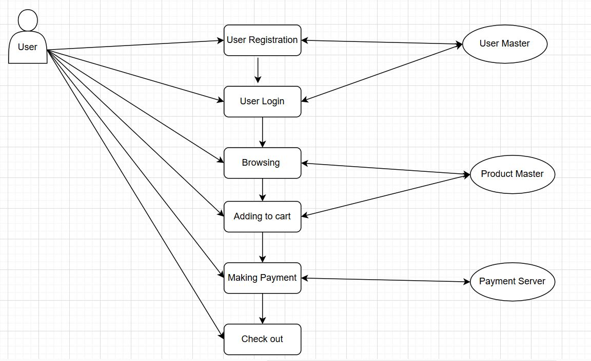

**Question 8** – Change Request

**Answer**:

A change request is a formal proposal to alter a product, system, or process. In project management, a change request can be a request to modify the scope, schedule, budget, or quality of a project.

Change requests can come from a variety of sources, including:

* **Clients**: A client may request a change to the deliverables of a project
* **Internal team members**: A team member may want to change a project deadline, product detail, or final output
* **Stakeholders**: A stakeholder may want to change a project deadline, product detail, or final output

Approach to be followed for any such change request is as follows:

* Identify the scope of the change request and assess its impact on the project.
* Analyse the cost and time required to implement the change request.
* Evaluate the benefits of the change request and its alignment with project goals.
* Prioritize the change request based on its urgency and importance.
* Communicate the change request to all relevant stakeholders, including the client, project manager, development team, and business analyst.
* Update the project plan and documentation to reflect the change request.
* Implement the change request and monitor its impact on the project.
* Obtain approval from the client or other relevant stakeholders before finalizing the change request.
* Communicate the status and impact of the change request to all stakeholders, including any updates to the project plan, timeline, or budget.

**Question 9** - Change Request Vs an Enhancement

**Answer**:

This is an enhancement request as it involves adding new features to the existing project. As a BA, I would prefer gathering more information/data from Ben and Kevin about the specific requirements of adding crop yields and implementing an auction system.

I would then as a second step would assess the impact of these changes on the project timeline, budget and technical feasibility. If the changes are possible and can be aligned with the existing project goals then, would document the new requirements and update and communicate the revised project plan with additional resources/cost to the concerned stakeholders.

A change request and an enhancement are both terms used in software development and project management, but they refer to slightly different things

Change Request:

* A change request is typically a formal proposal to alter a product, system, or project in some way.
* It often arises when there's a need to modify something that has already been defined or implemented. Change requests can involve fixing defects, addressing issues, or adjusting to meet new requirements.
* They are usually submitted when there's a deviation from the initial plan or specification, and they often require approval from stakeholders before implementation.

Enhancement:

* An enhancement, on the other hand, refers to an improvement or addition to a product or system that goes beyond its original specifications.
* Enhancements are typically intended to add new features, improve existing functionality, or enhance user experience.
* Unlike change requests, enhancements are often proactive and driven by a desire to make the product better rather than fixing something that's broken.
* While change requests are often reactive, responding to identified problems or changes in requirements, enhancements are more about adding value or staying competitive in the market.

**Question 10** – Estimations

**Answer**:

As per the project the following details can be deduced:

|  |  |
| --- | --- |
| Duration of the project | 18 months (i.e. 72 weeks) |
| Team Size (Currently) | 15 people |
| Project Budget | 2 crores |
| Type of Project | Medium Size |

Hence, the required man hours will be:

15 people x 72(no of weeks) x 40(hrs worked per week) = 43,200 hrs

Assumptions:

* Resources would be working 40 hours per week, or 8 hours per day, five days a week.
* The Resources are already well equipped and skilled for the job, so no training is required.
* The project will be completed without any delay due to external factors
* The Public holidays and leaves are ignored for the purpose of an approximate calculation.

**Question 11** – UAT

**Answer**:

UAT (User Acceptance Testing) is the final stage of the software development lifecycle where the end-users of the system test the product to ensure that it meets their requirements and is ready for deployment.

The UAT Acceptance process involves the following steps:

Planning: The business analyst works with the client to plan the UAT phase, including defining the scope, identifying the test scenarios and cases and setting the acceptance criteria.

Designing: In this stage all the test cases are design in way to make sure that there is no possible diversions from the expected output as was required by the user.

Test Execution: The end-users perform the testing on the software product in a real-world environment and provide feedback on its usability, functionality, and performance.

Issue Resolution: If any issues are identified during the UAT phase, they are recorded and addressed by the development team.

Sign-off: Once the UAT is completed successfully, the end-users sign-off on the product, indicating that it meets their requirements and is ready for deployment.

**Question 12** – Project Closure Document

**Answer**:

A project closure report is a formal document that summarizes the outcomes of a project after it has been completed. It’s a record of the project’s performance, captures lessons learned and provides a final assessment of whether the project met its objectives.

|  |  |  |  |
| --- | --- | --- | --- |
| **S. No** | **Points to Include** | **Details** | **Reference Link** |
| 1 | Did the client sign off on UAT testing |  | Business Scope.docx |
| Date of Sign off | 04-01-2025 |
| Name of Resource | Ronit Parekh |
| 2 | Objectives of the Project |  | Project Scope.docx |
| User Friendliness | Achieved |
| Customer Satisfaction | ROI in 6 months |
| More Categories | Achieved |
| 3 | Functionalities worked on |  | FRD.docx |
| Secured Payment Processing | Achieved |
| Other Categories | Achieved |
| 4 | Infrastructure |  | Procurement.docx |
| Software’s Installed | Achieved |
| Laptops Purchased | Achieved |
| 5 | Funding |  | Financials.docx |
| Amount Approved | 2 Crores |
| Amount Used | 2 Crores |
| 6 | Overall Project Information |  | Summary.docx |
| Escalations | 40 |
| Customer Satisfaction | High |
| 7 | Value to the Company | Company has gained successful integration of processes, increased turnover by 25%, increased efficiency by 20% |  |
| Positive / Negative |