**Deployment point pending in last**

**Document 1 - Business case document template**

* **Why is this project initiated?**

**HRM Application Project Initiation**

The HRM application is launched to streamline the entire employee lifecycle for both internal teams and client businesses. Developed using the Waterfall Model, its primary objectives are revenue generation through client subscriptions and exceptional service delivery to client businesses.

**Reasons for Initiation:**

**1. Employee Lifecycle Management:**

* Manages all stages of an employee's journey, from onboarding to exit.
* Key features include attendance tracking, leave management, productivity monitoring, and employee data management.

**2. Business Growth & Revenue Generation:**

* Monthly client subscriptions ensure a consistent revenue stream.

**3. Team Collaboration:**

* The project team includes the MD of the company, Project Manager, MERN Stack Developers, Data Analyst, UI/UX Developer, and Business Analyst for smooth execution.

**Core Functionalities:**

**Attendance Tracking:**

* Tracks employees’ daily punch-in/out for both internal and client teams.
* **Location Tracking:** Remains active during work hours for accountability.

**Leave Management:**

* Employees can apply for various leaves, including half-day, optional, privilege, sick, and comp-off.

**Employee Dashboard:**

* Displays essential employee information such as contact details, email, employee ID, and job designation.

**Productivity Monitoring:**

* Managers can track employee productivity by reviewing daily and weekly working hours, total present days, leave records, and absences.
* **Detailed Reports:** Include working hours, break hours, and overall attendance.

**Attendance Regularization:**

* Employees can adjust work hours using the calendar feature if they meet the 9-hour workday requirement.

**Leave Usage Insights:**

* Tracks leave balances and provides a clear leave usage history for transparency.
* **What are the current problems?**

1. **Inconsistent Use of Language and Formatting**:
   * **Issue**: The document contains grammatical errors, lack of punctuation, and inconsistent capitalization.
   * **Impact**: This can cause confusion and reduce the overall professionalism of the document.
2. **Location Tracking**:
   * **Issue**: The application requires employees to keep their location always on.
   * **Impact**: This may raise privacy concerns among users and can be seen as intrusive.
3. **Monthly Payment Model**:
   * **Issue**: The application is only accessible to clients with a monthly payment.
   * **Impact**: Potential clients may be deterred by the recurring costs, limiting the user base.
4. **Complexity of Features**:
   * **Issue**: The application offers a wide range of features, which might be overwhelming for some users.
   * **Impact**: Users may find it difficult to navigate and utilize all functionalities effectively.
5. **User Experience**:
   * **Issue**: The document does not mention any user training or onboarding process.
   * **Impact**: Lack of training might lead to underutilization of the application’s features and user dissatisfaction.
6. **Data Security and Privacy**:
   * **Issue**: No mention of data security measures or privacy policies.
   * **Impact**: This could be a significant concern for both internal employees and clients, affecting trust in the application.
7. **Feature Overload**:
   * **Issue**: Having too many features in one application without clear segmentation.
   * **Impact**: This can make the application cluttered and difficult to use efficiently.
8. **Technical Dependencies**:
   * **Issue**: The project involves various roles such as MERN stack developers, data analysts, UI/UX developers, etc.
   * **Impact**: Any delays or issues in these roles could impact the overall project timeline and quality.

**Recommendations:**

1. **Improve Documentation**:
   * Enhance the clarity and professionalism of the project documentation with proper grammar, punctuation, and formatting.
2. **Address Privacy Concerns**:
   * Provide clear information on how location data is used and ensure compliance with privacy regulations.
3. **Flexible Payment Models**:
   * Consider offering different pricing models, such as annual subscriptions or pay-per-use, to attract a broader client base.
4. **User-Friendly Design**:
   * Simplify the user interface and provide user training or onboarding sessions to help users make the most of the application’s features.
5. **Data Security Measures**:
   * Highlight the security measures in place to protect user data and comply with relevant privacy laws.
6. **Feature Prioritization**:
   * Prioritize key features and consider creating separate modules to avoid overwhelming users.
7. **Project Management**:
   * Ensure effective communication and coordination among all team members to address any technical dependencies promptly.

**➢ With this project how many problems could be solved?**

**1. Employee Attendance Management**

**Problem:** Manual attendance tracking is time-consuming and prone to errors.  
**Solution:**

* Tracks daily punch-in/out for internal and client employees.
* Shows working hours, break hours, and monthly attendance records.
* Allows employees to regularize attendance through the calendar feature.

**2. Leave Management**

**Problem:** Managing different types of leaves manually can cause confusion and delays.  
**Solution:**

* Employees can apply for various leaves, including half-day, optional, privilege, sick, and comp-off.
* Leave usage tracking ensures transparency.

**3. Productivity Monitoring**

**Problem:** Lack of visibility into employee productivity.  
**Solution:**

* Managers can track daily and weekly productivity metrics.
* Metrics include working days, present days, leave taken, absences, working hours, and break hours.

**4. Centralized Employee Information**

**Problem:** Scattered employee records lead to management inefficiencies.  
**Solution:**

* Employee details like contact numbers, email IDs, employee IDs, and designations are displayed on a central dashboard.

**5. Location Tracking**

**Problem:** Lack of accountability for employees working remotely or off-site.  
**Solution:**

* Real-time location tracking ensures employee accountability during work hours.

**6. Client Access & Payment Management**

**Problem:** Delayed payments and access control issues.  
**Solution:**

* Clients gain access only after monthly subscription payments, ensuring consistent revenue generation.

**7. Workflow Automation**

**Problem:** Manual data handling is inefficient and prone to human error.  
**Solution:**

* Automated tracking and reporting of attendance, leave, and productivity reduce administrative tasks.

**8. Revenue Generation**

**Problem:** Limited monetization opportunities.  
**Solution:**

* The monthly subscription model ensures a steady revenue stream.
* **Resources Required for HRM Application Development**

**1. Human Resources (Project Team Members)**

* **MD of the Company:** Provides strategic guidance and oversees project development.
* **Project Manager:** Manages project timelines, resources, and team coordination.
* **MERN Stack Developers:** Develop the front-end and back-end of the application.
* **Data Analyst:** Analyzes employee data for reports and insights.
* **UI/UX Developer:** Designs an intuitive and user-friendly interface.
* **Business Analyst:** Gathers and documents client requirements, ensuring business alignment.
* **Client-Side Team Members:** Collaborate for feature testing and provide requirement updates.

**2. Time Allocation**

* **Project Duration:** Expected to be completed within six months from the start date.

**3. Financial Resources (Budget)**

* **Total Budget:** Rs. 10,30,000 allocated as follows:
  + Core Development Costs (Hardware, Software, Training, Services): Rs. 10,00,000
  + Third-Party Software, Site Visits, External Services: Rs. 30,000

**4. Technical and Operational Resources**

* **Third-Party Software Integrations:** Payment gateways, cloud services, and analytics tools.
* **Site Visits:** To gather specific client requirements and on-ground feedback.
* **Market Research Reports:** To ensure competitive features and align with industry standards.
* **How much organizational change is required to adopt this technology?**

Implementing the HRM application requires adapting existing organizational processes, policies, and infrastructure. Key changes include:

**1. Process Automation**

* **Task Automation:** Shift from manual processes to automated systems for attendance, leave management, and productivity tracking.
* **Data-Driven Decisions:** Managers rely on system-generated reports for evaluating employee performance.

**2. Policy Updates**

* **Attendance & Leave Policies:** Update policies to align with automated tracking features like punch-ins, leave applications, and time regularization.
* **Data Privacy & Security:** Implement privacy policies due to location tracking and personal data management.

**3. Employee Training & Support**

* **System Training:** Conduct training sessions for employees, managers, and HR staff.
* **Change Management:** Offer workshops to ease the transition and minimize resistance.

**4. Technical Upgrades**

* **System Integration:** Integrate the HRM application with payroll, finance, and project management tools.
* **Data Migration:** Securely transfer existing employee records to the new system.

**5. Client Engagement & Support**

* **Onboarding Process:** Develop a client onboarding strategy, including training and technical assistance.
* Time frame to recover ROI?

1. **Initial Investment:**
   * This includes the total development cost, infrastructure, training, and other setup expenses.
2. **Revenue Generation:**
   * Monthly subscription fee charged to clients.
   * The number of clients subscribing to the software.
3. **Ongoing Costs:**
   * Maintenance and operational costs, including staff salaries and client support.
4. **Revenue Growth:**
   * As more clients adopt the system, monthly revenue will increase.

**Example Calculation:**

* **Initial Investment:** Rs. 1,000,000
* **Subscription Fee per Client:** Rs. 10,000/month
* **Initial Number of Clients:** 10
* **Monthly Revenue:** 10 clients * Rs. 10,000 = Rs. 100,000
* **Monthly Operational Costs:** Rs. 20,000

**Estimated ROI Recovery:**

1. **Net Monthly Revenue:** Monthly Revenue – Monthly Costs = Rs. 100,000 – Rs. 20,000 = Rs. 80,000
2. **ROI Recovery Time:** Initial Investment / Net Monthly Revenue = Rs. 1,000,000 / Rs. 80,000 = **12.5 months**

**➢ How to identify Stakeholders?**

**Understand the Project Scope**: Know the objectives and deliverables to identify who might be affected or interested.

**Categorize Stakeholders**:

* **Internal**: Project team, leadership, and employees using the system.
* **External**: Clients, vendors, regulatory bodies.
* **End Users**: Employees and managers interacting with the software.

**Use Stakeholder Mapping**: Group stakeholders by their influence and interest in the project:

* High Influence, High Interest (key decision-makers)
* High Influence, Low Interest (regulatory bodies)
* Low Influence, High Interest (end users)
* Low Influence, Low Interest (minimal attention needed)

**Define Roles**: Clarify responsibilities of each stakeholder (e.g., Project Manager, Business Analyst).

**Consult with the Team**: Ensure no stakeholders are missed by talking to team members and clients.

**Monitor Changes**: Stakeholders may change, so regularly update the list.

**Document 2- BA Strategy**

**Business Analyst Strategies I Have Performed**

1. **Elicitation Techniques:**
   * Interviews: Conducted one-on-one discussions with stakeholders to gain detailed insights.
   * Workshops: Facilitated collaborative sessions to align stakeholder expectations.
   * Surveys/Questionnaires: Collected diverse perspectives from a wider audience.
   * Observation: Observed current processes directly to understand real-time requirements.
   * Document Analysis: Reviewed existing documents for relevant requirement extraction.
2. **Stakeholder Analysis (RACI/ILS):**
   * Identify Stakeholders: Listed key internal and external project stakeholders.
   * RACI Chart: Assigned roles of Responsible, Accountable, Consulted, and Informed for tasks.
   * ILS Matrix: Analyzed stakeholders by influence and interest to guide engagement strategies.
3. **Documents Produced:**
   * Business Requirements Document (BRD): Defined core business needs and objectives.
   * Functional Requirements Document (FRD): Specified system functionalities and capabilities.
   * User Stories/Use Cases: Described system functionality from the user's perspective.
   * Traceability Matrix: Ensured all requirements were tracked throughout the project lifecycle.
   * Test Cases: Documented test scenarios to validate system compliance with requirements.
4. **Sign-Off Process:**
   * Client Review: Presented requirements documents to clients for feedback.
   * Incorporate Changes: Revised documents based on client input.
   * Formal Sign-Off: Secured client approval via email or signed documents.
5. **Communication Channels:**
   * Regular Updates: Sent project updates via email and project management tools.
   * Scheduled Meetings: Conducted regular progress meetings with stakeholders.
   * Collaboration Tools: Used tools like Slack or Teams for daily communication.
   * Document Sharing: Shared documents via cloud storage and project management systems.
6. **Change Request Management:**
   * Change Request Form: Logged formal change requests from stakeholders.
   * Impact Assessment: Evaluated changes for potential impact on scope, timeline, and cost.
   * Approval Process: Ensured necessary approvals were obtained before implementation.
7. **Progress Updates:**
   * Regular Reports: Delivered weekly/monthly reports highlighting key achievements.
   * KPIs Monitoring: Tracked project health and progress through Key Performance Indicators.
   * Progress Meetings: Held regular stakeholder meetings to discuss updates and concerns.
8. **UAT and Project Acceptance:**
   * User Acceptance Testing (UAT): Coordinated UAT scenario definition and execution with clients.
   * Feedback Collection: Collected and addressed UAT feedback.
   * Client Sign-Off: Secured client approval using the Client Project Acceptance Form after successful UAT.

**Document 3 - Functional Specifications**

|  |  |
| --- | --- |
| Project name | HRM Software for Employee Lifecycle Management |
| Customer name | ATC ltd. |
| Project Version | v1.0 |
| Project Sponsor | MD |
| Project Manager | Mr. Dinesh R |
| Project Initiation date | 01-06-2024 |

|  |  |  |  |
| --- | --- | --- | --- |
| Req ID | **Requirement Name** | **Requirement Description** | **Priority** |
| FR001 | Employee Attendance Tracking | Enable tracking of daily punch-in/punch-out times, including real-time location tracking during work hours. | 10 |
| FR002 | Leave Management | Allow employees to apply for half-day, optional, privilege, sick, and comp-off leaves, with usage tracking. | 10 |
| FR003 | Employee Dashboard | Display essential employee details like contact info, designation, employee ID, and leave status. | 10 |
| FR004 | Productivity Monitoring | Provide managers with daily/weekly productivity reports, including working hours, breaks, and leave data. | 10 |
| FR005 | Client Subscription Access | Restrict software access to clients based on monthly subscription payments. | 9 |
| FR006 | Attendance Regularization | Allow employees to regularize their attendance if 9-hour shifts are not completed. | 9 |
| FR007 | Real-Time Data Sync | Ensure real-time synchronization of employee attendance and productivity data across devices. | 9 |
| FR008 | Role-Based Access Control | Provide role-specific access levels for HR managers, employees, and clients. | 8 |
| FR009 | Data Security and Compliance | Ensure compliance with data protection laws and secure handling of sensitive employee data. | 8 |
| FR010 | Integration with Payroll | Enable integration with payroll systems to streamline salary processing and calculations. | 7 |

**Non functional requirements**

|  |  |  |  |
| --- | --- | --- | --- |
| **Req ID** | **Requirement Name** | **Requirement Description** | **Priority** |
| NFR001 | System Performance | Ensure system response time within 2 seconds for critical operations. | 10 |
| NFR002 | Data Security & Privacy | Encrypt sensitive employee data and implement secure authentication. | 10 |
| NFR003 | System Availability | Guarantee 99.9% system uptime with minimal downtime. | 10 |
| NFR004 | Data Backup & Recovery | Provide automated daily backups and disaster recovery protocols. | 9 |
| NFR005 | Scalability | Support up to 50,000 active users simultaneously. | 9 |
| NFR006 | Compliance & Legal Standards | Adhere to relevant labor and data protection laws (e.g., GDPR). | 9 |
| NFR007 | Usability | Ensure a user-friendly, intuitive, and accessible interface. | 8 |
| NFR008 | Real-Time Data Synchronization | Enable real-time synchronization of attendance and productivity data. | 8 |
| NFR009 | Integration Capability | Support integration with payroll, ERP, and third-party tools. | 7 |
| NFR010 | System Monitoring & Reporting | Implement system health checks and detailed operational reports. | 7 |

**Document 4- Requirement Traceability Matrix**

|  |  |  |  |  |  |  |  |
| --- | --- | --- | --- | --- | --- | --- | --- |
| **Req ID** | **Req Name** | **Req Description** | **Design D1** | **Test T1** | **Design D2** | **Test T2** | **UAT** |
| FR001 | User Login | Allow users to log in securely. | Pass | Pass | Pass | Pass | Pass |
| FR002 | Leave Application | Enable leave requests for employees. | Pass | Pass | Pass | Pass | Pass |
| FR003 | Attendance Tracking | Track daily punch-in/punch-out. | Pass | Pass | Pass | Pass | Pass |
| FR004 | Employee Dashboard | Show key employee details. | Pass | Pass | Pass | Pass | Pass |
| FR005 | Location Tracking | Track employee work location. | Pass | Pass | Pass | Pass | Pass |
| FR006 | Leave History | View leave usage summary. | Pass | Pass | Pass | Pass | Pass |
| FR007 | Subscription Payment | Enable monthly client payments. | Pass | Pass | Pass | Pass | Pass |
| FR008 | Productivity Reports | Generate productivity insights. | Pass | Pass | Pass | Pass | Pass |
| FR009 | System Security | Ensure data security compliance. | Pass | Pass | Pass | Pass | Pass |
| FR010 | Role Management | Manage employee roles and access. | Pass | Pass | Pass | Pass | Pass |

**Document 5 - BRD Template**

**1. Document Revisions**

|  |  |  |  |
| --- | --- | --- | --- |
| **Date** | **Version Number** | **Modified By** | **Documents changes** |
| 01-07-2024 | 0.1 | Initial Draft | Created the functional specifications  for the HRM system. |
| 22-07-2024 | 0.2 | Project Manager | Updated leave management and  dashboard requirements. |
| 05-08-2024 | 0.3 | Business Analyst | Added productivity metrics and  compliance specifications. |
| 15-09-2024 | 0.4 | QA Team | Revised test cases to align with updated  UAT guidelines. |

**2. Approvals**

|  |  |  |  |  |
| --- | --- | --- | --- | --- |
| **Role** | **Name** | **Title** | **Signature** | **Date** |
| Project Sponsor | Mr. Deepak | Sponsor | Deepak | 01-06-2024 |
| Business Owner | M/s Shivani | Business Owner | Shivani | 01-06-2024 |
| Project Manager | Mr. Tarun R | Project Manager | Tarun R | 01-06-2024 |
| System Architect | Mr. Sujay | System Architect | Sujay | 01-06-2024 |
| Development Lead | Mr. Vijay | Lead Developer | Vijay | 01-06-2024 |
| User Experience Lead | M/s Pranita | UX Lead | Pranita | 01-06-2024 |
| Quality Lead | M/s Sharon | QA Lead | Sharon | 01-06-2024 |
| Content Lead | Mr. Dinesh | Content Manager | Dinesh | 01-06-2024 |

**3. RACI Chart for this document**

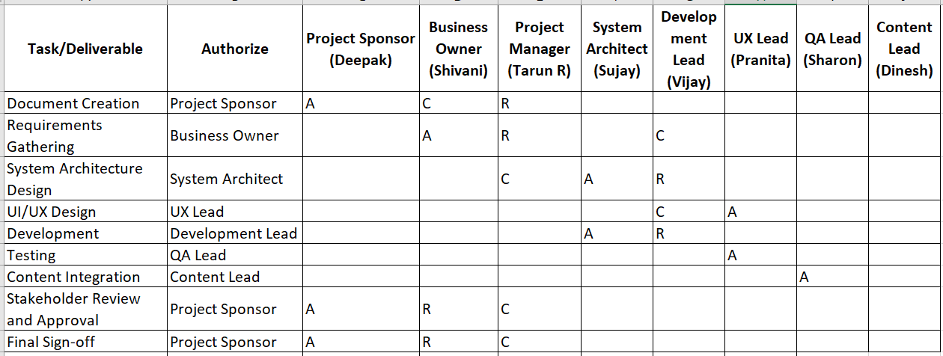

**4. Introduction**

**4.1. Business Goals & Organizational Need**

**Business Goals:**

1. **Improve Employee Lifecycle Management:**
   * Ensure seamless tracking and management of the entire employee journey, from recruitment to offboarding, to improve operational efficiency and reduce manual errors.
2. **Enhance Client Service Delivery:**
   * Offer clients a comprehensive, easy-to-use HR software solution that automates and simplifies employee management tasks, including attendance tracking, leave management, and productivity monitoring.
3. **Drive Revenue Generation:**
   * By offering HRM software as a subscription-based service, generate a steady stream of revenue through monthly client payments, creating long-term financial sustainability.
4. **Promote Scalability:**
   * Build a scalable HRM solution that can be easily customized to meet the needs of various clients, accommodating different industries and employee sizes.
5. **Enhance Data-Driven Decision Making:**
   * Provide clients with actionable insights through data analytics, supporting better HR decision-making regarding attendance, leave management, and employee productivity.

**Organization Need:**

1. **Automate HR Processes:**
   * Reduce manual processes, streamline HR workflows, and ensure accuracy and efficiency in tracking attendance, leave, and employee performance.
2. **Improve Client Satisfaction:**
   * Provide a reliable and user-friendly HR software system that meets client needs and fosters strong, long-term relationships.
3. **Facilitate Better Employee Management:**
   * Allow HR managers and business leaders to track and optimize employee performance, attendance, and leave policies, improving workforce efficiency and satisfaction.
4. **Ensure Compliance and Transparency:**
   * Keep up with labour laws and regulations, ensuring compliance through transparent and accurate employee data management.
5. **Create a Competitive Edge:**
   * By offering a robust and scalable HRM system, the organization aims to position itself as a market leader in HR technology solutions.

**4.2. Business Objectives**

**Objective:**  
To develop a comprehensive Human Resource Management (HRM) software solution that optimizes employee lifecycle management for internal teams and client organizations.

**Key Functionalities to Develop:**

1. **Attendance Management:**
   * Track employee check-in and check-out times with real-time location data.
   * Allow attendance regularization for shift adjustments.
2. **Leave Management:**
   * Enable employees to apply for various leave types, including sick leave, privilege leave, half-day, and compensatory leave.
   * Display leave usage and balances on the employee dashboard.
3. **Employee Dashboard:**
   * Provide a detailed view of employee details, including contact information, designation, and activity metrics.
   * Track performance metrics such as productivity, work hours, breaks, and absences.
4. **Payroll Integration:**
   * Integrate salary calculations based on attendance and leave data.
   * Offer seamless integration with payment processing systems.
5. **Productivity Monitoring:**
   * Track working hours versus break hours.
   * Generate reports on attendance, leave trends, and overall productivity.
6. **Client Access Control:**
   * Provide access to the HRM software for clients upon monthly subscription payments.
   * Offer tailored dashboards and functionalities for client-specific needs.
7. **Scalability and Integration:**
   * Ensure compatibility with third-party tools like payroll systems and performance management software.
   * Allow easy addition of features for scalability as per client requirements.

**4.3. Business Rules**

**1. Organizational Policies**

* Work Hours: Employees must complete a 9-hour workday, including breaks.
* Attendance Policy: Employees must punch in and out daily, with real-time location tracking enabled during work hours.

**2. Leave Management Rules**

* Leave Types: Employees can apply for various leaves, including:
  + Half-day
  + Sick Leave
  + Privilege Leave
  + Compensatory Off (Comp-off)
* Approval Process: Managers must approve leave requests before they are applied.
* Leave Balances: Leave balances reset annually or as per company policy.

**3. Payroll and Payments**

* Salary Calculations: Monthly payroll will be processed based on attendance and approved leave records.
* Client Subscriptions: The HRM software will be accessible only after clients pay the monthly subscription fee.

**4. Employee Data Management**

* Data Accuracy: Employees must keep their contact details and personal information updated in the system.
* Privacy Compliance: Employee data must be securely stored, following data protection and privacy regulations.

**5. Productivity and Performance Tracking**

* Monitoring Metrics: Employees’ working hours, break hours, and productivity statistics must be accurately tracked.
* Reporting Frequency: Managers must review productivity reports weekly or monthly.

**6. Security and Access Control**

* Role-based Access: Only authorized personnel can access sensitive HR data.
* Data Security: The system must comply with industry-standard cybersecurity protocols.

**7. Compliance and Audits**

* Compliance Checks: Regular system audits will ensure compliance with labour laws and data security standards.
* Policy Updates: Company policies must be regularly reviewed and updated in the system.

**8. Client-Specific Rules**

* Customization: Clients can request custom HR policies based on their organizational needs.
* Data Sharing: Only authorized client representatives can access and modify data relevant to their organization.

**4.4. Background**

The HRM software project was proposed to address key challenges faced by the organization in managing employee-related processes efficiently. The existing manual or outdated systems caused delays, errors in payroll processing, inconsistent attendance records, and lack of real-time employee performance monitoring.

**Business Issues Identified:**

1. **Inefficient Employee Management:** Manual processes led to delayed leave approvals, inaccurate attendance records, and payroll errors.
2. **Data Inaccuracy:** Employee data management was prone to errors due to outdated storage methods.
3. **Limited Performance Insights:** Lack of automated productivity tracking hindered performance evaluation.
4. **Compliance Challenges**: Difficulty in ensuring compliance with labor laws and data privacy regulations.
5. **Client Dependency: Client-**specific HR requirements were hard to manage without a centralized system.

**Expected Benefits:**

1. **Automated Employee Lifecycle Management:** Streamlined processes for hiring, payroll, attendance, leave, and performance tracking.
2. **Improved Data Accuracy:** Centralized data management minimizes errors and enhances decision-making.
3. **Enhanced Productivity Monitoring:** Real-time tracking and performance evaluation increase operational efficiency.
4. **Regulatory Compliance:** Automated compliance tracking reduces legal risks.
5. **Revenue Generation:** Offering the software as a subscription service creates a consistent revenue stream from clients.
6. **Scalable Solution:** Ability to adapt to growing business needs and integrate advanced features like AI-driven analytics.

**4.5 - Project Objective**

Theprimary goal of the HRM software project is to develop a comprehensive, scalable, and user-friendly application that automates and streamlines employee lifecycle management for both internal teams and clients. The product will integrate core HR functionalities such as attendance tracking, leave management, payroll processing, and productivity monitoring.

**High-Level Descriptions:**

1. **Employee Lifecycle Management:**
   * Manage all employee-related processes, from recruitment to retirement.
   * Centralize employee data for easy access and updates**.**
2. **Attendance and Productivity Monitoring:**
   * Track punch-in/punch-out and work hours in real time.
   * Provide productivity reports for employees and managers.
3. **Leave Management:**
   * Automate leave applications, approvals, and tracking.
   * Ensure transparency with real-time leave balance updates.
4. **Payroll and Compliance:**
   * Calculate salaries, tax deductions, and other employee benefits.
   * Ensure compliance with legal and organizational policies.
5. **Client Subscription Model:**
   * Offer the platform as a subscription service for revenue generation.
   * Enable scalable pricing based on client needs and workforce size.

**Alignment with Business Objectives:**

* Automation and Efficiency: Reduces manual tasks, increasing productivity.
* Data Accuracy and Security: Ensures reliable data storage and compliance.
* Revenue Generation: Supports a subscription model for recurring income.
* Enhanced Client Satisfaction: Provides personalized HR solutions for clients.

**System Integration Requirements:**

* Payment Gateway Integration: For subscription fee collection.
* Third-Party Software Compatibility: Integration with accounting and payroll services.
* Data Analytics Tools: For generating insightful HR reports and dashboards.
* Compliance and Audit Systems: To ensure legal adherence and policy updates.

**4.6. Project Scope**

**1. Employee Management**

* Centralized employee database.
* Employee profile creation and role management.

**2. Attendance Management**

* Daily punch-in/punch-out tracking.
* Location-based attendance verification.
* Attendance regularization requests.

**3. Leave Management**

* Leave application, approval, and tracking for various leave types (half-day, sick leave, privilege leave, comp-off).
* Real-time leave balance updates.

**4. Productivity Monitoring**

* Total working hours and break hours tracking.
* Performance metrics for employees and managers.
* Weekly and monthly productivity reports.

**5. Payroll and Payments**

* Salary calculation and payment processing.
* Integration with payment gateways.
* Compliance with tax and labour laws.

**6. Client Subscription Management**

* Monthly subscription-based access to the software.
* Automated billing and payment reminders.

**7. Reporting and Analytics**

* Customizable HR reports for attendance, leave, and payroll.
* Dashboard summaries for managers and HR staff.
* Employee performance insights.

**8. Security and Compliance**

* Role-based data access control.
* Secure employee data management.
* Compliance with industry-specific legal requirements.

**In Scope:**

1. **Employee Management**: Employee profiles, role assignments, and permissions.
2. **Attendance Management:** Punch-in/out, location tracking, and attendance regularization.
3. **Leave Management:** Leave application, tracking, and approval processes.
4. **Productivity Monitoring:** Work hours, break tracking, and performance reports.
5. **Payroll & Payments:** Salary calculations, payment processing, and tax compliance.
6. **Client Subscription Management:** Monthly billing and subscription tracking.
7. **Reporting & Analytics:** HR reports, dashboards, and custom analytics.
8. **Security & Compliance:** Data protection, role-based access, and industrycompliance**.**

**Out of Scope:**

1. Recruitment & Onboarding
2. Training & E-Learning Modules
3. Advanced Performance Management
4. Custom Integrations Beyond Core Modules
5. Multi-language Support (Initial Phase)
6. Custom HR Policy Configurations

**5. Assumptions**

**Assumptions**

1. **User Readiness:** Employees and managers will be trained to use the HRM system effectively.
2. **Data Accuracy:** All employee and organizational data provided will be accurate and up-to-date.
3. **System Access:** Users will have uninterrupted internet access for smooth system operation.
4. **Client Payments:** Clients will make timely monthly payments to access the system.
5. **Compliance Standards:** The system will follow industry-standard security and compliance protocols.
6. **Third-Party Integration:** Necessary third-party software and APIs will be available and compatible.
7. **Project Timeline:** Development and deployment will occur within the agreed six-month timeline.
8. **Stakeholder Involvement:** All stakeholders will actively participate during development, testing, and implementation phases.
9. **Support & Maintenance:** Ongoing system maintenance and customer support will be provided post-launch**.**
10. **Scalability Needs:** Future expansion or customization requests will be handled as separate phases or projects.

**6. Constraints**

1. **Budget Limitations:** The total budget for the project is capped at Rs. 1,030,000, which limits the scope for additional features or extensive third-party integrations.
2. **Timeline Restrictions:** The project must be completed within 6 months from initiation, limiting the time for testing and iteration.
3. **Client Dependency:** Clients can only use the HRM system after making monthly payments, potentially affecting early adoption rates.
4. **Data Privacy Regulations:** Compliance with data protection laws may limit the types of data stored or processed by the system.
5. **Resource Availability:** The availability of the project team, including developers, testers, and business analysts, is limited by other ongoing projects.
6. **Integration Compatibility:** The system must integrate with third-party software, which may require additional resources or customizations, leading to potential delays.
7. **User Training:** Adequate training for users may take time, affecting the speed of adoption and usage post-deployment.
8. **Device Compatibility:** The system must work efficiently across different platforms (e.g., Android and iOS), which could require additional resources for optimization**.**
9. **Security Requirements:** Adherence to high security and compliance standards could limit the flexibility in certain system designs or features**.**
10. **Vendor Dependence:** The use of third-party APIs or software may depend on their availability and performance, potentially impacting the project timeline.

**7. Risks**

**• User Resistance to Change**

* **Risk:** Employees and clients may resist transitioning from existing HR systems to the new HRM software.
* **Impact**: Delays in adoption, lower user engagement, and lack of effective utilization of the software.
* **Mitigation:** Offer comprehensive training and a gradual transition phase with user support.

• Data Security & Privacy Concerns

* **Risk:** The software may collect sensitive employee data, which could be vulnerable to breaches or misuse.
* **Impact:** Legal issues, loss of trust, and financial penalties due to non-compliance with data protection regulations.
* **Mitigation:** Implement strong encryption, access controls, and comply with data privacy laws such as GDPR.

**• Integration with Existing Systems**

* **Risk:** Integrating the HRM software with other enterprise systems (payroll, attendance, etc.) may be complex.
* **Impact:** Delays, additional costs, and operational disruption.
* **Mitigation:** Perform thorough testing of integrations and involve experienced developers for custom solutions.

**• Inaccurate or Incomplete Data**

* **Risk:** Data migration from legacy systems to the new HRM system could result in loss or corruption of data.
* **Impact:** Wrong employee information or incomplete records affecting operational decisions.
* **Mitigation:** Conduct multiple data audits and validation checks during migration.

**• Technical Issues and Software Bugs**

* **Risk:** Bugs and glitches may occur, affecting functionality, especially during the initial phase of usage.
* **Impact:** Decreased user satisfaction, operational inefficiencies, and system downtime.
* **Mitigation:** Perform rigorous testing, including user acceptance testing (UAT), and fix issues before the official rollout.

**• Budget Overruns**

* **Risk:** The project may exceed the planned budget due to unforeseen expenses or scope creep.
* **Impact:** Financial strain on the organization and potential delays in project delivery.
* **Mitigation:** Monitor project expenses closely and maintain a contingency fund for unforeseen costs.

**• Performance & Scalability Issues**

* **Risk:** The HRM software may not scale effectively to accommodate a large number of users or high volumes of data.
* **Impact:** Slow system performance and reduced user experience, especially during peak usage times.
* **Mitigation:** Use scalable cloud solutions and conduct load testing to identify and address performance issues.

**• Client Payment Delays**

* **Risk:** Clients may delay or fail to make timely monthly payments to access the software.
* **Impact**: Delayed revenue, cash flow issues, and difficulty maintaining the platform.
* **Mitigation:** Set clear payment terms and monitor payments closely to ensure timely processing.

**• Legal Compliance and Regulations**

* **Risk:** Failing to comply with local labor laws, tax laws, or other regulations could lead to legal repercussions.
* **Impact:** Fines, penalties, and reputation damage.
* **Mitigation:** Ensure that the software complies with all applicable legal requirements, and keep the system updated as regulations change.

**• Vendor or Third-Party Service Failures**

* **Risk:** Reliance on third-party services (such as payment gateways, cloud hosting, etc.) may lead to service disruptions.
* **Impact:** System downtime, poor user experience, and operational losses.
* **Mitigation:** Choose reliable vendors with service level agreements (SLAs) and back-up plans for critical services.

**• Lack of User Training and Support**

* **Risk:** Employees or clients may struggle with using the software if training is insufficient or support is not easily available.
* **Impact:** Low adoption rates and inefficiency in using the HRM system.
* **Mitigation:** Provide comprehensive training sessions and ongoing support through dedicated help desks or customer service.

**Business Process Overview**

**This section outlines the overall process flow from each phase of the HRM project, covering the current legacy system (AS-IS) and proposed recommendations (TO-BE).**

**8.1. Legacy System (AS-IS)**

In the legacy HRM system, processes are manual or semi-automated, leading to inefficiencies such as duplicate data entries, delays in leave approvals, and difficulties in tracking attendance and productivity. Reporting and analytics require significant manual effort.

**Process Flow Diagram:**

1. Employee Record Management: Manual data entry into spreadsheets.
2. Attendance & Productivity Tracking: Manual punch-ins, paper-based timesheets.
3. Leave Management: Leave requests via email or forms.
4. Payroll Processing: Manual calculations prone to errors.
5. Reporting & Analytics: Manual report generation, delayed insights.

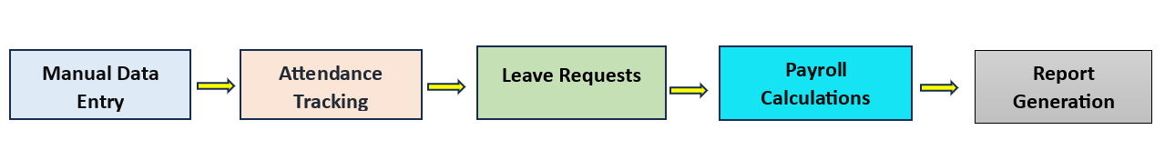

**8.2. Proposed Recommendations (TO-BE)**

The proposed HRM software will digitize and automate HR processes, reducing manual workload, enhancing data accuracy, and providing real-time insights. This system will centralize all employee-related processes, ensuring smooth operations, transparency, and compliance.

**Proposed System Process Flow Diagram:**

1. Employee Record Management: Centralized database with automated updates.
2. Attendance & Productivity Tracking: Real-time punch-in/out, automatic tracking with location-based monitoring.
3. Leave Management: Self-service portal for leave applications, real-time leave balance updates.
4. Payroll Processing: Automated payroll system integrated with attendance data.
5. Reporting & Analytics: Auto-generated reports with real-time insights and analytics dashboards**.**

**How the Proposed System Addresses Legacy Challenges:**

1. Data Accuracy: Centralized database reduces duplication and errors.
2. Process Automation: Automates repetitive tasks like attendance tracking and payroll processing.
3. Real-Time Insights: Instant access to productivity reports and leave balances.
4. Improved Employee Experience: Self-service portals reduce administrative delays.
5. Compliance & Security: Ensures compliance with labor laws through built-in policies and secure data handling.

**9. Business Requirements**

**Business Requirements**

This section outlines the specific business requirements for the HRM project, categorized by priority and functionality. These requirements were gathered from key stakeholders to ensure smooth implementation and alignment with business goals. Functional and non-functional requirements are tracked in a traceability matrix for seamless project monitoring.

**1. Functional Requirements**

|  |  |  |  |  |
| --- | --- | --- | --- | --- |
| **Req ID** | **Requirement Name** | **Description** | **Priority** | **Area of Functionality** |
| FR-01 | Employee Record Management | Maintain employee records in a centralized database. | High | Employee Management |
| FR-02 | Attendance Tracking | Track employee punch-in/out with real-time monitoring. | High | Attendance Management |
| FR-03 | Leave Management | Enable employees to apply for various leave types. | High | Leave Management |
| FR-04 | Payroll Processing | Calculate payroll based on attendance and working hours. | Medium | Payroll Management |
| FR-05 | Reporting & Analytics | Generate automated performance and leave reports. | Medium | Reporting & Analytics |
| FR-06 | Employee Self-Service Portal | Allow employees to access leave balances and payslips. | High | Employee Portal |
| FR-07 | Role-Based Access Control | Restrict access based on user roles and permissions. | High | Security & Compliance |
| FR-08 | Notification System | Send automated notifications for approvals and alerts. | Medium | Notifications & Alerts |

**2. Non-Functional Requirements**

|  |  |  |  |  |
| --- | --- | --- | --- | --- |
| **Req ID** | **Requirement Name** | **Description** | **Priority** | **Category** |
| NFR-01 | System Performance | Ensure system response time within 3 seconds. | High | Performance |
| NFR-02 | Data Security & Privacy | Protect sensitive data through encryption and access control. | High | Security |
| NFR-03 | System Scalability | Support up to 10,000 active users simultaneously. | Medium | Scalability |
| NFR-04 | System Availability | Ensure system availability of 99.9% uptime. | High | Reliability |
| NFR-05 | Compliance & Legal Standards | Follow legal regulations like GDPR for data protection. | High | Compliance |
| NFR-06 | Usability | Provide an intuitive and user-friendly interface. | High | User Experience |
| NFR-07 | Data Backup & Recovery | Enable automated backups and disaster recovery. | Medium | Data Management |
| NFR-08 | Integration Capability | Support integration with third-party tools like payroll systems. | Medium | Integration |

**Traceability Matrix:**The functional and non-functional requirements will be tracked using a requirements traceability matrix (RTM) linking each requirement to project phases, test cases, and implementation status.

**Supporting Documents:**

* Use Case Documentation
* Process Flow Diagrams
* System Architecture Diagrams

**10.1. List of Acronyms**

* HRM: Human Resource Management
* MD: Managing Director
* PM: Project Manager
* UI/UX: User Interface/User Experience
* BA: Business Analyst
* ATS: Applicant Tracking System

**10.2. Glossary of Terms**

* Employee Lifecycle: The entire process of managing employees from hiring to offboarding.
* Attendance Tracking: Recording employee work hours, including punch-ins and punch-outs.
* Leave Management: A system that manages various types of employee leaves.
* Client Subscription: Monthly payment for access to the HRM system.

**10.3. Related Documents**

* Business Requirement Document (BRD)
* Software Requirements Specification (SRS)
* Test Plans and Test Cases
* User Manuals and Training Guides
* Compliance and Security Guidelines

**Document 6 - Use case diagram, activity diagram and a use case specification document.**



**Activity diagram –**

**Punch in**

**User Registration –**



**Profile Management –**



**Track attendance –**



**Leave management -**



**Use case specification document**

|  |  |
| --- | --- |
| **Use Case Name** | User Log In |
| **Brief** | Allows users to access their accounts by entering valid login credentials. |
| **Description** | This use case describes the process where a user provides their email and  password to log into the system. Successful login grants access to their  dashboard and application features. |
| **Actors** | **Primary Actor:** Employee **Secondary Actor:** Database |
|  |  |
| **Pre -Condition** | The user must be registered in the system with a valid email and password.  The database must be accessible to verify credentials. |
| **Basic Flow** | The user opens the login page. |
| The user enters their email and password. |
| The system validates the credentials by checking the database. |
|  | If credentials are valid, the user is granted access to the dashboard. |
| **Alternate** | **Invalid Credentials:** |
| **Flow** | 1. If the email or password is incorrect, the system displays an error message:  "Invalid email or password." |
|  | 2. The user is prompted to re-enter login details. |
|  | **Forgot Password:** |
|  | 1. If the user forgets their password, they can click on the "Forgot Password" link. |
|  | 2. The system guides the user through the password recovery process. |
| **Post - Condition** | The user successfully logs in and accesses their dashboard. |
| If credentials are invalid, the user remains on the login page until valid credentials  are provided. |

|  |  |
| --- | --- |
| **Use Case Name** | Registration |
| **Brief** | Allows new users to create an account by providing their name, email, phone  number, and password. |
| **Description** | This use case describes the process where a new user registers in the system  by entering their details.  Upon successful registration, the user gains access to their account and  system features. |
| **Actors** | **Primary Actor:** Employee **Secondary Actor:** Database |
| **Pre -Condition** | The user must not already be registered in the system. |
| The database must be accessible to store user information. |
| **Basic Flow** | The user opens the registration page. |
| The user enters their name, email, phone number, and password. |
| The system validates the entered information (e.g., email format, unique  email, and password criteria). |
|  | If all validations pass, the system saves the user details in the database. |
|  | The system displays a success message: "Registration completed successfully." |
| **Alternate** | **Invalid Email Format:** |
| **Flow** | 1. If the email format is invalid, the system displays an error message: "Please  enter a valid email address." |
| 2. The user is prompted to correct the email format. |
|  | **Email Already Registered:** |
|  | 1. If the entered email is already registered, the system displays an error  message: "This email is already in use." |
|  | 2. The user is prompted to use a different email or log in. |
|  | **Weak Password:** |
|  | 1. If the password does not meet criteria (e.g., minimum length, special  characters), the system displays an error message: "Password must be at least 8 characters long and include a special character." |
|  | The user is prompted to enter a stronger password. |
|  | 2. The user is prompted to enter a stronger password. |
| **Post - Condition** | **Successful Registration:** The user's details are saved in the database, and the  user can log in to access the dashboard. |
| **Unsuccessful Registration:** The user remains on the registration page until all  validation errors are resolved. |

|  |  |
| --- | --- |
| **Use Case Name** | Track Attendance |
| **Brief** | Allows employees to view and track their attendance records, including daily  punch-in and punch-out times, total working hours, break hours, and attendance status. |
| **Description** | This use case describes the process where an employee accesses their attendance  records, reviews daily/weekly/monthly details, and ensures accuracy. The system provides real-time and historical data related to attendance, including the ability to regularize missed punches if necessary. |
| **Actors** | **Primary Actor:** Employee **Secondary Actor:** Database |
| **Pre -Condition** | The user must be logged into the system. |
| Attendance data for the employee must already exist in the database. |
| **Basic Flow** | The employee accesses the "Track Attendance" page from the dashboard. |
| The system retrieves the employee's attendance records from the database. |
| The system displays attendance details, including: |
|  | Daily punch-in and punch-out times. |
|  | Total working hours, total break hours. |
|  | Attendance status (e.g., Present, Absent, Leave). |
|  | The employee can toggle between daily, weekly, or monthly views for the records. |
|  | The system highlights any missing or incomplete attendance records. |
| **Alternate** | **Incomplete Attendance Records:** |
| **Flow** | 1. If there are missing or incomplete attendance entries, the system provides an  option to regularize attendance. |
| 2. The employee clicks on the regularization option and provides a reason for  the update. |
|  | 3. The system submits the regularization request to the manager for approval. |
|  | **Data Retrieval Failure:** |
|  | 1. If the system fails to retrieve attendance data due to a database error, an  error message is displayed: |
|  | *"Unable to load attendance records. Please try again later."* |
|  | 2. The employee is redirected to the dashboard. |
| **Post - Condition** | **Successful Attendance Tracking:** The employee reviews their attendance details  and ensures accuracy. |
| **Unsuccessful Attendance Tracking:** The employee cannot access attendance data due to system or database errors and must try again later. |
|  | validation errors are resolved. |

|  |  |
| --- | --- |
| **Use Case Name** | Leave Management |
| **Brief** | Allows employees to apply for leaves, view leave balances, track leave usage, and managers to approve or reject leave requests. |
| **Description** | This use case describes the process by which employees can manage their leaves, including applying for different types of leaves (e.g., half-day, optional, privilege, sick, or compensatory leave), viewing their leave history, and tracking balances. Managers can review and approve/reject leave requests submitted by employees. |
| **Actors** | **Primary Actor:** Employee **Secondary Actor:** Database, Manager |
| **Pre -Condition** | • The employee must be logged into the system. |
| • Leave types and balances for the employee must exist in the database.  • Manager access must be available for approval workflows. |
| **Basic Flow** | 1. The employee navigates to the "Leave Management" page. |
| 1. The system displays the employee’s leave balance for all available leave types. |
| 1. The employee selects the leave type (e.g., Sick, Privilege, Optional). |
|  | 1. The employee fills in the leave application form, including: |
|  | * Start and end date. |
|  | * Reason for leave. |
|  | 1. The system validates the application (e.g., sufficient leave balance). |
|  | 1. The leave request is submitted to the manager for approval. 2. The employee receives a confirmation that the request has been submitted successfully.   **Manager Perspective:** 8. The manager receives a notification about the leave request. 9. The manager reviews the application details and either approves or rejects it. 10. The employee is notified of the manager’s decision via the system. |
| **Alternate** | **Insufficient Leave Balance:** |
| **Flow** | If the employee selects a leave type with insufficient balance, the system displays a message: "You do not have enough balance for this leave type. Please select another leave type." |
| The employee can either cancel the application or modify the request. |
|  | **Manager Inaction:** |
|  | If the manager does not act on the request within a specified period, the system sends a reminder notification. |
|  | **Rejected Leave Request:** |
|  | If the manager rejects the leave request, the employee receives a notification with the reason for rejection. |
|  | The employee can modify and resubmit the request if necessary. |
| **Post - Condition** | • **Successful Leave Application:** The leave request is submitted and pending approval from the manager. |
| • **Leave Approved:** The leave request is approved, and the leave balance is updated in the system. |
|  | • **Leave Rejected:** The leave request is rejected, and the employee is notified with the reason. |

|  |  |
| --- | --- |
| **Use Case Name** | Report Generation |
| **Brief** | Allows managers and employees to generate reports on attendance, productivity, or leave details for a specified time period. |
| **Description** | This use case describes the process where managers or employees generate reports based on attendance records, productivity metrics, or leave usage. These reports help in monitoring performance and tracking data for decision-making. |
| **Actors** | **Primary Actor:** Manager **Secondary Actor:** Database, Employee |
| **Pre -Condition** | • The user must be logged into the system. |
| • The required data for the report (attendance, leave, productivity, etc.) must be available in the database. |
| **Basic Flow** | • The employee navigates to the "Report Generation" page. |
| • The system displays report categories such as "Attendance," "Leave History," and "Work Hours." |
| • The employee selects a report type. |
|  | • The employee enters filters (e.g., date range, department). |
|  | • The system fetches the data from the database. |
|  | • The report is displayed to the employee in a user-friendly format (e.g., table, chart). |
|  | • The employee can download the report in a preferred format (e.g., PDF, Excel). |
|  | **Manager Perspective:** 8. The manager navigates to the "Report Generation" page. 9. The system displays report categories such as "Team Attendance," "Productivity Metrics," and "Leave Approvals." 10. The manager selects a report type and applies relevant filters (e.g., employee ID, time range). 11. The system processes the data and displays the report. 12. The manager can download, print, or share the report. |
| **Alternate** | **No Data Available:** |
| **Flow** | If the selected date range or filters do not yield any data, the system displays a message: "No data available for the selected criteria. Please modify your filters." |
| The user can adjust the filters and retry. |
|  | **Export Failure:** |
|  | If the report fails to export due to a technical issue, the system displays an error message: "Unable to export the report. Please try again later." |
|  | The user is redirected to the report view page. |
|  | **Database Access Error:** |
|  | If the system cannot retrieve data from the database, an error message is displayed: "Data retrieval failed. Please try again later."  The user is prompted to retry the process after some time. |
| **Post - Condition** | **Successful Report Generation:** The user successfully views and downloads the report. |
| **No Data Generated:** The user remains on the "Report Generation" page and can modify filters. |
|  | **Database Error:** The user is notified of the error and is advised to retry later. |

**9. Assumptions about the project for the HRM software:**

**1. User Access**

* It is assumed that all users (employees, managers, and admins) will have unique login credentials to access the system securely.

**2. System Availability**

* The HRM software will be accessible 24/7, ensuring employees can log in, track attendance, and apply for leaves at any time.

**3. User Roles and Permissions**

* Different user roles (e.g., employee, manager, admin) will have different access levels to specific features of the application.

**4. Data Accuracy**

* It is assumed that employee-related data (e.g., attendance records, leave balance) will be accurate and up-to-date in the database.

**5. Third-Party Integrations**

* Payment processing will rely on integration with a third-party payment gateway that complies with security and privacy standards.

**6. Internet Connectivity**

* Users will need a stable internet connection to use the HRM application as it relies on real-time database interactions.

**7. Scalability**

* The system is designed to scale with an increasing number of users, assuming the database and server infrastructure are sufficient to handle high traffic.

**8. Compliance with Local Laws**

* The software will comply with labour laws and regulations for managing attendance, leave, and payroll in the countries where it is deployed.

**9. Data Privacy and Security**

* It is assumed that user data, including personal information and work records, will be securely stored and encrypted in the database.

**10. Regular Updates**

* The application will undergo regular updates to add new features, fix bugs, and improve system performance based on user feedback.

**Bottom of Form**

| **10. Constraint** |  |
| --- | --- |

|  |  |
| --- | --- |
| **Budget Constraints** | The project has a fixed budget, limiting the addition of advanced features or premium third-party tools. |
| **Time Constraints** | Development and delivery must be completed within a specific timeline as per the Waterfall model. |
| **Hardware/Software** | Users need compatible devices and browsers. The system may not support outdated hardware or OS. |
| **Server Capacity** | Initial server infrastructure may restrict the number of concurrent users the system can handle. |
| **User Training** | Employees and managers may need additional training to use the system effectively. |
| **Integration Constraints** | The system must integrate with existing payroll or productivity tracking systems, which may cause compatibility issues. |
| **Legal Compliance** | The system must adhere to labour laws and data privacy regulations like GDPR, which might limit certain functions. |
| **Data Migration** | Moving employee records from legacy systems into the new software could be time-intensive and prone to errors. |
| **Resource Availability** | Limited availability of skilled developers, testers, and project managers may impact project delivery. |
| **Customization Limits** | The rigid Waterfall model may limit the ability to customize the system according to individual client needs. |

**11. Dependencies**

1. **Third-party Integration**

Dependency on external services like payment gateways, payroll systems, or email notification services to function seamlessly within the HRM system.

1. **Hardware and Infrastructure**

The availability and reliability of server infrastructure, network bandwidth, and compatible hardware for hosting and running the HRM application.

1. **User Availability**

Timely feedback and input from stakeholders like HR managers, employees, and other end-users to ensure the application meets their requirements.

1. **Development Tools**

Dependency on development environments, frameworks, and tools like Axure for prototyping, MERN stack for development, and testing tools for quality assurance.

1. **Data Sources**

Access to accurate employee records, attendance logs, and payroll data for migration into the new system.

1. **Regulatory Compliance**

Adherence to labor laws, taxation rules, and data protection regulations (e.g., GDPR or local labor laws).

1. **Resource Availability**

Availability of skilled personnel, including developers, testers, business analysts, and project managers, for timely completion.

1. **Stakeholder Cooperation**

Dependency on timely approvals and feedback from stakeholders like department heads, HR leaders, and executives.

1. **Training and Documentation**

Dependency on training resources and documentation for ensuring that employees and managers can use the system effectively.

1. **Software Licensing**

Dependency on licenses for third-party tools, libraries, or platforms used in the development and operation of the software.

**12. Inputs**

**User Information**Employee registration details (Name, Email, Phone Number, Password).  
Employee designation and department details.

**Attendance Data**Daily punch-in and punch-out times.  
Location data during work hours.

**Leave Requests**Leave type (Half-day, Optional, Privilege, Sick, Comp-off).  
Leave dates and reason for the request.

**Productivity Data**Total working hours, break hours, and productivity statistics.  
Employee KPIs like present days, absent days, and overtime hours.

**Manager Input**Attendance regularization approvals.  
Leave request approvals/rejections.

**Payment Details**Subscription payment for external clients.  
Salary details for payroll integration.

**System Settings**Role-based access control settings for employees, managers, and clients.  
System preferences for notifications and alerts.

**Outputs**

**User Profile Dashboard**Employee details: Name, Contact Number, Email ID, Designation, Employee ID.

**Attendance Reports**Monthly attendance calendar with status (Present, Absent, Leave).  
Regularized attendance logs for employees.

**Leave Status Updates**Approved, Rejected, or Pending leave status.  
Leave balance and usage history.

**Productivity Reports**Daily/weekly productivity metrics for employees and managers.  
Total working hours and break hours summary.

**Notifications**Alerts for leave approvals/rejections.  
Subscription payment reminders for external clients**.**

**Payroll Data**Attendance and productivity data exported for payroll processing.

**Analytics Reports**Summary of employee attendance and leave trends.  
Department-level productivity analysis.

**System Logs**Audit logs for tracking changes to attendance, leave, and profile data.

**Client Billing Details**Invoice generation for subscription-based clients.

**Compliance Reports**Data exports for regulatory or legal compliance purposes.

**13. Business Rules for the HRM Project**

**User Registration and Login**

* Users must register with a unique email ID and password to access the system.
* Login credentials are verified against the database before granting access.
* Passwords must meet complexity requirements: at least 8 characters, including an uppercase letter, a number, and a special character.

**Attendance Tracking**

* Daily punch-in and punch-out times must be recorded with location data enabled.
* Employees must regularize attendance for incomplete records within 7 days.
* Attendance records must adhere to a standard 9-hour workday for productivity calculations.

**Leave Management**

* Leave requests must specify the leave type, reason, and dates.
* Managers must approve or reject leave requests within 48 hours.
* Leave balances are updated in real-time upon approval or rejection.
* Comp-off leave is granted only for approved overtime or special circumstances**.**

**Role-Based Access Control**

* Employees can view only their own data, such as attendance, leave, and productivity.
* Managers have access to team-level attendance and productivity data.
* Administrators manage system configurations and oversee access permissions.

**Payment and Subscription**

* Clients must pay the monthly subscription fee to access the software.
* Non-payment results in restricted access to the system for clients.

**Productivity Metrics**

* Productivity calculations include total working hours, break hours, and overtime.
* Key Performance Indicators (KPIs) such as present days, leave days, and absent without pay are tracked.

**Data Storage and Compliance**

* Employee attendance and leave data must be stored for at least one year.
* All user data must comply with local data privacy regulations (e.g., GDPR).

**Notifications and Alerts**

* Employees receive notifications for leave approvals, rejections, or pending regularizations.
* Clients are notified of subscription renewals and payment deadlines.

**Reporting and Analytics**

* Reports must be generated for employee attendance, productivity, and leave trends.
* Managers can access department-level analysis to monitor team performance.

**System Maintenance**

* Scheduled maintenance should not exceed two hours and must be notified 24 hours in advance.
* Any system changes require approval from the project manager and stakeholders.

**14. Miscellaneous Information for the HRM Project**

* **Security Measures**

Two-factor authentication (2FA) is recommended for enhanced security.

Regular security audits should be conducted to identify and address vulnerabilities.

* **Employee Self-Service**

Employees can update personal information, such as contact details and emergency contacts.

Self-service portals allow employees to view payslips and tax-related documents.

* **Mobile Access**

A mobile app or mobile-friendly version of the HRM system should be available for on-the-go access.

Mobile access should include features for attendance tracking, leave management, and notifications.

* **Integration Capabilities**

The HRM system should integrate with payroll software for seamless salary processing.

Integration with communication tools (e.g., email, messaging platforms) for sending notifications and alerts.

* **Backup and Recovery**

Regular data backups should be performed to prevent data loss.

A disaster recovery plan should be in place to ensure business continuity.

* **User Training and Support**

Comprehensive user training sessions should be conducted for new employees.

A dedicated support team should be available to assist with technical issues and queries.

* **Customization Options**

The HRM system should offer customization options to cater to the specific needs of different organizations.

Customizable dashboards and reports can help managers and administrators gain insights into key metrics**.**

* **Compliance and Legal Considerations**

The system should be compliant with local labor laws and regulations.

Legal documentation, such as employment contracts and policies, should be stored securely within the system.

**Document 7 – Screens and Pages**

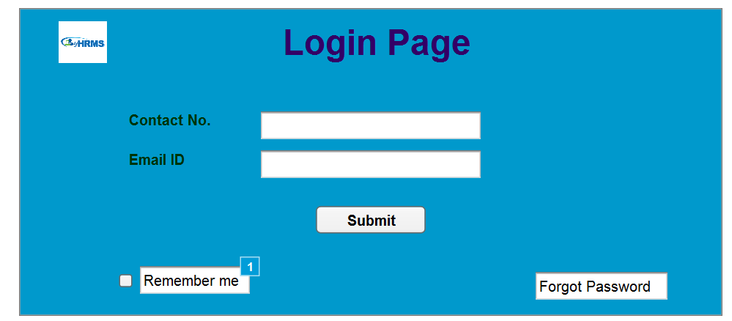

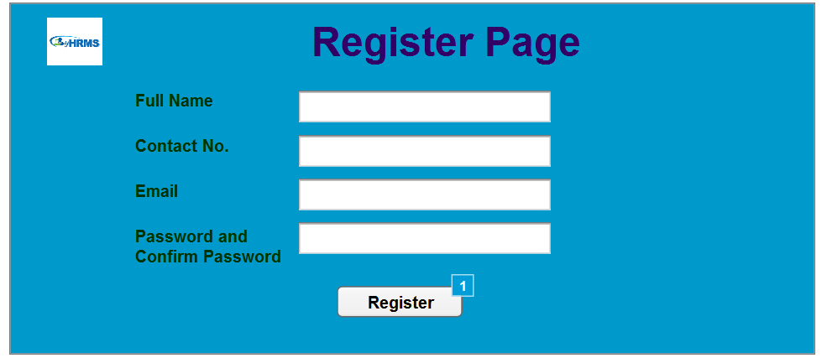

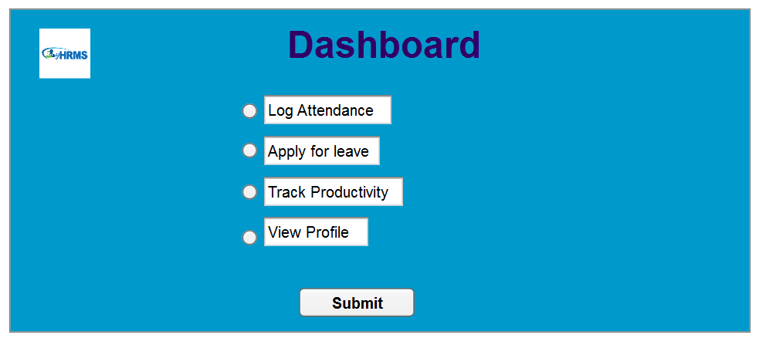

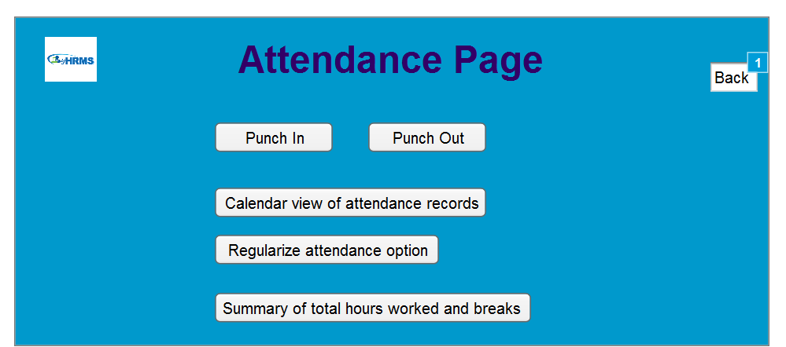

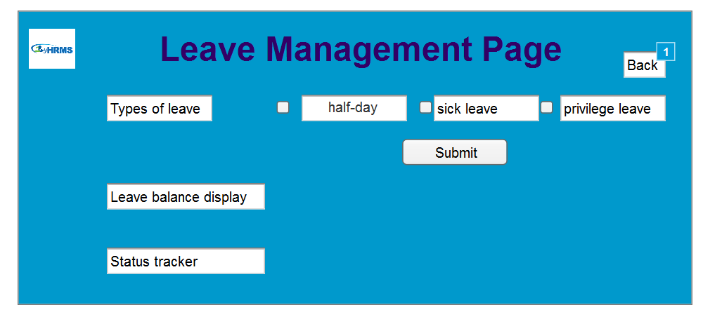

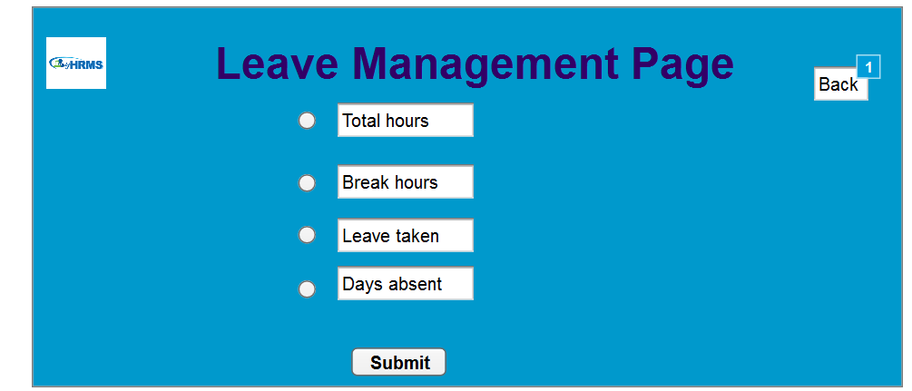

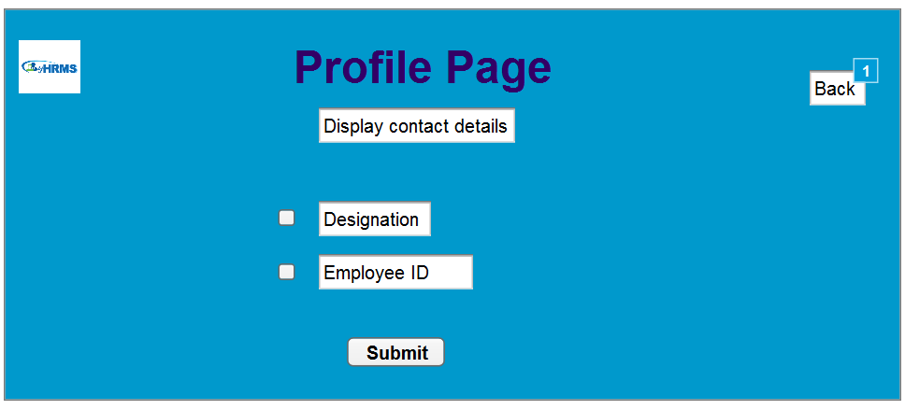

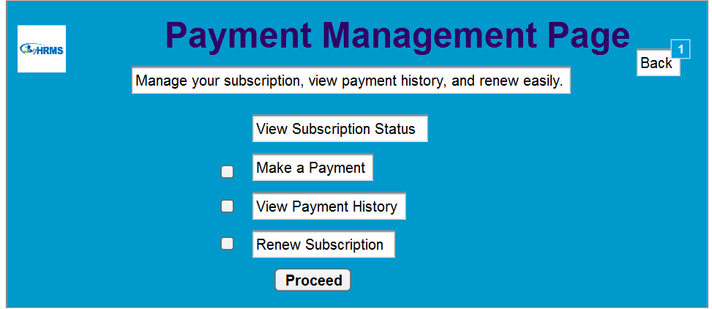

**Document 8 – Tools – MS visio and Axure experience**As a Business Analyst, my experience with Visio and Axure has been instrumental in effectively defining and communicating the requirements for the HRM software project. With Visio, I created clear and structured UML diagrams such as use case, activity, and sequence diagrams, enabling stakeholders and developers to understand workflows and system relationships seamlessly. Axure complemented this by allowing me to design interactive prototypes of essential pages like the login, attendance tracking, and leave management modules. The clickable wireframes provided stakeholders with a tangible user experience, facilitating early feedback and minimizing misinterpretations. Together, these tools enhanced collaboration, streamlined the requirements process, and ensured a shared understanding of the project vision across teams.

**Document 9- BA experience**

**1. Requirement Gathering:**

Requirement gathering has been a crucial part of my role as a Business Analyst. I collaborated with clients, project managers, and end-users to understand their needs and goals. Using techniques like interviews, workshops, and surveys, I identified key requirements and documented them clearly.

I also reviewed existing processes and documents to ensure no details were missed. During this phase, I prepared Business Requirements Documents (BRD) and Functional Requirements Documents (FRD) to define the project scope and system features. My focus was on clear communication and ensuring all stakeholders were aligned, making this phase both challenging and rewarding.

**2. Requirement Analysis:**

Requirement analysis has been a vital phase of my role, where I translated gathered requirements into actionable insights. I carefully examined the collected data to identify gaps, prioritize needs, and ensure alignment with business goals.

Using tools like process flow diagrams, use case diagrams, and activity diagrams, I visualized workflows and system functionalities. I collaborated with technical teams to confirm feasibility and with stakeholders to validate requirements. This phase helped in creating a solid foundation for development, ensuring clarity and reducing scope creep. It was key to delivering a solution that met both business and user expectations.

**3. Design:**

During the design phase, my focus was on bridging requirements with technical implementation. I worked closely with UI/UX designers and developers to ensure that the system's design aligned with the user requirements and business objectives.

I contributed by creating wireframes, mockups, and prototypes using tools like Axure and Visio, ensuring that user interfaces were intuitive and functional. I also reviewed and refined design documents to validate those workflows and layout adhered to business rules and user needs.

This phase involved regular collaboration with stakeholders to gather feedback and ensure the design met expectations, laying a clear path for the development team to build an effective solution.

**4. Development:**

In the development phase, I served as a key point of contact between the development team and stakeholders. I ensured that the development team clearly understood the requirements and translated them into functional components.

I conducted walkthrough sessions to clarify requirements and resolve ambiguities. Regular check-ins with developers ensured alignment with the project scope and addressed challenges promptly.

Additionally, I collaborated on creating user stories and acceptance criteria, providing developers with a clear understanding of the desired functionality. I also participated in sprint planning and stand-ups to track progress and ensure the development remained on schedule.

This phase required continuous communication to address changes and confirm that the output aligned with business goals and user expectations.

**5. Testing**

In the testing phase, I ensured that the application adhered to the defined requirements and functioned as intended. I collaborated with the QA team to develop detailed test cases aligned with user stories and acceptance criteria.

I actively participated in user acceptance testing (UAT), working alongside stakeholders to validate the system's functionality and ensure it met business objectives. Any issues identified during testing were documented and communicated to the development team for prompt resolution.

Additionally, I facilitated defect triage sessions, prioritizing issues based on their impact and urgency. This phase demanded attention to detail and effective coordination to deliver a high-quality product on time.

**6. Deployment**

In the deployment phase, my focus was on ensuring a seamless transition of the application to the production environment. I collaborated with stakeholders to develop a comprehensive deployment plan, outlining timelines, resource allocation, and potential risks.

I contributed to preparing user documentation, training materials, and manuals to support end-users effectively. Working closely with the development and IT teams, I monitored the deployment process, resolving any last-minute challenges to avoid delays.

Post-deployment, I facilitated user feedback collection to identify enhancements and confirm the system's performance met expectations. My efforts ensured that the application delivered its intended value while maintaining smooth operations for all stakeholders.