 **USE CASE DIAGRAM**





**ACTIVITY DIAGRAM**

**Use Case Specifications:**

|  |  |
| --- | --- |
| **Use Case ID** | **UC001** |
| **Use Case Name** | User Login |
| **Actor (Primary)** | All Users |
| **(Secondary)** | Authentication System |
| **Description** | Allows all users to login in with their employee id and password. |
| **Pre-Condition** | User must have valid credentials. |
| **Post-Condition** | User is logged into the system. |
| **Basic Flow** | User enters credentials. |
|  | System authenticates the user. |
|  | User is granted access. |
| **Alternative Flow** | Invalid credentials prompt retry or password recovery. |
|  | The system is down or connectivity issue. |
|  | User forgets password. |
| **Exceptional Flow** | If too many failed attempts occur, the system locks the account temporarily. |
| **Assumptions** | Users know their credentials. |
| **Constraints** | Must comply with company security standards. |
| **Dependencies** | Authentication service must be operational. |
| **Input** | Username and Password |
| **Output** | Access token or error messages |
| **Business Rules** | Users must update passwords every 90 days. |
| **Miscellaneous** | Multi-factor authentication is optional. |

|  |  |
| --- | --- |
| **Use Case ID** | **UC002** |
| **Use Case Name** | Access HRMS Module |
| **Actor (Primary)** | Employees, HR Managers |
| **(Secondary)** | HRMS System |
| **Description** | Provides employees and HR manager’s access to HRMS functionalities. |
| **Pre-Condition** | User must be logged in. |
| **Post-Condition** | Changes made are saved to the database. |
| **Basic Flow** | User selects the HRMS module. |
|  | User performs tasks like viewing or updating data. |
| **Alternative Flow** | If access is unauthorized, the system denies entry. |
| **Exceptional Flow** | If the module is under maintenance, the system notifies the user. |
| **Assumptions** | Module permissions are preconfigured. |
| **Constraints** | Restricted to authorize users only. |
| **Dependencies** | Functional HRMS backend system. |
| **Input** | Employee ID, task details |
| **Output** | Updated records |
| **Business Rules** | HR Managers can edit, employees can only view. |
| **Miscellaneous** | System tracks all actions for audit purposes. |

|  |  |
| --- | --- |
| **Use Case ID** | **UC003** |
| **Use Case Name** | Approve Leave Requests |
| **Actor (Primary)** | Managers |
| **(Secondary)** | Employees |
| **Description** | Enables managers to review and approve leave requests. |
| **Pre-Condition** | Requests are submitted. |
| **Post-Condition** | Leave status is updated and employees notified. |
| **Basic Flow** | Manager views pending leave requests. |
|  | Approves or rejects the requests. |
| **Alternative Flow** | If the request exceeds leave balance, the system flags it. |
| **Exceptional Flow** | If the manager is unavailable, another authorized person approves. |
| **Assumptions** | Managers have access to the system. |
| **Constraints** | Approvals cannot be backdated. |
| **Dependencies** | Leave management module. |
| **Input** | Request details |
| **Output** | Approval/rejection notification |
| **Business Rules** | Managers cannot approve their own leave. |
| **Miscellaneous** | Notification logs maintained. |
|  |  |
| **Use Case ID** | **UC004** |
| **Use Case Name** | Generate Payroll Reports |
| **Actor (Primary)** | HR Managers |
| **(Secondary)** |  |
| **Description** | Generates payroll summaries for specified periods. |
| **Pre-Condition** | Payroll data exists for the period. |
| **Post-Condition** | Report is generated and downloadable. |
| **Basic Flow** | User selects a reporting period. |
|  | System retrieves data and generates a report. |
| **Alternative Flow** | If data is incomplete, the system alerts the user. |
| **Exceptional Flow** | If the payroll module is offline, generation fails. |
| **Assumptions** | Data integrity is maintained. |
| **Constraints** | Restricted to HR Managers. |
| **Dependencies** | Payroll database. |
| **Input** | Date range |
| **Output** | Payroll report |
| **Business Rules** | Reports are confidential. |
| **Miscellaneous** | Reports are time stamped. |
|  |  |
| **Use Case ID** | **UC005** |
| **Use Case Name** | Access E-Learning Materials |
| **Actor (Primary)** | Employees |
| **(Secondary)** | E-Learning System |
| **Description** | Allows employees to access and complete training modules. |
| **Pre-Condition** | Courses are assigned. |
| **Post-Condition** | Completion status is updated. |
| **Basic Flow** | User navigates to the E-Learning module. |
|  | Selects and completes a training course. |
| **Alternative Flow** | If a course is unavailable, the system notifies the user. |
| **Exceptional Flow** | System crashes during training. |
| **Assumptions** | Courses are configured properly. |
| **Constraints** | Employees can only access assigned courses. |
| **Dependencies** | E-Learning backend. |
| **Input** | User ID, course selection |
| **Output** | Completion certificates |
| **Business Rules** | Time tracking enabled for courses. |
| **Miscellaneous** | Assessments included in courses. |

|  |  |
| --- | --- |
| **Use Case ID** | **UC006** |
| **Use Case Name** | Submit Expense Claims |
| **Actor (Primary)** | Employees |
| **(Secondary)** | Finance Department |
| **Description** | Enables employees to submit and track expense claims. |
| **Pre-Condition** | Employee has access to the claims module. |
| **Post-Condition** | Claim is submitted and under review. |
| **Basic Flow** | Employee fills out the expense claim form. |
|  | Attaches supporting documents. |
|  | Submits the claim for approval. |
| **Alternative Flow** | If documents are missing, the system prompts the user. |
| **Exceptional Flow** | If the claim exceeds policy limits, it requires additional approval. |
| **Assumptions** | Employees are familiar with the process. |
| **Constraints** | Claims without receipts are not allowed. |
| **Dependencies** | Financial systems for reimbursement processing. |
| **Input** | Claim details, receipts |
| **Output** | Claim approval/rejection status |
| **Business Rules** | Claims over Rs.1000 require additional approval. |
| **Miscellaneous** | Notifications sent for every status update. |
|  |  |
| **Use Case ID** | **UC007** |
| **Use Case Name** | Schedule Tasks and Reminders |
| **Actor (Primary)** | Users |
| **(Secondary)** |  |
| **Description** | Enables users to manage tasks with reminders. |
| **Pre-Condition** | User is logged in. |
| **Post-Condition** | Task is saved with a reminder. |
| **Basic Flow** | User adds a new task. |
|  | Sets a due date and reminder. |
| **Alternative Flow** | If the reminder conflicts with another, the system alerts the user. |
| **Exceptional Flow** | Task scheduling fails due to a system error. |
| **Assumptions** | Tasks are defined properly. |
| **Constraints** | Maximum 50 tasks per user. |
| **Dependencies** | Calendar service integration. |
| **Input** | Task Details |
| **Output** | Task Notification |
| **Business Rules** | Overdue tasks trigger alerts. |
| **Miscellaneous** | Tasks sync with mobile apps. |
|  |  |
| **Use Case ID** | **UC008** |
| **Use Case Name** | Conduct Performance Reviews |
| **Actor (Primary)** | Managers |
| **(Secondary)** | Employees |
| **Description** | Allows managers to evaluate employee performance. |
| **Pre-Condition** | Employee records are available. |
| **Post-Condition** | Review is saved to the system. |
| **Basic Flow** | Manager selects an employee. |
|  | Fills out a performance review form. |
|  | Submits the review for record-keeping. |
| **Alternative Flow** | If incomplete data is entered, the system prompts for corrections. |
| **Exceptional Flow** | If the employee is no longer active, review is invalid. |
| **Assumptions** | Managers follow the review template. |
| **Constraints** | Reviews must be completed within the appraisal period. |
| **Dependencies** | Employee data module. |
| **Input** | Review metrics, comments |
| **Output** | Review results |
| **Business Rules** | Managers cannot review direct family members. |
| **Miscellaneous** | Reviews are archived for future reference. |

**Document 7- Screens and pages**

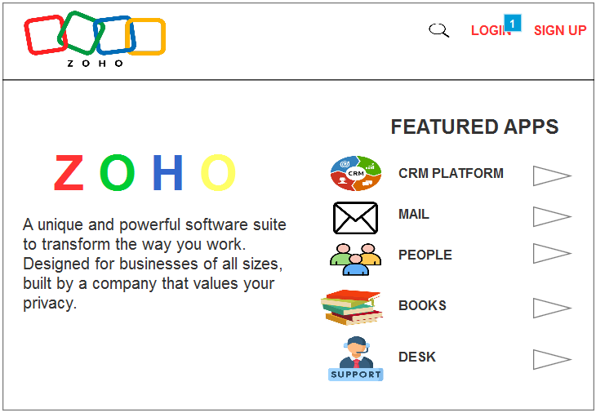

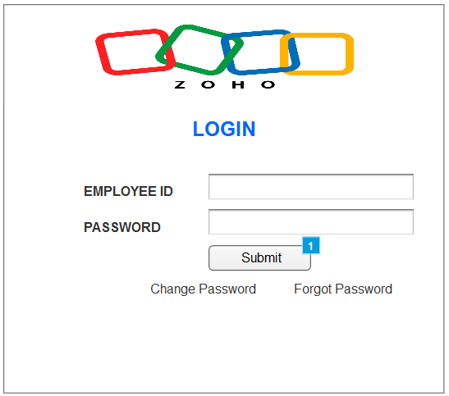

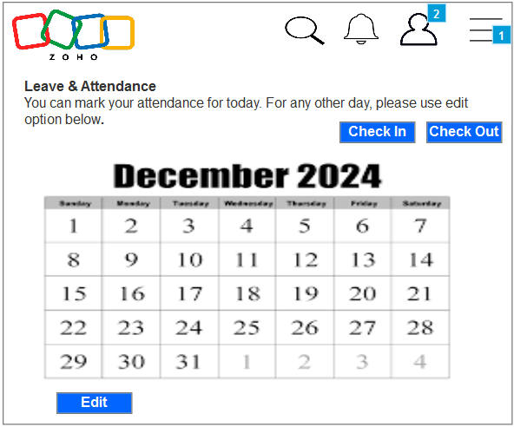

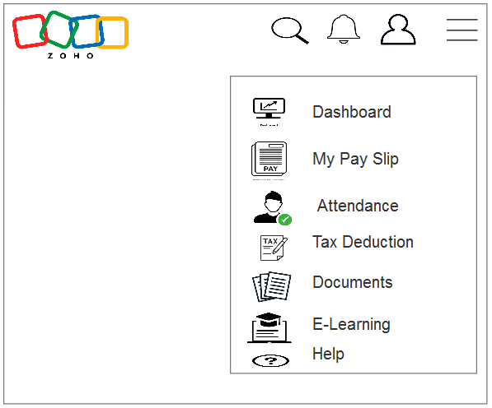

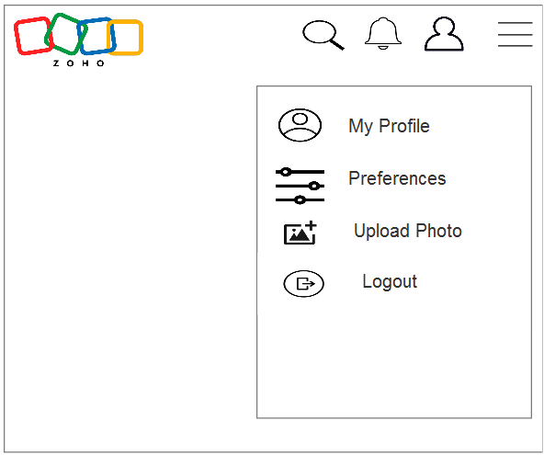

**Document 8- Tools-Visio and Axure**

During the ZOHO Application project, **Visio** and **Axure** played crucial roles in translating project requirements into clear, actionable visual representations and interactive prototypes.

**Microsoft Visio** was leveraged to create detailed diagrams, including use case diagrams, activity diagrams, and process flow charts, which were instrumental in mapping out the project's workflows and system interactions. Its user-friendly interface and extensive library of shapes and templates made it easier to construct accurate and professional visuals, fostering a shared understanding among stakeholders, project managers, and development teams. These diagrams acted as foundational tools for discussions, aligning the team on both high-level and granular aspects of the project.

**Axure RP**, on the other hand, was invaluable for developing interactive prototypes, which enabled us to simulate user interactions with the proposed system. This helped stakeholders, including end-users and business sponsors, gain a hands-on understanding of how the final product would function. The ability to create clickable wireframes with dynamic content allowed us to validate requirements early in the project, identify potential usability issues, and refine functionalities iteratively. By showcasing these prototypes, we minimized the risks of misinterpretation or misalignment with business objectives.

The combined use of **Visio** and **Axure** streamlined the design and requirement validation processes. Visio ensured that the project’s technical aspects were documented clearly and comprehensively, while Axure brought the designs to life, making abstract concepts tangible. These tools not only enhanced collaboration among team members but also accelerated decision-making by providing stakeholders with clear visuals and interactive previews. Ultimately, this approach helped maintain alignment between business goals and technical solutions throughout the project lifecycle.

**Document 9- BA experience**

**1. Requirement Gathering**

* Utilized the **MoSCoW technique** to prioritize requirements effectively into Must-Have, Should-Have, Could-Have, and Won't-Have categories.
* Addressed challenges due to client unavailability by identifying alternative points of contact to gather critical information promptly.
* Validated gathered requirements using the **FURPS technique** (Functionality, Usability, Reliability, Performance, and Supportability) for quality assurance.
* Identified and eliminated duplicate or redundant requirements to maintain clarity and efficiency.
* Employed **prototyping** to refine and specify requirements, ensuring mutual understanding between stakeholders and the development team.

**2. Requirement Analysis**

* Created **UML diagrams**, such as use case and sequence diagrams, to visually articulate system requirements and interactions.
* Developed **activity diagrams** to illustrate the process flows and interactions between system components.
* Facilitated discussions with team members to communicate these visual representations, incorporated feedback, and made necessary modifications.
* Authored both **BRS (Business Requirements Specification)** and **SRS (Software Requirements Specification)** to document the requirements comprehensively.

**3. Design**

* Derived **test cases** from use case diagrams to ensure test coverage aligns with user scenarios.
* Engaged in iterative communication with the client to validate design documents and proposed solutions.
* Created both **positive and negative test cases** to address edge cases and potential system vulnerabilities.
* Ensured **completeness of test cases**, recognizing their critical impact on later project phases.
* Prepared **test data** for use in testing and updated the **RTM (Requirements Traceability Matrix)** to ensure every requirement was adequately addressed.

**4. Development**

* Organized and facilitated **JAD (Joint Application Development) sessions** to bridge gaps between stakeholders and developers.
* Responded to queries from the technical team during the coding phase, ensuring alignment with project goals.
* Addressed disagreements or lack of cooperation by conducting one-on-one discussions, fostering a collaborative environment.
* Ensured developers referred to diagrams and specifications for accurate coding of units.
* Scheduled and conducted regular meetings with the technical team and client, managing attendance challenges through recordings and follow-up discussions.

**5. Testing**

* Prepared comprehensive test cases based on use cases to guide the testing process.
* Performed high-level testing to verify the core functionality and quality of the system.
* Collaborated with the client to obtain test data relevant to the project's requirements.
* Regularly updated the RTM to track test coverage and ensure all requirements were tested.
* Secured **client sign-off** after the successful completion of testing phases and prepared them for **UAT (User Acceptance Testing)**.

**6. Deployment**

* Delivered the updated **RTM** to the client, attaching it to the **project closure document** for formal project completion.
* Coordinated with teams to prepare and share detailed **end-user manuals** for smooth on boarding.
* Planned and conducted **training sessions** for end-users to familiarize them with the deployed system.
* Ensured all stakeholders attended the training sessions, addressing any scheduling conflicts to maintain comprehensive participation.

This structured approach ensured smooth project execution, stakeholder alignment, and successful delivery of the ZOHO Application project.