Document 1 - Definition of Done

DOD for User Story:
- Code written for the functionality
- Assumptions of the user story are met
- Project build without errors
- Unit Tests written and passing
- Project deployed on the test environment identical to production platform
- Tests on devices/browsers listed in the project assumptions passed
- Feature ok-ed by UX designer
- QA performed & issues resolved
- Feature is tested against acceptance criteria
- Feature ok-ed by Product Owner
- Refactoring completed
- Any configuration or build changes documented
- Documentation updated
- Peer Code Review performed

DOD for Sprint:
- DoD of each single User story, included in the Sprint are met
- “To do’s” are completed
- All unit tests passing
- Product backlog updated
- Project deployed on the test environment identical to production platform
- Tests on devices/browsers listed in documentation passed
- Tests of backward compatibility passed
- The performance tests passed
- All bugs fixed
- Sprint marked as ready for the production deployment by the Product Owner

DOD for Release
- Code Complete
- Environments are prepared for release
- All unit & functional tests are green
- All the acceptance criteria are met
- QA is done & all issues resolved
- All “To Do” annotations must have been resolved
- OK from the team: UX designer, developer, software architect, project manager, product owner, QA,
- Check that no unintegrated work in progress has been left in any development or staging environment
- Basic UI check on the Production
- Notify Client the time production will be down for release

Document 2 – Product Vision

Scrum Project  Name: | WCRA
Venue: | WCRA Office, Pune
Date: 18/12/2024 | Start Time: 11:00 A.M. | End Time: 4:00 P.M. | Duration: 4 hours
Client: WCRA
Stakeholder list: | WCRA Chairperson – Dr. Srinath Anand  Secretary – Dr. Venkatesh Prasad  Scheduler – Dr. Prashant Patil  Scrum Team
Scrum Team
Scrum Master: | Abhijeet Deolalikar
Product Owner: | Nilesh Sabale
Scrum Developer 1: | Ashish Siwalakar
Scrum Developer 2: | Nagesh Madale
Scrum Developer 3: | Yogesh Chaurse

Vision: To help WCRA to reach out scientists and researchers all over the world and efficiently manage process of assigning facilities to the scientists and researchers for their study

Target Group  The website will target the people in the field of Astrophysics  The target group would be researchers, scientist and PHD students related to the field | Needs  The website is useful as it will help researchers to submit their research and request time to use facilities at WCRA  The WCRA can efficiently manage the research submitted and can decide on time allocation with ease through the website | Product  The website is a platform for the researchers all around the world to submit their research to request time to use facilities for research at WCRA. The website also helps WCRA in efficiently managing the operations at WCRA | Value  The website will help WCRA increase its efficiency and help decide which research they allot time to.  The aim of the website is to have a common platform where researchers can find WCRA to request facilities for research and WCRA can analyze and allot time accordingly

Document 3 – User Stories

User Story No: 1 | Tasks: 2 |  | Priority: Highest
AS A RESEARCHER/SCIENTIST
I WANT TO REGISTER TO WCRA
SO THAT I CAN SUBMIT RESEARCH AND REQUEST FACILITES

BV: 500 |  | CP: 02
Acceptance Criteria:
Registration Screen
Text Boxes/Dropdown to enter Username Password, Mobile number, Email, Institution, Address, Nationality
Click on Register Button
Successful User Registration and Email Sent

User Story No: 2 | Tasks: 2 |  | Priority: Highest
AS A RESEARCHER/SCIENTIST
I WANT TO LOGIN TO WCRA
SO THAT I CAN USE THE WEBAPP FEATURES

BV: 500 |  | CP: 01
Acceptance Criteria:
Login Screen
Text box Enter Username and Password
Click Login Button and redirect to Homepage

User Story No: 3 | Tasks: 2 |  | Priority: Highest
AS A RESEARCHER/SCIENTIST
I WANT TO SUBMIT RESEARCH PAPER
SO THAT I CAN REQUEST TIME TO USE FACILITIES

BV: 500 |  | CP: 03
Acceptance Criteria:
User able to enter research details and upload documents to request time
User needs to enter all required fields
Review and Submit option available
User receives email on successfully submitting proposal

User Story No: 4 | Tasks: 2 |  | Priority: Medium
AS A RESEARCHER/SCIENTIST
I WANT TO VIEW SUBMITTED PROPSAL
SO THAT I CAN CHECK DETAILS OF PROPOSAL

BV: 200 |  | CP: 01
Acceptance Criteria:
View Proposal Option Available
User able to view details of submitted proposal

User Story No: 5 | Tasks: 2 |  | Priority: Highest
AS A CHAIRPERSON
I WANT TO LOGIN TO WCRA
SO THAT I CAN PERFORM DIFFERENT WCRA TASKS

BV: 500 |  | CP: 02
Acceptance Criteria:
Login Screen
Enter Username and Password
Successful login to chairperson account

User Story No: 6 | Tasks: 2 |  | Priority: Highest
AS A CHAIRPERSON
I WANT TO START WCRA CYCLE
SO THAT WCRA CAN ACCEPT PROPOSALS

BV: 200 |  | CP: 01
Acceptance Criteria:
Start Cycle Option
Enter Details
Cycle Begins and Researchers get option to submit proposals

User Story No: 7 | Tasks: 2 |  | Priority: Highest
AS A CHAIRPERSON
I WANT TO VIEW ALL SUBMITTED PROPOSALS
SO THAT I CAN REVIEW THE PROPOSALS

BV: 200 |  | CP: 02
Acceptance Criteria:
Select Cycle
View the Submitted Proposals List

User Story No: 8 | Tasks: 2 |  | Priority: Medium
AS A CHAIRPERSON
I WANT TO ADD RATING AND COMMENTS TO PROPOSAL
SO THAT I CAN RANK PROPOSALS

BV: 500 |  | CP: 02
Acceptance Criteria:
Option to rank proposals and add comments
Secretary and other committee members should see comments and rank on proposals

User Story No: 9 | Tasks: 2 |  | Priority: Medium
AS A CHAIRPERSON
I WANT TO ACCEPT/REJECT PROPOSAL
SO THAT I CAN REPLY TO RESEARCHERS

BV: 200 |  | CP: 03
Acceptance Criteria:
Send Accept / Reject Mail Option
Researcher receive the accept/reject mail

User Story No: 10 | Tasks: 2 |  | Priority: Medium
AS A TAC MEMBER
I WANT TO VIEW PROPOSALS OF MY EXPERTISE
SO THAT I CAN ADD RATING AND COMMENTS

BV: 200 |  | CP: 02
Acceptance Criteria:
View Proposals of Only Area Expertise
Add Rating and Comment Option
Comments and Rating should be visible to Chairperson and Secretary

User Story No: 11 | Tasks: 2 |  | Priority: Low
AS AN ADMIN
I WANT TO ASSIGN ROLES FOR CYCLE
SO THAT I CAN DEFINE ROLES FOR THE CYCLE

BV: 100 |  | CP: 01
Acceptance Criteria:
Select Cycle
Assign/Change roles for Chairperson Secretary Scheduler and TAC Members
Save the Roles
The roles reflect in next cycle

User Story No: 12 | Tasks: 2 |  | Priority: Medium
AS AN ADMIN
I WANT TO MAKE CHANGES IN THE CYCLE DETAILS
SO THAT I CAN DEFINE CYCLE ACCORDING TO REQUIREMENTS
BV: 200 |  | CP: 02
Acceptance Criteria:
Edit cycle details
Save details
Details reflect in next cycle

User Story No: 13 | Tasks: 2 |  | Priority: Medium
AS A SCHEDULER
I WANT TO SCHEDULE TIME FOR ACCEPTED PROPOSALS
SO THAT I CAN SEND TIME DETAILS TO RESEARCHER

BV: 500 |  | CP: 03
Acceptance Criteria:
Select proposal
Enter Details to Schedule time
Send mail to researcher for scheduled time details

Document 4 – Agile PO Experience
- In this project I have learned how to perform market analysis keeping in mind need and demand of the product. Also building a product vision and roadmap with essential feature to be delivered firsthand. Also communicating with the stakeholders about the product requirements, arranging meetings and noting the requirements down focusing on critical features and points
- Managing the sprint meetings and handling the essentials of sprint such as sprint planning, daily scrum meeting, sprint backlog, sprint review, sprint retrospective and backlog refinement. Managing the backlog items with prioritizing the essential features according to the client need. Presenting the features to the client and making sure client has understood the functionality
- Managing User Stories, the details involved in each user story such as effort required, priority of the user story, acceptance criteria and business value. Explaining the user story to the team and clearing the doubts regarding the user stories
- Managing communication between customer and the project team with explaining the need of the customers to the project team and explaining the functionality to the customer

Document 5 – Product and sprint backlog and product and sprint burndown charts

Sprint Backlog

User Story ID | User Story | Tasks | Priority | BV | CP | Sprint
UST001 | Chairperson – View Submitted Proposals | 02 | Highest | 200 | 02 | 1
UST002 | Chairperson/TAC Member/Scheduler – Add Ratings and Comments to Proposal | 02 | Medium | 500 | 02 | 1
UST003 | Admin – Assign Roles for cycle | 02 | Low | 100 | 01 | 2
UST004 | Admin – Make Changes in Cycle Details | 02 | Medium | 200 | 02 | 2
UST005 | Scheduler – Schedule Proposals | 03 | Medium | 500 | 02 | 2

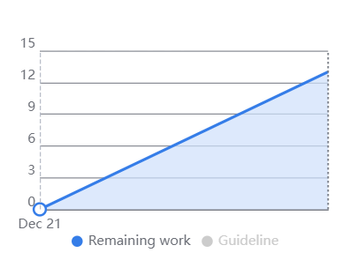

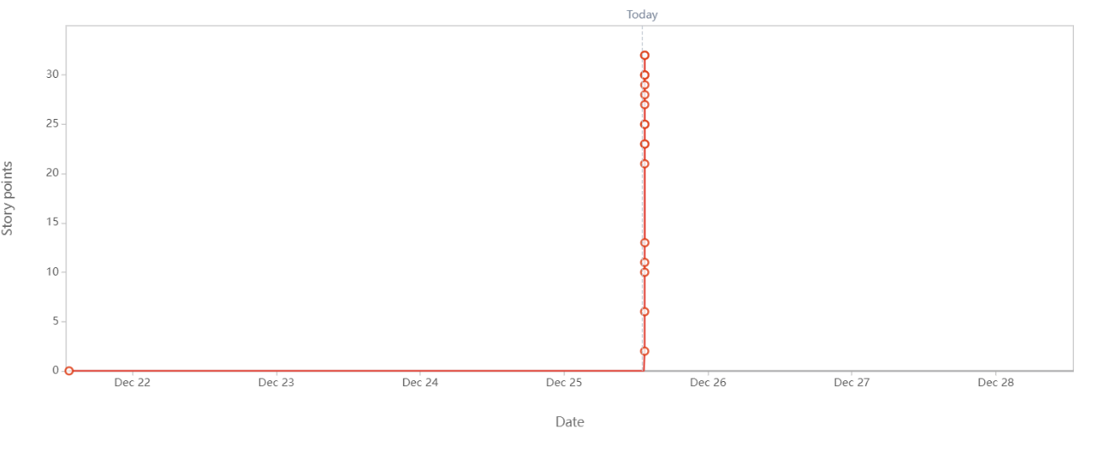
Sprint Burndown Chart
Document 6 – Sprint Meeting

- Sprint Planning Meeting

Date | 2/12/2024
Time | 10:00 A.M.
Location | Office
Prepared by | Manager
Attendees | Developers, Testers, Manager, Team Lead

Agenda Topics
Topic | Presenter | Time Allotted
Login Functionality | Team Lead | 20 mins
Registration Functionality | Team Lead | 20 mins
Chairperson – Start Cycle | Team Lead | 10 mins
Researchers – Submit Proposals | Team Lead | 10 mins

Other Information
Observers | None
Resources | None
Special Notes | Discuss that the start cycle option should have and end date or automatically closed after time

- Sprint Review Meeting

Date | 16/12/2024
Time | 10:00 A.M.
Location | Office
Prepared by | Manager
Attendees | Developers, Testers, Manager, Team Lead

Sprint status | Things to demo | Quick Updates | What’s next
Closed | - Login Functionality  - Register Functionality  - Chairperson Start Cycle | Chairperson – View Proposals and Add Comments and Rating functionality is in progress and will move to next sprint | Add Single Sign-On Option to Login and Register by Gmail  Check Time for editing after submitting proposals

- Sprint Retrospective Meeting

Date | 16/12/2024
Time | 11:00 A.M.
Location | Office
Prepared by | Manager
Attendees | Developers, Testers, Manager, Team Lead

Agenda | What went well | What didn’t go well | Questions | Reference
Completing User Stories | Completed major functionalities Login and Registration and tested them efficiently | All the user stories could not be completed | Did the effort estimate for the user stories was right? | None

- Daily Standup Meeting

Question | Name/Role | Week 1 (from 02-12-2024 to 6-12-2024)
 |  | Monday | Tuesday | Wednesday | Thursday | Friday
What did you do yesterday? | Ashish Shiwalkar | Prepared plan, flowchart, DFD for Login functionality | Prepared database schema for WCRA | Worked on Logic of login functionality and wrote code for it | Write logic for API call of logic functionality | Sync API call with Logic and Database Layer
 | Nagesh Madale | Prepared a design of webpage for Login functionality | Prepared a design of webpage for Login functionality | Wrote code for webpage design | Wrote API call for the login functionality | Wrote API call for the login functionality
 | Yogesh Chaurse | Prepared plan, flowchart, DFD for Login functionality | Prepared database schema for WCRA | Created and Setup Database | Checked Database Connection and write data retrieval code | Synced API call with Logic and Database Layer
What will you do today? | Ashish Shiwalkar | Prepare database schema for WCRA | Work on Logic of login functionality | Write logic for API call of logic functionality | Prepare database schema for WCRA | Test the Functionality and fix bug
 | Nagesh Madale | Prepare a design of webpage for Login functionality | Write code for webpage design | Write API call for the login functionality | Write API call for the login functionality | Test the Functionality and fix bug
 | Yogesh Chaurse | Prepare database schema for WCRA | Create and Setup Database | Check Database Connection and write data retrieval code | Sync API call with Logic and Database Layer | Test the Functionality and fix bug
What (if any) is blocking your progress? | Ashish Shiwalkar | Software Installation Pending | Eclipse editor not installed | None | Error in Unit Testing | API endpoint not accessible
 | Nagesh Madale | Software Installation pending | Software Installation pending | None | None | API endpoint not accessible
 | Yogesh Chaurse | Software Installation pending | Eclipse editor not installed | None | None | API endpoint not accessible

Question | Name/Role | Week 2 (from 09-12-2024 to 13-12-2024)
 |  | Monday | Tuesday | Wednesday | Thursday | Friday
What did you do yesterday? | Ashish Shiwalkar | Prepared plan, flowchart, DFD for Registration functionality | Worked on Logic of login registration functionality and wrote code for it | Sync Database Layer with Application Layer logic | Write logic for API call of logic functionality | Test Registration and Create Cycle
 | Nagesh Madale | Prepared a design of webpage for Registration functionality and Create Cycle | Prepared a design of webpage for Registration functionality and Create Cycle | Wrote code for webpage design and API call | Wrote code for webpage design and API call | Test Registration and Create Cycle
 | Yogesh Chaurse | Prepared plan, flowchart, DFD for Registration functionality | Database Layer Logic for Registration functionality | Sync Database Layer with Application Layer logic | Worked on Create Cycle functionality | Test Registration and Create Cycle
What will you do today? | Ashish Shiwalkar | Worked on Logic of login registration functionality and wrote code for it | Sync Database Layer with Application Layer logic | Write logic for API call of logic functionality | Test Registration and Create Cycle | Fix bugs for Registration functionality
 | Nagesh Madale | Prepared a design of webpage for Registration functionality and Create Cycle | Wrote code for webpage design and API call | Wrote code for webpage design and API call | Test Registration and Create Cycle | Fix bugs for Registration functionality
 | Yogesh Chaurse | Database Layer Logic for Registration functionality | Sync Database Layer with Application Layer logic | Worked on Create Cycle functionality | Test Registration and Create Cycle | Fix bugs for Registration functionality
What (if any) is blocking your progress? | Ashish Shiwalkar | Need mandatory field to be included in registration | None | None | None | None
 | Nagesh Madale | None | None | None | Created cycle not closing on date | None
 | Yogesh Chaurse | Need mandatory field to be included in registration | None | None | None | None

