CAPSTONE PROJECT-1

PART -3

DECEMBER 29, 2024

COPED

Nurturing Process

**Functional requirements** specify what a system should do. these define the core functions, features, and behaviours the system must perform to fulfil its purpose.

**Question 1 – Functional Requirements - 15 Marks**

examples:

1. The system must allow users to log in with a username and password.
2. Users should be able to add, edit, and delete items in the product catalog.

**Non-functional requirements** specify how the system should perform. These define the system's quality attributes, such as performance, security, and usability.

Examples:

1. The system must handle up to 1,000 concurrent users.
2. Passwords must be encrypted.
3. The system should load the homepage within 2 seconds under normal load.

|  |  |  |  |
| --- | --- | --- | --- |
| **Req ID** | **Req Name** | **Req Description** | **Priority** |
| FR0001 | Farmer / Manufacturer Registration | A farmer or manufacturer should be able to register with email ID or mobile into the application | 8 |
| FR0002 | Farmer Search for Products | A farmer should be able to search for the available products like fertilizers, seeds, and pesticides. | 8 |
| FR0003 | Product Selection | The farmer should be able to select the product as per need | 8 |
| FR0004 | No matching Product | The farmer should be able to Notify when no matching product is found on the search | 6 |
| FR0005 | Filter | As per brand, price, etc., farmers should be able to filter the product. | 7 |
| FR0006 | Finalize the product | The farmer should be able to add his finalized product to cart | 6 |
| FR0007 | Suggestion of products | After the finalized product application should display some suggested products | 5 |
| FR0008 | Place order | The farmer should be able to Place the order from his cart list | 6 |
| FR0009 | History | Farmers should also be able to check history of privies orders | 7 |
| FR0010 | Payment | The system should pop up the available payment options, for example, cash, card UPI, COD, etc. | 8 |
| FR0011 | Final order confirmation | After the order is placed, farmers should get confirmation by email and mobile number | 9 |
| FR0012 | Order received status | The system should be able to track location of product time by time | 5 |
| FR0013 | Tracking system activate | Execution of the dispatch tracking system will get activated for further alerts | 6 |
| FR0014 | Payment Confirmation | Manufacture is also able to match payment to application ID by system | 7 |
| FR0015 | Error message for login | In case Error message appears if incorrect credential is used | 7 |
| FR0016 | View the purchase item | The application should be able to display all the item which were selected by the user in cart | 7 |
| FR0017 | Pop-up message for duplicate entry | Availability of pop-up message in case of duplicate selection of same product by the user, if any | 8 |
| FR0018 | Notification of new product | Farmers should be able to receive the notification for newly launched or arrived product from the manufacturer | 8 |
| FR0019 | Return Policy | Availability of product return policy option/cancelation of product in the application | 8 |
| FR0020 | No duplicate register | If the mail ID or mobile number is already registered with system, it should pop up the message | 9 |
| Req ID | Req Name | Req Description | Priority |
| FR0021 | Taxes | Product price should be inclusive of government taxes | 10 |
| NFR0101 | Page Loading Time | Each Page should load within 2 seconds. | 9 |
| NFR0102 | WCAG 2.1. | The system must meet Web Content Accessibility Guidelines WCAG 2.1. | 8 |
| NFR0103 | All product catalogue | On the web page preview, maximum 5 products are displayed of Manufacturing companies’ catalogs. | 6 |
| NFR0104 | Technically supported system | Application can be used on any Android mobile, and customers can browse the site. | 10 |
| NFR0105 | Time limit for OTP | Max 1 minute of time allowed for inputting OTP while registration or login process | 4 |
| NFR0106 | Logout System | If the user is nonoperational for a maximum 15 minutes, log out the user automatically | 7 |
| NFR0107 | Mode of alters | The user should be able to choose mode of alerts | 6 |
| NFR0108 | Stock Available | Availability of stock with the manufacturer and should get updated on a real-time basis. | 6 |
| NFR0109 | SMS & Mail confirmation | Automated SMS and Email confirmation should be sent to farmer as well as manufacturer | 9 |
| NFR0110 | Payment Option | The user should choose any one payment option out of available payment choices | 6 |
| NFR0111 | Stock alerts | Manufacture should get stock alerts when stock is minimum as per season and orders | 6 |
| NFR0112 | Payment Receipt | Generation of payment details on white paper receipt of 4” 6 | 7 |
| NFR0113 | Check Stock | Once a product is sold by the manufacturer, the stock of the manufacturer should be reduced. | 8 |
| NFR0114 | Alerts by SMS and email | The alert message or email should be to the reg email ID for each activity for the user ID. | 9 |
| NFR0115 | Disable policy | User ID should be disabled if not logged in for 1 year | 9 |
| NFR0116 | Taxation system | 10% government taxes should be added to the product final price. | 10 |

Question 2–Minimum 5 page designs - 15 Marks

**Wireframes:**

1. **Log In Page**

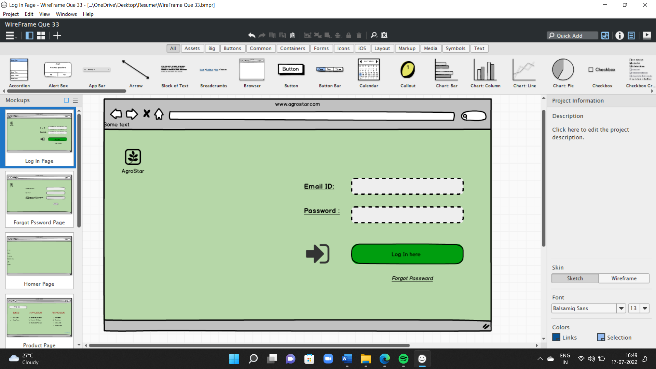

1. **Forgot Password Page**

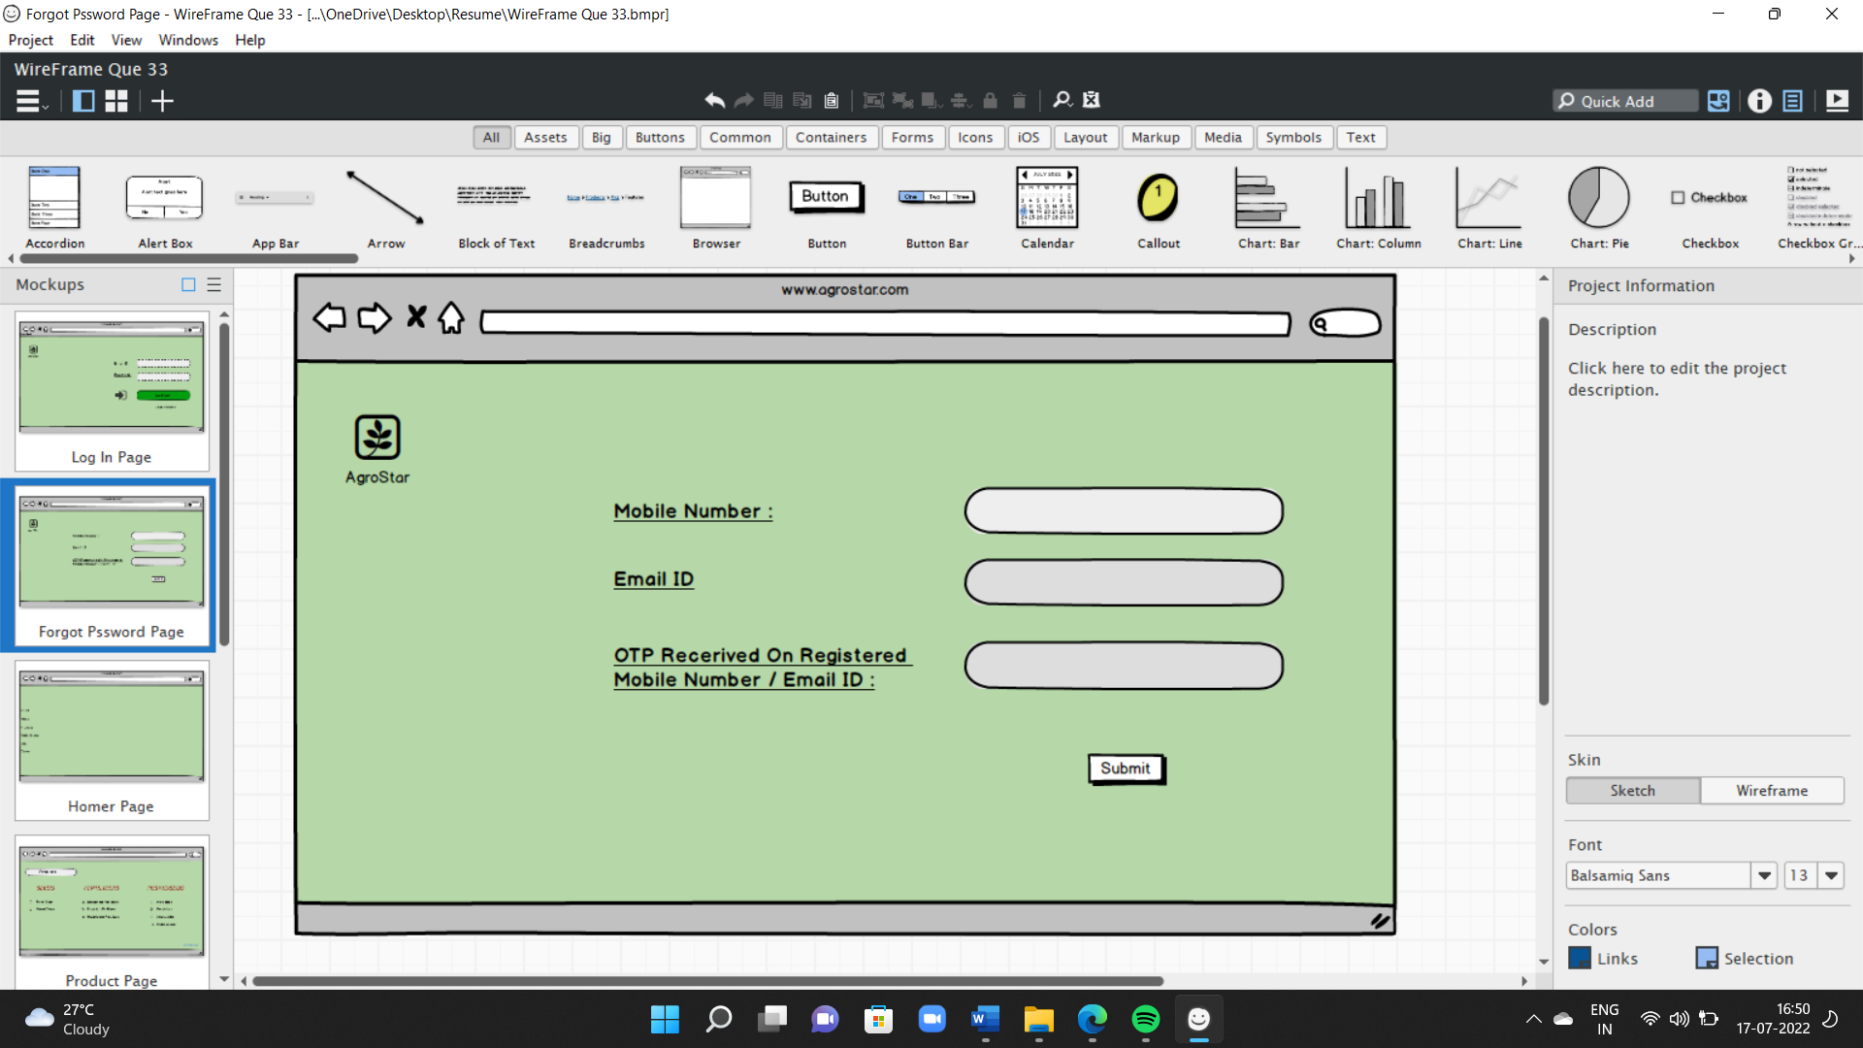

1. **Home Page**

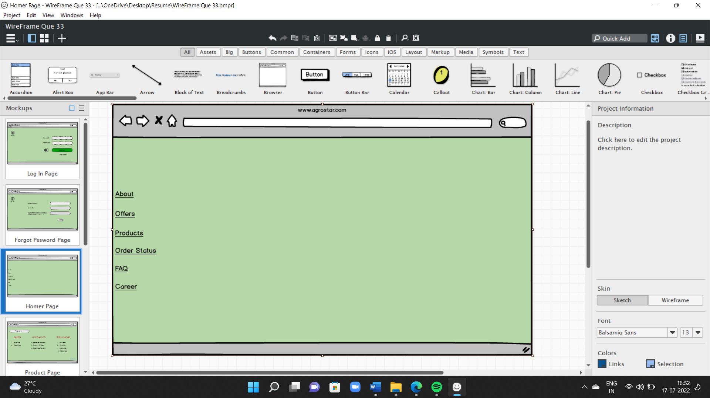

1. **Product Page**

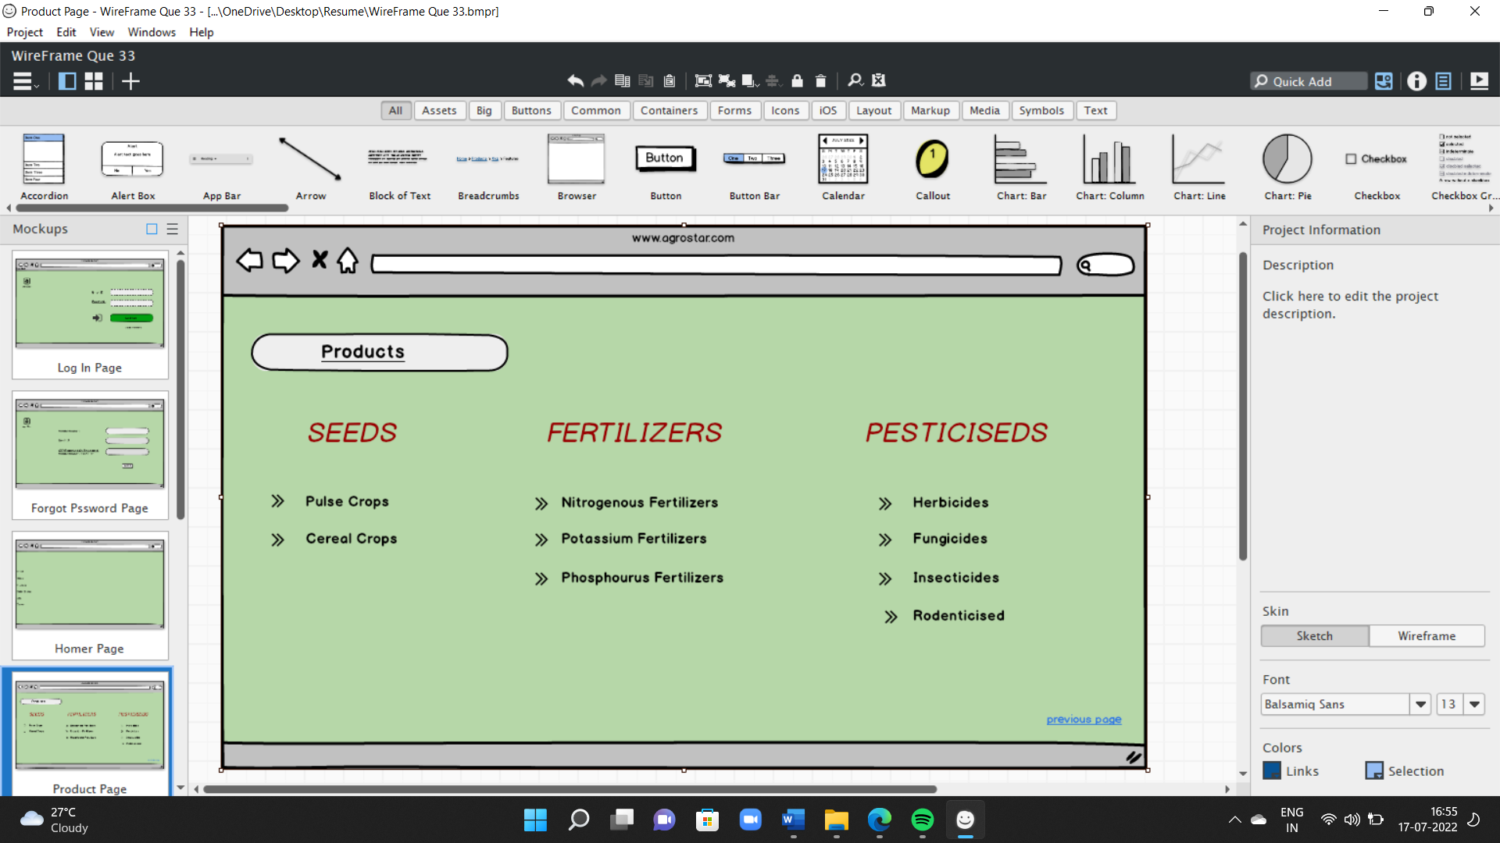

1. **Payment Page**

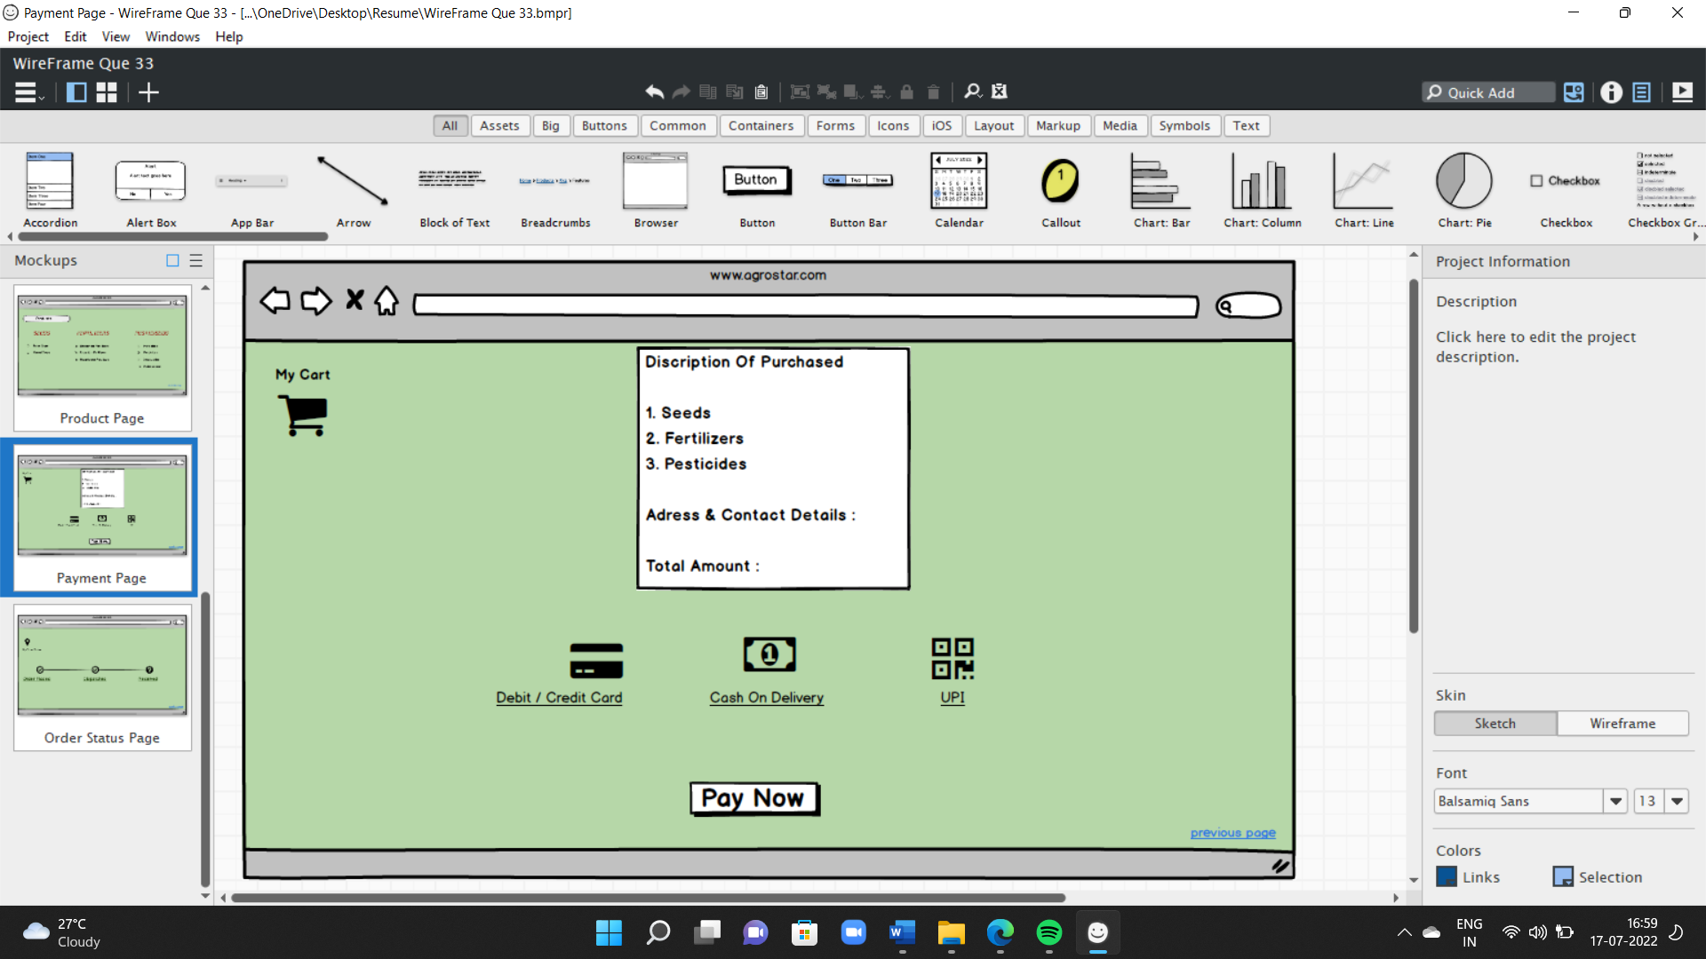

1. **Order Status Page**

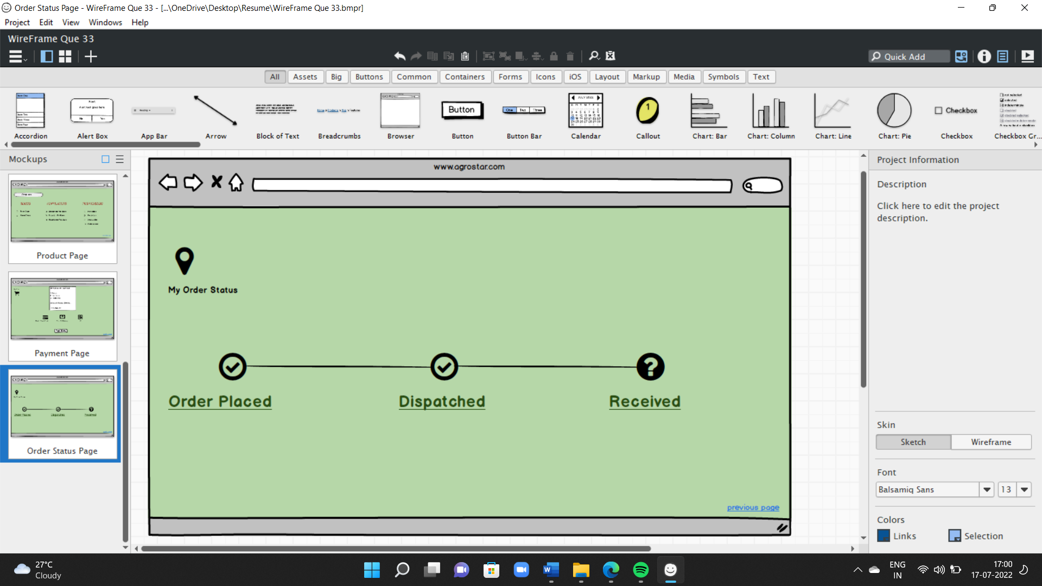

**Prototypes:**

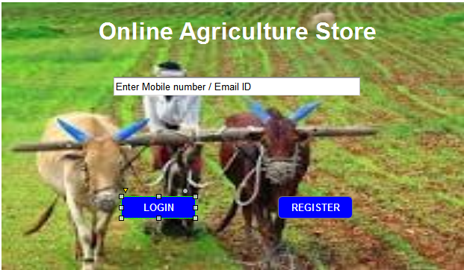

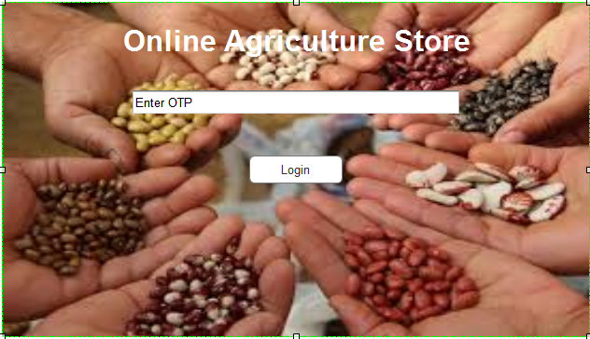

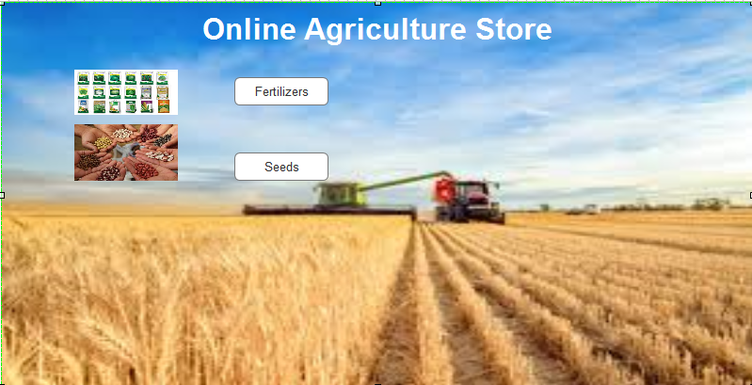

**Question 3 – Tools (Visio, Balsamiq) - 15 Marks**

Answer-

* **Visio -** Microsoft Visio is software for drawing a variety of diagrams. These include flowcharts, org charts, building plans, floor plans, data flow diagrams, process flow diagrams, business process modelling, swim lane diagrams, 3D maps, and many more. It share functionality with MS Office Word and Excel, such as text and colour choices, and allow data feeds directly from MS Excel and Access. As with other diagram software, Visio provides a library of templates and shapes for various types of charts to help you get started.
* **Balsamiq –** It is a web-based user interface design tool for creating wireframes (sometimes called mock-ups or low-fidelity prototypes). We can use it to generate digital sketches of our idea or concept for an application or website, to facilitate discussion and understanding before any code is written. The completed wireframes can be used for user testing, clarifying our vision, getting feedback from stakeholders, or getting approval to start development.
* **Axure -** It is a dedicated rapid prototyping tool that allows anyone with even a basic familiarity with the software to create simple wireframes. It uses a ‘what you see is what you get’ (WYSIWYG) interface that allows you to drag shapes onto a canvas and build up your design. Axure is particularly well suited to low fidelity prototyping as it has a very short learning curve. Within a few hours, anyone can be creating designs that are quick and cheap to change. A single click will render your prototype in a web browser on your desktop, tablet or phone and allow you to gain feedback from users or other stakeholders.

**Question 4 – RTM - 6 Marks**

|  |  |  |  |  |  |  |  |  |  |  |  |  |
| --- | --- | --- | --- | --- | --- | --- | --- | --- | --- | --- | --- | --- |
| **Req ID** | **Req Name** | **Req Description** | **Design** | **D1** | **T1** | **D2** | **T2** | **D3** | **T3** | **D4** | **T4** | **UAT** |
| FR0001 | Farmer Registration | Farmer should be able to register with email ID or mobile into the application | **✓** | **✓** | **✓** | **✓** | **✓** | **✓** | **✓** | **✓** | **✓** | **✓** |
| FR0002 | Farmer Search for Products | Farmer should be able to search for the available products in fertilizers, seeds, pesticides. | **✓** | **✓** | **✓** | **✓** | **✓** | **✓** | **✓** | **✓** | **✓** | **×** |
| FR0003 | Product Selection | Farmer should be able to select the product as per need | **✓** | **✓** | **✓** | **✓** | **✓** | **✓** | **✓** | **×** | **×** | **×** |
| FR0004 | No matching Product | Farmer should be able to Notify when no matching product is found on the search | **✓** | **✓** | **✓** | **✓** | **✓** | **✓** | **✓** | **×** | **×** | **×** |
| FR0005 | Filter | As per brand, price and croup etc. farmers should be able to filter | **✓** | **✓** | **✓** | **×** | **×** | **×** | **×** | **×** | **×** | **×** |
| FR0006 | Finalize the product | Farmer should be able to add his finalize product add to cart | **×** | **×** | **×** | **×** | **×** | **×** | **×** | **×** | **×** | **×** |

**Question 5 – 10 Test Case Documents**

|  |  |  |  |
| --- | --- | --- | --- |
| **Test Case** | TC001 | **Test Case  Name** | New User Registration |
| **Project ID** | PRJ001 | **Project Name** | Online Agriculture Product Store |
| **PM ID** | PM001 | **Tester ID** | T001 |
| **Test Strategy ID** | TS001 | **Tester Name** | Mr John |
| **Test Plan ID** | TP001 | **Date of Test** | XX/YY/ZZZZ |
| **Test Schedule ID** | TSCH001 | **Prepared By** | BA |
|  |  |  |  |
| **Scenario** | The user enters valid phone number or email id and clicks on the register button. User receives an OTP. User enters the OTP and click on login button. | | |
|  |  |  |  |
| **Action** | **Input** | **Expected Output** | **Actual Output** |
| Enter Phone Number/Email id and click on register. Enter OTP and click on login. | Phone-1234567890, Email-abc@gmail.com, OTP-0000 | The user should be registered and should be directed to homepage. | User Successfully logged in and directed to the homepage. |

|  |  |  |  |
| --- | --- | --- | --- |
| **Test Case** | TC002 | **Test Case  Name** | Attempt to login with invalid credentials |
| **Project ID** | PRJ001 | **Project Name** | Online Agriculture Product Store |
| **PM ID** | PM001 | **Tester ID** | T002 |
| **Test Strategy ID** | TS002 | **Tester Name** | Mr John |
| **Test Plan ID** | TP001 | **Date of Test** | XX/YY/ZZZZ |
| **Test Schedule ID** | TSCH002 | **Prepared By** | BA |
|  |  |  |  |
| **Scenario** | The user enters invalid phone number or email id and clicks on the register button. User receives an OTP. User enters the invalid OTP and click on login button. | | |
|  |  |  |  |
| **Action** | **Input** | **Expected Output** | **Actual Output** |
| Enter Phone Number/Email id and click on register. Enter OTP and click on login. | Phone-1234567890, Email-invalid@gmail.com, OTP-00 | The system should display an error message - "invalid Phone number/Email" | Error message was displayed. |

|  |  |  |  |
| --- | --- | --- | --- |
| **Test Case** | TC003 | **Test Case  Name** | Add Product to cart |
| **Project ID** | PRJ001 | **Project Name** | Online Agriculture Product Store |
| **PM ID** | PM001 | **Tester ID** | T003 |
| **Test Strategy ID** | TS003 | **Tester Name** | Mr John |
| **Test Plan ID** | TP001 | **Date of Test** | XX/YY/ZZZZ |
| **Test Schedule ID** | TSCH003 | **Prepared By** | BA |
|  |  |  |  |
| **Scenario** | The user selects some products and add it to the cart | | |
|  |  |  |  |
| **Action** | **Input** | **Expected Output** | **Actual Output** |
| Click on the product, select the required quantity and then click on "Add to Cart" button | Product - Organic Seeds, Tomato Seeds, Quantity - 1 Kg | The product should be added to the cart with accurate quantity | Product was added to the cart with correct quantity. |

|  |  |  |  |
| --- | --- | --- | --- |
| **Test Case** | TC004 | **Test Case  Name** | Remove product from cart |
| **Project ID** | PRJ001 | **Project Name** | Online Agriculture Product Store |
| **PM ID** | PM001 | **Tester ID** | T004 |
| **Test Strategy ID** | TS004 | **Tester Name** | Mr John |
| **Test Plan ID** | TP001 | **Date of Test** | XX/YY/ZZZZ |
| **Test Schedule ID** | TSCH004 | **Prepared By** | BA |
|  |  |  |  |
| **Scenario** | The user removes a product from the cart | | |
|  |  |  |  |
| **Action** | **Input** | **Expected Output** | **Actual Output** |
| Select the product from the cart and then click on the remove button. | Product - Pesticides, Quantity - 2 Litres | The user should be able to remove the product from the cart. | User was able remove the product from the cart. |

|  |  |  |  |
| --- | --- | --- | --- |
| **Test Case** | TC005 | **Test Case  Name** | Search for a product |
| **Project ID** | PRJ001 | **Project Name** | Online Agriculture Product Store |
| **PM ID** | PM001 | **Tester ID** | T005 |
| **Test Strategy ID** | TS005 | **Tester Name** | Mr John |
| **Test Plan ID** | TP001 | **Date of Test** | XX/YY/ZZZZ |
| **Test Schedule ID** | TSCH005 | **Prepared By** | BA |
|  |  |  |  |
| **Scenario** | The user searches for a specific product | | |
|  |  |  |  |
| **Action** | **Input** | **Expected Output** | **Actual Output** |
| Type cucumber seeds in product search bar and hit enter | search cucumber seeds 1 Kg | The user should be able to search for 1 Kg cucumber seeds. | User was able to search the product. |

|  |  |  |  |
| --- | --- | --- | --- |
| **Test Case** | TC006 | **Test Case  Name** | Add product to favourites |
| **Project ID** | PRJ001 | **Project Name** | Online Agriculture Product Store |
| **PM ID** | PM001 | **Tester ID** | T006 |
| **Test Strategy ID** | TS006 | **Tester Name** | Mr John |
| **Test Plan ID** | TP001 | **Date of Test** | XX/YY/ZZZZ |
| **Test Schedule ID** | TSCH006 | **Prepared By** | BA |
|  |  |  |  |
| **Scenario** | The user adds a product to favourites or wish list | | |
|  |  |  |  |
| **Action** | **Input** | **Expected Output** | **Actual Output** |
| Find the product and then click on the LOVE symbol | Product - Power Fertilizers | The user should be able to add the product to wish list | Product was successfully added to favourites. |

|  |  |  |  |
| --- | --- | --- | --- |
| **Test Case** | TC007 | **Test Case  Name** | Update product quantity in cart |
| **Project ID** | PRJ001 | **Project Name** | Online Agriculture Product Store |
| **PM ID** | PM001 | **Tester ID** | T007 |
| **Test Strategy ID** | TS007 | **Tester Name** | Mr John |
| **Test Plan ID** | TP001 | **Date of Test** | XX/YY/ZZZZ |
| **Test Schedule ID** | TSCH007 | **Prepared By** | BA |
|  |  |  |  |
| **Scenario** | User updates the quantity of the product in cart | | |
|  |  |  |  |
| **Action** | **Input** | **Expected Output** | **Actual Output** |
| Goto cart and change the quantity of the product from 2 Kg to 3 Kg | Product - Power Fertilizers, Quantity - 3 Kg | The user should be able to change the quantity of the product | User was able to change the quantity. |

|  |  |  |  |
| --- | --- | --- | --- |
| **Test Case** | TC008 | **Test Case  Name** | Display total cost of the products |
| **Project ID** | PRJ001 | **Project Name** | Online Agriculture Product Store |
| **PM ID** | PM001 | **Tester ID** | T008 |
| **Test Strategy ID** | TS008 | **Tester Name** | Mr John |
| **Test Plan ID** | TP001 | **Date of Test** | XX/YY/ZZZZ |
| **Test Schedule ID** | TSCH008 | **Prepared By** | BA |
|  |  |  |  |
| **Scenario** | The user gets the total cost of the products by clicking the Checkout button | | |
|  |  |  |  |
| **Action** | **Input** | **Expected Output** | **Actual Output** |
| Click on the checkout button after adding 2 products | Product - Fertilizers & Pesticides, Quantity - 1 & 2 Kg | The system should display the total cost of 2 products | Total cost of products was displayed including GST |

|  |  |  |  |
| --- | --- | --- | --- |
| **Test Case** | TC009 | **Test Case  Name** | Select COD & place order |
| **Project ID** | PRJ001 | **Project Name** | Online Agriculture Product Store |
| **PM ID** | PM001 | **Tester ID** | T009 |
| **Test Strategy ID** | TS009 | **Tester Name** | Mr John |
| **Test Plan ID** | TP001 | **Date of Test** | XX/YY/ZZZZ |
| **Test Schedule ID** | TSCH009 | **Prepared By** | BA |
|  |  |  |  |
| **Scenario** | User should select the payment mode as COD and place the order | | |
|  |  |  |  |
| **Action** | **Input** | **Expected Output** | **Actual Output** |
| On checkout screen, select COD as mode of payment and then click on the order button | Payment Mode - COD, Product - Fertilizers, Quantity - 1 Kg | The user should be able to place the order by selecting COD. | Order was successfully placed. |

|  |  |  |  |
| --- | --- | --- | --- |
| **Test Case** | TC010 | **Test Case  Name** | Cancel the existing order |
| **Project ID** | PRJ001 | **Project Name** | Online Agriculture Product Store |
| **PM ID** | PM001 | **Tester ID** | T010 |
| **Test Strategy ID** | TS010 | **Tester Name** | Mr John |
| **Test Plan ID** | TP001 | **Date of Test** | XX/YY/ZZZZ |
| **Test Schedule ID** | TSCH010 | **Prepared By** | BA |
|  |  |  |  |
| **Scenario** | The user selects the existing order and clicks on cancel button | | |
|  |  |  |  |
| **Action** | **Input** | **Expected Output** | **Actual Output** |
| Select the live order and click on the cancel button | Product - Tomato Seeds, Quantity - 2 Kg | The user should be able to cancel the order. | Order was successfully cancelled. |

**Question 6 – DB Design**

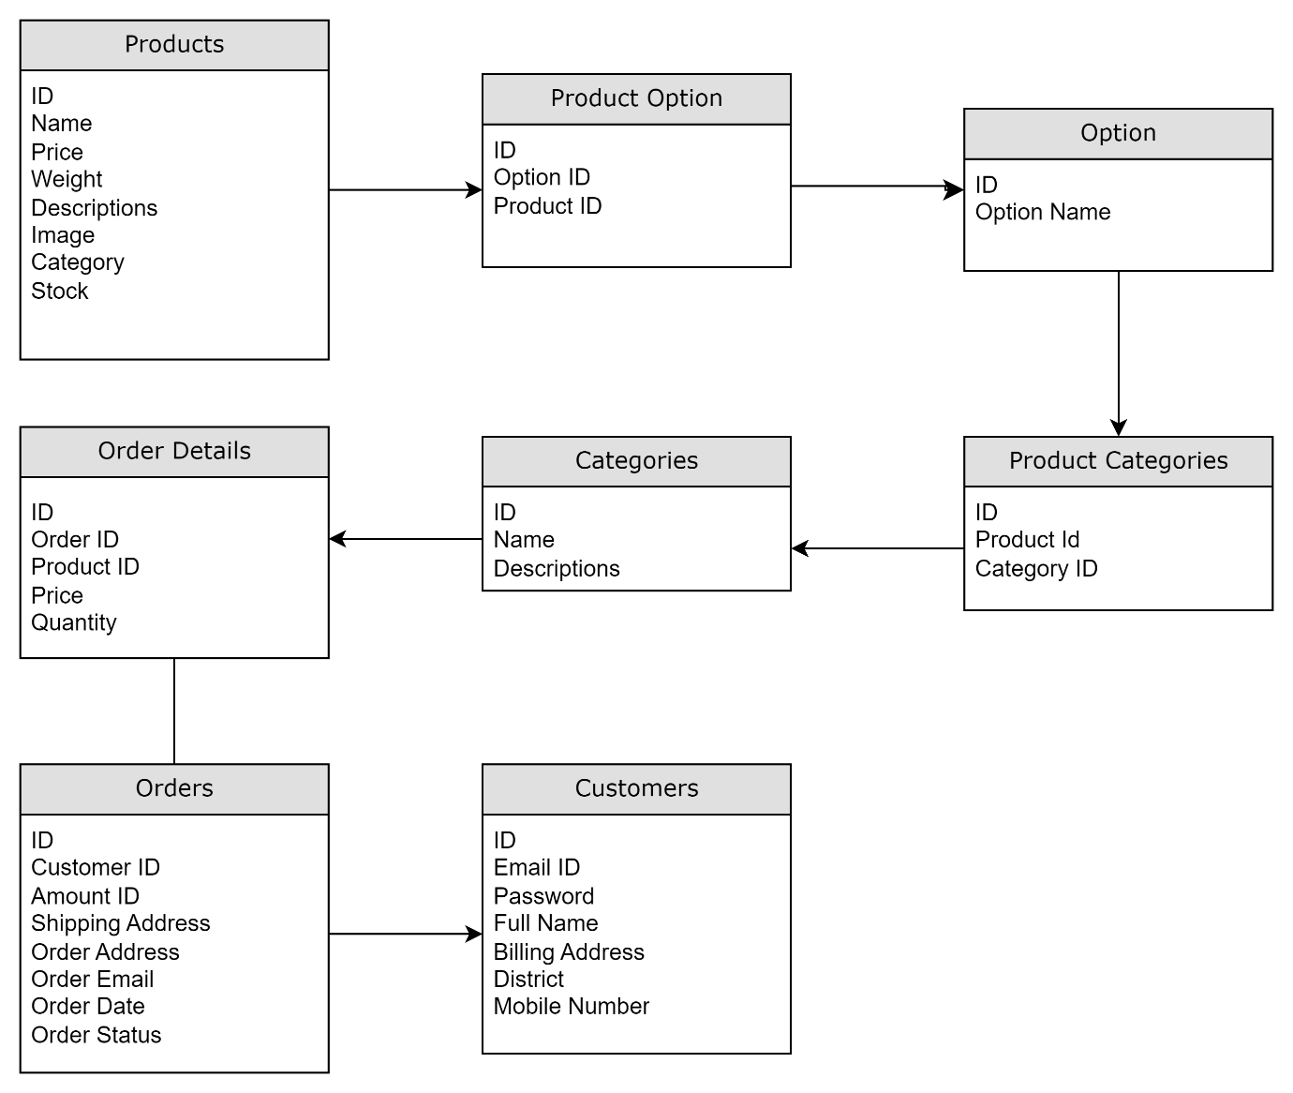

**ER Diagram –**

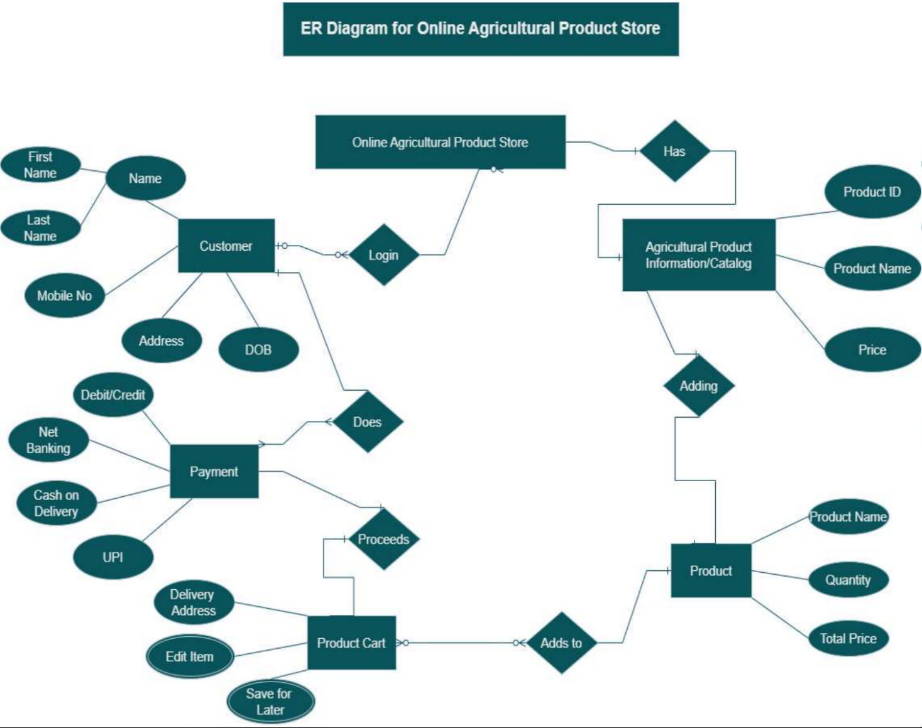

**Question 7 – Data Flow Diagram**



A data flow diagram is a way of representing a flow of data through a process or a system. The DFD also provides information about the outputs and inputs of each entity and the process itself. A data flow diagram has no control flow there are no decision rules and no loops.

**Registered User**

**Product List**

**User List**

**Payment List**

**Order List**

**Product List**

**User List**

**Question 8 – Change Request**

As a BA first I will document the change request. Then analyse the change request. Then I will get the approval from project manager. Here the change request is the changes in the govt. taxation structure so I will inform and discuss this with the stakeholders that we must change our own taxation structure so that our budget to complete this project will be changed.

As a business analyst, we can handle change requests in a project by following the steps below:

Understand the Request: Understand the nature of the request and the reason behind it. Is the request asking for a modification to an existing feature or a new feature altogether?

Analyse the Impact: Analyse the impact of the request on the project. Will the request require significant changes to the project's scope, timeline, or budget?

Evaluate the Priority: Evaluate the priority of the request. Is the request critical to the project's success, or can it be deferred to a later phase?

Determine the Type: Based on the above analysis, determine whether the request is a change request or an enhancement. A change request is a request to modify an existing feature, while an enhancement is a request to add a new feature.

Document the Request: Document the request in detail, including the reason behind the request, the impact on the project.

**Question 9 – Change Request Vs an Enhancement**

This sounds like an enhancement request as it involves adding new features to the existing project. As a BA, I would first gather more information from Ben and Kevin about the specific requirements for adding crop yields and implementing an auction system. I would then assess the impact of these changes on the project timeline, budget, and other existing requirements. If the changes are feasible and align with the project goals, I would document the new requirements and update the project plan and relevant stakeholders accordingly.

According to my understanding change Request mean in any IT project we can change all process, or we add new process or system instance of old remove. Enhancement is a part of change request. For example, we provide only service through web, and we are not available at application services, and we lunch new application at android platform that change request Enhancement mean add something new in existing process or system for example if farmer can process payment by only UPI and Debit card and now, we add new feature farmer can pay payment by credit card and online banking.

**Question 10 – Estimations**

As per the case study, the duration of the project is 18 months, and the current team size is around 15. This will come under medium project. As the trained resources are available, trainers are not required. Hence the required man hours will be 15 x 72 (no of weeks) x 30 (Hrs worked per week) = 21,600 Hrs.

**Question 11 – UAT**

UAT is the final stage of the software development lifecycle where the end-users of the system test the product to ensure that it meets their requirements and is ready for deployment. The UAT Acceptance process involves the following steps –

**Planning:** The business analyst works with the client to plan the UAT phase, including defining the scope, identifying the test scenarios and cases, and setting the acceptance criteria.

**Test Execution:** The end-users perform the testing on the software product in a real-world environment and provide feedback on its usability, functionality, and performance.

**Issue Resolution:** If any issues are identified during the UAT phase, they are recorded and addressed by the development team.

**Sign-off:** Once the UAT is completed successfully, the end-users sign-off on the product, indicating that it meets their requirements and is ready for deployment. To close the project, the following steps can be taken: Project Review: The business analyst conducts a project review to ensure that all the requirements have been met, and the project objectives have been achieved.

**Documentation:** All project documentation, including requirements documents, design documents, test cases, and project plans, are reviewed and updated.

**Closure Meeting:** A closure meeting is held with the stakeholders to discuss the success of the project, any lessons learned, and future recommendations.

**Project Closure Report:** The business analyst prepares a project closure report that includes the project review, documentation updates, closure meeting outcomes, and any final recommendations.

**Archiving:** The project documentation and artifacts are archived for future reference, and the project team is disbanded.

**Question 12 – Project Closure Document**

|  |  |  |  |
| --- | --- | --- | --- |
| **Sr. No.** | **Points to Include** | **Details** | **References** |
| **1** | **Did the client sign of UAT** | | |
|  | Date of signoff | AA/BB/CCCC | Business_Scope.docx |
|  | Name of the resources | Mr Henry |
| **2** | **Objective of the project** | | |
|  | User friendliness | Achieved |  |
|  | Customer satisfaction | ROI in 6 months |  |
|  | More sales | Achieved |  |
| **3** | **Functionalities worked on** | | |
|  | Secure payment processing | Achieved | FRD.docx |
|  | Categories | Achieved |
| **4** | **Infrastructure** | | |
|  | Software installed |  | Procurement.docx |
|  | Server setup |  |
| **5** | **Funding** | | |
|  | Amount Sanctioned | 2 crores | FinancialDetails.xlsx |
|  | Amount Used | 2 crores |
| **6** | **Overall project information** | | |
|  | Escalations | 12 |  |
|  | Customer satisfaction | High |  |
| **7** | **Value to the organization** | | |
|  | Positive/Negative | Company has successfully integrated the project, increased turnover by 30% and increased efficiency by 20% |  |