Document 6- Use case specification document
Use case 1 : Attendance
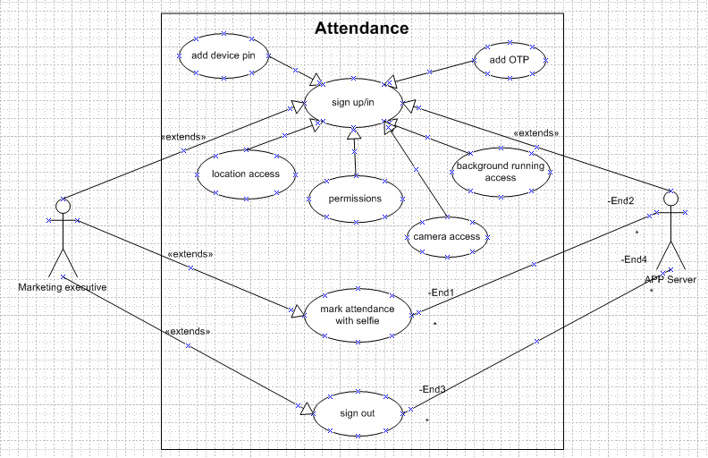
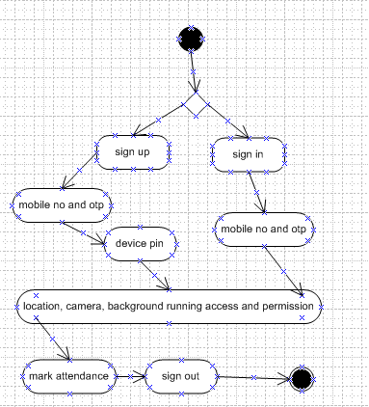

1. Use case Name : Mark attendance
2. Use case Description : Marking of attendance by marketing representatives daily
3. Actors Primary Actors Secondary actors : marketing representatives, app server
4. Basic Flow
- Add mobile number generate OTP and add the same
- Add device pin
- Give access of precise location permissions all time
- Give access for app to run in background and camera access
- Long press on green tab for marking attendance
- Click a selife when prompted
- After the whole days work is completed click on the “out” tab which is just below the checkin/out tab
- Long press red colour out tab.

5. ALTERNATE FLOW
- App not logging in due to wrong phone number
- App not logging in due to invalid corporate pin
- Not able to add attendance due to lack of permissions
6. Exceptional flows
- Managers will have a track option to see the subordinates activity
7. Pre- Conditions : active internet android or iphone
8. post-conditions: the app data will be saved in server for backend access
9. Assumptions : all marketing personel will use, active internet is available for all at all time
10. Constraints : 24/7 uptime maintenance
11. Dependencies :- depending on subcontractor and telephone service providers
12. Inputs and Outputs :- marking of attendance is an input, getting the same data as a report is output
13. Business Rules :- min 8hrs of work for full day, min 4 hrs of work for half day else leave is considered
14.Miscellaneous Information: need valid punch for consideration of attendance else will be considered as holiday, single punch will invite 3 warnings and half day consideration
Use case 2 : Dealer visit
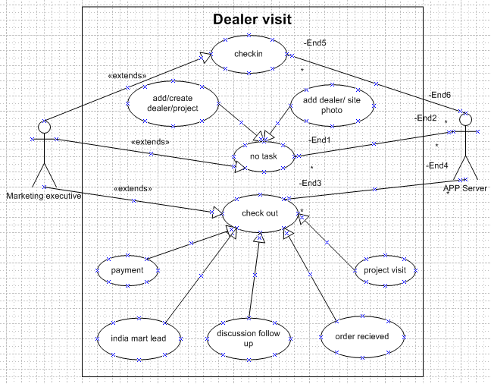
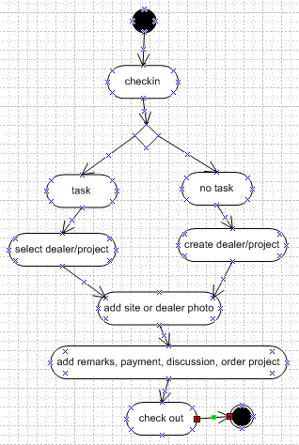
1. Use case Name : Dealer Visit
2. Use case Description : Marking of dealer visits entry and exit
3. Actors Primary Actors Secondary actors : marketing representatives, app server
4. Basic Flow
- Long press on checkin
- NO task
- Add dealer name if existing site/customer, create customer if new
- Add dealer photo/site photo and submit
- After work is completed
- Long press on checkout
- Select status of visit (order received, follow up/discussions, payment received, Project visit, india mart lead)
- Add remarks *, amount if received, image if cheque received and submit
5. ALTERNATE FLOW
- Checkin not happening due to lack of permissions
- Checkout not happening due to geofencing voilation
- Not able to upload store photo due to connectivity issues
6. Exceptional flows
- Managers will have a track option to see the subordinates daily visits along with kilometers
7. Pre- Conditions : active internet android or iphone
8. post-conditions: the checkin chekout data will be saved in server for backend access
9. Assumptions : all marketing personel will use, active internet is available for all at all time
10. Constraints : 24/7 uptime maintenance
11. Dependencies :- depending on subcontractor and telephone service providers
12. Inputs and Outputs :- marking of dealer visit is an input, getting the same data as a report is output
13. Business Rules: - min 5 dealer visits however project a minimum of 1 visit required
14.Miscellaneous Information: need valid dealer/ project visit as per the above business rule else 3 times an individual will be warned and then penalized

Use case 3 : reimbursement claim
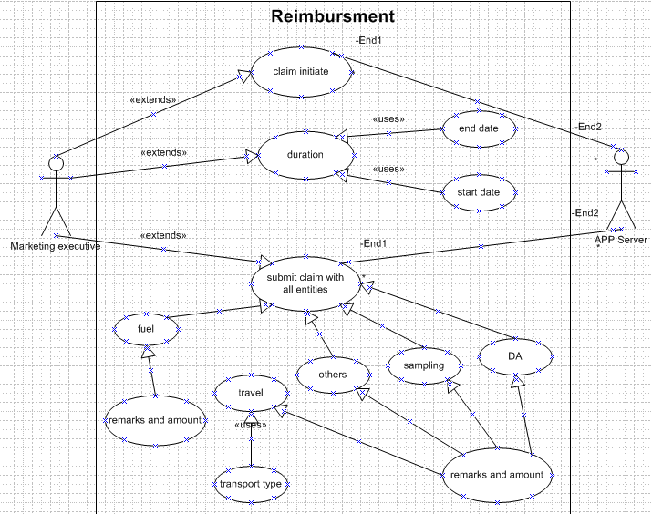
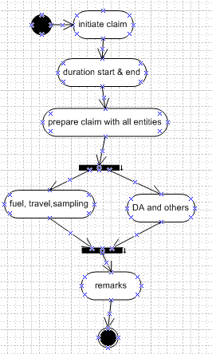
1. Use case Name : Reimbursement claim
2. Use case Description : putting up Dearness allowance and lodge and travel bills where ever applicable
3. Actors Primary Actors Secondary actors : marketing representatives, app server
4. Basic Flow
- Click on reimbursment
- Add Tour start date
- Add Tour end date
- Select reimbursement type (travel, fuel, others, sampling, DA)
- For fuel and travel select transport type, add amount and remarks and submit
- For others, sampling and DA add amount, remarks and submit

5. ALTERNATE FLOW
- App not logging in due to internet issue
- Reimbursement viewing and filters for date range
6. Exceptional flows
- Managers will have a reimbursement filter option to see the subordinates claims
7. Pre- Conditions : active internet android or iphone
8. post-conditions: the reimbursement data will be saved in server for backend access
9. Assumptions : all marketing personel will use, active internet is available for all at all time
10. Constraints : 24/7 uptime maintenance
11. Dependencies :- depending on subcontractor and telephone service providers
12. Inputs and Outputs :- adding reimbursement claim is an input, getting the same data as a report is output
13. Business Rules :- min 8hrs of travel is needed for half DA and 24hrs for full DA, other claims will be applicable on the designation or the marketing personel
14.Miscellaneous Information: need valid punch for consideration of attendance else will be considered as holiday, single punch will invite 3 warnings and half day consideration

Use case 4 : Lead view and feedback(mobile) front end
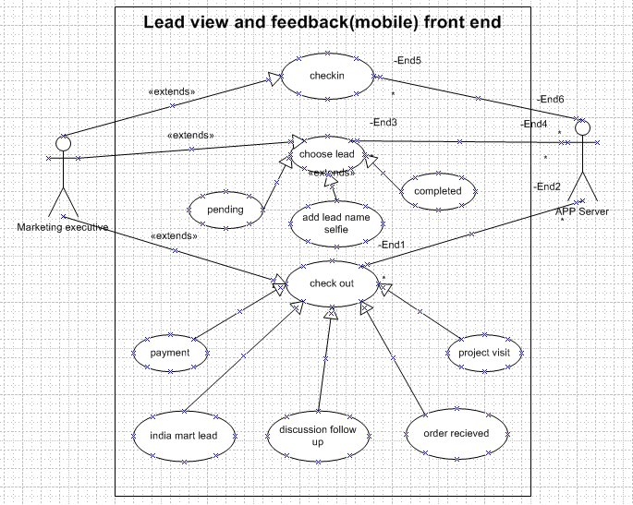
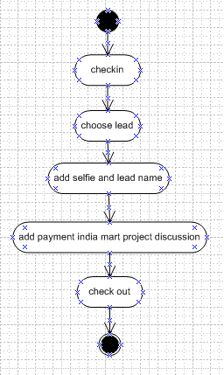
1. Use case Name : Lead view and feedback(mobile) front end
2. Use case Description : addressing assigned leads and providing a feedback by marketing representatives daily
3. Actors Primary Actors Secondary actors : marketing representatives, app server
4. Basic Flow
- Long press on checkin
- Choose lead (pending or completed)
- create customer as per details assigned
- Add dealer photo/site photo and submit
- After work is completed
- Long press on checkout
- Select status of visit (order received, follow up/discussions, payment received, Project visit, india mart lead)
- Add remarks *, amount if received, image if cheque received and submit
5. ALTERNATE FLOW
- Contact details with requirement not available
- App not logging in due to lack of internet
6. Exceptional flows
- Managers will have a track option to see the subordinates activity
7. Pre- Conditions : active internet android or iphone
8. post-conditions: the app data will be saved in server for backend access
9. Assumptions : all marketing personel will use, active internet is available for all at all time
10. Constraints : 24/7 uptime maintenance
11. Dependencies :- depending on subcontractor and telephone service providers
12. Inputs and Outputs :- working on a lead and giving feedback is an input, getting the same data as a report is output
13. Business Rules :- conversion rate of leads assigned must be above 30%
14.Miscellaneous Information: Simply putting up as customer not interested is not acceptable

Use case 5 : Lead Addition and Assigning(portal) back end
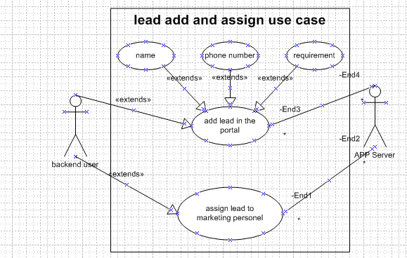
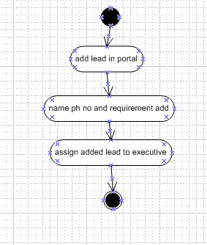
1. Use case Name : Lead Addition and Assigning(portal) back end
2. Use case Description : Lead Addition and Assigning(portal) back end daily
3. Actors Primary Actors Secondary actors : Backend user, app server
4. Basic Flow
- Add lead(name, ph no, requirement)
- Assign lead
5. ALTERNATE FLOW
- Lead not getting added (due to incomplete details submitted)
- Not able to assign lead (select marketing personnel)
6. Exceptional flows
- Admin will have a track option to see the subordinates activity
7. Pre- Conditions : active internet and a PC
8. post-conditions: the data will be saved in server for backend monitoring
9. Assumptions : PC is working fine and active internet is available for all at all time
10. Constraints : 24/7 uptime maintenance
11. Dependencies :- depending on subcontractor and telephone service providers
12. Inputs and Outputs :- creating lead and assigning lead is input, getting the same data as a report is output
13. Business Rules :- All the leads received on india mart needs to be created and assigned daily
14.Miscellaneous Information: Any backlog from previous day will attract warnings initially and then penalty
Document7- Screens and pages
Please follow the following steps to create the mock-ups
- Kindly use balsamic or Axure.
- Always start with a home page of an application.
- Take a feature and follow it to the end
  - Eg: Home page of SCRUM Foods
  - Select Login- Create a login page
  - Let’s assume, you want to search a restaurant
  - Search page- Type the restaurant name and select the dish
  - Add to cart page
  - Payment page
  - Logout page
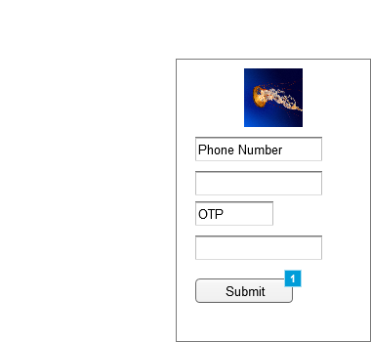

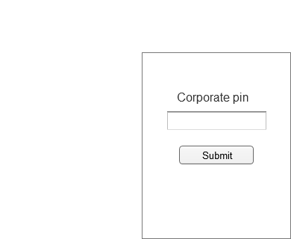
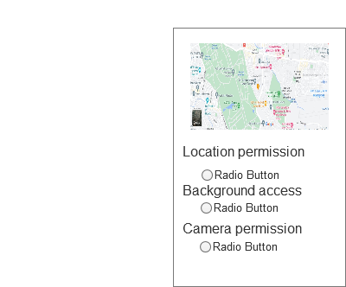
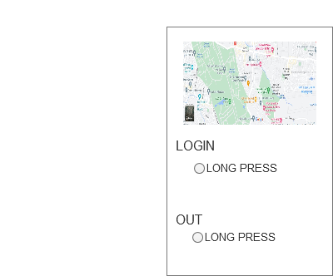
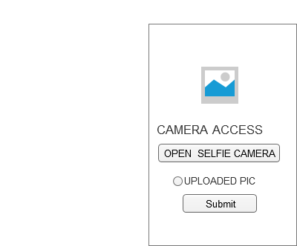

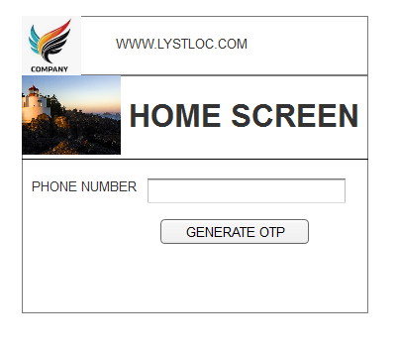
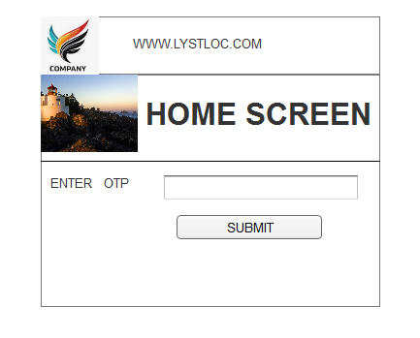
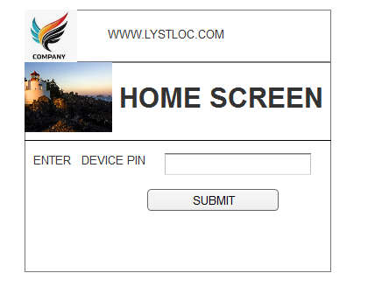
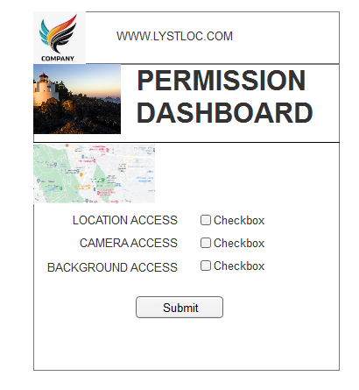
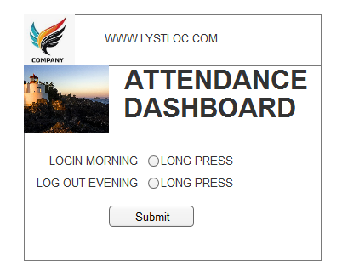
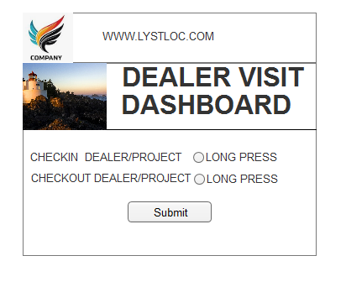
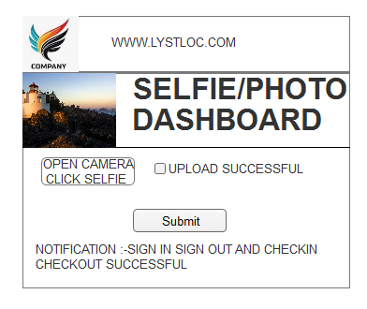

Document 8- Tools-Visio and Axure
Write a paragraph on your experience using Visio and Axure for the project.
Both visio and axure are good tools for pictorial representation of the project be it templates or workflow or understanding anything while ensuring we don’t miss out any information
Pictorial representation of each and every screen is designed for clear understanding
Data to be entered is also illustrated
Interaction between screens is also defined
In all we get a fair idea of what kind of website or an application that gets developed of conceptualized
It is like a prototype ie mini solution in the initial stages itself before start of development
Document 9- BA experience
My experience as BA in following phases:
- Requirement gathering:
- To gather requirements, we used MOSCOW technique.
- Client is not available for some period of time during this phase. So as a BA i need to source out point of contacts from his side and get the information asap.
- I validate the requirements using FURPS technique
- There are many requirements which are duplicated or repeated. We need to remove them immediately
- Prototyping is used to give more specific requirements
I spoke to the marketing executive, backend users ie HR and Sales team to gather requirements and made a list of the requirements and then sorted the requirements and prioritized the same and validated it, got a prototyping done to get better clarity and add a few mote requirements if required

- Requirement Analysis:
- We need to draw UML diagrams to visually describe the requirements
- Activity diagrams also used to describe the process flow
- Communicate the diagrams to team. Some team members might not agree with them and might make changes. As a BA we need to consider the points and make modifications
- Prepare BRS and SRS
As per above documents we have drawn uml diagrams and activity diagrams is used to depict process flow, this is intimated to the stakeholders and any inputs is considered for changes and documented the same
- Design:
- From the usecase diagrams, we prepare test cases
- Communicate with client on design and solution documents
- Write negative test cases as well along with positive test cases.
- Do not miss a single test case. It might have huge impact on project development in later stages
- Prepare test data for testing
- Update RTM. This is must as we need to make sure that all the requirements are met
Testcase is prepared with respect to all the features and results are shared with end users for them to communicate the feedback on all features and recheck as per RTM
- Development:
- Organized JAD sessions
- Clarifying queries of tech team during coding
- There might be some team members who doesn't agree with the concept or who doesn’t cooperate during JAD sessions. As a BA i handle the situation gently and had one on one discussion with them. Explained how their actions are going to affect the project. Setup healthy environment within the team.
- Referred diagrams to code the Unit
- Conduct regular meetings with technical team and client which is challenging. Some team members might not be available for the meeting. Recording the session and providing that to missed one and having one to one discussion later with that missed person is all i need to do
Since this is a SAAS model it is more of checking if the features available are tuned and configured to suit our business process. With respect to this i as a BA will coordinate with development team continusly
- Testing:
- Prepare test cases from use cases
- Perform high level testing
- Test data is requested by BA from client
- Updated RTM
- Take signoff from client
- Prepare client for UAT
Like said earlier test cases are prepared and ensure all stakeholders also test the same and once every one are on same page i will take a sign off from my team and plan for a UAT
- Deployment:
- Forwarded RTm to client which should be attached to project closure document
- Coordinates to complete and share end user manuals
- Plans and organizes training sessions
- Make sure all the candidates attend the meeting
Extended training sessions and knowledge transfer sessions are arranged to ensure allthe stake holders are comfortable with the product and can handle operations

