**ONLINE AGRICULTURE PRODUCT STORE**

**Question 21 – Audits - 3 Marks**

**5 Quarterly Audits are planned Q1 , Q2, Q3, Q4, Q5 for this Project. What is your knowledge on how these Audits will happen for a BA ?**

Audit is an inspection of the quality of work. There are two types of audits planned.

Internal Audit – Here IT or Development Company arrange audit by specified team within the company

External Audit – Here Clients arrange audits by their team.

Quarterly audits in Business Analysis usually involve:

* **Q1: Analysis of Requirements:** Ensuring gathered requirements are comprehensive and clear.

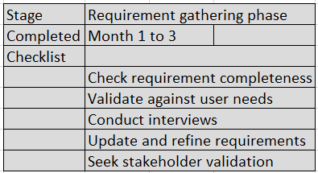

* **Q2: Design Review:** Assessing the design phase progress, architecture, and system design.

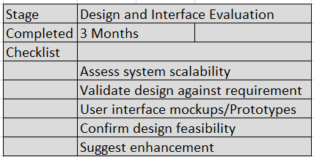

* **Q3: Development Progress:** Reviewing the development progress, coding standards, and adherence to timelines.

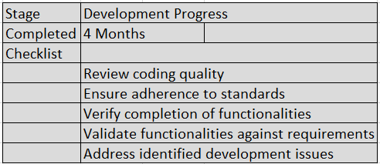

* **Q4: Testing and Quality Assurance:** Checking the testing processes, identifying and resolving defects, and ensuring quality.

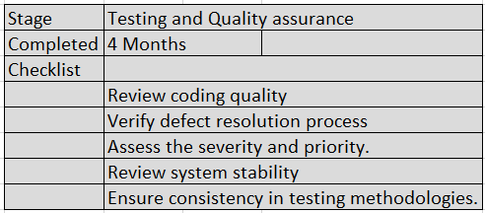

* **Q5: Deployment and User Acceptance:** Confirming successful deployment and gathering user feedback to match system functionality with user expectations.

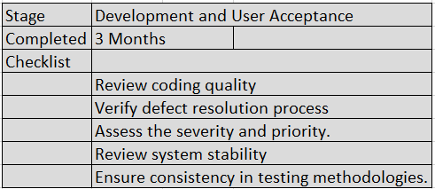

**Question 22 – BA Approach Strategy - 5 Marks**

**Before the Project is going to Kick Start, The Committee asked Mr. Karthik to submit BA Approach Strategy Write BA Approach strategy (As a business analyst, what are the steps that you would need to follow to complete a project – What Elicitation**

**Techniques to apply, how to do Stakeholder Analysis RACI/ILS, What Documents to Write, What process to follow to Sign off on the Documents, How**

**to take Approvals from the Client, What Communication Channels to establish and implement, How to Handle Change Requests, How to update the**

**progress of the project to the Stakeholders, How to take signoff on the UAT- Client Project Acceptance Form)**

I would recommend to use below elicitation techniques for requirement analysis:

1. Focused Group

2. Joint Application Developments

3. Interview

4. Prototyping

We will do stakeholder analysis using the RACI matrix. RACI matrix is used to indicate the roles of stakeholder while managing the change request in BRD.

Codes used for RACI chart

Responsible – Responsible for creating the documents

Accountable – Accountable for accuracy of this documents

Consulted – Provides Inputs

Informed – Must be informed for any chang

**Elicitation technique**

* Existing System.
* Brainstorming.
* Focus Groups.
* Interviews.

**RACI matrix**

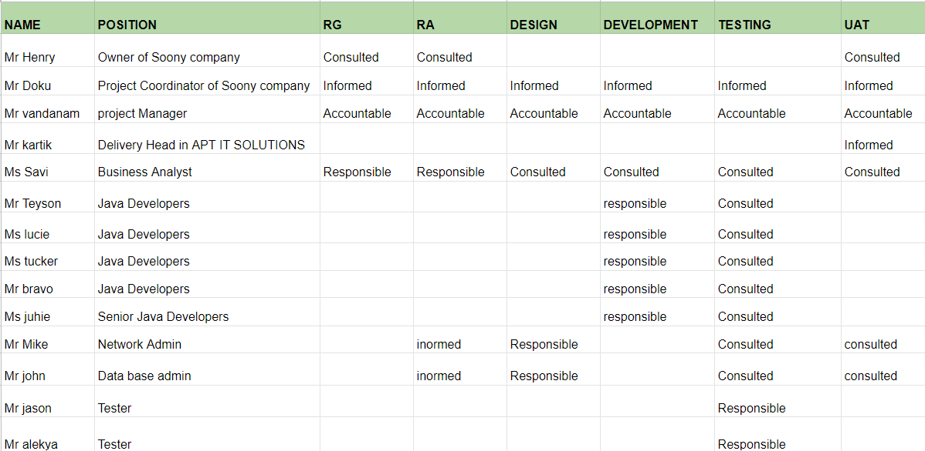

* Documents to write-Business requirement document, FRD functional Requirement document,
* How to take approval from the client- discuss the overall project with the client, confirm the requirements and solutions , and take the approval on the mail.
* What Communication channels to establish in implement – Mail followed by a phone call.
* How to handle the change process – Whatever change request comes; we will discuss with stakeholders as per the RACI chart. We will check feasibility, risk, effect on scope and delivery time. After approval from the key stakeholder, the decision will be informed to the client.
* How to update the progress of the project to the stakeholders – We will track the progress of project as per the gantt chart submitted along with the
* timesheets of all stakeholders. After completion of every phase (coding and testing), we will keep informed to all stakeholder and take confirmation from the client.
* How to take sign off on UAT: For User Acceptance Testing, we can launch a prototype and take feedback from various customers.

**Question 23 – 3-Tier Architecture - 1 Marks**

3 tier architecture has three layers

(i) Application Layer –It constitutes the front-end layer of the application and the interface with which end-users will interact directly. Which includes screens, pages , Logic , Functions, etc

(ii) Business Layer – It controls the application’s core functionality by performing detailed processing and is usually coded in programming languages which includes “Control Unit “

(iii) Data Layer - Houses database servers where information is stored and retrieved.Which includes “Database”

**Question 24 – BA Approach Strategy for Framing Questions - 3 Marks**

**Business Analyst should keep What points in his/her mind before he frames a Question to ask to the Stakeholder ( 5W 1H – SMART – RACI – 3 Tier Architecture – Use Cases, Use case Specs, Activity Diagrams, Models, Page designs)**

5W1H – It is an interview type requirement elicitation technique. We should ask 5W1H type questions like what, when, why, where, who and How.

SMART – It is one of the methods of Validating requirements. A well form requirement should comply with SMART i.e. Specific, Measurable,Attainable, Realistic, Traceable / Time bound.

RACI - RACI matrix is used to indicate the roles of stakeholder while managing the change request in BRD (Business Requirement Document).

Codes used for RACI chart

Responsible – Responsible for creating the documents

Accountable – Accountable for accuracy of this documents

Consulted – Provides Inputs

Informed – Must be informed for any change.

3 tier architecture has three layers

(i) Application Layer –It constitutes the front-end layer of the application and the interface with which end-users will interact directly. Which includes screens, pages , Logic , Functions, etc

(ii) Business Layer – It controls the application’s core functionality by performing detailed processing and is usually coded in programming languages which includes “Control Unit “

(iii) Data Layer - Houses database servers where information is stored and retrieved.Which includes “Database.

Use Cases – A use case diagram is used to represent the dynamic behavior of a system. It encapsulates the system's functionality by incorporating use cases, actors, and their relationships. It models the tasks, services, and functions required by a system/subsystem of an application.way

The UCD have 4 main elements – The actors, that the system you are describing interacts with

. The system, itself.

The Use cases – or service(activity) that the system knows how to perform. The lines that represent the relationships.

The use Case specs – Every use case will have its own use case specification.

* Use case name
* Use Case description
* Actors
* Basic flow
* Alternate Flow
* Exceptional flow
* Precondition
* Postcondition
* Assumptions
* Constraints
* Input and output

Activity Diagrams- Activity diagram is basically a flowchart to represent the flow from one activity to another activity. Activity can be described as an operation of the system. So, the control flow is drawn from one operation to another. An activity diagram is drawn to model how the system should function in order to achieve business logic, business functionality and business objective.

Models- As a BA we should be able to identify the correct SDLC model to choose to execute the project. Like waterfall model in Sequential SDLC method, Spiral Model in Evolutionary SDLC method OR Scrum model in Agile SDLC method.

Page designs - We can use tools like Axure OR Balsamiq to design pages for Wireframe or Prototype. Wireframe is nothing but a sketch of graphical representation of the user interface and Prototype is a clickable version of wireframe.

**Question 25 – Elicitation Techniques - 3 Marks**

**As a Business Analyst, What Elicitation Techniques are you aware of?**

**( BDRFOWJIPQU)** ..

Elicitation is the cornerstone of any project, as it plays a critical role in bringing the requirements for a project to the table. Scientists and engineers agree that elicitation errors are one of the most common causes of project failures and abandonment that negatively impact the bottom line.

To avoid the possibility of fatal mistakes hampering a project, adequate research and preparation are hence necessary for the elicitation process

**Brainstorming**The requirements elicitation process begins with brainstorming. To facilitate focused and fruitful brainstorming sessions, business analysts should set up a team with representatives of all stakeholders for capturing new ideas.

**Document Analysis.** During this step of the requirements elicitation process, business analysts review existing documentation at hand, with the intent of identifying requirements for changes or improvements.

**Focus Group** In a focus group, relevant stakeholders provide feedback to refine processes, ideas, or solutions that emerged as an outcome of earlier elicitation activities, such as brainstorming and document analysis. The feedback and comments are recorded for use in later phases of requirements elicitation

**Interface Analysis** At the core of interface, analysis is the idea of deconstructing how external and internal systems interact with each other and with end-users

**Interviews**. A great way to extract critical data is via interviews. Business analysts engage in group or one-to-one interviews in an informal or formal setting to elicit project requirements through questions directed at Subject Matter Experts, stakeholders, and end-users.

**Observation** Also referred to as job shadowing, observation is an excellent elicitation technique that helps understand requirements based on observations related to process flows and work environments of stakeholders.

**Prototyping** One of the most important phases of the requirements elicitation process, prototyping enables business owners and end-users to visualize realistic models of applications before they are finally developed

**Workshops** For multi-stakeholder, complex projects, workshops are one of the most resource-efficient methods to elicit requirements. Intense, focused, and highly productive workshops have a key role to play in getting all parties onto the same page.

**Survey** When multiple Subject Matter Experts and stakeholders are involved in a project, business analysts conduct a survey for the elicitation of requirements.

**Question26 .Which Elicitation Techniques can be used in this Project and Justify your selection of Elicitation Techniques? Prototyping Use case Specs Document Analysis Brainstorming.**

I will prefer brainstorming and Creative thinking is the result of the brainstorming session, plenty of ideas in a short time. Promotes equal participation and Joint Application development as .Documentation is completed within hours and is provided quickly back to participants for review, You can get on the spot confirmation on requirements. Successfully gathered requirements from a large group in a short period. Consensus can be achieved as issues and questions are asked in the presence of all the stakeholders.

**Question 27 – 10 Business Requirements- 5 Marks**

* BR001 – Farmers should be able to search for available products in fertilizers, seeds, pesticides
* BR002 – Manufacturers should be able to upload and display their products in the application
* BR003-Manufacture should be able to edit and remove the displayed item.
* BR004- Farmers should be able to login to their account with email id or mobile number
* BR005- Manufacturer should be able to login with their credentials.
* BR006 Farmers should be able to wishlist the item, and add the item to the cart
* BR007-Farmers should be able to search the product according to the location.
* BR008-Farmers should be able to make the payment. By multiple payment methods..
* BR009-Farmers should be able to save and change the address.
* BR010 Farmers should be able to track the order after placing the order.
* BR011 Farmers should be able to get the sms or email confirmation.
* BR012-Farmers should be able to cancel or modify the order.

**Question 28 –Assumptions- 2 Marks List your assumptions**

1. Farmers has good internet connectivity.
2. Farmers are aware of online shopping.
3. Farmers have smartphones or systems to use the app.
4. Service is provided to remote areas.
5. Manufacturers have variety of products to display on the app as per farmers requirement.
6. Manufacturer has stock available for delivery

**Question 29 – This project Requirements Priority - 1 Marks Give Priority 1 to 10 numbers ( 1 being low priority – 10 being high priority) to these Requirements after discussions with the stakeholders.**

|  |  |  |
| --- | --- | --- |
| **Number** | **Business Requirement** | **priority** |
| **BR001** | Farmers should be able to search for available products in fertilizers, seeds, pesticides | **4** |
| **BR002** | Manufacturers should be able to upload and display their products in the application | **3** |
| **BR003** | Manufacture should be able to edit and remove the displayed item | **2** |
| **BR004** | Farmers should be able to login to their account with email id or mobile number | **1** |
| **BR005** | Manufacturers should be able to login with their credentials. | **7** |
| **BR006** | Farmers should be able to wishlist the item, and add the item to the cart | **6** |
| **BR007** | Farmers should be able to search the product according to the location | **5** |
| **BR008** | Farmers should be able to make the payment. By multiple payment methods. | **8** |
| **BR009** | Farmers should be able to save and change the address | **9** |
| **BR010** | Farmers should be able to track the order after placing the order | **10** |

**Question 30 – Use Case Diagram - 3 Marks**

**Draw use case diagram Use case diagram drawn using MS Visio tool.**

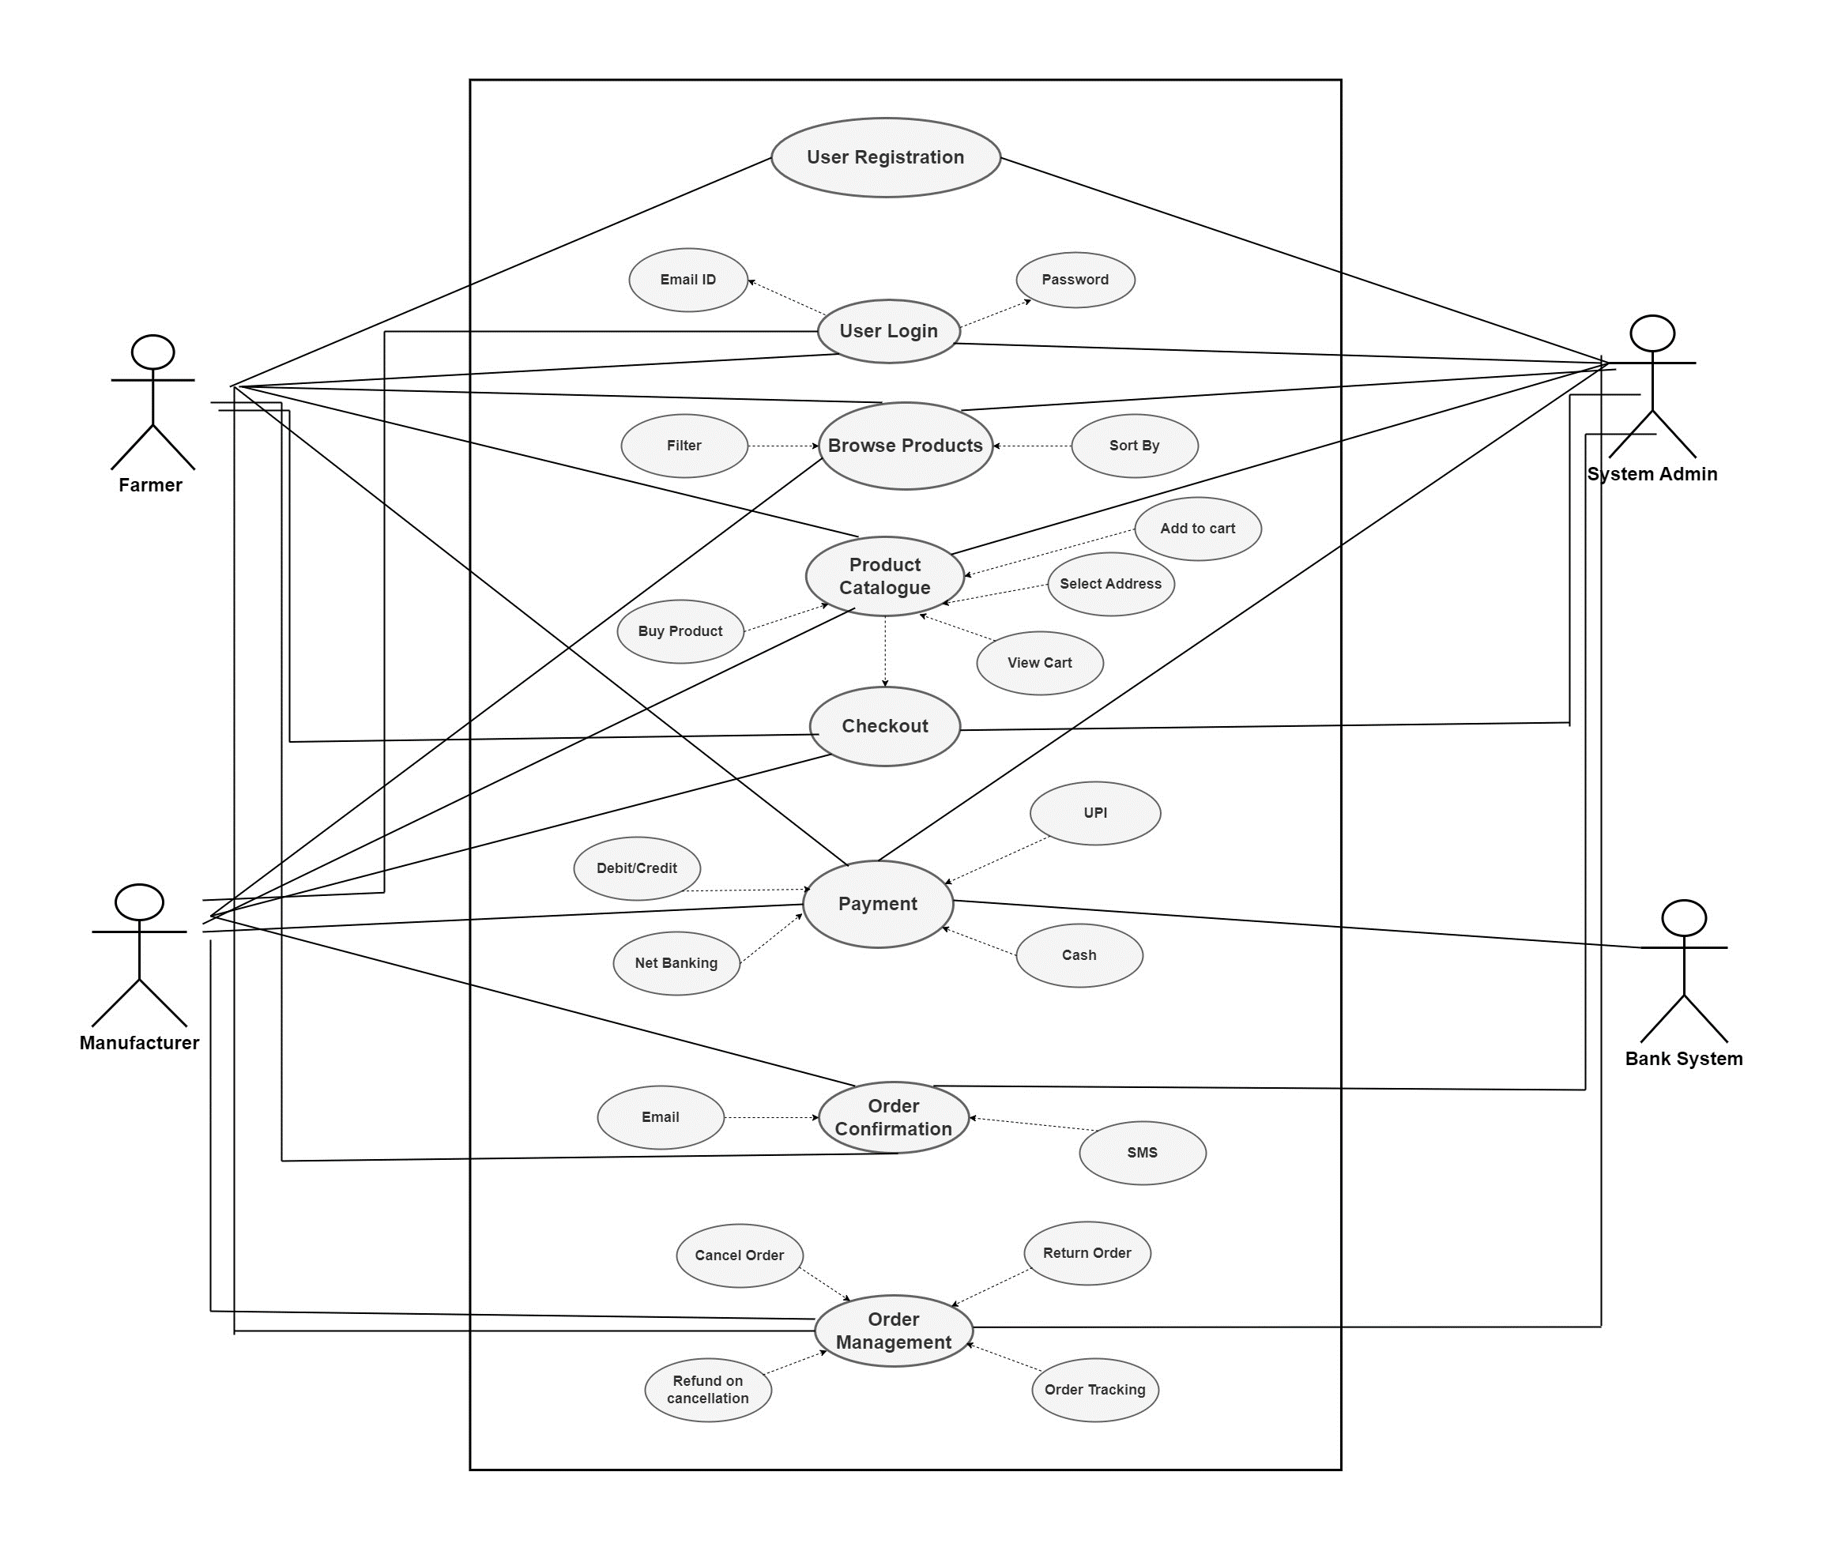

**Question 31 – (minimum 5) Use Case Specs - 3 Marks**

Use Case name- Online Agriculture shopping platform

Use case description- Manufacturer will list the agricultural products in the portal with the prices, Farmers will use this platform to search online agri products, Farmer will use online portal to search, buy Agri products such as Fertilizers, seeds and Pesticides. They will buy the product through online payment mode or COD.

Actors:

a. Primary Actors – Farmer , Manufacturer

b. Secondary Actors – User Database , Product Database , Bank Server , Delivery Tracking System

1.Use Case: User Registration

**Actors:** User

**Description:** This use case describes the process by which a user registers for an account on the online agriculture product store platform.

**Preconditions:** The user accesses the registration page of the platform.

**Main Flow**:

User navigates to the registration page and clicks on the "Sign Up" button.

User enters required information, including name, email address, password, and contact details.

User confirms registration by clicking on the "Register" button.

System validates user inputs and creates a new account.

Alternate Flows:

If the user enters invalid information, the system displays error messages and prompts the user to correct the fields.

Postconditions: The user receives a confirmation email and gains access to their account dashboard.

**2 Use Case:** Browse Products

**Actors:** User

**Description:** This use case describes the process by which a user browses products available on the online agriculture product store platform.

Preconditions: The user is logged into their account and navigates to the product browsing page.

**Main Flow**:

User navigates to the product browsing page.

User views a list of available products, organized by category or type.

User filters products based on criteria such as price, brand, or rating.

User clicks on a product to view detailed information and images.

Alternate Flows:

If there are no products available in a certain category, the system displays a message indicating so.

**Postconditions**: The user can view product details, add items to their cart, or proceed to checkout.

**3 Use Case:** Add Product to Cart

**Actors:** User

**Description:** This use case describes the process by which a user adds a product to their shopping cart on the online agriculture product store platform.

Preconditions: The user is logged into their account and views product details.

**Main Flow:**

User selects a product from the product browsing page.

User clicks on the "Add to Cart" button.

System adds the selected product to the user's shopping cart.

Alternate Flows:

If the user attempts to add a product that is out of stock, the system displays a message indicating so.

**Postconditions:** The user can view their updated shopping cart with the added product.

**4 Use Case:** Checkout Process

**Actors:** User, System

**Description:** This use case describes the process by which a user completes their purchase and proceeds to checkout on the online agriculture product store platform.

Preconditions: The user has added one or more products to their shopping cart.

**Main Flow:**

User navigates to the shopping cart page and clicks on the "Checkout" button.

User reviews the items in their cart and updates quantities or removes items if necessary.

User enters shipping address and payment information.

User confirms the order and clicks on the "Place Order" button.

System validates the order and processes the payment.

**Alternate Flows:**

If the user's payment method is declined, the system displays an error message and prompts the user to try again or use an alternative payment method.

**Postconditions:** The user receives an order confirmation email and the system updates inventory and payment records accordingly.

**5 Use Case:** Track Order

**Actors:** User

**Description:** This use case describes the process by which a user tracks the status of their order on the online agriculture product store platform.

Preconditions: The user has completed an order and received an order confirmation.

**Main Flow:**

User logs into their account and navigates to the order tracking page.

User enters the order number or selects the order from their order history.

System retrieves order details, including status, shipping information, and estimated delivery date.

**Alternate Flows:**

If the user enters an invalid order number or selects an order that does not exist, the system displays an error message.

**Postconditions:** The user can view the current status and location of their order, helping them anticipate delivery.

**Question 32 – (minimum 5) Activity Diagrams - 3 Marks**

Activity diagrams

Activity diagram drawn in MS visio and attached.

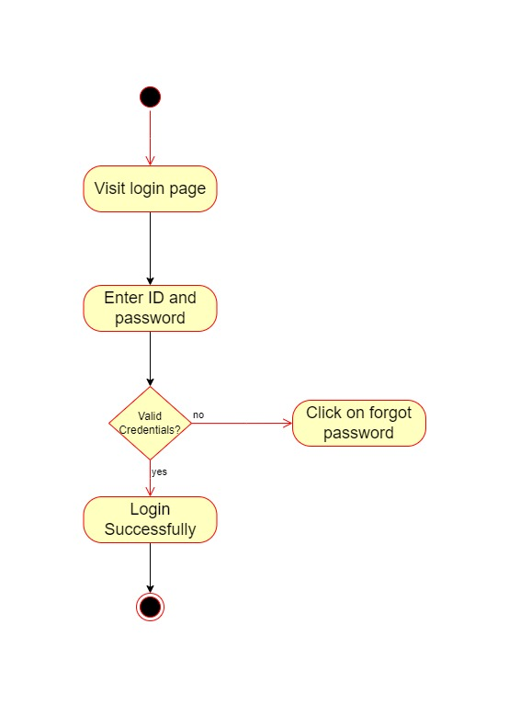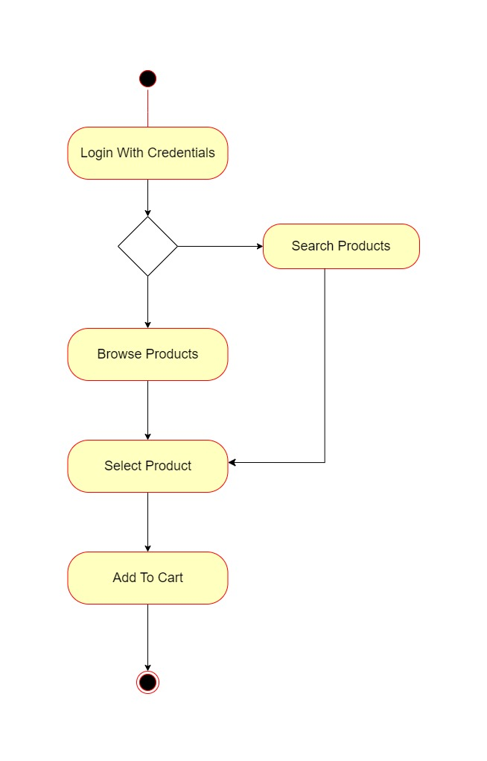

Add to cart

LOGIN

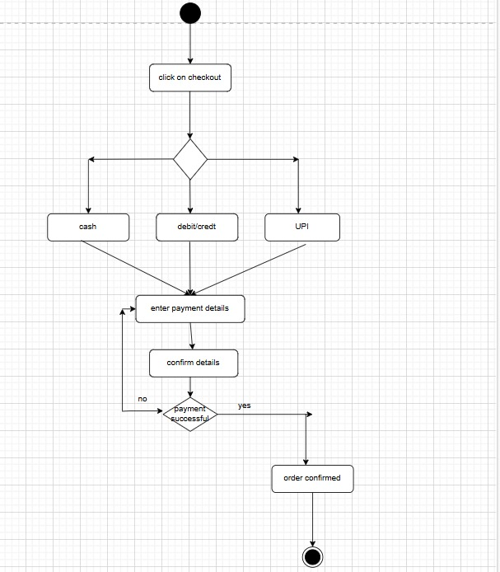

Payment

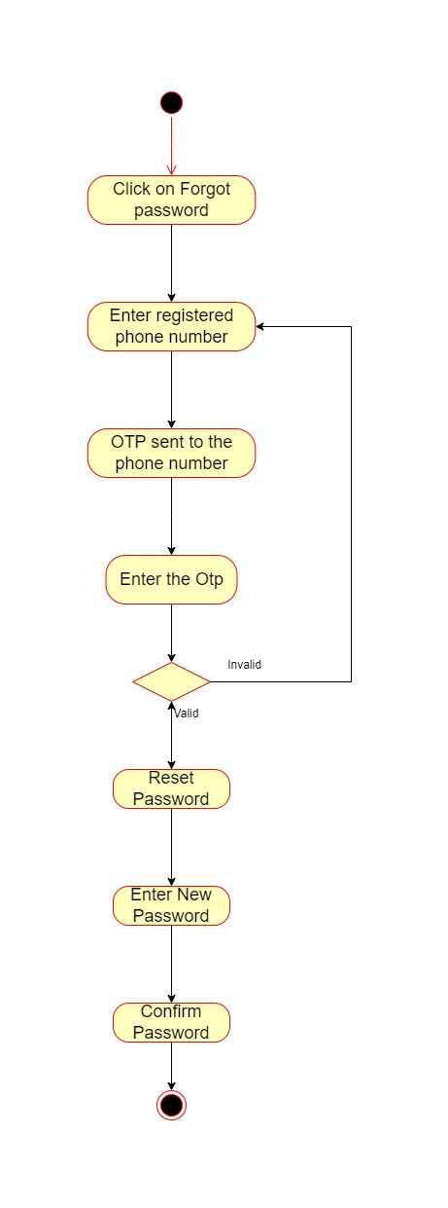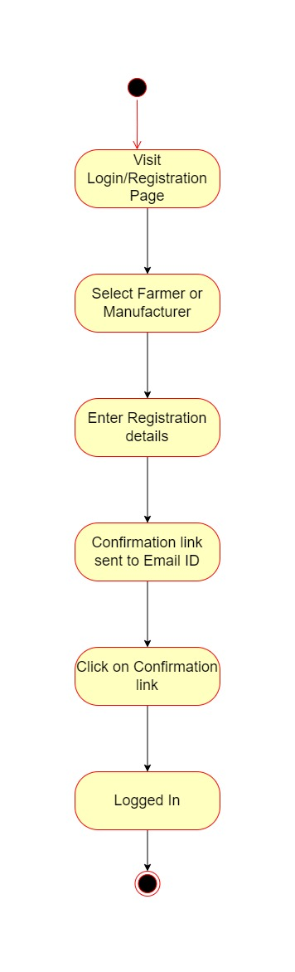

User Registration

Forgot Password