AGILE DOCUMENTS
Document 1: Definition of Done Checklist for a Fraud Management Project:
Checklist Item | Description
- Produced Code for Presumed Functionalities | All planned functionalities, as per user stories, have been implemented.
- Assumptions of User Story Met | All business and technical assumptions in the user story are validated and fulfilled.
- Project Builds Without Errors | The code compiles successfully with no errors in the build pipeline.
- Unit Tests Written and Passing | Unit tests cover the agreed minimum coverage and pass successfully.
- Project Developed on Test Environment | Development and testing performed on an environment identical to production.
- Test on Devices/Browsers Listed Passed | Feature tested on all supported devices, browsers, and platforms as listed in project assumptions.
- Feature OK-ed by UX Designer | UX design and usability approved by the UX designer
- QA Performed and Issues Resolved | QA validated the features, and all issues raised are resolved.
- Feature Tested Against Acceptance Criteria | Feature satisfies all acceptance criteria and business requirements.
- Feature OK-ed by Product Owner | The Product Owner has reviewed and approved the completed feature.
- Refactoring Completed | Code refactoring is performed to enhance maintainability and performance.
- Configuration or Build Changes Documented | Any system configuration or build changes are documented clearly.
- Documentation Updated | User guides, technical specs, and other documentation are updated as necessary.
- Peer Code Review Performed | Code reviewed by peers and approved for quality and standards.

Document 2- Product Vision
Scrum Project
Name: Mastercard Developer Zone (Fraud Management)
Venue: Kalpana Chawala meeting room
Date: 13/12/2024 | Start Time: 10 am | End Time: 12 pm | Duration: 2 hrs
Client: Marian Western
Stakeholder List:
- Vijay Singh
- Rami Lengadhare
- Puja Sahay
- Komal Pardeshi
- Jayashree Gosavi
Scrum Team
Scrum Master: Jayesh Rajput
Product Owner: Kunal Datta
Scrum Developer 1: Sandeep Goyal
Scrum Developer 2: Rakhi Thakare
Scrum Developer 3: Neeta Singh
Scrum Developer 4: Amit Verma
Scrum Developer 5: Digvijay Khade
Scrum Developer 6: Nikhil Sharma
Vision: To create an intelligent, adaptive, and user-friendly fraud management solution that proactively detects and prevents fraudulent activities in real time, safeguarding businesses and customers while ensuring compliance with regulatory standards.
Target Group | Needs | Product | Value
Market Segment Addressed  Industries:  Financial Services (Banks, Payment Processors, FinTechs )  E-Commerce and Retail  Insurance Providers  Market Type:  Enterprises handling large-scale transactions or sensitive customer data.  Business operating in high-risk environments prone to fraudulent activities.  Target Users and Customers  Primary User (Operational Level):  Fraud Analysts: Investigating suspicious activities.  Risk Management Teams: Monitoring fraud trends and preventing losses.  Compliance Officers: Ensuring adherence to regulations like AML, PCI-DSS, GDPR.  IT Teams: Managing system integration and performance.  Customers (Decision-Makers):  C-Level Executives  Risk Managers and Directors  Business Owners  Government and Regulatory Bodies | Problem the Product Solves  1. Fraud Detection and Prevention:  - Identifies and mitigates fraudulent activities in real-time (e.g. transaction fraud, identity theft).  - Operational Inefficiency:  - Reduces the time and resources spent on manual fraud detection processes.  - Financial Loss:  - Minimize monetary losses caused by fraud across industries.  Benefits Provided  - Enhanced Security:  - Provides businesses with robust fraud prevention mechanism and data.  - Real-Time Insights:  - Delivers actionable alerts and insights for swift decision-making. | The product is an intelligent fraud management system that combines advanced analytics, machine learning, and real-time monitoring to detect, prevent and mitigate fraudulent activities across industries.  What Makes it Desirable and Special?  - Real-Time Fraud Detection:  - Uses AL/ML algoriths to identify suspicious patterns and anomalies as they occur.  - Comprehensive Coverage:  - Monitors transactions, user behaviour, and other critical data points across multiple channels (web, mobile, APIs)  Is it Feasible to Develop the Product?  Yes, the product is feasible to develop considering the following factors:  - Technological Maturity:  - Proven technologies like AI/ML, big data analytics, and cloud computing are available to support the system.  - Market Demand:  - Growing need across industries for robust fraud management solutions. | How the Product Benefits the Company  - Revenue Protection:  Reduces finacial losses caused by fraud, ensuring profitability.  - Market Differentiation:  Positions the company as a trusted provider of fraud prevention solutions, enhancing its competitive edge.  Business Goals  - Increase Market Share:  Capture a significant portion of the fraud prevention market across industries.  - Revenue Growth:  Achieve profitability through subscription-based or licensing revenue streams.  - Strength Brand Reputation:  Establish the company as a trusted leader in fraud management solutions.

Document 3: User stories

User story No: 1 | Tasks:  - Define criteria for suspicious activities.  - Implement real-time monitoring system.  - Test with historical data | Priority:  High
Value Statement:
As a user, I want to detect suspicious transactions in real-time, so that I can minimize potential losses.
BV: 500 | CP: 10
Acceptance criteria:
- Transactions flagged for anomalies within 5 seconds.
- Alert sent to the appropriate team.

User story No: 2 | Tasks: 1. Design report templates.  2. Integrate with data base.  3. Ensure real time updates. | Priority: Medium
Value Statement: As user, I want to view detailed reports of fraudulent activities, so that I can analyze patterns
BV: 200 | CP: 10
Acceptance criteria: - Reports generated in under 2 minutes.
- Includes key details like time, amount, and pattern description.

User story No: 3 | Tasks: 1. Establish account blocking criteria.  2. Automate the blocking process.  3. Notify users of actions taken. | Priority: High
Value Statement: As a user, I want to block the flagged accounts automatically, so that I can prevent further fraud.
BV: 500 | CP: 10
Acceptance criteria:
- Accounts flagged as fraudulent are blocked instantly.
- Notifications sent within 5 minutes.

User story No: 4 | Tasks: 1. Develop a review dashboard.  2. Implement an approval workflow.  3. Log reviewer actions. | Priority: Medium
Value Statement: As a user, I want to review flagged transactions manually, so that I can verify false positives.
BV: 200 | CP: 20
Acceptance criteria:
- Reviewers can access transactions easily.
- Decisions logged with time stamps.

User story No: 5 | Tasks: 1. Define risk thresholds.  2. Create notifications on the system (email/SMS).  3. Test notifications for speed. | Priority: High
Value Statement: As a user, I want to receive alerts for high-risk transactions, so that I can act immediately.
BV: 500 | CP: 10
Acceptance criteria:
- Alerts received within 1 minute of detection.
- Include transaction details for quick actions.

User story No: 6. | Tasks: 1. Develop a whitelist feature.  2. Test with sample data.  3. Allow updates to the whitelist | Priority: Low
Value Statement: As a user, I want to whitelist trusted user, so I can reduce false positive.
BV: 100 | CP: 10
criteria:
- Trusted users bypass fraud checks successfully.
- Whitelist updated without errors.

User story No: 7 | Tasks: Login monitoring | Priority: High
Value Statement: As a user, I want unusual login patterns flagged to prevent unauthorized access.
BV: 500 | CP: 20
Acceptance criteria:
Alert triggered when multiple failed login attempts occur within 5 minutes

User story No: 8 | Tasks: Transaction anomaly detection | Priority: Medium
Value Statement: As a user, I want anomalous transactions flagged to prevent financial loss.
BV: 200 | CP: 10
Acceptance criteria: Any transaction deviating by 30% from typical behaviour is flagged within 5 seconds.

User story No: 9 | Tasks: Geolocation mismatch alerts | Priority: High
Value Statement: As a user, I want to be notified if my account is accessed from multiple locations rapidly.
BV: 500 | CP: 20
Acceptance criteria: Notifications sent for logins occurring in two locations > 50 miles apart within 1 hour.

User story No: 10 | Tasks: Suspicious device detection | Priority: High
Value Statement: As a user, I want login attempts from unknown devices flagged for review.
BV: 500 | CP: 10
Acceptance criteria: Alert sent if a device not previously linked to the account attempts to access.

User story No: 11 | Tasks: Password strength check | Priority: High
Value Statement: As a user, I want to ensure my password meets complexity requirements to prevent breaches.
BV: 500 | CP: 10
Acceptance criteria: Password must be > 8 charts, including uppercase, lowercase, numbers, and symbols.

User story No: 12 | Tasks: Two-factor authentication | Priority: High
Value Statement: As a user, I want to enable 2FA to add an extra layer of security.
BV: 500 | CP: 20
Acceptance criteria: Users can enable 2FA, and login requires both password and OTP.

User story No: 13 | Tasks: Blacklist flagged IPs | Priority: Medium
Value Statement: As a user, I want to know if fraudulent IPs are blocked to secure my account.
BV: 200 | CP: 10
Acceptance criteria: All login attempts from blacklisted Ips are denied access.

User story No: 14 | Tasks: Real-time fraud notifications | Priority: High
Value Statement: As a user, I want instant alerts for suspected fraudulent activity.
BV: 500 | CP: 20
Acceptance criteria: Alerts sent within 10 seconds of suspicious activity detection.

User story No: 15 | Tasks: Account freeze feature | Priority: Medium
Value Statement: As a user, I want to freeze the account immediately if fraud is detected.
BV: 200 | CP: 20
Acceptance criteria: User can freeze their account via app or web, blocking all actions.

User story No: 16 | Tasks: Unusual transaction approval | Priority: High
Value Statement: As a user, I want to approve transactions flagged as unusual.
BV: 500 | CP: 10
Acceptance criteria: Notifications sent for flagged transactions with options to approve or decline.

User story No: 17 | Tasks: Frequent password change alert | Priority: Medium
Value Statement: As a user, I want alerts for frequent password changes to detect potential fraud.
BV: 200 | CP: 10
Acceptance criteria: Users receive alerts if more than 2 password changes occur within 24 hours.

User story No: 18 | Tasks: Role-based access control | Priority: High
Value Statement: As an admin, I want role-based permissions to limit fraud exposure.
BV: 500 | CP: 20
Acceptance criteria: Users only access the functionalities based on their assigned roles.

User story No: 19 | Tasks: Audit trail logging | Priority: Medium
Value Statement: As an admin, I want all activities logged for review during investigations.
BV: 200 | CP: 10
Acceptance criteria: Logs must capture user ID, time stamp, and action details for all activities.

User story No: 20 | Tasks: Data encryption | Priority: High
Value Statement: As a user, I want sensitive data encrypted to prevent unauthorized access.
BV: 500 | CP: 20
Acceptance criteria: All PII is encrypted in transit and at rest using industry-standard protocols.

User story No: 21 | Tasks: Fraud metrics dashboard | Priority: Medium
Value Statement: As a manager, I want a dashboard showing key fraud metrics to monitor trends.
BV: 200 | CP: 10
Acceptance criteria: The dashboard displays the number of flagged transactions.

User story No: 22 | Tasks: Machine learning integration | Priority: Low
Value Statement: As a user, I want fraud detection to improve using machine learning
BV: 100 | CP: 10
Acceptance criteria: ML model identifies patterns and reduces false positive by 10%

User story No: 23 | Tasks: Customer reporting feature | Priority: Medium
Value Statement: As a user, I want to report suspected fraud for immediate investigation.
BV: 200 | CP: 20
Acceptance criteria: User can submit fraud reports via app or web, and receive confirmation.

User story No: 24 | Tasks: Automatic account lock | Priority: High
Value Statement: As user, I want my account locked after repeated failed access attempts.
BV: 500 | CP: 20
Acceptance criteria: Account locked after 5 failed login attempts within 10 minutes.

User story No: 25 | Tasks: Anti-phishing warnings | Priority: Medium
Value Statement: As a user, I want warnings for suspected phishing message.
BV: 200 | CP: 20
Acceptance criteria: Flagged emails or messages contain warnings and reporting options.

User story No: 26 | Tasks: Device fingerprinting | Priority: Low
Value Statement: As a user, I want my devices uniquely identified to flag unfamiliar devices.
BV: 100 | CP: 10
Acceptance criteria: Each device generates a unique ID; anomalies are flagged if new IDs appear.

User story No: 27 | Tasks: Suspicious time activity flag | Priority: Medium
Value Statement: As a user, I want alerts for account activity during unusual hours.
BV: 200 | CP: 20
Acceptance criteria: Alerts sent if transactions occur between 2 AM and 4 AM outside typical patterns.

User story No: 28 | Tasks: Fraud detection API | Priority: Low
Value Statement: As a developer, I want an API to integrate fraud detection with other systems.
BV: 100 | CP: 10
Acceptance criteria: API provides real-time fraud risk assessments for input transactions.

User story No: 29 | Tasks: High-value transactions alerts. | Priority: Medium
Value Statement: As a user, I want alerts for high-value transactions to confirm them.
BV: 200 | CP: 20
Acceptance criteria: Transactions > $ 5000 require use confirmation.

User story No: 30 | Tasks: Session timeout enforcement | Priority: High
Value Statement: As a user, I want automatic logouts after inactivity to secure my account.
BV: 500 | CP: 20
Acceptance criteria: Sessions expire after 10 minutes of inactivity.

Document 4: Agile PO Experience
The Product Owner plays a critical role in defining and delivering a fraud management product by blending domain expertise with market awareness. Below are the responsibilities tailored to a fraud management project:
- Market Analysis:
- The PO conducts thorough research on market needs and demand for fraud detection and prevention solutions.
- The PO analyzes trends in fraudulent activities across industries (e.g. financial services, e-commerce, insurance).
- Study competitive products in the fraud management domain to identify unique selling points (USPs) and gaps.
- Assess emerging technologies like AI, machine learning, and behavioral analytics for fraud detection.
- Engage with industry experts, regulatory bodies, and stakeholders to understand compliance requirements.
- Enterprise Analysis:
In a fraud management project, Enterprise Analysis focuses on evaluating the feasibility, value, and alignment of the product with organizational goals.
- Due Diligence on Market Opportunities:
The PO assesses the financial and strategic opportunity of developing a fraud management system. This involves understanding the customer base (e.g. banks, fintech, e-commerce) and determining ROI based on the reduction in fraud incidents and compliance adherence.
- Product Vision and Roadmap
- Product Vision Keeping Market Analysis in Mind:
The vision for the fraud management system is to create a robust, AI-driven, and adaptive tool that detects and prevents fraudulent activities in real time, ensuring minimal disruption to genuine users.
- Product Roadmap with High-Level Features and Timelines:
The roadmap includes milestones such as integrating machine learning models, multi-channel fraud detection, and providing advanced reporting tools. Timelines account for iterative development and continuous feedback.
- Managing Product Features
- Managing Stakeholder Expectations:
The PO works closely with stakeholders like banks, security teams, and regulatory bodies to gather requirements and address their concerns.
- Prioritization of Epics, Stories, and Features:
Features such as real-time anomaly detection, user behavior analysis, and customizable risk scoring are prioritized based on criticality and ROI.
- Managing Product Backlog:
- Prioritization of User Stories:
User stories like “As a fraud analyst, I want to receive real-time alerts for suspicious activities” are ranked based on urgency and user impact.
- Re-Prioritization Based on Stakeholder Needs:
Adjustments are made to address emerging threats or regulatory changes. For instance, a new law requiring detailed audit trails might lead to a reprioritization of backlog items.
- Managing Overall Iteration Progress
- Sprint Progress Review:
The PO participates in sprint reviews to assess completed work, ensuring alignment with the product vision.
- Re-Prioritization of Sprints and Epics if Needed:
If market demands shift, such as an uptick in fraud via mobile channels, the PO adapts the roadmap to prioritize mobile-specific features.
- Sprint Retrospectives with Business Analyst:
Post-sprint reviews involve discussing challenges, such as delayed feedback from fraud analysts, and finding solutions to improve future iterations.

- From this project I have learned how to handle sprint meetings such as
- Sprint Planning Meeting:
- Collaborated with the scrum Master and Development Team to define sprint aligned with the product roadmap.
- Prioritized user stories from the product backlog based on their value and urgency, ensuring alignment with stakeholder needs.
- Clearly communicated acceptance criteria for features such as real-time fraud detection and customizable dashboards.
- Addressed any technical or functional queries from the team, ensuring the scope of work was well understood.
- Daily Scrum Meeting:
- Participated as an observer to understand team progress and any roadblocks they faced, ensuring I could provide support where necessary.
- Provided clarifications on user stories to keep the team aligned with the sprint goal.
- Monitored progress on high-priority tasks like fraud alert system integration to ensure timely delivery.
- Sprint Review Meeting:
- Reviewed the completed work with stakeholders, ensuring it met acceptance criteria and aligned with the fraud management vision.
- Demonstrated key features, such as machine learning-driven fraud detection, to stakeholders for feedback and validation.
- Documented feedback for refining or reprioritizing upcoming backlog items based on stockholder insights.
- Sprint Retrospective Meeting
- Collaborated with the Scrum Master and team to reflect on what went well and areas for improvement.
- Discussed challenges like delays in third-party API integration for fraud detection and proposed solutions for early dependency management.
- Suggested process improvements, such as more frequent stakeholder check-ins to enhance communication and reduce rework.
- Backlog Refinement Meeting:
- Engaged with the Business Analyst and team to refine and elaborate user stories, ensuring they were ready for upcoming sprints.
- Adjusted priorities based on emerging fraud trends or regulatory changes, such as the need for real-time compliance reporting.

- Also, User stories creation and what things will be included in user stories such as
User Story Template
- Story No: Unique identifier for tracking (e.g. FMS-001)
- Title: A short, descriptive title for the story.
- Description: Follows the format:
- As a [type of user],
- I want to [perform an action],
- So that [achieve a goal]
- Tasks: Key tasks needed to complete the story.
- Priority: The level of importance (High, Medium, Low)
- Acceptance Criteria: Clear conditions that must be met for the story to be considered done.
- BV (Business Value): The value this story delivers to the business.
- CP (Complexity Points): The estimated effort or complexity of the story.

Example:
- Story No: FMS-001
- Title: Detect fraudulent transactions in real-time
- Description:
- As a fraud analyst,
- I want the system to identify and flag suspicious transactions in real-time,
- So that I can review and take necessary action promptly.
- Tasks:
- Integrate a rule-based fraud detection engine.
- Configure real-time transaction monitoring.
- Send flagged transactions to the review queue.
- Priority: High
- Acceptance Criteria:
- Transactions exceeding the predefined thresholds are flagged automatically.
- Notifications are sent to fraud analysts within 5 seconds of detection.
- A log of flagged transactions is maintained for further review.
- BV: 8
- CP: 5

Document 5: Product and sprint backlog and product and sprint burndown Charts

Product backlog:
User Story ID | User Story | Tasks | Priority | BV | CP | Sprint
US 001 | As a fraud analyst, I want to monitor transactions in real-time, so I can detect an opalise quickly. | Design a real-time monitoring dashboard and implement anomaly detection logic Integrate data streams for transactions. | High | 500 | 20 | Sprint 1
US 002 | As a compliance, I want a report of flagged transactions, so I can meet regulatory requirements. | Define reporting templates, implement data export functionality, and add filters for flagged transactions | High | 500 | 20 | Sprint 1
US 003 | As a risk manager, I want AI-powered risk scoring, so I can prioritize potential threats. | Develop risk scoring model Train and test AI algorithms Integrate scoring into dashboards. | High | 500 | 20 | Sprint 2
US 004 | As a fraud analyst, I want to customize detection rules, so I can adapt to changing fraud patterns. | Create rule editor UI-Implement rule engine backend Test rule application on sample data. | Medium | 200 | 10 | Sprint 2
US 005 | As an IT admin, I want to configure access controls, so only authorized user can access the system. | Design role-based access control system- Develop user authentication mechanism. Test permission | Medium | 200 | 10 | Sprint 3
US 006 | As a business owner, I want a summary dashboard,, so I can track overall fraud trends at a glance. | Design dashboard layout.  - Implement trend analysis charts- Test summary report generation. | Low | 100 | 10 | Sprint 3

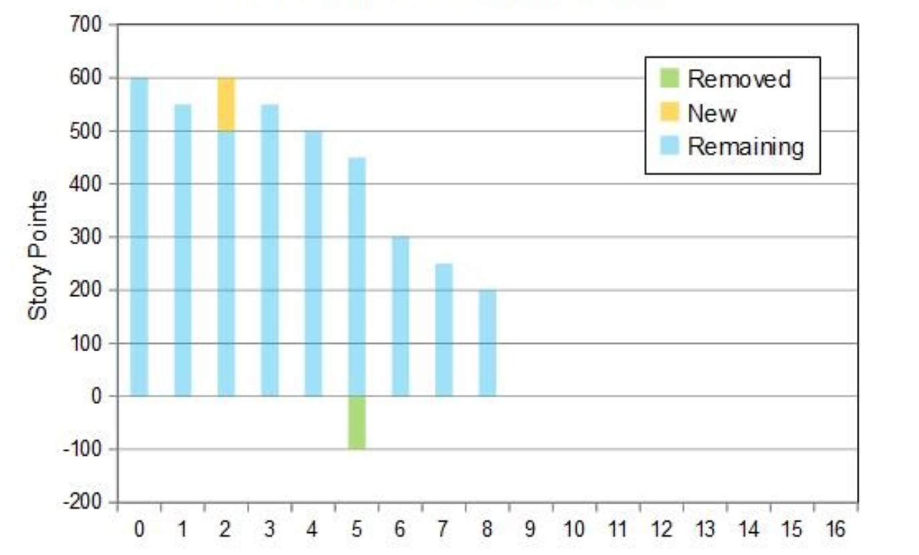
Sprint backlog:

User Story ID | User Story | Tasks | Owner | Status | Estimated efforts
US 001 | As a fraud analyst, I want to monitor transactions in real-time, so I can detect anomalies quickly. | Design a real-time monitoring dashboard to implement anomaly detection logic and integrate data streams for transactions. | Developer A | In-progress | 16
US 002 | As a compliance officer, I want a report of flagged transactions, so I can meet regulatory requirements. | Define reporting templates and implement Data export functionality. | Developer B | Not started | 12
US 003 | As a risk manager, I want AI-powered risk scoring, so I can prioritize potential threats. | Develop risk scoring model Train and test AI algorithms Integrate scoring into the dashboard | Data Scientist C | In progress | 20
US 004 | As a fraud analyst, I want to customize detection rules, so I can adapt to changing fraud patterns. | - Create rule edit or UI-Implement rule engine backend-Test rule application on sample data. | Developer (Amit Verma) | Not Started | 15
US 005 | As an IT admin, I want to configure access controls, so that only authorized users can access the system | - Design a role-based access control system Develop a user authentication mechanism.  - Test permission | Developer (Kunal Datta) | Not Started | 10

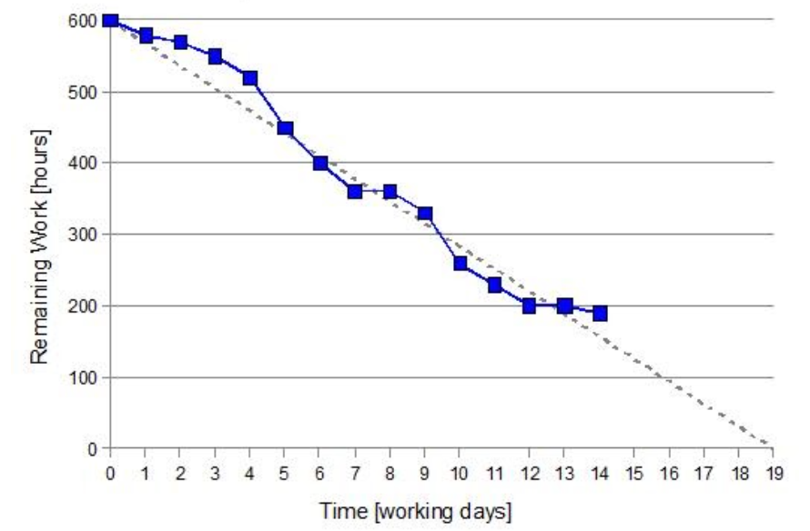
Document 6: Sprint meetings
Meeting TypeMeeting Type 1: Sprint Planning meeting
Date | 1-12-2024
Time | 10 am
Location | Pune
Prepared By | Komal Pardeshi
Attendees | Rami Lengadhare, Puja Sahay, Nikhil Sharama, Digvijay Khade

Agenda Topics
Topic | Presenter | Time allotted
Introduction to Fraud Management | Rami Lengadhare | 10
Types of Fraud | Sreelekha Ashok | 15
Fraud Detection Technique | Puja Sahay | 15
Case studies | Nikhil Sharma | 20
Fraud Prevention Strategies | Digvijay Khade | 25
Tools and Technologies in Fraud | Amruta Patil | 15
Q & A Session | Sujoy Datta | 20

Other Information:
Category | Details
Observers | Aarju Patel
 | Ketan Somane
 | Pratik Sawant
Resources | Presentation Slides
 | - Fraud Management Software (Azure)
 | - Internet Access
 | - Reference Documents (case studies)
Special Notes | - Ensure all participants have access to the necessary resources beforehand.
 | - Q & A session to be moderated by Pallavi Patil
 | - Observer to provide feedback at the end of the session.
 | - Backup of all materials to be stored on TRC for future use.

Meeting Type 2: Sprint review meeting
Date | 13-12-2024
Time | 12 pm
Location | Homi Bhabha meeting room
Prepared By | Komal Pardeshi

Sprint status | Things to demo | Quick updates | What’s next
Current Sprint: Sprint 3 | Fraud detection workflow (UI/UX) | - The fraud prevention module is in final testing phase | Begin integration testing with payment gateway systems
Overall Status: On Track/At Track/ Delayed | - Reports generated from fraud detection module | - Stakeholder review schedule for Date | - Conduct a workshop for end users on fraud alert dashboards
Key Completed Tasks:  - Finalized fraud detection requirements  - Integrated fraud detection algorithm  - Prepared user stories for fraud prevention workflows  Pending Tasks:  - Test validation for fraud alerts  - Stakeholder review of the case study module  Blockers:  - Delayed feedback from Nikhil Mane  - Dependency on third-party fraud detection API integration | - Sample fraud case study documentation | - QA team identified and fixed [3] of bugs | - Complete documentation for fraud detection guidelines.

Meeting Type 3: Sprint retrospective meeting
Date | 23-12-2024
Time | 10 am
Location | Rameswaram meeting room
Prepared By | Komal Pardeshi
Attendees | Rami Patil
 | Manoj Kumar
 | Jaykirthee Nayar
 | Poonam Wagh

Agenda | What Went Well | What Didn’t Go Well | Questions | References
- Welcome and Objectives of the Retrospective | - Fraud detection requirements were finalized ahead of schedule. | - Delays in third-party API responses affecting integration timelines. | - What steps can we take to avoid rework in the next sprint? | - Sprint Goal Document (3)
- Review of Sprint Goals | - Seamless collaboration between the development and QA teams | - Limited testing resources led to a backlog in test cases. | -How can we communicate between stakeholders and the team? | - Project Timeline and Deliverable Plan
- Discuss “What Went Well” | - Successful integration of fraud detection tools with the existing system. | - Miscommunication on fraud alert dashboard requirements causes rework. | - What additional resources or tools do we need to address current blockers? | - Issue/Bug Tracker Logs
- Discuss “What didn't Well” | Delay in third-party API responses affecting integration timelines | - Insufficient time allocated for stakeholder's training. | - Are there any process improvements to speed up API integration? | - Stakeholder Feedback from Sprint Demo
- Identify Improvement Areas | Finalized fraud detection requirements ahead of schedule. | Misalignment in understanding fraud alert dashboard requirements caused rework | What measures can be taken to prevent rework in requirements? | Stakeholder Feedback Notes from Sprint Demo
- Action Items and Next Steps | The team met 90% of the sprint goals on time, despite external challenges. | Limited test coverage for edge cases due to insufficient time and resources. | What strategies can be implemented to improve test coverage for edge cases? | Test Coverage Metrics Report
- Wrap-Up and Closing Remarks | Resolved critical issues in the fraud reporting module ahead of the deadline. | Limited focus on user training and onboarding processes. | How can we improve our testing strategy to cover all edge cases in the next sprint? | Test Reports Highlighting Gaps and Coverage

Meeting Type 4: Daily Stand-up meeting

Question | Name/Role
 |  | Monday | Tuesday | Wednesday | Thursday | Friday
What did  you do  yesterday? | - Amruta Madale  - Sumit Solankar  - Nikhil Sharma | - Designed the real-time monitoring dashboard.  - Started integrating transaction data streams. | - Finished integrating data streams.  - Developed initial anomaly detection algorithm. | -Tested anomaly detection logic.  - Made adjustments based on the test results.  - Refined dashboard layout. | - Implemented filters for flagged transactions.  - Completed export functionality for compliance reports. | - Completed rule editor UI draft.Finalized user authentication design.
What will  you do  today? | - Puja Patil  - Sarika Raghuvanshi  - Raj Pardeshi | - Complete data stream integration.  - Begin implementing anomaly detection logic. | - Test anomaly detection logic.  - Refine monitoring dashboard layout. | Implement filters for flagged transactions in compliance reports. | - Start working on rule editor UI.  - Draft user authentication mechanism design. | - Conduct peer reviews of implemented features.  - Resolve pending bugs.
What (if  any) is  blocking  your  progress? | - Sachin Raghuvanshi  - Sahil Kamble  - Aarju Patel | None | Delay in receiving test data from QA team. | Dependency on database configuration updates | - Pending confirmation rule editor specs. | None

