**Live Project Waterfall Assignment 2/2**

Q.6. Prepare a use case diagram, activity diagram and a use case specification document

**A. Use case diagram:**

|  |  |  |  |
| --- | --- | --- | --- |
| Use Case ID | UC001 | | |
| Use case Name | Enhanced banking software of customer onboarding. | | |
| Created By | Mrs ABC | Last Updated | February 10, 2024 |
| Date Created | January 10, 2024 | Last Revision Date | January 29, 2024 |
| Primary Actors | Bank Employees | | |
| Secondary Actors | 1. IT Employees 2. Bank Customers | | |
| Description | The use case describes how bank employees can use application for new customer onboarding. | | |
| Pre-Condition | Customers should have adequate documents. | | |
| Post-Condition | Customer can get customer ID and Account number. | | |
| Basic Flow | Step 1: Customer visits branch or uploads through mobile.  Step 2: Customer provides documents  Step 3: Customer is able to see different pages.  Step 4: Employee checks documents.  Step 5: Employee enters details in system and matches it with guidelines.  Step 6: Account Number and Customer ID is generated. | | |
| Alternate Flow | Step 1: If Customer has wrong documents.  Step 2: Employee rejects form.  Step 3: If mobile application customer face connectivity issue, then there should be an alert system. | | |
| Exception | 1. If there is connectivity loss in branch, there should be adequate backup.  2. If password is forgotten by employee, it can be generated through his supervisors ID. | | |
| Frequency | High | | |
| Assumption | 1. Customer is already having right set of documents. 2. Customers are having access to all features of the web, mobile and branch coverage. 3. Bank staff and customers are adequately trained in using the new system. | | |
| Constraints | 1. Employees should be prepared for the change and training them can be a constraint. 2. System integration with old system taking into consideration core banking. 3. Consistent experience across all channels (branch, mobile, web). | | |
| Misc. Info | User friendly website. | | |

**Use Case Diagram: Customer Onboarding**

|  |  |  |  |
| --- | --- | --- | --- |
| Use Case ID | UC002 | | |
| Use case Name | Enhanced banking software to include Locker Management. | | |
| Created By | Mrs ABC | Last Updated | February 10, 2024 |
| Date Created | January 10, 2024 | Last Revision Date | January 29, 2024 |
| Primary Actors | Bank Employees | | |
| Secondary Actors | Bank Customers | | |
| Description | The use case describes how bank employees can use application for new and existing locker customers. | | |
| Pre-Condition | Customers should have a locker or have applied for new locker | | |
| Post-Condition | Employees can maintain the locker details in branch itself. | | |
| Basic Flow | Step 1: Customer visits branch  Step 2: Customer provides locker number and signature to employee.  Step 3: Employee enters details in software when customer comes for locker access.  Step 4: Employee checks signature in the software.  Step 5: Locker Number is generated. | | |
| Alternate Flow | Step 1: If Customer details not fetched, employee can make necessary changes.  Step 2: Employee does not allow customer if signature does not match. | | |
| Exception | 1. If there is connectivity loss in branch, there should be adequate backup. | | |
| Frequency | High | | |
| Assumption | 1. Customer is already having right set of documents. 2. Bank staff and customers are adequately trained in using the new system. | | |
| Constraints | 1. Employees should be prepared for the change and training them can be a constraint. 2. System integration with old system taking into consideration core banking. | | |
| Misc. Info | User friendly website. | | |

**B. Activity Diagram:**

**Onboarding System:**

**Locker Management:**

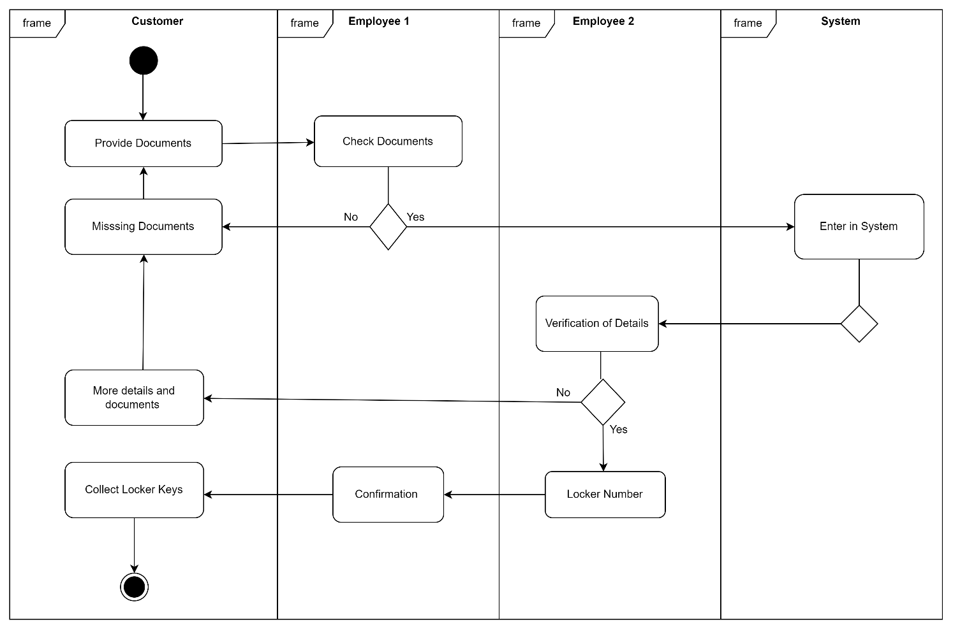

**Q.7. Screens and pages:**

**Login Page of Application:**

**Screen after Login:**

**Onboarding Window:**

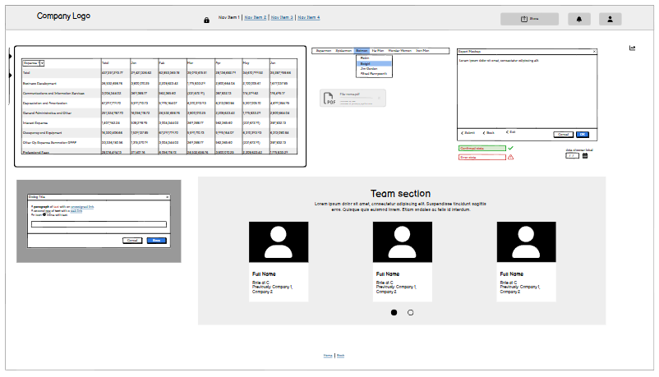

**Locker Management System:**

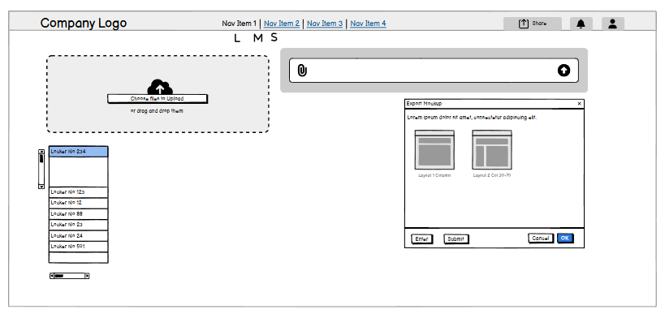

**Verification Screen:**

**Q.8. Tools-Visio and Axure:**

For the project I needed to use MS Visio for creating use cases diagrams and activity diagrams. The tool was easy to use with detailed diagrams. It allowed me to visualize the real work that can be done. Though I did not find the include relation, so I used the text to give name to show the relationship. MS Visio is useful tool even when we are using it for the first time.

Axure was used by me for prototyping, which was also easy to use and understand. I could use most of it without any difficulty.

I also used Draw-io for creating Use case diagrams and Activity diagrams. The application is easy to use and the drag and drop option worked great win the application. I could easily visualise the diagram and diagram with the help of Draw-io.

Apart from this I used Balsamiq tool for wireframe diagrams which helped me to imagine and create webpages. The tool has many logos, icons and frameworks and model to be used which gave a very realistic look to the web pages.

**Q.9. My Experience as Business Analyst:**

This project was initiated with the aim of enhancing the current software of Fincare. The branches can use it for onboarding new customers in system directly as against initially where they sent it to processing centre which was a time consuming and also prone to many errors. The management thus decided to enhance the software and make changes like including:

* Direct onboarding by branch employees.
* Integration of financial transactions.
* Locker management functionality.
* Implementation of the **4-eye principle** for verification, ensuring higher accuracy and security.

My experience in stages of waterfall project of Fincare are given below:

**Requirement Stage:**

* In requirement stage I collected the information using the Interview technique whereby I interviewed the employees who would be using the application.
* Also, I interviewed the sponsor or the top management for their experience. Also, I used the observation technique for understanding the working of the system.
* I used the MoSCoW prioritization method to categorize requirements into Must-Have, Should-Have, Could-Have, and Won't-Have categories, ensuring a clear understanding of priorities.
* At times the employee was unavailable, I identified alternative points of contact from their team to source critical information promptly, preventing delays in the project timeline.
* Applied the **FURPS framework** (Functionality, Usability, Reliability, Performance, and Supportability) to validate requirements, ensuring they met quality standards.
* Worked on the requirements collected. Sorted the information and arranged to find if there were any duplicates or unwanted information.

**Requirement Analysis:**

* I created UML diagrams such as use case diagrams and class diagrams to visually represent the requirements, ensuring clear understanding across the team.
* The activity diagrams will give a fair idea to developers to work on.
* I then communicated these diagrams to team members.
* I documented the points of disagreement and suggestions from the team members and made the necessary modifications.
* I also prepared the Business Requirement Specification document noting all the details of the project including the team details and the related RASCI chart.
* The System Requirement Specification document is also prepared showing the technical and functional requirements.

**Design Stage:**

* I prepared the test cases ensuring covering the requirements.
* Conducted a meeting with bank employees for discussing the design and other planned functional aspects of the project.
* To check how the system will work in failures I will also work on negative test cases thus mitigating the future risk. For e.g. when there is network issue in the branch the system should automatically save the latest entries and should logout immediately.
* Continuously updating the Requirement Traceability Matrix (RTM) and checking if all the requirements are properly incorporated.

**Development Stage:**

* I arranged the Joint Application Development (JAD) session to get all the stakeholders, sponsors and developers together and explain the progress of the project.
* During the development stage I was the SPOC (Single Point of Contact) for the stakeholders i.e. the solving the queries raised by the bank team and between the developer team.
* This was the stage which required we ensure that the project was progressing along the lines of the UML diagrams.
* In this stage I needed to continuously carry out meeting between all the teams and the stakeholders to ensure that the project is successful.

**Testing Stage:**

* At this stage I needed to prepare test cases according to the UML diagrams.
* We carried out high level testing ensuring that all the things that were decided and discussed in meeting and BRS documentation.
* At this stage I updated the RTM and checked if the progress is as per the plan.
* Informed the client to carry out User Acceptance Test (UAT) after I explained them all the necessary things the application is capable of doing.
* In this stage I also prepared the documentation for client signoff after once again checking if all the requirements have been met.

**Deployment Stage:**

* In this stage I made sure that I share the RTM with the client which clearly shows that all the planned project items were accounted for and are completed.
* I coordinated in the preparation of user manual and explanatory notes and ensured that they are distributed to the project in-charge of the bank.
* This being the last stage and with the completion of the project I coordinated with the bank team and fixed a schedule for conducting a training session to explain the add- ons in the new application and solve their doubts.
* I ensured that the core people should get a proper clarification of the working of the application. I needed to conduct the session in 3 batches considering the availability of the people.

**************************