**Requesting For Tools Installation**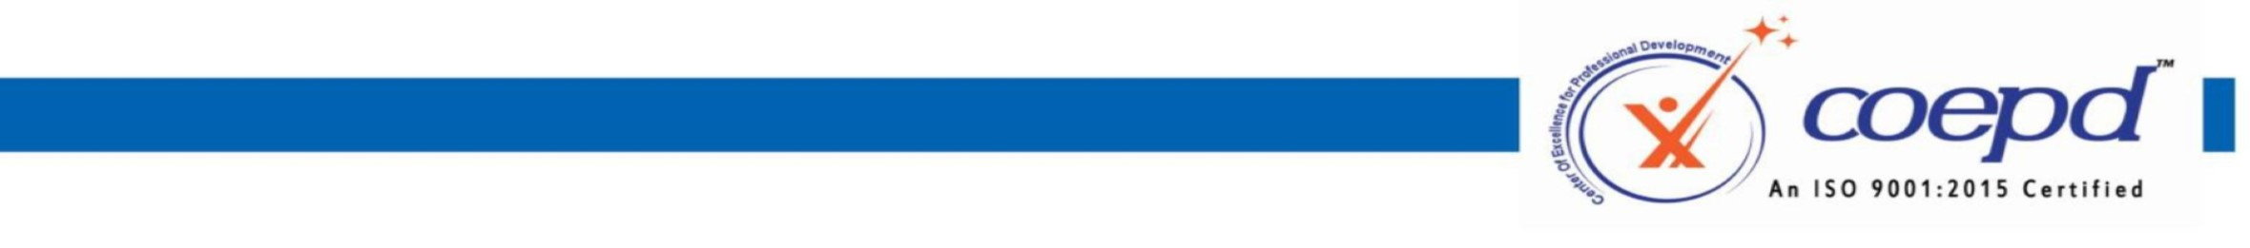

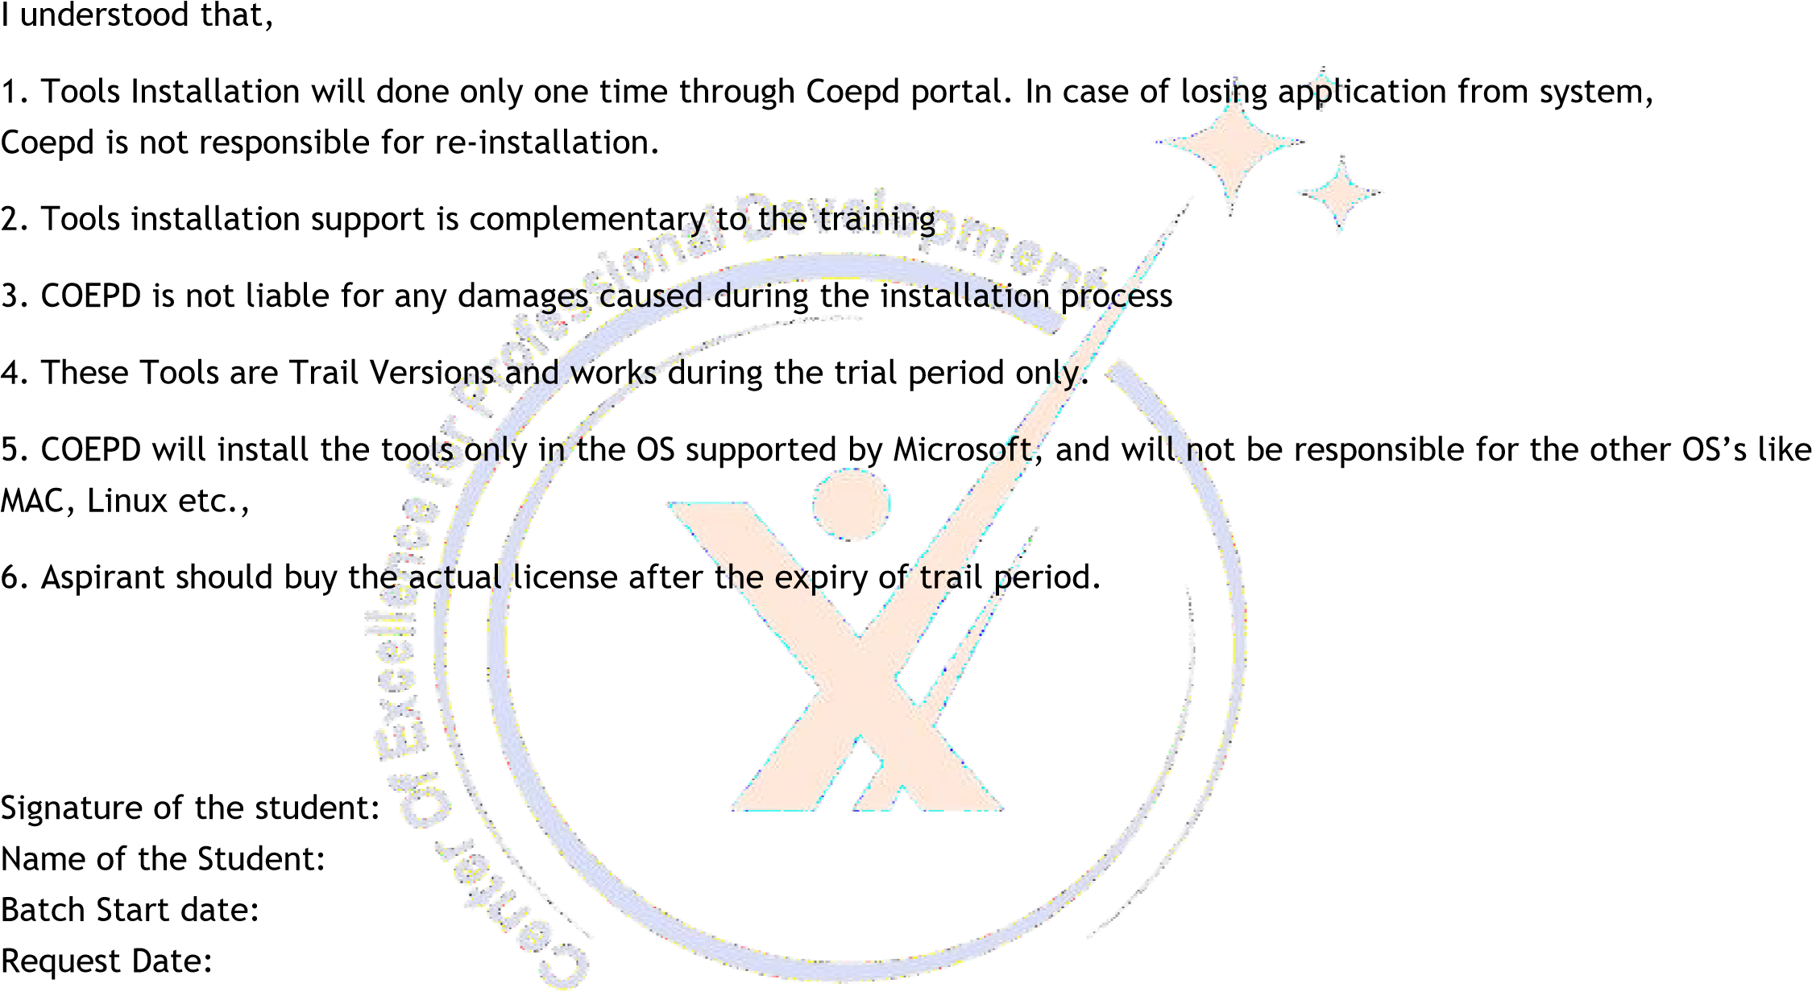I _______________Ritika Pandey_______, enrolled for Business Analyst Training with COEPD, hereby voluntarily declare that, I completed BA Workshop sessions. I request COEPD to support me in installing the tools in my system.

3rd Floor, Sahiti Arcade, Beside S.R. Nagar Police Station, S.R. Nagar, Hyderabad - 500038

www.coepd.cominfo@coepd.com