**Project Name: CTS Support**

**Document 1: Definition of done**

The definition of done is an agile concept that establishes a shared vision between the development team and the customer or product owner. The definition of done in agile is an agreement across product teams on the set of requirements that must be met in order to deem backlog items genuinely done. Product teams utilize a definition of done to ensure that the activities they conduct for each backlog item are consistent. The Definition of Done is typically created when a new team is formed during the initial stages of a project. It evolves over time as every member of the team gains experience with the project for future references.

* It provides clear information to all team members in the project about what is "done".
* The definition of done maintains quality standards and meets the requirements of the client by reducing defects and incomplete work.
* It establishes a common understanding among the team members who are working on the project about the completion criteria.
* It provides customer satisfaction by completing the work on time.

The product manager can create a checklist in collaboration with the architects, stakeholders, marketing team, design team, testing team, etc. However, the product manager is responsible for ensuring that all the items in the Definition of Done are executed, and the product manager has the responsibility for shipping the work to end users.

**Checklist for DOD:**

* Produced code for presumed functionalities
* Assumptions of User Story met
* Project builds without errors
* Unit tests written and passing
* Project deployed on the test environment identical to production platform
* Tests on devices/browsers listed in the project assumptions passed
* Feature ok-ed by UX designer
* QA performed & issues resolved
* Feature is tested against acceptance criteria
* Feature ok-ed by Product Owner
* Refactoring completed
* Any configuration or build changes documented
* Documentation updated
* Peer Code Review performed

**Document 2: Product Vision**

|  |  |
| --- | --- |
| **Scrum Project Name** | CTS Support |
| **Venue** | Pune |
| **Date** | 11.01.2025 |
| **Start Time** | 9:00 a.m. |
| **End Time** | 12:00 p.m. |
| **Duration** | 3 Hours |
| **Client** | IDFC First Bank |
| **Stakeholder List** | Ms. Priyanka – Project Head  Mr. Rajesh – SME  Ms. Harshita & Ms. Devika – End User |
| **Scrum Team** | |
| **Scrum Master** | Mr. Hanumant |
| **Product Owner** | Mr. Rohit |
| **Scrum Developer 1** | Mr. Gajanan |
| **Scrum Developer 2** | Mr. Kishor |
| **Scrum Developer 3** | Mr. Yogesh |
| **Scrum Developer 4** | Ms Madhuri |
| **Scrum Developer 5** | Ms Anshika |
| **Scrum Developer 6** | Ms Chandani |
| **Scrum Developer 7** | Ms Sneha |
| **Scrum Developer 8** | Mr Amit |

|  |  |
| --- | --- |
| **Vision** | To create an application for CTS clearing cheque reporting and eradicate the existing process of reporting being done basis email |
| **Target Group** | CTS Clearing Team and IDFC First Bank Branch Staff |
| **Needs** | Tedious task of email tracking by CTS Clearing Team eradicated  Daily Collation of cheque collection data  Easy reconciliation of daily cheque collection data  Consolidated data available across the clearing Grids |
| **Product** | CTS Support application was identified as a solution which would require all branches to update client account number, cheque number and cheque amount CTS Support application. Post which cheque lodgment data would be created in an excel format. This data from each individual branches can be accessed by Central clearing processing team. This product facilitates easy reconciliation and storage of cheque collection data. After doing a feasibility study it is confirmed that such application can developed in the banks system |
| **Value** | The business goal of the bank pertaining to CTS clearing is smooth processing collection of cheques.  The business model is that cheque collection at branched to be reported flawlessly and the same to be processed be vendor and CTS clearing team within RBI stipulated timelines  The benefit of the application will help bank in faster processing of CTS clearing cheques leading to increase in cheque collection value and assist to build the banks profitability. |

**Document 3: User Stories**

**SPRINT - 1**

|  |  |  |
| --- | --- | --- |
| **User Story No 1** | Task 1 | Priority - Highest |
| AS A BRANCH USER  I WANT TO LOGIN INTO CTS SUPORT APPLICATION  SO THAT I CAN UPDATE CHEQUE COLLECTION DATA | | |
| **Business Value : 500** | | **CP : 5** |
| **Acceptance Criteria**  Login with Employee Id and Domain Password  Click on submit button  Successful Login Screen Page Pop Up | | |

|  |  |  |
| --- | --- | --- |
| **User Story No 2** | Task 1 | Priority - Highest |
| AS A BRANCH USER  I WANT TO SELECT BRANCH CODE AND CHEQUE CATEGORY  SO THAT I CAN UPDATE BRANCH CODE AND CHEQUE CATEGORY | | |
| **Business Value : 500** | | **CP : 5** |
| **Acceptance Criteria**  Select Branch Code  Select Cheque Category  Click on submit button  Brand Code and Cheque category updated successfully  Branch MICR Code updated successfully  Business Rules : Branch Code is 5 digits Only  Cheque category has drop down option | | |

|  |  |  |
| --- | --- | --- |
| **User Story No 3** | Task 1 | Priority - Highest |
| AS A BRANCH USER  I WANT TO UPDATE ACCOUNT NUMBER, CHEQUE NUMBER AND AMOUNT  SO THAT I CAN UPDATE CHEQUE COLLECTION AT BRANCH | | |
| **Business Value : 500** | | **CP : 5** |
| **Acceptance Criteria**  Fill Account Number Details  Fill Cheque Number Details  Fill Cheque Amount Details  Click on submit button  Cheque Data Updated successfully  Business Rules : Account Number is 11 digits Only  Cheque number is 6 digits Only | | |

|  |  |  |
| --- | --- | --- |
| **User Story No 4** | Task 1 | Priority - Highest |
| AS A BRANCH USER  I WANT NEED TO VIEW CHEQUE SUMMARY AND CHEQUE DETAILS REPORT  SO THAT I CAN PRINT CHEQUE SUMMARY AND CHEQUE DETAILS REPORT | | |
| **Business Value : 500** | | **CP : 5** |
| **Acceptance Criteria**  Select Report  Print Report  Business Rules : Cheque summary report is in pdf format only  Cheque details report is in excel format only | | |

|  |  |  |
| --- | --- | --- |
| **User Story No 5** | Task 1 | Priority - Highest |
| AS A BRANCH USER  I WANT NEED TO UPDATE NIL CHEQUE REPORTING  SO THAT I CAN REPORT NIL CHEQUES COLLECTION | | |
| **Business Value : 100** | | **CP : 2** |
| **Acceptance Criteria**  Select NIL cheque collection  Click on submit button | | |

|  |  |  |
| --- | --- | --- |
| **User Story No 6** | Task 1 | Priority - Highest |
| AS A BRANCH USER  I WANT NEED TO UPLOAD CHEQUE COLLECTION FILE  SO THAT I CAN UPDATE CHEQUE COLLECTION AT BRANCH | | |
| **Business Value : 100** | | **CP : 2** |
| **Acceptance Criteria**  Select Branch Code  Select Cheque Category  Select Cheque Upload Button  Click On Submit Button  Business Rules : Minimum Number for cheques for Cheque Upload option should be  100  Uploaded Excel file should be in standard format | | |

|  |  |  |
| --- | --- | --- |
| **User Story No 7** | Task 1 | Priority - Highest |
| AS A CLEARING TEAM MEMBER  I WANT NEED TO VIEW CHEQUE SUMMARY AND CHEQUE DETAILS REPORT FOR A PARTICULAR BRANCH  SO THAT I CAN RECONCILE CHEQUE COLLECTION DATA | | |
| **Business Value : 200** | | **CP : 3** |
| **Acceptance Criteria**  Select Branch Code  Select Report  Generate and View Report  Business Rules : Cheque details report is in excel format only | | |

|  |  |  |
| --- | --- | --- |
| **User Story No 8** | Task 1 | Priority - Highest |
| AS A CLEARING TEAM MEMBER  I WANT NEED TO VIEW ENTIRE CHEQUE COLLECITON REPORT FOR WEST GRID  SO THAT I CAN RECONCILE CHEQUE COLLECTION DATA FOR WEST GRID | | |
| **Business Value : 200** | | **CP : 3** |
| **Acceptance Criteria**  Select Grid Type  Select Report  Generate and View Report  Business Rules : Cheque details report is in excel format only | | |

|  |  |  |
| --- | --- | --- |
| **User Story No 9** | Task 1 | Priority - Highest |
| AS A CLEARING TEAM MEMBER  I WANT NEED TO VIEW ENTIRE CHEQUE COLLECITON REPORT FOR WEST GRID  SO THAT I CAN RECONCILE CHEQUE COLLECTION DATA FOR WEST GRID | | |
| **Business Value : 200** | | **CP : 3** |
| **Acceptance Criteria**  Select Grid Type  Select Report  Generate and View Report  Business Rules : heque details report is in excel format only | | |

|  |  |  |
| --- | --- | --- |
| **User Story No 10** | Task 1 | Priority - Highest |
| AS A CLEARING TEAM MEMBER  I WANT NEED TO VIEW CHEQUE COLLECTION REPORT FOR A PARTICULAR DATE  SO THAT I CAN RESOLVE QUERIES | | |
| **Business Value : 200** | | **CP : 3** |
| **Acceptance Criteria**  Select Branch Code  Select From and To Date  Select Report  Generate and View Report  Business Rules : Cheque details report is in excel format only | | |

|  |  |  |
| --- | --- | --- |
| **User Story No 11** | Task 1 | Priority - Highest |
| AS AN ADMIN  I WANT NEED TO INTIATE AUTOMATED CHEQUE DEPOSTION REMINDER EMAIL  SO THAT EACH BRANCH RECEIVES REMINDER MAIL WHO HAVE NOT UPDATE CHEQUE DEPOSITION | | |
| **Business Value : 500** | | **CP : 5** |
| **Acceptance Criteria**  Application to initiated automate mail to branches pending for cheque collection reporting  Business Rules: Clearing Cut Off 15:00 Hrs.  Number of Reminder Mails - 3  GAP between Reminder Mails – 1 Hour | | |

|  |  |  |
| --- | --- | --- |
| **User Story No 12** | Task 1 | Priority - Highest |
| AS AN ADMIN  I WANT NEED TO INTIATE AUTOMATED CHEQUE DEPOSTION EMAIL FOR RESPECTIVE BRANCE  SO THAT EACH BRANCH RECEIVES CHEUQE DEPOSTION MAIL FOR ITS RESPECTIVE BRANCH | | |
| **Business Value : 200** | | **CP : 3** |
| **Acceptance Criteria**  Application to initiated automate mail to branches for cheque collection reporting  Business Rules: Clearing Lodgment Activity is confirmed as completed. | | |

|  |  |  |
| --- | --- | --- |
| **User Story No 13** | Task 1 | Priority - Highest |
| AS AN ADMIN  I WANT NEED TO VIEW CHEQUE LODGEMENT REPORT LOCATION WISE  SO THAT LOCATION WISE CHEQUE DATA IS AVAILABLE FOR REPORTING | | |
| **Business Value : 200** | | **CP : 3** |
| **Acceptance Criteria**  Select Location Name  Select Generate and View Report  Business Rules : Cheque details report is in excel format only | | |

|  |  |  |
| --- | --- | --- |
| **User Story No 14** | Task 1 | Priority - Highest |
| AS AN ADMIN  I WANT NEED TO VIEW CHEQUE LODGEMENT REPORT GRID WISE  SO THAT GIRD WISE CHEQUE DATA IS AVAILABLE FOR REPORTING | | |
| **Business Value : 200** | | **CP : 3** |
| **Acceptance Criteria**  Select Grid Name  Select Generate and View Report  Business Rules : Report is in excel format only | | |

|  |  |  |
| --- | --- | --- |
| **User Story No 15** | Task 1 | Priority - Highest |
| AS AN ADMIN  I WANT NEED TO VIEW NUMBER OF BRANCHES GRID WISE  SO THAT I HAVE BRANCHES DATA GRID WISE | | |
| **Business Value : 200** | | **CP : 3** |
| **Acceptance Criteria**  Select Grid Name  Select View Branches  Select Generate and View Report  Business Rules : Report is in excel format only | | |

**Document 4: Agile Product Owner Experience**

The Product Owner has a vision of the product keeping the domain/industry experience and the market need.

Following are the responsibilities of PO in a project

* Market Analysis, Analysis of market need/demand Availability of similar products in the market
* Enterprise Analysis , Due diligence on the market opportunity
* Product Vision and Roadmap, Product vision keeping the need analysis in mind, Product roadmap with high-level features and timeline
* Managing Product Features, Managing stakeholder expectations and prioritizing needs ▫Prioritization of the epics, stories, and features based on criticality and ROI involved
* Managing Product Backlog, Prioritization of user stories, Reprioritization based on stakeholders' needs, Epics planning
* Managing Overall Iteration Progress, Sprint progress review, Reprioritization of sprints and epics if needed, Sprint retrospectives with Business Analyst

From this project, I have learned how to handle sprint meetings such as

* Sprint planning meeting
* Daily scrum meeting
* Sprint review meeting
* Sprint retrospective meeting
* Backlog refinement meeting

User stories creation and what things will be included in user stories such as

* Story Number
* Tasks
* Priority
* Acceptance criteria
* BV & CP value

In Scrum, a product owner serves as the liaison between multiple areas of an organization. This person communicates with business stakeholders and collaborates closely with Scrum teams to keep all areas of the business informed on a project's development.

The product owner develops a vision of a product's function and operation, which in turn allows this Scrum team member to define product features and break those features into product backlog items.

**Document 5: Product and Sprint Backlog, Product and Sprint Burn down Charts**

* **Product Backlog** is the stage when a user stories have an acceptance criteria, business value and complexity points. The product backlog is a high-level repository of all the user stories, features, enhancement and fixes that could be a part of the product. Characteristics of product back log are as below :

**Long-term perspective:** The product backlog represents in terms of long-term perspective representing all potential work for the entire project lifecycle.

**Prioritization:** Items in the product backlog are prioritized based on their business value, complexity points, market demand using techniques like **MoSCoW** and **MVP – Minimal Viable Product.**

**Constant evolution:** Product backlog continuously changes as new requirements emerge.

|  |  |  |  |  |  |  |
| --- | --- | --- | --- | --- | --- | --- |
| User Story ID | User Story | Tasks | Priority | BV | CP | Sprint |
|  |  |  |  |  |  |  |
|  |  |  |  |  |  |  |

* **Sprint Backlog** is a sub set of product backlog. It consist of a sprint, which ideally lasts for 2 to 4 weeks.

Sprint backlog has four phases

* Product backlog
* Tasks – Unit of work done in 1 scrum day
* Work In progress
* Done

|  |  |  |  |
| --- | --- | --- | --- |
| Product Backlog Item | Tasks | Work In Progress | Done |
|  |  |  |  |

Characteristics of product backlog are as below

* **Short Term focus** - The Sprint Backlog is concerned with the work to be completed during a single sprint (2 to 4 weeks). It is a snapshot of the Product Backlog items selected for the current sprint.
* **Fixed Focus** - Once the sprint begins, the contents of the Sprint Backlog are generally fixed, and new items are not added unless necessary. Changes to the sprint scope are minimized to maintain focus and predictability.

**Concrete Tasks:** The items in the Sprint Backlog are broken down into more detailed tasks that can be completed within the sprint. These tasks are often technical and specific, outlining the work required to deliver the associated Product Backlog items.

|  |  |  |  |  |
| --- | --- | --- | --- | --- |
| User Story ID | User Story | Owner | Status | Estimated Effort |
|  |  |  |  |  |
|  |  |  |  |  |

* **Sprint Burn Up Report –** This report shows the amount of work completed in a sprint

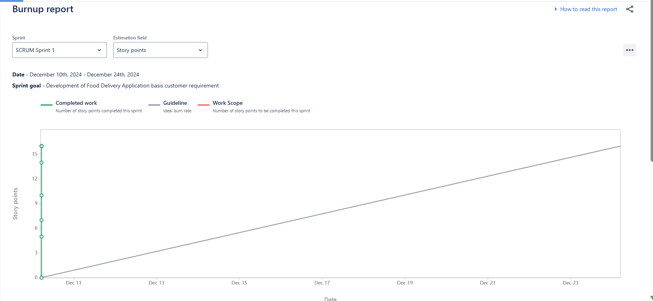

* **Sprint Burn Down Report -** This report shows the amount of work remaining in a sprint

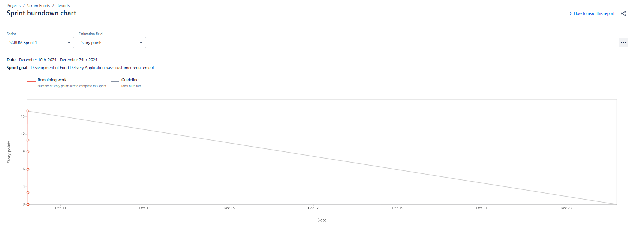

* **Product Burn Down Chart** - A burn down chart shows the amount of work that has been completed in an epic or sprint, and the total work remaining.



**Document 6: Sprint Meetings**

**Meeting Type 1 - Sprint Planning Meeting**

* **Sprint Planning Meeting –** In this meeting, the product owner explains the product vision. The team members decide the amount of work that can be completed in a sprint. During this meeting user stories are shortlisted to be moved from product backlog to sprint backlog

|  |  |
| --- | --- |
| **Date** |  |
| **Time** |  |
| **Location** |  |
| **Prepared By** |  |
| **Attendees** |  |

**Agenda Topics**

|  |  |  |
| --- | --- | --- |
| **Topic** | **Presenter** | **Time Allotted** |
|  |  |  |
|  |  |  |

**Other Information**

|  |  |
| --- | --- |
| **Observers** |  |
| **Resources** |  |
| **Special Notes** |  |

**Meeting Type 2 – Sprint Review Meeting**

* **Sprint Review Meeting –** It is attended by the client, 3rd party stakeholders, scrum team, SME. Here they discuss how many user stories were taken, completed and pending, what are the challenges. In this meeting, we draw sprint burn down charts and product burn down charts.

|  |  |
| --- | --- |
| **Date** |  |
| **Time** |  |
| **Location** |  |
| **Prepared By** |  |
| **Attendees** |  |

|  |  |  |  |
| --- | --- | --- | --- |
| **Sprint Status** | **Things to Demo** | **Quick Updates** | **What’s Next** |
|  |  |  |  |

**Meeting Type 3 – Sprint Retrospective Meeting**

* **Sprint Retrospective Meeting –** This meeting is attended by the developers only, the agenda of this meeting is lessons learnt, accordingly improvisations are implemented in the next sprint planning meeting. The topics covered here are what went well, what didn’t meet the expectation and what needs to be improvised.

|  |  |
| --- | --- |
| **Date** |  |
| **Time** |  |
| **Location** |  |
| **Prepared By** |  |
| **Attendees** |  |

|  |  |  |  |  |
| --- | --- | --- | --- | --- |
| **Agenda** | **What Went Well** | **What Didn’t Go Well** | **Questions** | **Reference** |
|  |  |  |  |  |

**Meeting Type 4 – Daily Stand Up Meeting**

* **Scrum Meeting –** This is a short meeting to discuss on issues, challenges faced, progress, updates on their tasks. Also known as **Daily Stand Up Meeting –** It is conducted at the end of day during a sprint to answer following questions – What did you do today, what will you work on tomorrow and any challenges faced or when will you complete the user story.

**Week X – Date from DDMMYYYY to DDMMYYYY**

|  |  |  |  |  |  |  |  |
| --- | --- | --- | --- | --- | --- | --- | --- |
| **Question** | **Name / Role** | **Mon** | **Tue** | **Wed** | **Thurs** | **Fri** | **Sat** |
| **What Did You Do Yesterday** | Developer 1  Developer 2  Developer 3 |  |  |  |  |  |  |
| **What Will You Do Today** | Developer 1  Developer 2  Developer 3 |  |  |  |  |  |  |
| **What will you do Tomorrow, What is Blocking Your Progress, If Any** | Developer 1  Developer 2  Developer 3 |  |  |  |  |  |  |