**Document 6- Please prepare a use case diagram, activity diagram and a use**

**case specification document.**

**Use case diagram :**

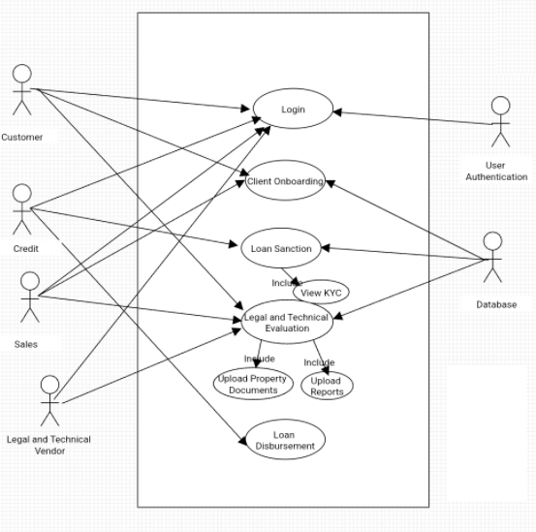

**Activity diagram :**

1. **Login**

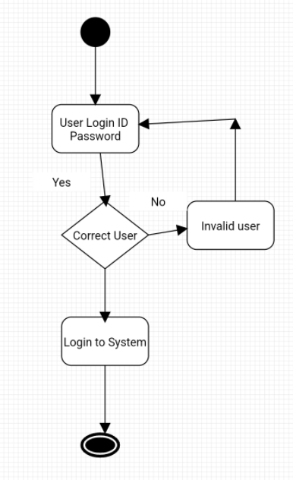

1. **Sanction**

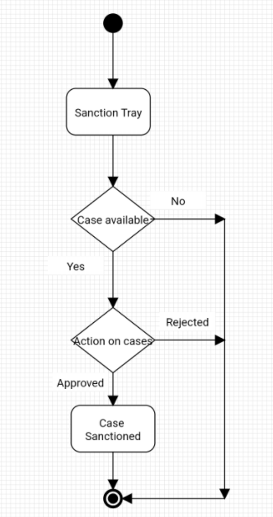

1. **Legal and Technical Evaluation:**

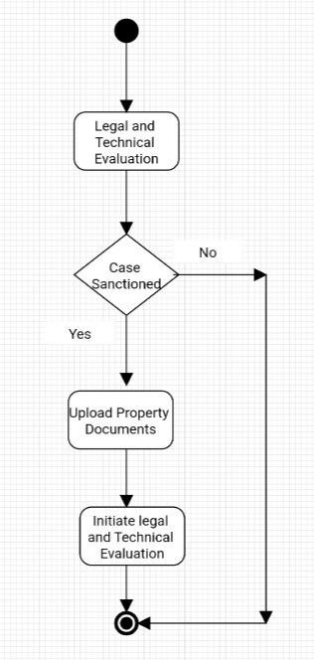

1. **Document Signin**

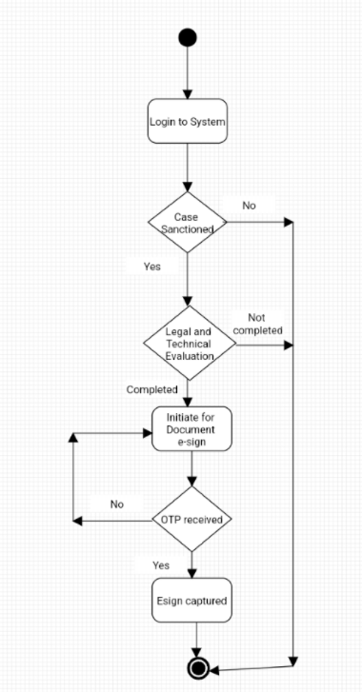

1. **Customer Onboarding**

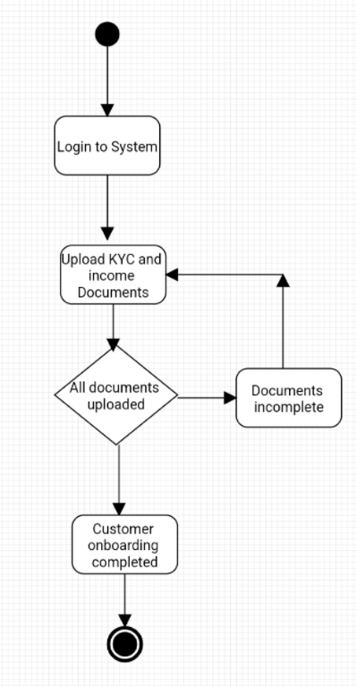

**A use case specification document**

A use case specification document is a detailed description of a use case that helps to understand how a system works and what tasks can be completed in each use case.

**Use case 1:**

|  |  |
| --- | --- |
| **Use Case Name** | Log in |
| **Use Case Description** | Login into the system |
| **Actors Primary Actors Secondary Actors** | Customer and Admin |
| **Basic Flow** | Step 1: Customer visit i-lens Web page Step 2: Customer Enters the login ID and password Step 3: Customer Clicks on login button to login into the application |
| **Alternate Flow** | In Step 3, If customer not having login credentials or entered wrong login ID and password  System should response with error message as " User doesn't exists or wrong login ID and password ". |
| **Pre- Conditions** | User should have login credentials |
| **Post-Conditions** | Customer should able to login into the application |
| **Assumptions** | Customer is well known to use computer |
| **Constraints** | NA |
| **Dependencies** | Internet connections |
| **Inputs And Outputs** | Input : Login ID and Password  Output : Login into the application |
| **Business Rules** | NA |
| **Miscellaneous Information** | NA |

**Use case 2:**

|  |  |
| --- | --- |
| **Use Case Name** | Loan Sanction |
| **Use Case Description** | Credit team need to login in the system and view the loan application for processing loan sanction |
| **Actors Primary Actors Secondary Actors** | Credit and Admin |
| **Basic Flow** | Step 1: Credit visit i-lens Web page Step 2: Credit Enters the login ID and password Step 3: Credit Clicks on login button to login into the application Step 4: Credit team will view the pending loan application for Sanction Step 5: Credit team will select the application and click and Approved to Loan |
| **Alternate Flow** | In Step 3, If credit not having login credentials or entered wrong login ID and password  System should response with error message as " User doesn't exists or wrong login ID and password ".  In Step 4, If the credit team click on approve without selecting loan application.  System should response with error message as " Loan application not selected". |
| **Pre- Conditions** | Credit team should have login credentials. Credit team should have their access role in the system. |
| **Post-Conditions** | Credit team should able to view and verify the loan for sanction |
| **Assumptions** | Credit team know about the system |
| **Constraints** | System should get auto logout if system is not in use for 10mins |
| **Dependencies** | Internet connections |
| **Inputs And Outputs** | Input : Loan Application Output : Loan Sanction |
| **Business Rules** | NA |
| **Miscellaneous Information** | NA |

**Use Case 3:**

|  |  |
| --- | --- |
| **Use Case Name** | Loan Disbursement |
| **Use Case Description** | Credit team need to login in the system and view the loan application for processing loan Disbursement |
| **Actors Primary Actors Secondary Actors** | Credit and Admin |
| **Basic Flow** | Step 1: Credit visit i-lens Web page Step 2: Credit Enters the login ID and password Step 3: Credit Clicks on login button to login into the application Step 4: Credit team will view the loan application for disbursement Step 5: Credit team will select the application and click and disburse the Loan |
| **Alternate Flow** | In Step 3, If credit not having login credentials or entered wrong login ID and password  System should response with error message as " User doesn't exists or wrong login ID and password ".  In Step 4, If the credit team click on approve without selecting loan application.  System should response with error message as " Loan application not selected". |
| **Pre- Conditions** | Credit team should have login credentials. Credit team should have their access role in the system. Loan should be sanctioned and legal and technical verification should be completed |
| **Post-Conditions** | Credit team should able to view and verify the loan for Disbursement |
| **Assumptions** | Credit team know about the system |
| **Constraints** | System should get auto logout if system is not in use for 10mins |
| **Dependencies** | Internet connections |
| **Inputs And Outputs** | Input : Loan Application Output : Loan Disbursed |
| **Business Rules** | NA |
| **Miscellaneous Information** | NA |

**Use Case 4:**

|  |  |
| --- | --- |
| **Use Case Name** | Client Onboarding |
| **Use Case Description** | Customer or sales Team need to login into the system to upload all the KYC and income documents to complete onboarding. |
| **Actors Primary Actors Secondary Actors** | Customer, Sales and Admin |
| **Basic Flow** | Step 1: Customer/Sales visit i-lens Web page Step 2: Customer/Sales Enters the login ID and password Step 3: Customer/Sales Clicks on login button to login into the application Step 4: Customer/Sales team will view the loan application and Upload all the KYC and income documents Step 5: Customer/Sales Click on submit the onbarding. |
| **Alternate Flow** | In Step 4, If Customer/Sales not upload all the KYC and Income documents   System should response with error message as " All Documents not uploaded in system ". |
| **Pre- Conditions** | Customer/Sales should have login credentials. |
| **Post-Conditions** | Customer/Sales should upload documents successfully. |
| **Assumptions** | Customer/Sales team know about the system |
| **Constraints** | Documents should be uploaded within 10MB size |
| **Dependencies** | Internet connections |
| **Inputs And Outputs** | Input : Upload Documents Output : Loan Onboarding |
| **Business Rules** | NA |
| **Miscellaneous Information** | NA |

**Use Case 5:**

|  |  |
| --- | --- |
| **Use Case Name** | Client Onboarding |
| **Use Case Description** | Customer or sales Team need to login into the system to upload all the KYC and income documents to complete Onboarding. |
| **Actors Primary Actors Secondary Actors** | Customer, Sales and Admin |
| **Basic Flow** | Step 1: Customer/Sales visit i-lens Web page Step 2: Customer/Sales Enters the login ID and password Step 3: Customer/Sales Clicks on login button to login into the application Step 4: Customer/Sales team will view the loan application and Upload all the KYC and income documents Step 5: Customer/Sales Click on submit the onbarding. |
| **Alternate Flow** | In Step 4, If Customer/Sales not upload all the KYC and Income documents   System should response with error message as " All Documents not uploaded in system ". |
| **Pre- Conditions** | Customer/Sales should have login credentials. |
| **Post-Conditions** | Customer/Sales should upload documents successfully. |
| **Assumptions** | Customer/Sales team know about the system |
| **Constraints** | Documents should be uploaded within 10MB size |
| **Dependencies** | Internet connections |
| **Inputs And Outputs** | Input : Upload Documents Output : Loan Onboarding |
| **Business Rules** | NA |
| **Miscellaneous Information** | NA |

**Document 7- Screens and pages**

**Please follow the following steps to create the mock-ups**

1. **Login page :**

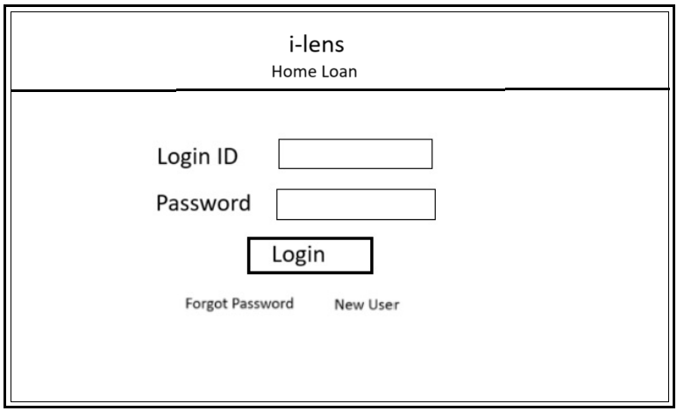

1. **Home Page :**

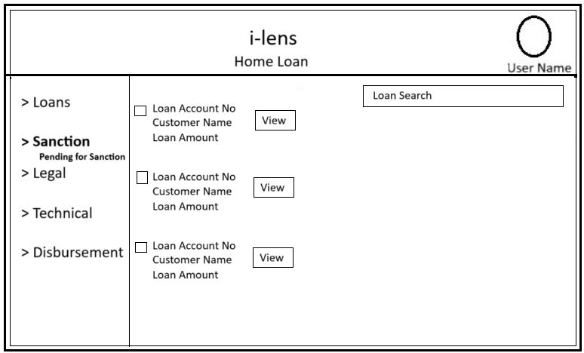

1. **Search page :**

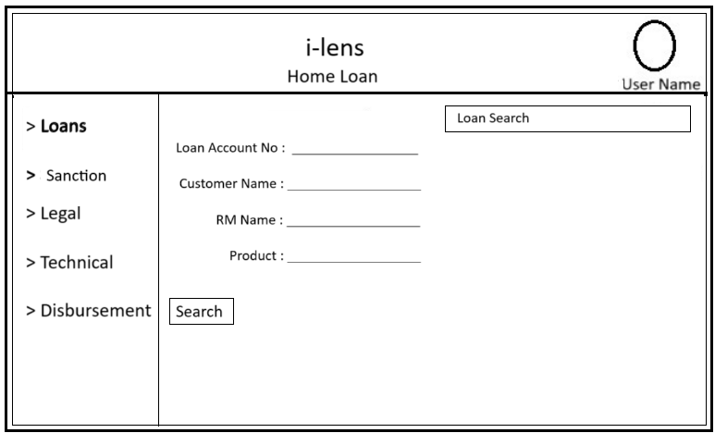

**Legal Page :**

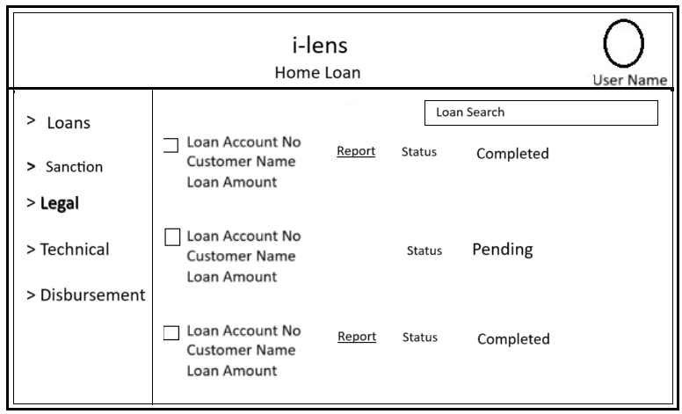

**Disbursement page:**

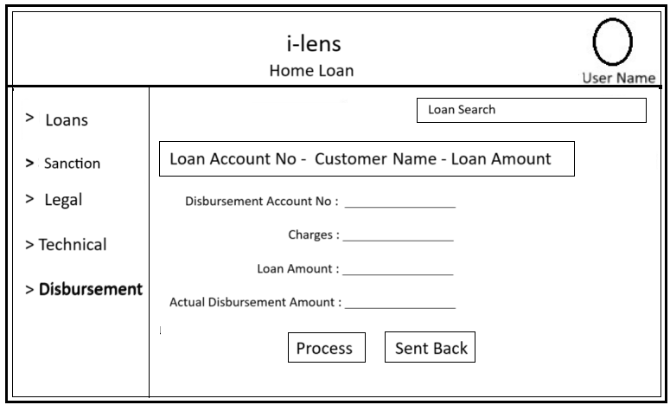

**Document 8- Tools-Visio and Axure**

**Write a paragraph on your experience using Visio and Axure for the project.**

**Microsoft Visio**

Visio helps me in creating process flows diagrams. The variety of templates and shapes made it easy to get started, and its integration with other Microsoft tools was seamless. I particularly liked the drag-and-drop functionality and the ability to link data from Excel to enhance my diagrams. Using Visio I have prepared Use case diagrams, Activity diagrams which help me to explain the flow to the development team more understandable.

**Axure RP**

Axure really stood out when it came to prototyping and interactive designs. I used it to build a clickable prototype, and the ability to add conditional logic and dynamic panels was a incredible. It allowed me to test and demonstrate user interactions effectively. The documentation feature was also handy for sharing specs with the development team.

Visio and Axure are both powerful tools and serve very different needs. Visio is excellent for business diagrams, while Axure shines in creating functional, interactive prototypes. For my project, I used Visio for initial process mapping and Axure for refining user journeys and testing interactivity. Both tools complemented each other well.

**Document 9- BA experience**

**My experience as BA in following phases:**

**1.Requirement gathering:**

In Requirement gathering I have gathered the requirements using an elicitation technique such as interviews and Observation as it is an enhancement project most of the requirements are been gathered from the existing system and process.

Once all the requirement are gathered, I have validate the requirements to know any duplicate requirements are available or not. For Validation I use an technique FURPS ( Functionality, Usability, Reliability, Performance and Security).

During the requirement gathering phase, sometimes client will not be available for some period. So i have to source out point of contacts from his side and get the information ASAP from the next level contact of the client, who will be a backup in absent of his presence.

**2. Requirement Analysis:**

In Requirement analysis i have draw an UML diagrams to visually describe the requirements to make a clear vision of the project and it makes me to make understand the requirement in an easier way.

In other hand Activity diagrams also used to describe the process flow in an diagrammatic way.

Using the diagram i have explain and communicate the flow and steps to team. If Some team members might not agree with them and might make changes. I have consider the points and note down the changes and discuss with stakeholders and need perform necessary actions.

Post requirement analysis i have prepare documents like BRS and SRS, so that the requirements will be completed.

**3. Design:**

At the time of requirement analysis stage i have prepare the use case and activity diagrams from which i have prepare test cases for the project.

I have prepared the Test case both negative test cases as well along with positive test cases, so that i have analysis and monitor the behavior of the system. And while performing testing i have not miss even an single test case. Because it will have huge impact on project development in later stages. And it will affect the outcome of the project and project delivery time.

Once design and testing is done i will update the RTM frequently. So that i can have track of all the requirements.

**4.Development:**

In development Phase, i have to organized JAD sessions with the stakeholders and development team to make sure every one understand the need of the project development.

During the meetings some team members who doesn't agree with the concept or who doesn’t cooperate during JAD sessions. i have handle the situation gently and had one on one discussion with them. Explained how their actions are going to affect the project. which help me to Setup an healthy environment within the team.

**5. Testing:**

In Testing i have Prepared multiple test cases from the use case diagram. Based on the test case i have performed the testing and recorded and observed the activities of the system. Once the testing is completed i have updated the RTM. So that the requirement can be tracked and monitored. Once the testing is completed i have taken signoff from client for the testing completion procedure.

**6. Deployment:**

Final stage of the project is deployment of the project in an live environment. To process deployment i have circulate the updated or completed RTM to client along with the project closure document and i have taken signoff from the client over the mail and processed for the deployment in live environment. And i have Coordinates between teams to complete and share end user manuals so that the client will understand how to use the project and it will provide the basic functionality of the project. And I have also planned and organizes an training sessions with the client and stakeholders and Made all the candidates to attend the meeting by gathering all the members available time and sending remainders for the meeting.