**Document 1- Business case document template**

**➢ Why is this project initiated?**

Currently ICICI is using a third-party software – Finacle for managing the end-to-end process of business loans. The contract will expire soon with the third party so ICICI decided to build a software inhouse.

**➢ What are the current problems?**

The volume of loan applications is increasing at a very high pace. As a result, the cost of processing the loan is very high. Another challenge is that borrowers are not able to track the status of their application and are required to contact the processors for every minute detail burdening the processors unnecessarily. Also, introducing internal change in the system is time consuming.

**➢ With this project how many problems could be solved?**

With this project, the borrowers will be able to track their loan process in real time. Also, introducing any changes in the internal policy of the bank will be easier and can be quickly implemented.

**➢ What are the resources required?**

A total of 11 resources are required including BA, PM, DB Admin, NW Admin, 4 Developers and 3 Testers.

**➢ How much organizational change is required to adopt this technology?**

There will not be much of the organizational changes as the employees are already working on a third-party software. ICICI needs to conduct training sessions for its employees for introduction of the proposed software.

**➢ Time frame to recover ROI?**

Approximately 15 months.

**➢ How to identify Stakeholders?**

The ILS Matrix (Interest, Legitimacy and Strength) will be used to identify the stakeholders. Interest is the degree of concern about the project, Legitimacy is the involvement in the project and Strength is the ability to influence the project.

**Document 2: BA Strategy**

**BA Approach Strategy**: The role of a BA is to ensure that the project meets the business needs. The project is completed within the time and budget and all the requirements of the stakeholders are met. The purpose of BA Approach Strategy is to document the steps which will be followed during the project. Following are the steps –

**Enterprise Analysis:**

* As a BA, we will do the enterprise analysis to identify the business needs, clarify those needs and defining the scope of the solution.
* We will conduct feasibility study to evaluate risks, constraints and dependencies.

**Stakeholders Analysis:**

* There are three types of stakeholders – Business stakeholders, Project stakeholders and Third-Party stakeholders.
* Stakeholders Analysis can be done using techniques like RACI Matrix (Responsible, Accountable, Consulted and Informed) and ILS Matrix (Interest, Legitimacy and Strength).

**Requirement Gathering and Analysis:**

* As a BA, we will be gathering the requirements using elicitation techniques. Various elicitation techniques are Brainstorming, Prototyping, Interview, Focus Groups, JAD, Documentation, Reverse Engineering, Workshops, Observation and Surveys/Questionnaire.
* After gathering the requirements, we will sort the requirements, prioritize using techniques like MoSCoW, 100 Dollars Test and Numerical Assignment and validate the requirements using FURPS, CUCV and SMART techniques.
* After validating the requirements, we will prepare Business Requirement Document (BRD).
* After all the verifications and validations, the business requirements will be converted into functional and non-functional requirements
* We will prepare Functional Requirement Document (FRD) capturing all the functionalities, As Is of the business and stakeholders information.

**Documents Preparation:**

* As a BA we need to prepare various documents throughout the project like –

Business Requirement Document (BRD), Stakeholders Requirement Document (SRD), Solution Requirement Specification (SRS), Functional Requirement Document (FRD), Requirements Traceability Matrix (RTM), Change Request Logs, Use Case and Activity Diagrams, Test Cases and Traceability Matrix.

**Process for Sign off on the documents:**

* To ensure that all the key stakeholders agree on the requirements, we will follow below process for sign-off –

Draft the Documents, Internal Review, Stakeholders Review, Revise the document (if required), Final Review after implementing the changes and Sign-off of the document.

**Taking approvals from the client:**

* For taking approvals, we will present the document of final requirements to the project sponsors.
* If any concerns are raised by the client, we will address them.
* After making the final adjustments, the document will be presented to the client for the final approval.

**Communication channels:**

* For efficient and effective communication, we will establish proper channels like – Email, instant messenger (teams, slack), meetings (zoom, skype, teams) and project management tools (Jira, Trello).

**Handle change requests:**

* As a BA we will analyse any change requests raised by the client.
* We will document all the details of change in Change Request Log.
* We will implement the changes in the system with the help of developers and inform the client about the same.

**Updating the progress of the project to the stakeholders:**

* To ensure transparency and to keep the stakeholders informed, we will provide regular updates to the stakeholders.
* We will provide Weekly/Monthly Status Reports, Meetings and Dashboards.

**UAT Acceptance:**

* User Acceptance Testing is a phase where the client verifies that the system meets the business requirements.
* For UAT sign-off, we will prepare UAT plan and will share Client Project Acceptance Form.
* We will conduct UAT and address all the concerns raised by the client if any.
* We will document the final approval and sign-off.
* After all the bugs are removed, we will send an email to the client with the RTM and Test Cases regarding the sign-off from the project. We will mail for the approval from the client to sign-off.

**Document 3- Functional Specifications**

**Functional Specifications:**

|  |  |
| --- | --- |
| Project Name | Loan Management System |
| Customer Name | ICICI Bank Loan Department |
| Project Version | LMS1.0 |
| Project Sponsor | ICICI Bank |
| Project Manager | Mayank Lodha |
| Project Initiation Date | 31st December 2024 |

**Functional Requirement Specifications:**

|  |  |  |  |
| --- | --- | --- | --- |
| **Req ID** | **Req Name** | **Req Description** | **Priority** |
| FR0001 | User Registration | Allow users to create an account by registration and login to the application | 10 |
| FR0002 | User Login | Allow users to login to the application | 10 |
| FR0003 | Browse loan types | Allow users to scroll through the available loan types | 8 |
| FR0004 | Loans search based on collateral | Allow users to type and search the available loans based on collaterals | 8 |
| FR0005 | Apply for loans | Allow customers to apply for various types of loans like personal loans, home loans, vehicle loans and business loans | 10 |
| FR0006 | Collect & Validate information | The system must collect and validate customers information like personal details, income details, employment details, credit history and assets | 10 |
| FR0007 | Unique application ID | System must generate unique application ID for each loan | 10 |
| FR0008 | Status updates | The system must show real time updates of the status of the loans (submitted, under review, approved, denied) | 7 |
| FR0009 | Loan processing | The system must allow loan officers to review the applications | 9 |
| FR0010 | Approval/Denial | The system must allow loan officers to approve or reject the loan applications | 10 |
| FR0011 | Loan eligibility | The system must calculate loan eligibility based on predefined rules of income, credit and assets | 10 |
| FR0012 | Ratios calculation | The system must calculate important ratios like Debt-to-Income Ratio, Housing Ratio, Loan to Value, Liquidity ratio etc. | 10 |
| FR0013 | Loan Agreements | The system must generate loan agreements and allow customers to digitally sign the agreement | 8 |
| FR0014 | Risk Assessment | The system must assess the risk factors associated with the credit history and other financial data of the customers | 9 |
| FR0015 | Credit Report generation | The system must be able to retrieve Credit Reports of the borrower through third-party credit bureaus | 10 |
| FR0016 | Schedule disbursements | The system must allow loan officers to schedule disbursements as per the customer request | 10 |
| FR0017 | Funds disbursements | The system must allow loan officers to credit the disbursements in specific account or in customer's account after final approval | 10 |
| FR0018 | Notifications on approval | The system must notify the customers about loan approval and disbursement via email and SMS | 7 |
| FR0019 | Notifications on denial | The system must notify the customers about loan rejection via email and SMS | 7 |
| FR0020 | Sign Out | Users will be able to log off from the application using sign out tab | 6 |
| FR0021 | Feedback & Service reviews | Allow customers to rate & review the services and provide feedback | 5 |
| FR0022 | Repayment Schedule | The system must generate repayment schedule based on loan amount, tenure and interest rate | 8 |
| FR0023 | Repayment Schedule | The system must allow customers to view the repayment schedule on the application | 8 |
| FR0024 | Payment modes | The system must allow customers to make the loan repayments through various modes like UPI, net banking, credit card and debit card | 10 |
| FR0025 | ECH Setup | The system must allow customers to set automatic debits of the EMI directly through the customer's account | 9 |
| FR0026 | Reminders setup | The system must send automated reminders of upcoming payments and overdue payments | 8 |
| FR0027 | Imposition of penalties | The system must calculate and impose penalties for late payments or no payments | 8 |
| FR0028 | Interest rate calculation | The system must calculate interest rate using methods like fixed rate and reducing balance | 9 |
| FR0029 | Amount breakdown | The system must reflect the breakup of all the charges and fees | 9 |
| FR0030 | Regulations and policies | The system must display the financial regulations, RBI Rules and internal policies of the bank | 7 |
| FR0031 | Customization of loan products | The system must allow the customization of loan products for specific customer segments like students, army personnel, small businesses, farmers etc | 8 |
| FR0032 | Collateral Information | The system must allow customers to provide the collateral information at the time of application | 8 |
| FR0033 | Collateral Documents | The system must securely record the collateral documents and link them with the corresponding application | 10 |
| FR0034 | Scalability | The system must be scalable to handle increasing numbers of customers and transactions | 10 |
| FR0035 | Integration | The system must integrate with external systems like credit bureaus and payment gateways | 9 |
| FR0036 | Audit Log | The system must log all user activities for compliance, statutory and internal audit purposes | 7 |
| FR0037 | Notifications | The system must send important changes like change in interest rates in real time | 9 |
| FR0038 | Information Updation | The system must allow users to update their information | 8 |
| FR0039 | Reporting | The system must provide customizable reports for loan portfolio performance, delinquency rates, and approval/rejection statistics | 9 |
| FR0040 | Data encryption | The system must encrypt sensitive personal data and financial data | 10 |
| FR0041 | Processing requests | The system must allow customers to request loan restructuring, pre-payment or refinancing | 9 |
| FR0042 | Integration with recovery partners | The system must integrate with external recovery partners in case of any delinquencies | 7 |
| FR0043 | Multi-Currency support | The system must support loans in multiple currencies to cater the international customers | 9 |
| FR0044 | Currency conversions | The system must support currency conversions and exchange rate fluctuations | 9 |
| FR0045 | Adding/Deleting parties | The system must allow customers to add or delete any co-applicants | 8 |
| FR0046 | Optional services and charges | The system must suggest the customers for the available optional services and their charges | 7 |
| FR0047 | Channels | The system must allow the customers to access the loan services through various channels like app, web page and in-branch kiosks | 9 |
| FR0048 | Queries and complaints | The system should allow the customers to raise any queries or complaints regarding their loans | 7 |
| FR0049 | Query tracking | The system should allow the customers to track their queries | 7 |
| FR0050 | Documents upload | The system must allow the customers to upload their documents securely during the application process and further any additional documents if required | 8 |

**Document 4- Requirement Traceability Matrix**

**RTM:** Requirement Traceability Matrix is a document to track the requirements throughout the project lifecycle, ensuring that the system is progressing as expected and no requirement is overlooked.

|  |  |  |  |  |  |  |  |  |
| --- | --- | --- | --- | --- | --- | --- | --- | --- |
| **Req ID** | **Req Name** | **Req Description** | **Design** | **D1** | **T1** | **D2** | **T2** | **UAT** |
| FR0001 | User Registration | Allow users to create an account by registration and login to the application | Yes | Yes | Yes | Yes | No | Yes |
| FR0002 | User Login | Allow users to login to the application | Yes | Yes | No | No | No | No |
| FR0003 | Browse loan types | Allow users to scroll through the available loan types | Yes | Yes | No | No | No | No |
| FR0004 | Loans search based on collateral | Allow users to type and search the available loans based on collaterals | Yes | Yes | Yes | No | No | No |
| FR0005 | Apply for loans | Allow customers to apply for various types of loans like personal loans, home loans, vehicle loans and business loans | Yes | Yes | Yes | Yes | Yes | No |
| FR0006 | Collect & Validate information | The system must collect and validate customers information like personal details, income details, employment details, credit history and assets | Yes | No | Yes | Yes | Yes | No |
| FR0007 | Unique application ID | System must generate unique application ID for each loan | Yes | No | Yes | Yes | Yes | No |
| FR0008 | Status updates | The system must show real time updates of the status of the loans (submitted, under review, approved, denied) | Yes | No | Yes | Yes | Yes | No |
| FR0009 | Loan processing | The system must allow loan officers to review the applications | Yes | No | Yes | No | No | Yes |
| FR0010 | Approval/Denial | The system must allow loan officers to approve or reject the loan applications | No | No | Yes | No | No | Yes |
| FR0011 | Loan eligibility | The system must calculate loan eligibility based on predefined rules of income, credit and assets | Yes | No | Yes | No | No | Yes |
| FR0012 | Ratios calculation | The system must calculate important ratios like Debt-to-Income Ratio, Housing Ratio, Loan to Value, Liquidity ratio etc. | Yes | No | No | Yes | No | Yes |
| FR0013 | Loan Agreements | The system must generate loan agreements and allow customers to digitally sign the agreement | No | No | No | Yes | No | Yes |
| FR0014 | Risk Assessment | The system must assess the risk factors associated with the credit history and other financial data of the customers | No | No | No | Yes | Yes | Yes |
| FR0015 | Credit Report generation | The system must be able to retrieve Credit Reports of the borrower through third-party credit bureaus | No | No | No | Yes | Yes | No |
| FR0016 | Schedule disbursements | The system must allow loan officers to schedule disbursements as per the customer request | No | No | No | Yes | Yes | No |
| FR0017 | Funds disbursements | The system must allow loan officers to credit the disbursements in specific account or in customer's account after final approval | No | No | No | Yes | Yes | No |
| FR0018 | Notifications on approval | The system must notify the customers about loan approval and disbursement via email and SMS | Yes | Yes | No | No | Yes | Yes |
| FR0019 | Notifications on denial | The system must notify the customers about loan rejection via email and SMS | Yes | Yes | No | No | Yes | Yes |
| FR0020 | Sign Out | Users will be able to log off from the application using sign out tab | Yes | Yes | Yes | Yes | Yes | Yes |
| FR0021 | Feedback & Service reviews | Allow customers to rate & review the services and provide feedback | Yes | Yes | Yes | Yes | Yes | Yes |
| FR0022 | Repayment Schedule | The system must generate repayment schedule based on loan amount, tenure and interest rate | Yes | Yes | Yes | Yes | Yes | Yes |
| FR0023 | Repayment Schedule | The system must allow customers to view the repayment schedule on the application | Yes | Yes | Yes | Yes | No | Yes |
| FR0024 | Payment modes | The system must allow customers to make the loan repayments through various modes like UPI, net banking, credit card and debit card | Yes | Yes | Yes | Yes | No | Yes |
| FR0025 | ECH Setup | The system must allow customers to set automatic debits of the EMI directly through the customer's account | No | Yes | Yes | Yes | No | Yes |
| FR0026 | Reminders setup | The system must send automated reminders of upcoming payments and overdue payments | No | Yes | Yes | Yes | No | Yes |
| FR0027 | Imposition of penalties | The system must calculate and impose penalties for late payments or no payments | Yes | Yes | Yes | Yes | No | No |
| FR0028 | Interest rate calculation | The system must calculate interest rate using methods like fixed rate and reducing balance | Yes | Yes | Yes | Yes | No | No |
| FR0029 | Amount breakdown | The system must reflect the breakup of all the charges and fees | Yes | No | No | No | No | No |
| FR0030 | Regulations and policies | The system must display the financial regulations, RBI Rules and internal policies of the bank | Yes | No | No | No | No | No |
| FR0031 | Customization of loan products | The system must allow the customization of loan products for specific customer segments like students, army personnel, small businesses, farmers etc | Yes | No | No | Yes | No | No |
| FR0032 | Collateral Information | The system must allow customers to provide the collateral information at the time of application | Yes | No | Yes | Yes | No | No |
| FR0033 | Collateral Documents | The system must securely record the collateral documents and link them with the corresponding application | Yes | No | Yes | Yes | Yes | No |
| FR0034 | Scalability | The system must be scalable to handle increasing numbers of customers and transactions | No | No | Yes | Yes | Yes | No |
| FR0035 | Integration | The system must integrate with external systems like credit bureaus and payment gateways | Yes | No | Yes | Yes | Yes | No |
| FR0036 | Audit Log | The system must log all user activities for compliance, statutory and internal audit purposes | Yes | Yes | Yes | Yes | Yes | No |
| FR0037 | Notifications | The system must send important changes like change in interest rates in real time | Yes | Yes | Yes | Yes | Yes | No |
| FR0038 | Information Updation | The system must allow users to update their information | Yes | Yes | Yes | Yes | Yes | Yes |
| FR0039 | Reporting | The system must provide customizable reports for loan portfolio performance, delinquency rates, and approval/rejection statistics | Yes | Yes | Yes | Yes | Yes | Yes |
| FR0040 | Data encryption | The system must encrypt sensitive personal data and financial data | Yes | Yes | Yes | No | Yes | Yes |
| FR0041 | Processing requests | The system must allow customers to request loan restructuring, pre-payment or refinancing | Yes | Yes | Yes | No | Yes | Yes |
| FR0042 | Integration with recovery partners | The system must integrate with external recovery partners in case of any delinquencies | Yes | Yes | Yes | No | Yes | Yes |
| FR0043 | Multi-Currency support | The system must support loans in multiple currencies to cater the international customers | No | Yes | Yes | No | Yes | Yes |
| FR0044 | Currency conversions | The system must support currency conversions and exchange rate fluctuations | No | Yes | Yes | No | No | Yes |
| FR0045 | Adding/Deleting parties | The system must allow customers to add or delete any co-applicants | Yes | Yes | Yes | No | No | Yes |
| FR0046 | Optional services and charges | The system must suggest the customers for the available optional services and their charges | Yes | Yes | Yes | No | No | Yes |
| FR0047 | Channels | The system must allow the customers to access the loan services through various channels like app, web page and in-branch kiosks | Yes | Yes | No | No | No | Yes |
| FR0048 | Queries and complaints | The system should allow the customers to raise any queries or complaints regarding their loans | Yes | Yes | No | No | No | Yes |
| FR0049 | Query tracking | The system should allow the customers to track their queries | Yes | No | No | No | No | Yes |
| FR0050 | Documents upload | The system must allow the customers to upload their documents securely during the application process and further any additional documents if required | Yes | No | No | No | No | Yes |

**Document 5- BRD Template**

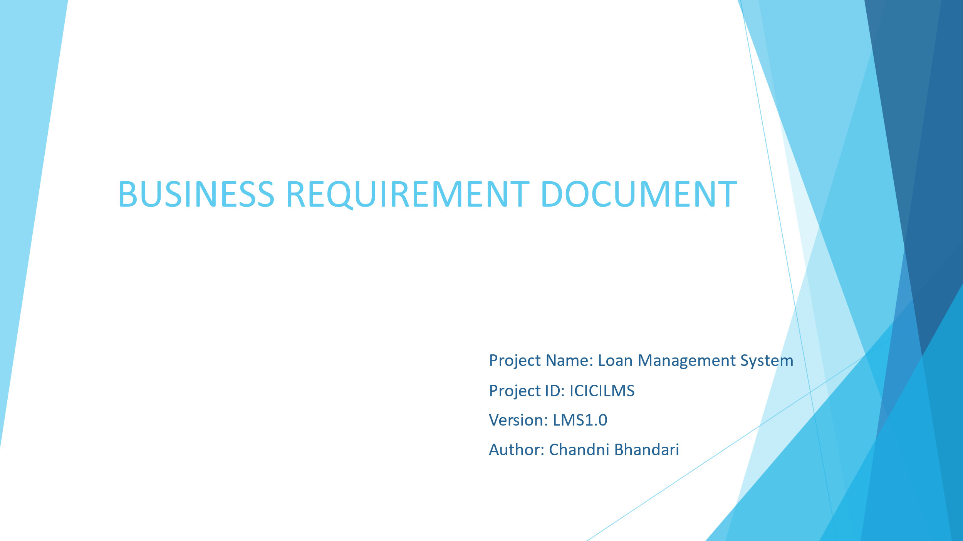

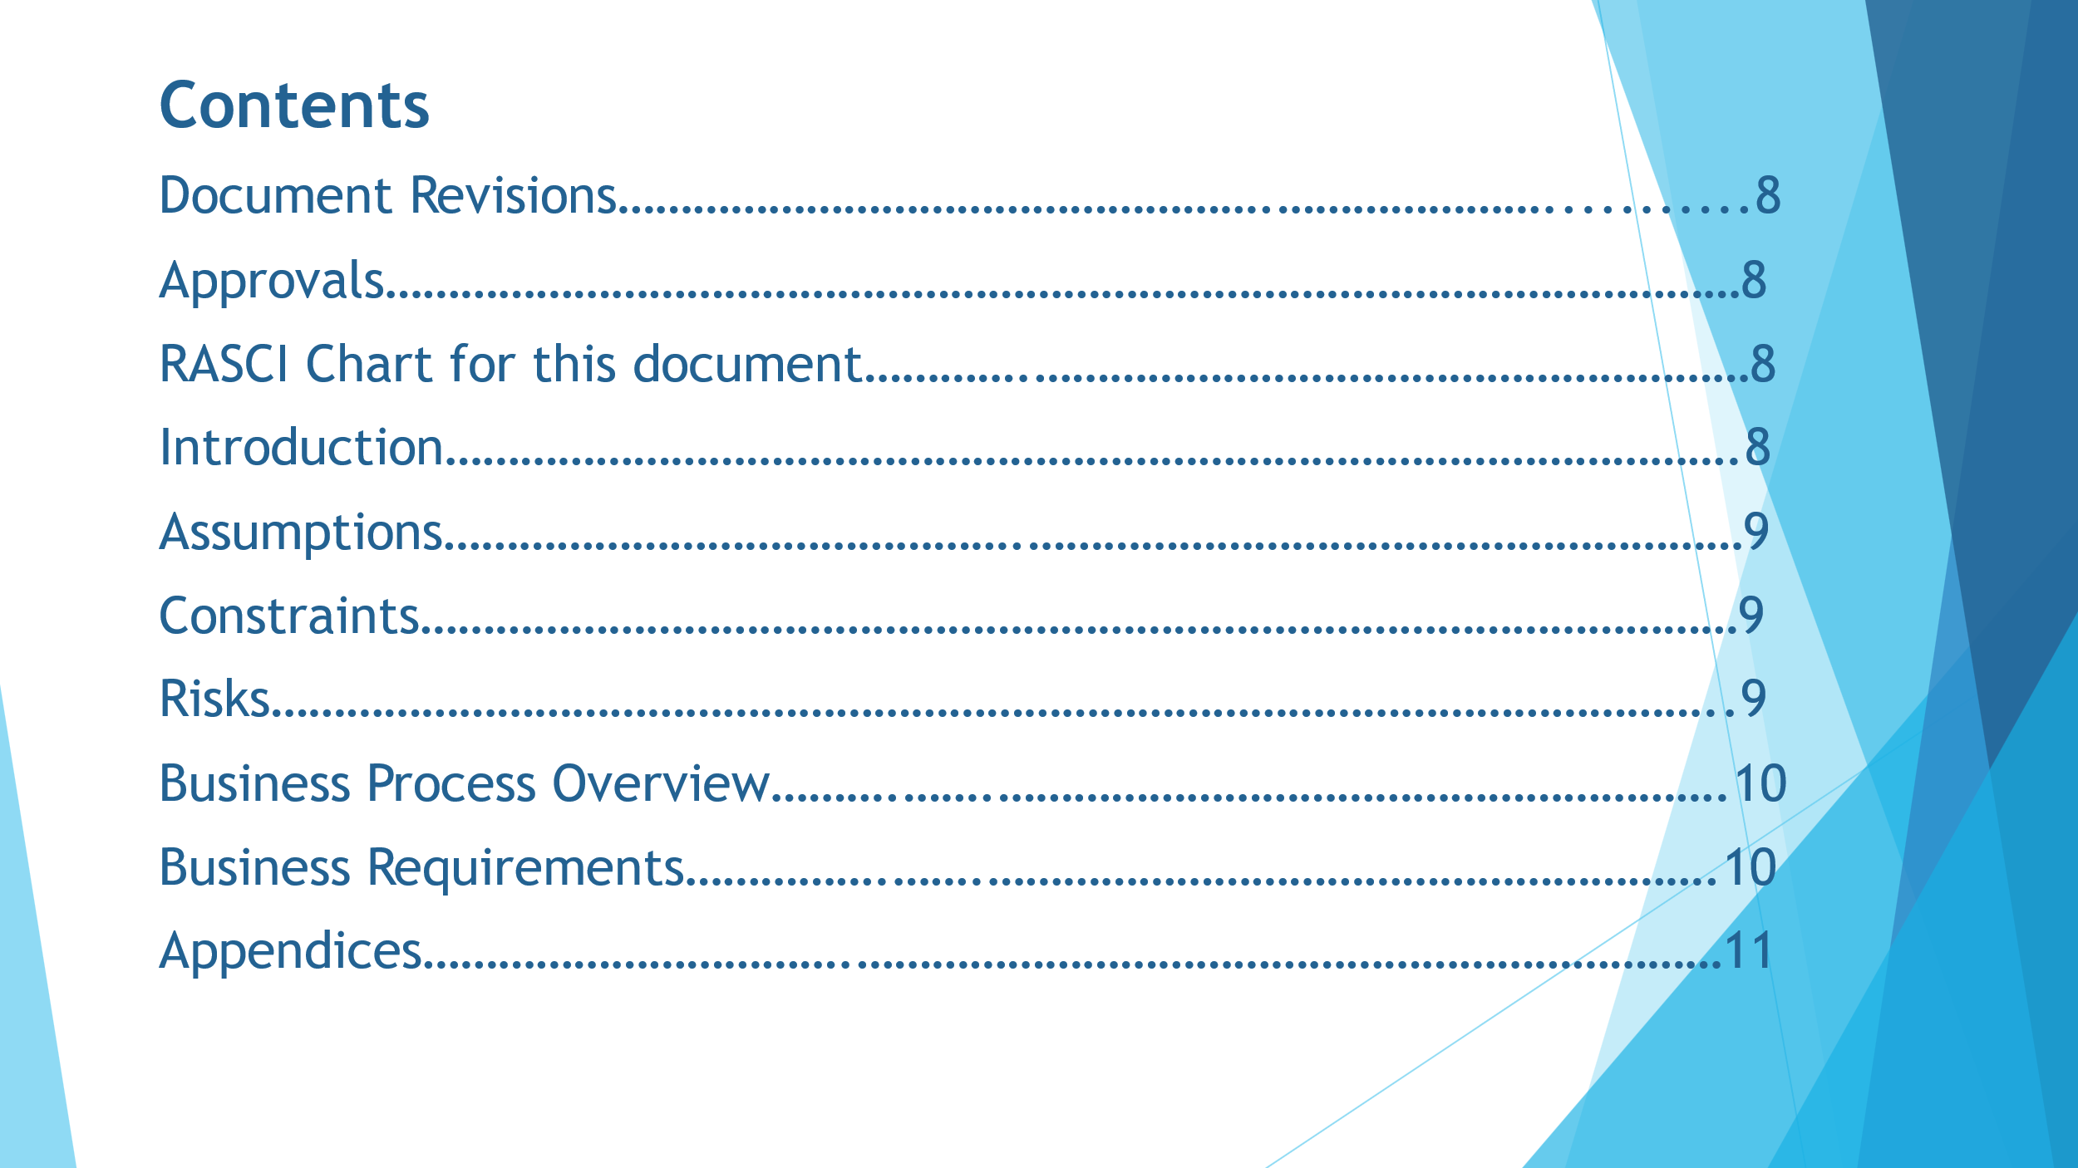

1. **Document Revisions**

|  |  |  |
| --- | --- | --- |
| Date | Version Number | Document Changes |
| 31/12/2024 | 1.0 | Initial Draft |
|  |  |  |
|  |  |  |

**2. Approvals**

|  |  |  |  |  |
| --- | --- | --- | --- | --- |
| **Role** | **Name** | **Title** | **Signature** | **Date** |
| Project Sponsor | ICICI Bank |  |  | 31/12/2024 |
| Business Owner | Vikas Jaiswal |  |  |  |
| Project Manager | Mayank Lodha |  |  |  |
| System Architect | Mike |  |  |  |
| Development Lead | Juhi Singh |  |  |  |
| User Experience Lead | Ankit Jain |  |  |  |
| Quality Lead | Gayatri Kulkarni |  |  |  |
| Content Lead | Nikhil Anupare |  |  |  |

1. **RASCI Chart for this document**

The RACI chart identifies the persons who need to be contacted whenever changes are made to this document. RACI stands for responsible, accountable, consulted, and informed. These are the main codes that appear in a RACI chart, used here to describe the roles played by team members and stakeholders in the production of the BRD. They are adapted from charts used to assign roles and responsibilities during a project.

The following describes the full list of codes used in the table:

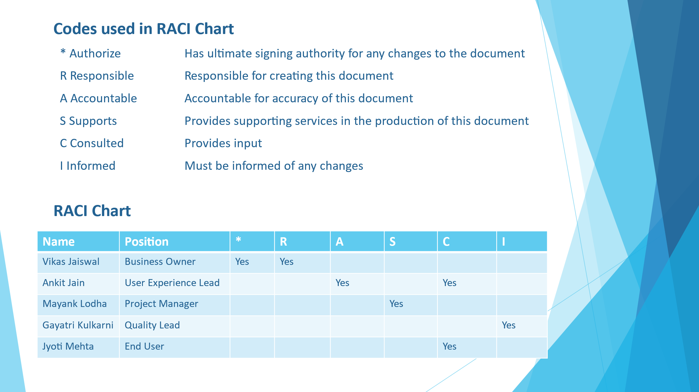

1. **INTRODUCTION**
   1. **Business Goals:** To develop an in-house loan management system to provide end-to-end loan solutions. This software will perform the tasks from application to the final sign-off.
   2. **Business Objectives:**

* To provide an IT solution for streamlining and automating the entire loan lifecycle ensuring efficiency, accuracy, compliance and customer satisfaction.
* To develop an application for android and iOS and a web page
* To develop e-learning management system for giving training to the staff and the users
* To develop a dedicated unit for assistance to the customers
  1. **Business Rules**: ICICI Bank works in a very strict environment in terms of security and compliance which needs to be followed by each associate.
  2. **Background:** Currently ICICI is using a third-party software – Finacle for managing the end-to-end process of business loans. The contract will expire soon with the third party so ICICI decided to build a software inhouse.
  3. **Project Objective:** The objective of Loan Management System is to design and implement an efficient, secure and user-friendly platform that streamlines the loan lifecycle, enhance customer experience and supports the bank’s operational and strategic goals.
  4. **Project Scope:** The scope is to define the boundaries, functionalities and deliverables of the project. In this project, we are going to develop a software for processing the loan from start to end to save on the cost and efforts**.** 
     1. **In Scope Functionality:**
* LMS access will be given to the loan officers/processors for underwriting the loans
* Access will be given to the users for applying and tracking the loan application
* Unique application ID will be generated for each loan application
* Linking the collateral documents with the corresponding application
  + 1. **Out Scope Functionality:**
* Only limited access will be given to the users
* Documents will be only in Read Only access for the underwriting team

1. **ASSUMPTIONS**

* The team will be having prior knowledge of processing the loans
* The bank has necessary IT Infrastructure to support the LMS
* Adequate resources like funding and skilled staff are available to develop and maintain the system
* The system has been designed in accordance with the applicable laws and regulations

1. **CONSTRAINTS**

* Challenges in designing a system capable of handling future increases in loan volume and user traffic without significant reengineering
* Adhering to regulatory requirements that may vary across regions and jurisdictions
* High costs associated with advanced features and third-party integrations

1. **RISKS:** A riskis something that could affect the success or failure of a project.
   1. **Technological Risk:** Difficulty in integrating the LMS with the existing banking systems**.**
   2. **Skills Risk:** Employees should have proper underwriting experience so they can analyse and process the loan adequately.
   3. **Political Risk:** Frequent changes in banking regulations, loan policies and compliance requirements can disrupt LMS functionality and require costly updates or reconfigurations.
   4. **Business Risk:**

* The initial cost of developing and customizing the LMS may exceed budgeted limits affecting the bank’s financial stability
* If the LMS does not deliver expected efficiency, cost savings or revenue growth, it could result in financial losses
* Delays in LMS implementation could disrupt loan processing and repayment leading to revenue loss.
  1. **Requirement Risk:** Requirements gathering was not done properly due to high dependency on third-party software
  2. **BA Risk:**
* Unable to understand the requirements
* Proper documentation not done
* Lack of knowledge of banking IT domain
* Communication gap between the stakeholders
  1. **Project Risk:**
* End users are not familiar with the LMS
* Violation of customers personal and financial data
  1. **Other Risk:** Access needs to be given with expectation that the customer information is secure and their will be no theft of information.

1. **BUSINESS PROCESS OVERVIEW**
   1. **Legacy System (AS-IS):** In the legacy system, the loan processor will create a loan application and upload all the initial documents. Once the documents are uploaded, the loan will be assigned to the underwriting team for review. In case of any additional information is required, the loan will be in pending stage and will be assigned back to processor with all the pendency. LO will inform the customer for all the pendency. After the customer provides the required information to the LO, LO will again upload the documents in the system and put the loan in processing stage. Once the additional documents are reviewed, the underwriting team will convey the status of the loan (approved or rejected) to LO and LO will convey the same to the customer through email.
   2. **Proposed Recommendations (TO-BE):** In the proposed system, once the customer applies for the loan, Loan Processor will start with the loan verification process. It will be updated in pending queue and through the integrated system it will reflect in customer dashboard in real time. The underwriting team will review the loan and will provide feedback accordingly if any additional documentation is required. The loan will reflect in the processing queue. Once the customer is informed about the requirement, the customer will upload the necessary documents and the loan will be assigned back to the underwriter. If no rework is required, it will reflect in the completed queue. Based on the assessment of all the parameters, the loan will be approved or denied.

