**Online Agriculture Products Store**

**Decode the case study**

1. **Project Idea**: - To Develop an online agriculture product store to facilitate remote area farmers to buy agricultural products.
2. **Current Needs: -** Build online platform user friendly, easy accessible and should be able to accept products (seeds, fertilizers, pesticides etc. ) from manufacturers. Farmers will browse the products according to them, what they need, and request to buy and deliver to farmer’s location.
3. **Overview of the Project: -** It is an online agriculture platform, which will build from scratch where farmers can buy products from companies through online.
4. **Current Problems: -** Farmers are not able to buy fertilizers, seeds, pesticides etc due to remote area.

**Question 1 :- Identify minimum 20 functional requirements**

**Answer :-**

|  |  |  |  |
| --- | --- | --- | --- |
| **Req ID** | **Functional requirement** | **Requirement Description** | **Priority** |
| 1 | Farmer registration | Farmers should be able to register with the application | 9 |
| 2 | Farmer search for products | Farmers should be able to search for available products in fertilizers, seeds, pesticides | 8 |
| 3 | Manufacturer Registration | Manufacturers should be able to register with the application | 7 |
| 4 | Manufacturer Product listing | Manufacturer should be able to list their products in the catalog | 7 |
| 5 | Product catalog | Along with the product name, basic details should be given.ex;weight, ingredients, manufacturer details | 9 |
| 6 | Add to Cart | Users should be able to add products to their shopping cart for purchase | 8 |
| 7 | Cart Management | Users should be able to view and manage the contents of their shopping cart, including adding removing products | 8 |
| 8 | Wishlist management | Users should be able to manage their wish list or buy-later list, including adding or removing products | 7 |
| 9 | Multiple Payment gateways | The Platform should integrate with multiple payment gateways to facilitate secure and convenient transactions | 9 |
| 10 | Order Placement | Users should able to place orders for selected products, specifying quantity and delivery address | 9 |
| 11 | Order confirmation | Users should receive an order confirmation with details such as order numbers, products, quantities, total amount, and estimated delivery date. | 9 |
| 12 | Order Tracking | User should be able to track the status and location of their orders in real-time | 9 |
| 13 | Order History | Users should be able to view their order history, including past orders, order details, and statuses | 7 |
| 14 | Customer Support | Users should have access to customer support, either through live chat, email, or phone, for assistance with their orders or inquiries | 8 |
| 15 | User Rating and Reviews | Users should be able to provide ratings and reviews for products they have purchased | 8 |
| 16 | Product Recommendations | The platform should provide personalized product recommendations based on user preferences and browsing history | 8 |
| 17 | Social Sharing | Users should have the option to share products or their purchase experience on social media platforms | 7 |
| 18 | Secure Transactions | The platform should ensure secure transactions by implementing appropriate encryption and security measures | 9 |
| 19 | Product Filtering | Users should be able to filter products based on various criteria such as price range, brand, or product type | 8 |
| 20 | Account Management | Users should be able to manage their account settings, including profile information, password changes, and email preferences | 7 |

|  |  |  |  |
| --- | --- | --- | --- |
| **Req ID** | **Non Functional req Name** | **Non Functional Requirement Description** | **Priority** |
| NFR001 | Page Loading Time | Each Page should load within 2 seconds time | 10 |
| NFR002 | Technical Supported System | Application can be used only on any OS( Android/IOS) | 6 |
| NFR003 | Time limit for OTP | OTP time limit should be given max 0f 5 minutes for login and registration process | 10 |
| NFR004 | Logout System | Ig the page is not accessed for more than 5 minutes , the page should log out automatically | 7 |
| NFR005 | Stock availability | Stock availability should be updated on a real-time basis | 8 |
| NFR006 | SMS & Miall confirmation | Automated email and sms notifications should be sent to users | 6 |
| NFR007 | Back up | All data should get backup automatically | 7 |
| NFR008 | Connectivity | System should be connected to internet | 8 |
| NFR009 | Stock Alerts | Seller should receive stock alert notifications when stock is reduced , every week | 6 |
| NFR0010 | Net Banking | Bank account should be active in nature for smooth payment process | 8 |
| NFR0011 | Check Stock | Once the product is sold, the stock of the product should be reduced | 7 |
| NFR0012 | Email Address | Email address should be active for receiving email notifications | 5 |
| NFR0013 | Taxation System | All products should be included with additional Tax | 8 |
| NFR0014 | Password | User should receive password cahnge alert every 30 days | 4 |
| NFR0015 | Payment Receipt | Generation of payment detail on white paper receipt | 5 |

These functional requirements cover various aspects of the online agriculture products store, including user registration, product management, shopping cart functionality, payment processing, order management, customer support, and user experience enhancements.

**Question 2** :- **Make wireframe and prototypes.**

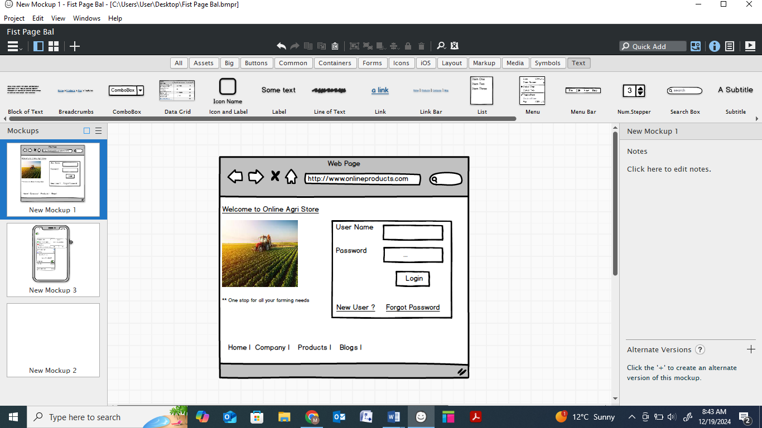

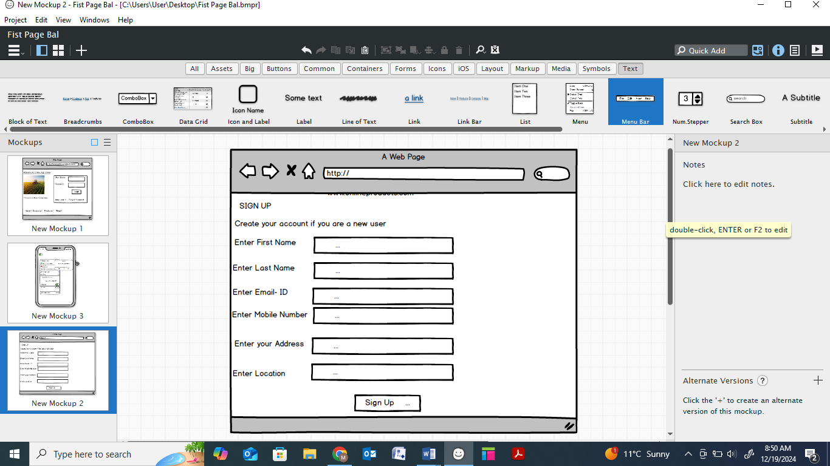

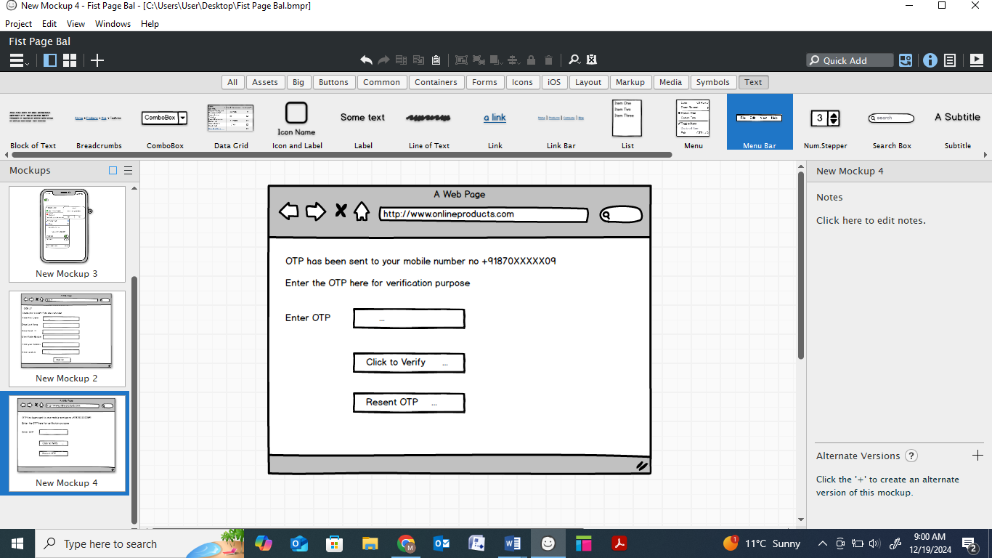

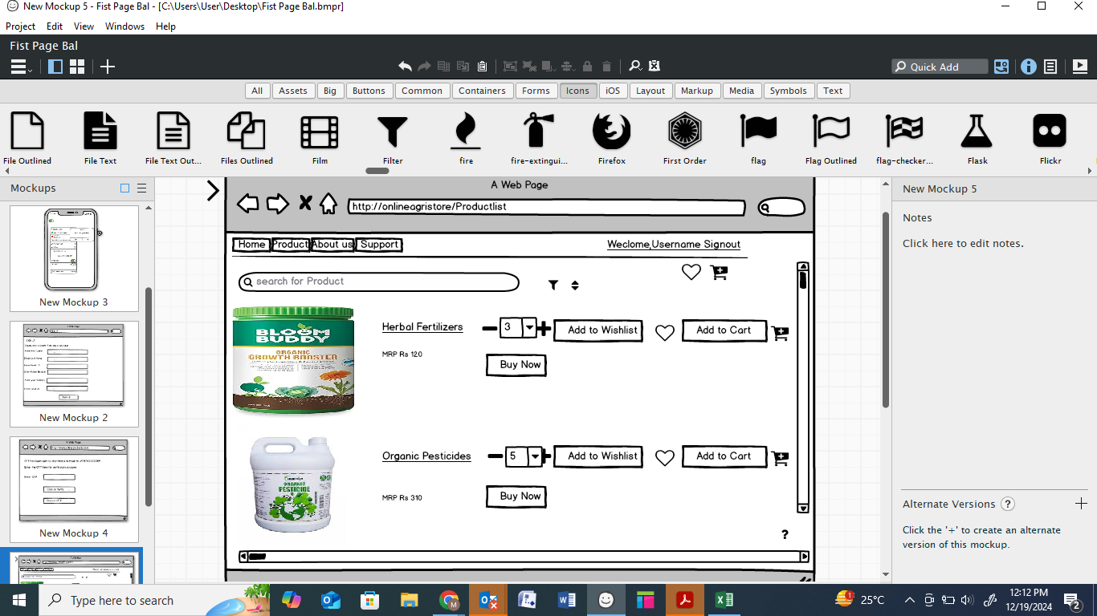

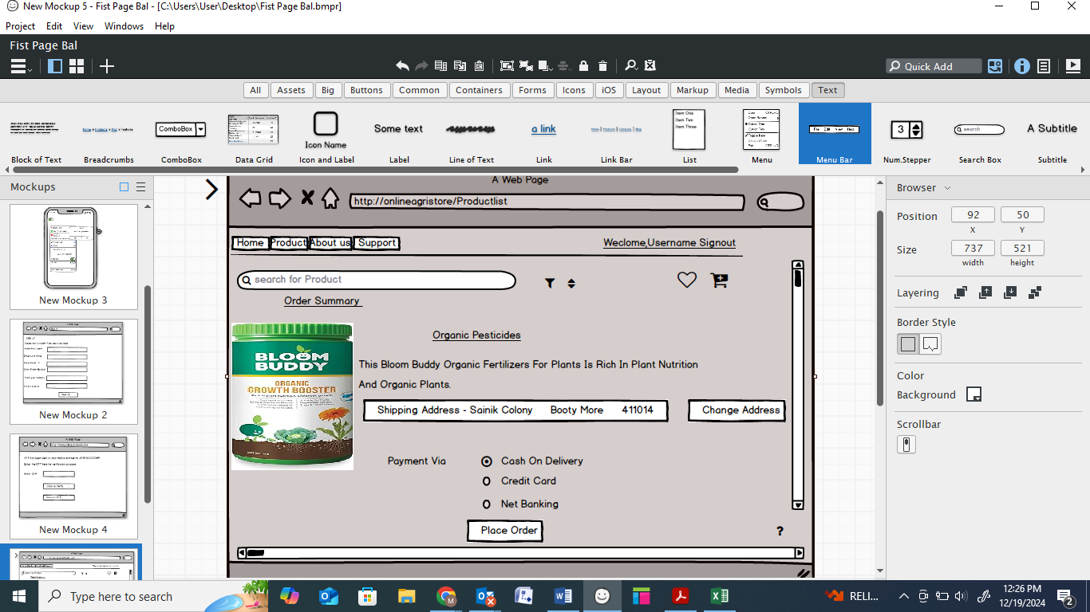

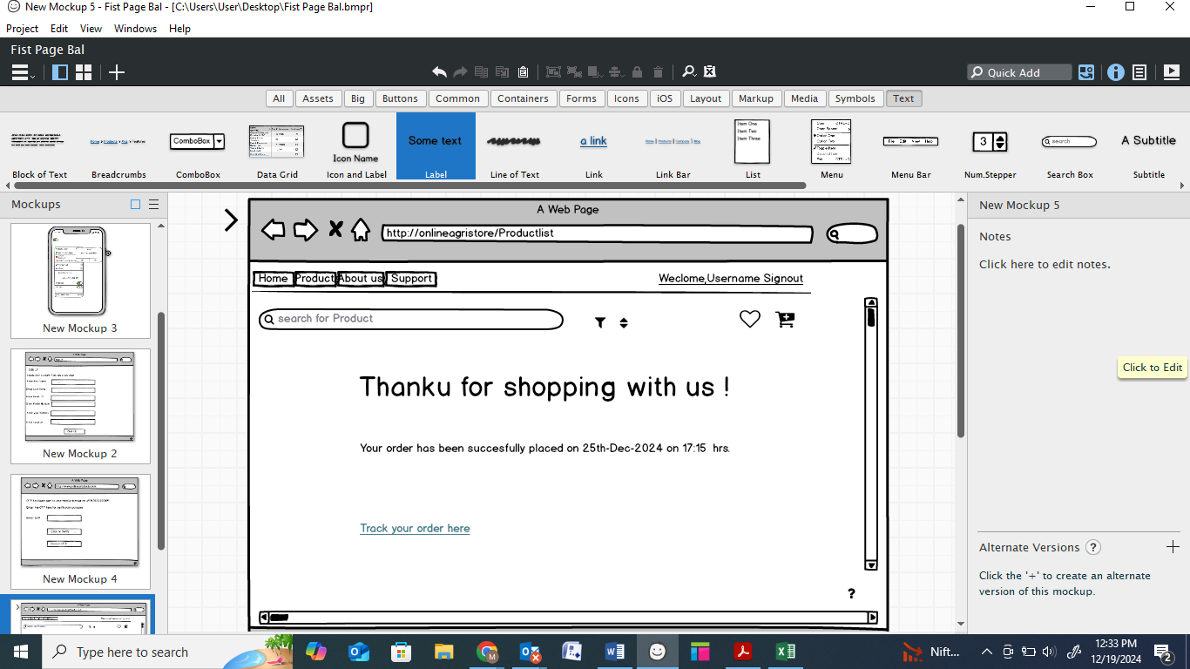

**Question 3** :- **Make a note of the Tools, which you are using for above concepts**

Some commonly used tools for the concepts:-

1. **Microsoft Visio**: Microsoft Visio is a popular tool for creating diagrams, flowcharts,and wireframes. It offers a wide range of templates and shapes to create visual representations of processes and systems.Microsoft Visio is used to create diagram types such as [flowcharts](https://en.wikipedia.org/wiki/Flowcharts), [org charts](https://en.wikipedia.org/wiki/Organizational_chart), [floor plans](https://en.wikipedia.org/wiki/Floor_plans), [network diagrams](https://en.wikipedia.org/wiki/Network_diagram), [UML diagrams](https://en.wikipedia.org/wiki/UML), [mind maps](https://en.wikipedia.org/wiki/Mind_map) and more. It is also commonly used for scenarios such as [Process Mapping](https://en.wikipedia.org/wiki/Process_Mapping) and Visual Collaboration. The latest version of Visio also has [data visualization](https://en.wikipedia.org/wiki/Data_visualization) that allows users to create diagrams from Excel data and also embed Visio diagrams in [Power BI](https://en.wikipedia.org/wiki/Power_BI) dashboards.

**Visio is a diagramming and drawing program** that allows users to create visual representations of complex ideas. It offers a variety of templates and shapes that can be used to create diagrams such as flowcharts, timelines, floor plans, mind maps, charts, graphs, and more. Users can also create their own elements and add them to the Visio palette

2. **Balsamiq:** Balsamiq is a wireframing tool that allows you to create low-fidelity wireframes quickly. It has a simple and intuitive interface, making it easy to sketch out ideas and concepts.

Balsamiq Wireframes is a graphical user interface  [website wireframe](https://en.wikipedia.org/wiki/Website_wireframe) builder application. It allows the designer to arrange pre-built [widgets](https://en.wikipedia.org/wiki/GUI_widget) using a [drag-and-drop](https://en.wikipedia.org/wiki/Drag-and-drop) [WYSIWYG](https://en.wikipedia.org/wiki/WYSIWYG) editor.

**Balsamiq's product is Balsamiq Wireframes**. Launched in June 2008, Wireframes helps software designers and developers build great software by letting them easily sketch out their ideas, then quickly collaborate and iterate over them. Balsamiq Mockups has netted over $6,600,000 in sales in the first 3 years of business and is gathering positive reviews.

Balsamiq is a small group of passionate individuals who believe work should be fun and that life is too short for bad software.

**Question 4 :- RTM**

**A business analyst’s key responsibilities are to keep track of the requirements and make sure that no requirement is missed. Mr. Henry and peter have approached you regarding the current status of the project. How will you tackle this situation?**

|  |  |  |  |  |  |  |  |  |  |  |  |
| --- | --- | --- | --- | --- | --- | --- | --- | --- | --- | --- | --- |
| **Req ID** | **Req Name** | **Req Description** | **Category** | **Sub Category** | **Design** | **Code** | **Unit Testing** | **Component Testing** | **System Testing** | **System Integration** | **UAT** |
| 1 | Farmer registration | Farmers should be able to register with the application | Registration | Name, mobile , details | ABC123.doc, Farmer registration 15,28 ///ABC123/FRD PA779429, 12th Nov 2024 | ABC123.doc, Farmer registration 15,30 ///ABC123/FRD PA779429, 13th Nov 2024 | ABC123.doc, Farmer registration 15,32 ///ABC123/FRD PA779429, 14th Nov 2024 | ABC123.doc, Farmer registration 15,34 ///ABC123/FRD PA779429, 15th Nov 2024 | ABC123.doc, Farmer registration 15,36///ABC123/FRD PA779429, 16th Nov 2024 | ABC123.doc, Farmer registration 15,38 ///ABC123/FRD PA779429, 17th Nov 2024 | ABC123.doc, Farmer registration 15,40 ///ABC123/FRD PA779429, 18th Nov 2024 |
| 2 | Farmer search for products | Farmers should be able to search for available products in fertilizers, seeds, pesticides | Searching | Search | ABC123.doc, Farmer search for products 15,28 ///ABC123/FRD PA779429, 13th Nov 2024 | ABC123.doc, Farmer search for products 15,28 ///ABC123/FRD PA779429, 14th Nov 2024 | ABC123.doc, Farmer search for products 15,28 ///ABC123/FRD PA779429, 16th Nov 2024 | ABC123.doc, Farmer search for products 15,28 ///ABC123/FRD PA779429, 18th Nov 2024 | ABC123.doc, Farmer search for products 15,28 ///ABC123/FRD PA779429, 22th Nov 2024 | ABC123.doc, Farmer search for products 15,28 ///ABC123/FRD PA779429, 26th Nov 2024 | ABC123.doc, Farmer search for products 15,28 ///ABC123/FRD PA779429, 12th Nov 2024 |
| 3 | Manufacturer Registration | Manufacturers should be able to register with the application | Registration | Name, GST number , email | ABC123.doc, Manufacturer Registration15,28 ///ABC123/FRD PA779429, 14th Nov 2024 | ABC123.doc, Manufacturer Registration15,28 ///ABC123/FRD PA779429, 16th Nov 2024 | ABC123.doc, Manufacturer Registration15,28 ///ABC123/FRD PA779429, 18th Nov 2024 | ABC123.doc, Manufacturer Registration15,28 ///ABC123/FRD PA779429, 20th Nov 2024 | ABC123.doc, Manufacturer Registration15,28 ///ABC123/FRD PA779429, 21th Nov 2024 | ABC123.doc, Manufacturer Registration15,28 ///ABC123/FRD PA779429, 24th Nov 2024 | ABC123.doc, Manufacturer Registration15,28 ///ABC123/FRD PA779429, 27th Nov 2024 |
| 4 | Manufacturer Product listing | Manufacturer should be able to list their products in the catalog | Product listing | types, variety of products | ABC123.doc, Manufacturer Product listing 15,28 ///ABC123/FRD PA779429, 15th Nov 2024 | ABC123.doc, Manufacturer Product listing 15,28 ///ABC123/FRD PA779429, 17th Nov 2024 | ABC123.doc, Manufacturer Product listing 15,28 ///ABC123/FRD PA779429, 18th Nov 2024 |  |  |  |  |
| 5 | Product catalog | Along with the product name, basic details should be given.ex;weight, ingredients, manufacturer details | Product details | weight, ingredients, manufacturer details | ABC123.doc, Product catalog 15,28 ///ABC123/FRD PA779429, 14th Nov 2024 | ABC123.doc, Product catalog 15,28 ///ABC123/FRD PA779429, 16th Nov 2024 | ABC123.doc, Product catalog 15,28 ///ABC123/FRD PA779429, 18th Nov 2024 |  |  |  |  |
| 6 | Add to Cart | Users should be able to add products to their shopping cart for purchase | Cart details | Pesticides, seeds, fertilizers | ABC123.doc,Add to Cart 15,28 ///ABC123/FRD PA779429, 16th Nov 2024 | ABC123.doc,Add to Cart 15,28 ///ABC123/FRD PA779429, 18th Nov 2024 | ABC123.doc,Add to Cart 15,28 ///ABC123/FRD PA779429, 20th Nov 2024 |  |  |  |  |
| 7 | Cart Management | Users should be able to view and manage the contents of their shopping cart, including adding removing products | Cart manage | remove, add products | ABC123.doc, Farmer registration 15,28 ///ABC123/FRD PA779429, 14th Nov 2024 | ABC123.doc, Farmer registration 15,30 ///ABC123/FRD PA779429, 15th Nov 2024 | ABC123.doc, Farmer registration 15,32 ///ABC123/FRD PA779429, 17th Nov 2024 | ABC123.doc, Farmer registration 15,34 ///ABC123/FRD PA779429, 18th Nov 2024 | ABC123.doc, Farmer registration 15,36///ABC123/FRD PA779429, 20th Nov 2024 | ABC123.doc, Farmer registration 15,38 ///ABC123/FRD PA779429, 21th Nov 2024 | ABC123.doc, Cart Management15,28 ///ABC123/FRD PA779429, 22th Nov 2024 |
| 8 | Wishlist management | Users should be able to manage their wishlist or buy-later list, including adding or removing products | wishlist manage | add products to wishlist | ABC123.doc, Cart Management15,28 ///ABC123/FRD PA779429, 14th Nov 2024 | ABC123.doc, Cart Management15,28 ///ABC123/FRD PA779429, 16th Nov 2024 | ABC123.doc, Cart Management15,28 ///ABC123/FRD PA779429, 18th Nov 2024 | ABC123.doc, Cart Management15,28 ///ABC123/FRD PA779429, 19th Nov 2024 | ABC123.doc, Cart Management15,28 ///ABC123/FRD PA779429, 20th Nov 2024 | ABC123.doc, Cart Management15,28 ///ABC123/FRD PA779429, 26th Nov 2024 | ABC123.doc, Cart Management15,28 ///ABC123/FRD PA779429, 29th Nov 2024 |
| 9 | MultiplePaymentGateways | The Platform should integrate with multiple payment gateways to facilitate secure and convenient transactions | payment | UPI, Credit cards, debit cards, net banking , COD | ABC123.doc, MultiplePaymentGateways 15,28 ///ABC123/FRD PA779429, 17th Nov 2024 | ABC123.doc, MultiplePaymentGateways 15,28 ///ABC123/FRD PA779429, 19th Nov 2024 | ABC123.doc, MultiplePaymentGateways 15,28 ///ABC123/FRD PA779429, 21th Nov 2024 | ABC123.doc, MultiplePaymentGateways 15,28 ///ABC123/FRD PA779429, 23th Nov 2024 | ABC123.doc, MultiplePaymentGateways 15,28 ///ABC123/FRD PA779429, 26th Nov 2024 | ABC123.doc, MultiplePaymentGateways 15,28 ///ABC123/FRD PA779429, 28th Nov 2024 |  |
| 10 | Order Placement | Users should able to place orders for selected products , specifying quantity and delivery addresse | Order status | quantity, delivery adresse | ABC123.doc, Order Placement 15,28 ///ABC123/FRD PA779429, 16th Nov 2024 | ABC123.doc, Order Placement 15,30 ///ABC123/FRD PA779429, 18th Nov 2024 |  |  |  |  |  |
| 11 | Order confirmation | Users should receive an order confirmation with details such as order numbers, products , quantities, total amount, and estimated delivery date. | Order confirmation | Order number, amount, delivery date | ABC123.doc, Order confirmation15,28 ///ABC123/FRD PA779429, 17th Nov 2024 | ABC123.doc, Order confirmation 15,30 ///ABC123/FRD PA779429, 19th Nov 2024 |  |  |  |  |  |
| 12 | Order Tracking | User should be able to tracke the status and location of their orders in real time | Tracking | Live location of order | ABC123.doc, Farmer registration 15,28 ///ABC123/FRD PA779429, 18th Nov 2024 | ABC123.doc, Farmer registration 15,30 ///ABC123/FRD PA779429, 19th Nov 2024 | ABC123.doc, Farmer registration 15,32 ///ABC123/FRD PA779429, 20th Nov 2024 | ABC123.doc, Farmer registration 15,34 ///ABC123/FRD PA779429, 22th Nov 2024 | ABC123.doc, Farmer registration 15,36///ABC123/FRD PA779429, 23th Nov 2024 | ABC123.doc, Farmer registration 15,38 ///ABC123/FRD PA779429, 28th Nov 2024 |  |
| 13 | Order History | Users should be able to view their order history,including past orders, order details, and statuses | History | order details, history , current status | ABC123.doc, Order History15,28 ///ABC123/FRD PA779429, 19th Nov 2024 | ABC123.doc, Order History15,28 ///ABC123/FRD PA779429, 23th Nov 2024 | ABC123.doc, Order History15,28 ///ABC123/FRD PA779429, 28th Nov 2024 | ABC123.doc, Order History15,28 ///ABC123/FRD PA779429, 29th Nov 2024 | ABC123.doc, Order History15,28 ///ABC123/FRD PA779429, 30th Nov 2024 | ABC123.doc, Order History15,28 ///ABC123/FRD PA779429, 30th Nov 2024 |  |
| 14 | Customer Support | Users should have access to customer support,either through live chat, email, or phone, for assistance with their orders or inquiries | Support | Customer support 24X7 | ABC123.doc, Customer Support15,28 ///ABC123/FRD PA779429, 18th Nov 2024 | ABC123.doc, Customer Support15,28 ///ABC123/FRD PA779429, 22th Nov 2024 | ABC123.doc, Customer Support15,28 ///ABC123/FRD PA779429, 23th Nov 2024 | ABC123.doc, Customer Support15,28 ///ABC123/FRD PA779429, 27th Nov 2024 |  |  |  |
| 15 | User Rating and Reviews | Users should be able to provide ratings and reviews for products they have purchased | Rating and reviews | review on internet like google, social media | ABC123.doc, User Rating and Reviews15,28 ///ABC123/FRD PA779429, 15th Nov 2024 | ABC123.doc, User Rating and Reviews15,28 ///ABC123/FRD PA779429, 18th Nov 2024 | ABC123.doc, User Rating and Reviews15,28 ///ABC123/FRD PA779429, 19th Nov 2024 | ABC123.doc, User Rating and Reviews15,28 ///ABC123/FRD PA779429, 21th Nov 2024 |  |  |  |
| 16 | Product Recommendations | The platform should provide personalized product recommendations based on user preferences and browsing history | Recommendation | Recommendation of varioud agricultural products | ABC123.doc, Product Recommendations 15,28 ///ABC123/FRD PA779429, 16th Nov 2024 | ABC123.doc, Product Recommendations 15,30 ///ABC123/FRD PA779429, 19th Nov 2024 |  |  |  |  |  |
| 17 | Social Sharing | Users should have the option to share products or their purchase experience on social media platforms | Social Media | social media platforms sharing feature | ABC123.doc, Social Sharing 15,28 ///ABC123/FRD PA779429, 17th Nov 2024 | ABC123.doc, Social Sharing 15,28 ///ABC123/FRD PA779429, 18th Nov 2024 | ABC123.doc, Social Sharing 15,28 ///ABC123/FRD PA779429, 21th Nov 2024 | ABC123.doc, Social Sharing 15,28 ///ABC123/FRD PA779429, 23th Nov 2024 | ABC123.doc, Social Sharing 15,28 ///ABC123/FRD PA779429, 27th Nov 2024 |  |  |
| 18 | Secure Transactions | The platform should ensure secure transactions by implementing appropriate encryption andsecurity measures | Payment security | payment gateways security | ABC123.doc, Secure Transactions 15,28 ///ABC123/FRD PA779429, 18th Nov 2024 | ABC123.doc, Secure Transactions 15,28 ///ABC123/FRD PA779429, 19th Nov 2024 | ABC123.doc, Secure Transactions 15,28 ///ABC123/FRD PA779429, 21th Nov 2024 | ABC123.doc, Secure Transactions 15,28 ///ABC123/FRD PA779429, 23th Nov 2024 | ABC123.doc, Secure Transactions 15,28 ///ABC123/FRD PA779429, 25th Nov 2024 |  |  |
| 19 | Product Filtering | Users should be able to filter products based onvarious criteria such as price range, brand, or product type | Product filter | Product filter , price, colour, brand etc | ABC123.doc, Product Filtering15,28 ///ABC123/FRD PA779429, 18th Nov 2024 | ABC123.doc, Product Filtering15,30 ///ABC123/FRD PA779429, 19th Nov 2024 | ABC123.doc, Product Filtering 15,32 ///ABC123/FRD PA779429, 21th Nov 2024 |  |  |  |  |
| 20 | Account Management | Users should be able to manage their account settings, including profile information, passwordchanges, and email preferences | Manage the account | manage of account like , email, mobile , password | ABC123.doc, Account Management 15,28 ///ABC123/FRD PA779429, 16th Nov 2024 | ABC123.doc, Account Management 15,30 ///ABC123/FRD PA779429, 18th Nov 2024 | ABC123.doc, Account Management 15,32 ///ABC123/FRD PA779429, 21th Nov 2024 |  |  |  |  |

.

|  |  |  |  |  |  |  |  |  |  |  |  |  |
| --- | --- | --- | --- | --- | --- | --- | --- | --- | --- | --- | --- | --- |
| **Req ID** | **Non Functional req Name** | **Non Functional Requirement Description** | **Design** | **D1** | **T1** | **D2** | **T2** | **D3** | **T3** | **D4** | **T4** | **UAT** |
| NFR001 | Page Loading Time | Each Page should load within 2 seconds time | Y | Y | Y | Y | Y | Y | Y | Y | Y | N |
| NFR002 | Technical Supported System | Application can be used only on any OS( Android/IOS) | Y | Y | Y | Y | Y | N | N | N | N | N |
| NFR003 | Time limit for OTP | OTP time limit should be given max 0f 5 minutes for login and registration process | Y | Y | Y | N | N | N | N | N | N | N |
| NFR004 | Logout System | Ig the page is not accessed for more than 5 minutes , the page should log out automatically | Y | Y | Y | N | N | N | N | N | N | N |
| NFR005 | Stock availability | Stock availability should be updated on a real time basis | Y | Y | Y | N | N | N | N | N | N | N |
| NFR006 | SMS & Mail confirmation | Automated email and sms notifications should be sent to users | Y | Y | Y | Y | Y | N | N | N | N | N |
| NFR007 | Back up | All data should get backup automatically | Y | Y | Y | Y | N | N | N | N | N | N |
| NFR008 | Connectivity | System should be connected to internet | Y | Y | Y | Y | Y | Y | N | N | N | N |
| NFR009 | Stock Alerts | Seller should receive stock alert notifications when stock is reduced , ecery week | Y | Y | Y | N | N | N | N | N | N | N |
| NFR0010 | Net Banking | Bank account should be active in nature for smooth payment process | Y | Y | Y | N | N | N | N | N | N | N |
| NFR0011 | Check Stock | Once the product is sold, the stock of the product should be reduced | Y | Y | Y | Y | Y | N | N | N | N | N |
| NFR0012 | Email Address | Email address should be active for receiving email notifications | Y | Y | Y | N | N | N | N | N | N | N |
| NFR0013 | Taxation System | All products should be included with additional Tax | Y | Y | Y | N | N | N | N | N | N | N |
| NFR0014 | Password | User should receive password change alert every 30 days | Y | Y | Y | N | N | N | N | N | N | N |
| NFR0015 | Payment Receipt | Generation of payment detail on white paper receipt | Y | Y | Y | N | N | N | N | N | N | N |

**Question 5 :- Prepare 10 Test Case Documents**

|  |  |  |  |  |  |  |  |
| --- | --- | --- | --- | --- | --- | --- | --- |
| 1. **Test Case for User Login details** | |  |  |  |  |  |  |
| **Pre -Conditions** | User need a valid user name and password for login |  |  |  |  |  |  |
| **Dependencies** | User should have an active internet |  |  |  |  |  |  |
| Test Scenario | Test Case | Test Steps | Test Data | Expected result | Post Conditions | Actual Results | Status |
| Verify the login of Online agriculture product store | Entered valid Username valid Password | Enter username | <valid username> | Successful login | Home Page | Successfully Logged in | Pass |
| Enter Password | <Valid password>> |
| Click Login Button |  |

|  |  |  |  |  |  |  |  |
| --- | --- | --- | --- | --- | --- | --- | --- |
|  |  | Enter Password | <Valid password>> |  |  |  |  |
| Click Login Button |  |
| Verify the login of Online agriculture product store | Entered valid Username and Invalid Password | Enter username | <valid username> | The Usernameor Pwd is notcorrect.Please entercorrectUsername or Pwd | Invalid username or password | Pop up banner show "invalid password" | Fail |
| Enter Password | <invalid password>> |
| Click Login Button |  |
| Verify the login of Online agriculture product store | Entered InvalidUsername and valid Password | Enter username | <invalid username> | The Usernameor Pwd is not correct.Please entercorrectUsername or Pwd | Invalid username or password | Pop up banner show "invalid password" | Fail |
| Enter Password | <valid password>> |
| Click Login Button |  |
| Verify the login of Online agriculture product store | Entered InvalidUsername andvalid Password | Enter username | <invalid username> | The Usernameor Pwd is notcorrect.Please entercorrectUsername or Pwd | Invalid username or password | Pop up banner show "invalid password" | Fail |
| Enter Password | <invalid password>> |
| Click Login Button |  |

|  |  |  |  |  |  |  |  |
| --- | --- | --- | --- | --- | --- | --- | --- |
| **II. Test Case for Cash on delivery/Pay on delivery** | |  |  |  |  |  |  |
| **Pre -Conditions** | User should have a bank account for any payment gateway to select |  |  |  |  |  |  |
| **Dependencies** | User should have an active internet |  |  |  |  |  |  |
| Test Scenario | Test Case | Test Steps | Test Data | Expected result | Post Conditions | Actual Results | Status |
| Verify the availability of COD | Select COD payment gateway | COD | <Cahs,UPI, Card also accepted> | Order Placed | Home page | Order Placed | Pass |
|
|
| Verify the availability of COD | COD not available | COD not available | <COD available on selected items > | Choose another payment method | payment page | COD not available | Fail |

|  |  |
| --- | --- |
| **III. Test Case for credit Card** | |
| **Pre -Conditions** | User should have a Debit card and bank account for this payment method |
| **Dependencies** | User should have an active internet |
| Test Scenario | Test Case | Test Steps | Test Data | Expected result | Post Conditions | Actual Results | Status |
| Verify the selection of debit cars as payment method | Entered Card details and OTP correctly | Enter Card number | <Valid Card number> | Payment successful | Order Page | Order Placed | Pass |
|
|
| Enter expiry date | <valid expiry> |
| Enter CVV | <Valid OTP> |
|
| Verify the selection of debit cars as payment method | Entered Card number correcty,but Incorrect Expiry date | Enter Card number | <Valid Card number> | Enter correct expiry date | Incorrect expiry date | enter correct expiry date | Fail |
|
|
| Enter expiry date | <incorrect expiry date> |
|
|
| Enter CVV |  |
|
| Verify the selection of debit cars as payment method | Entered Card number correcty,but Incorrect OTP | Enter Card number | <Valid Card number> | Enter correct OTP | Incorrect OTP Entered | Enter correct OTP | Fail |
|
|
| Enter expiry date | <correct expiry date> |
|
|
| Enter CVV | <invalid otp> |
|

|  |  |  |  |  |  |  |  |
| --- | --- | --- | --- | --- | --- | --- | --- |
| **IV. Test Case for credit Card** | |  |  |  |  |  |  |
| **Pre -Conditions** | User should have a credit card and bank account for this payment method |  |  |  |  |  |  |
| **Dependencies** | User should have an active internet |  |  |  |  |  |  |
| Test Scenario | Test Case | Test Steps | Test Data | Expected result | Post Conditions | Actual Results | Status |
| Verify the selection of debit cars as payment method | Entered Card details and OTP correctly | Enter Card number | <Valid Card number> | Payment succesfull | Order Page | Order Placed | Pass |
|
|
| Enter expiry date | <valid expiry> |
| Enter CVV | <Valid OTP> |
|
| Verify the selection of debit cars as payment method | Entered Card number correcty,but Incorrect Expiry date | Enter Card number | <Valid Card number> | Enter correct expiry date | Incorrect expiry date | enter correct expiry date | Fail |
|
|
| Enter expiry date | <incorrect expiry date> |
|
|
| Enter CVV |  |
|
| Verify the selection of debit cars as payment method | Entered Card number correctly,but Incorrect OTP | Enter Card number | <Valid Card number> | Enter correct OTP | Incorrect OTP Entered | Enter corect OTP | Fail |
|
|
| Enter expiry date | <correct expiry date> |
|
|
| Enter CVV | <invalid otp> |
|

|  |  |  |  |  |  |  |  |
| --- | --- | --- | --- | --- | --- | --- | --- |
| **V. Test Case for product availability for selected address** | |  |  |  |  |  |  |
| **Pre -Conditions** | User should have a valid postal address with postal code |  |  |  |  |  |  |
| **Dependencies** | Use should have an active internet |  |  |  |  |  |  |
| Test Scenario | Test Case | Test Steps | Test Data | Expected result | Post Conditions | Actual Results | Status |
| Verify the product delivery on the selected postal code | Entered valid postal code to check the delivery | Enter Postal Code | <postal code available> | Product is available to this postal code | Product Page | Page accepts the postal code for product selection | Pass |
|
|
|
|
|
| Verify the product delivery on the selected postal code | Entered incorrect postal code to check the delivery | Enter Postal Code | <Currently out of stock> | Product is notavailable to this postal code | Product Page | Pop up banner shows "currently out of stock for postal code" | Fail |
|
|
|
|
|
|
|

|  |  |  |  |  |  |  |  |
| --- | --- | --- | --- | --- | --- | --- | --- |
| **VI. Test Case for product cancellation for selected address** | |  |  |  |  |  |  |
| **Pre -Conditions** | User should have a valid postal addess with postal code |  |  |  |  |  |  |
| **Dependencies** | Use should have an active internet |  |  |  |  |  |  |
| Test Scenario | Test Case | Test Steps | Test Data | Expected result | Post Conditions | Actual Results | Status |
| Testing the product cancellation/Return | Select the product for cancel /Return within the return period | Select Cancel/return | <cancel/retrun selected> | Product cancel/return succesfull | Product Cancel page | Product cancel/return succesfull | Pass |
| Enter Cancel/retrun | <cancel reason selected> |
| Select Pick up address | <pick up addresse selected> |
|
| Testing the product cancellation/Return | Select the product for cancel /Return within the return period | Select cancel/retrun | <Cancellation not available> | Product is not available for cancel because it is out of cancellation period | order page | Pop up banner shows "cancel/return not available" | Fail |
|
|
|
|
|
|
|

|  |  |  |  |  |  |  |  |
| --- | --- | --- | --- | --- | --- | --- | --- |
| **VIII. Test Case for Applying Coupon code** | |  |  |  |  |  |  |
| **Pre -Conditions** | User should be a registered customer |  |  |  |  |  |  |
| **Dependencies** | User should have an active internet |  |  |  |  |  |  |
| Test Scenario | Test Case | Test Steps | Test Data | Expected result | Post Conditions | Actual Results | Status |
| Test that user should be able to add coupons | Entering the correct coupon code in checkout page | Apply coupon code | <coupon code accepted> | Coupon code accepted and price adjusted accordingly | checkout page | banner shows"coupon code applied" | Pass |
|
|
|
| Test that user should be able to add coupons | Entering the incorrect coupon code in checkout page | Apply coupon code | <coupon code already used> | coupon code not accepted | checkout page | banner shows"coupon codealready used" | Fail |
|
|
|
|
|
|
|

|  |  |  |  |  |  |  |  |
| --- | --- | --- | --- | --- | --- | --- | --- |
| **IX. Test Case for Product search** | |  |  |  |  |  |  |
| **Pre -Conditions** | User should have online application installed |  |  |  |  |  |  |
| **Dependencies** | User should have an active internet |  |  |  |  |  |  |
| Test Scenario | Test Case | Test Steps | Test Data | Expected result | Post Conditions | Actual Results | Status |
| Test if the user is able to search the product | Enter the name of the product user want to search | Enter product Name | <product list up for search > | product lists up succedfully | product search page | banner show "searched itrem listed" | Pass |
|
|
|
| Test that user should be able to add coupons | Enter the name of the product user want to search which is not available | Enter product Name | <product searched not available > | Product searched not succeffully | product search page | banner show "searched item not listed" | Fail |
|
|
|
|
|
|
|

|  |  |  |  |  |  |  |  |
| --- | --- | --- | --- | --- | --- | --- | --- |
| **X. Test Case for seller adding product within limit** | |  |  |  |  |  |  |
| **Pre -Conditions** | Seller should be a registered seller |  |  |  |  |  |  |
| **Dependencies** | User should have an active internet |  |  |  |  |  |  |
| Test Scenario | Test Case | Test Steps | Test Data | Expected result | Post Conditions | Actual Results | Status |
| Test the maximum product adding limit | Seller adding product within limit | Upload product image | <product image uploaded> | Product added successfully | home page | banner shows"product added successfully" | Pass |
| Enter product Name | <product name updated> |
| Update product orice | <product price updated> |
|
| Test the maximum product adding limit | Seller adding product over the limit | Upload product image | <product image uploaded> | Duplicate product already available | HomePage | Banner shows"produc already available .upload new product " | Fail |
| Enter product Name | <Duplicate product available > |
| Update product orice |  |
|
|

**Question 6 – DB Design**

**After the requirements are thoroughly explained to the entire project team by business analyst, the Database architects have decided to do the database design and also to represent the in-flow and out-flow of data.**

**Draw database schema and ER diagram.**

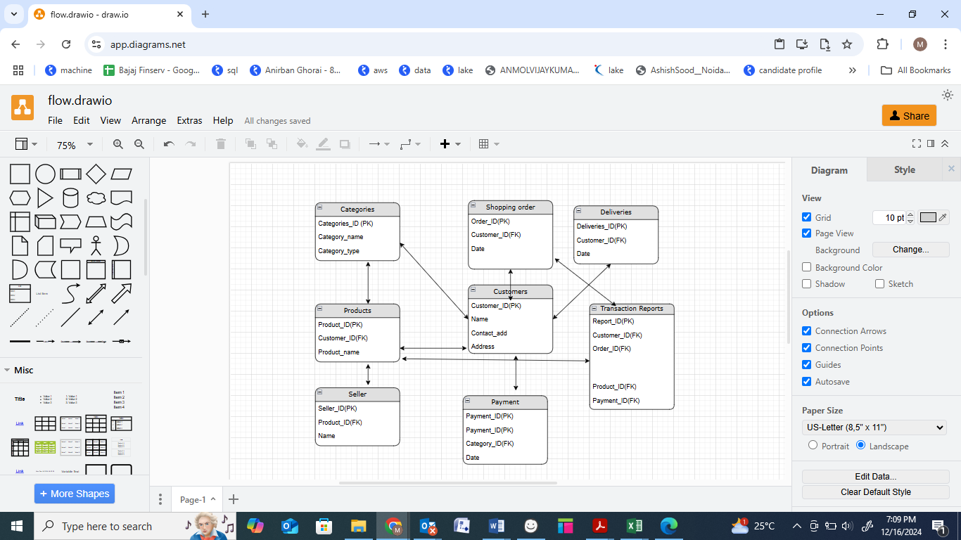

**Question 7 :- Data Flow Diagram**

**What is a data flow diagram? Draw a data flow diagram to represent the in-flow and out-flow of data when a Farmer is placing an order for the product**

**A data-flow diagram** is a way of representing a flow of data through a [process](https://en.wikipedia.org/wiki/Process) or a system (usually an [information system](https://en.wikipedia.org/wiki/Information_system)). The data flow diagram also provides information about the outputs and inputs of each entity and the process itself.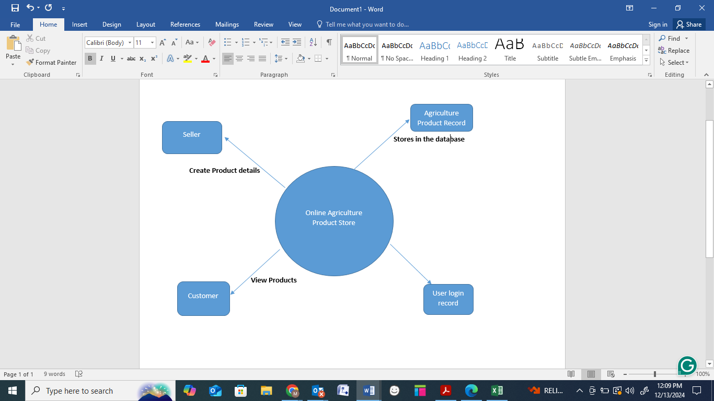

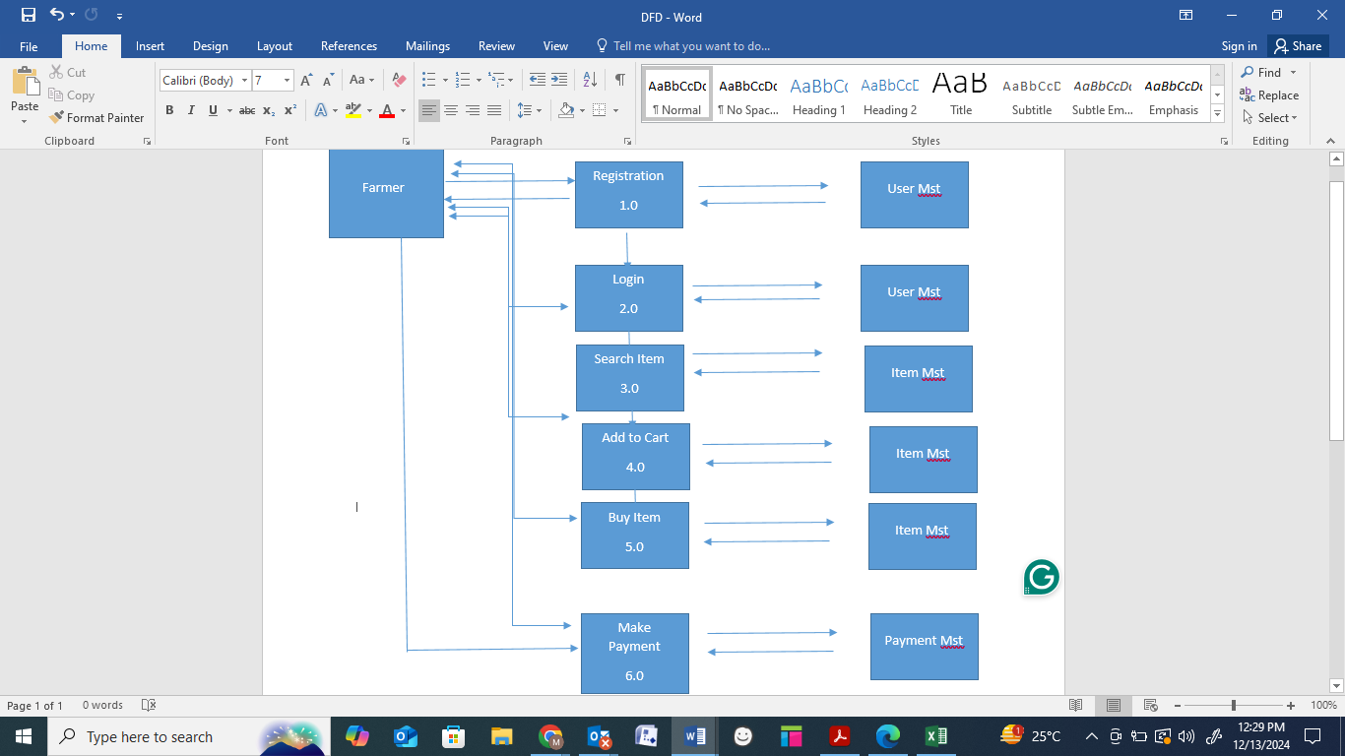

**Question 8 – Change Request**

**Due to change in the Government Taxation structure. we should change the Tax structure**

**How do you handle change requests in a project?**

**Answer :-**

As a BA first I will document the change request. Then analyze the change request. Then I will get the approval from project manager. Here the change request is the changes in the govt. taxation structure so I will inform and discuss this with the stakeholders that we have to change our own taxation structure so that our budget to complete this project will be changed

**I will follow the below steps to change the project as per the client’s requirement**.

1. Document the change request
2. Look for any supporting materials to help in adding this change
3. Need to assess, whether the changes is an inside or outside scope. As it is an outside scope, the budget and time will be impacted.
4. BA and PM should ensure whether the change is a minor or a major change. Policy changes by Govt is a major change request and we need to ensure that the change should be done according to the Govt instructions.
5. Fill the change request form and get approval from the Project Manager.
6. We also need to ensure that our team understand the priority of this change request.
7. We also need to discuss the change with the change control board who will recommend the necessary change on the project.
8. Once this is approved. the project deliverables will need to be updated. This can include plans and schedules, business process documents, and the requirement documents.
9. Once these update have been made, the project manager can communicate the new course of action to everyone who will be impacted . . Now you can delegate the necessary task to the people of implementing these new changes.

**And also handling change requests** in a project involves a systematic process to ensure that changes are effectively managed while minimizing disruption to the project's scope, timeline, and resources. Here are the steps typically followed to handle change requests:

1. **Change Request Identification**: Identify and document the change request, including the specific details of the change, the reason for the change, and its potential impact on the project.

2. **Change Impact Analysis**: Assess the impact of the change on various aspects of the project, such as scope, timeline, cost, resources, and risks. Evaluate the feasibility and implications of implementing the change.

3. **Change Evaluation**: Review the change request with key stakeholders, including project sponsors, clients, and relevant team members. Discuss the potential benefits, risks, and trade-offs associated with the change. Consider the project objectives, constraints, and priorities in the evaluation process.

4. **Change Prioritization**: Prioritize the change request based on its urgency, impact, and alignment with project goals. Determine whether the change is critical and must be implemented immediately or can be scheduled for a future phase or release.

5. **Change Approval**: Obtain formal approval from the appropriate stakeholders, such as project sponsors or change control boards. Ensure that all stakeholders are in agreement regarding the change and its implications.

6. **Change Implementation**: Incorporate the approved change into the project plan, including any necessary adjustments to the scope, schedule, budget, or resources. Communicate the change to the project team and other relevant stakeholders. Update project documentation, such as requirements, design, and test plans, to reflect the approved change.

7. **Change Communication**: Communicate the approved change to all relevant parties, including team members, clients, and other stakeholders. Clearly explain the reasons for the change, its impact on the project, and any adjustments to expectations or deliverables.

8. **Change Tracking and Documentation**: Track and document all approved changes, including the rationale, approvals, and implemented modifications. Maintain a change log or change register to ensure transparency and accountability throughout the project.

9. **Change Control and Monitoring**: Continuously monitor the impact of implemented changes on the project's progress, risks, and quality. Maintain open lines of communication with stakeholders to address any concerns or issues related to the approved changes. Monitor the project's overall alignment with the revised scope, timeline, and objectives.

By following these steps, a project can effectively manage change requests, ensuring changes are evaluated, approved, and implemented in a controlled manner, while minimizing disruptions and maintaining project success

**Question :- 9 :- Change Request Vs an Enhancement.**

**As the project is in process, Ben and Kevin have contacted you. The reason is to inform you that**

**they want the Farmers to sell their crop yields through this application i.e. Farmers should be able to add their crop yields or products and display to general public and should be able to sell them.They also want to introduce Auction system for their Crop yields. As a BA, what will be your response?**

**Is this a change request or an enhancement???**

**Answer :-**

As a business analyst, my response to Ben and Kevin's request would be to classify it as an enhancement rather than a change request. A change request typically involves modifications to existing functionality or requirements, while an enhancement introduces new features or capabilities that were not initially specified. In this case, the request to allow farmers to add their crop yields, display them to the general public, and enable selling through the application represents an enhancement because it introduces new functionality that goes beyond the initial scope of the project. Additionally, the introduction of an auction system for crop yields adds another layer of functionality to the application.

To address this enhancement request, I would follow the standard process for handling requirements:

1. **Requirement Gathering**: I would meet with Ben and Kevin to gather detailed requirements for the new functionality. This would involve understanding the specific features they envision, such as the process for farmers to add and manage their crop yields, the display of products to the public, and the implementation of the auction system.

2**. Impact Analysis**: I would analyze the impact of these enhancements on the existing project scope, timeline, budget, and resources. This assessment would help determine the feasibility and potential implications of incorporating the requested features.

3**. Stakeholder Analysis**: I would identify and involve relevant stakeholders, such as the project sponsor, development team, and other key personnel, to assess their perspectives and gather their inputs on the potential enhancements.

4. **Documentation and Communication**: I would document the detailed requirements and changes in the project scope, and communicate them to the project team .stakeholders, and any other parties involved. This would ensure everyone is aware of the proposed enhancements and their implications.

5. **Evaluation and Prioritization**: I would work with the project team and stakeholders to evaluate the value and priority of the requested enhancements. This evaluation would consider factors such as the potential benefits, impact on project goals, alignment with business objectives, and available resources.

6. **Planning and Execution**: If the enhancements are deemed feasible and approved, I will update the project plan, schedule, and resources accordingly. I would collaborate with the development team and other stakeholders to incorporate the new features into the application, ensuring proper testing and quality assurance.

By treating this request as an enhancement, the project can effectively manage the additional requirements and deliver the desired functionality while considering the impact on the ongoing project

**Question 10 :- Come up with estimations – How many Manhours required ?**

**Answer :-**

Estimating the number of man-hours required for the requested enhancements (adding crop yields, displaying them to the public, and implementing an auction system) would depend on various factors, including the complexity of the features, the size of the existing system, the development team's expertise, and the development methodology used. Without specific details about the project, it's challenging to provide an accurate estimation. However, I can offer a general guideline based on industry standards and experience.

1. **Requirement Gathering and Analysis**: 10-20 man-hours

This includes meetings with stakeholders, gathering detailed requirements, analyzing the impact, and documenting the enhancements.

2. **Design and Architecture**: 20-40 man-hours

This involves designing the system components, database structure, and user interface for the new features. It also includes identifying the necessary changes to accommodate the enhancements.

3. **Development and Coding**: 40-80 man-hours

 The actual development of the new features, including backend and frontend coding, integration with existing modules, and implementation of the auctions system.

4. **Testing and Quality Assurance**: 20-40 man-hours

This phase involves writing test cases, performing unit testing, integration testing, and ensuring the proper functioning and stability of the added features.

5. **Deployment and User Acceptance Testing (UAT):** 10-20 man-hours

Deploying the updated system to a testing environment, conducting user acceptance testing, and resolving any issues identified during UAT.

6.**Documentation and Training**: 10-20 man-hours

Documenting the new features, updating user manuals or guides, and providing training or support materials for farmers and users.

It's important to note that these estimations are rough figures and can vary significantly depending on the complexity and scale of the enhancements, the team's productivity, and other project-specific factors. It's recommended to involve the development team in the estimation process to get a more accurate assessment based on their expertise and knowledge of the project.

**Question 11**

**Project has finally completed all the stages i.e., design, development, testing etc. Now, it is the role of a business analyst to contact the client for testing of the final product and have to successfully complete it. How are you going to handle this situation? And once it is done, what will be the process to close the project? Explain UAT Acceptance process**

**Answer :-**

To handle the situation of testing the final product and successfully completing it, the business analyst can follow these steps:

1. **UAT Planning**: Prepare a plan for User Acceptance Testing (UAT) in consultation with the client. This plan should include the scope of testing, test scenarios, test data, and timelines.

2. **Test Environment Setup**: Ensure that the required test environment is set up and available for the client to perform testing. This may include providing access to the testing environment, necessary test accounts, and any additional resources needed for testing.

3. **Test Execution**: Coordinate with the client to execute the planned test scenarios. Monitor the testing progress, provide support for any questions or issues that arise, and track the test results.

4. **Defect Management**: If any defects are identified during UAT, work closely with the client to understand the issues, document them, and track their resolution Collaborate with the development team to address the reported defects and verify their fixes.

5. **UAT Sign-off:** Once the client has completed testing and is satisfied with the product's functionality, obtain their formal sign-off or approval. This indicates that the client has accepted the final product and is ready to move forward with its deployment

**UAT Acceptance Process: The User Acceptance Testing (UAT) Acceptance process involves the following steps:**

1. **Test Planning**: Define the scope of UAT and identify the key features or functionalities to be tested. Prepare test scenarios and test cases based on user requirements.

2. **Test Execution**: Perform the planned test scenarios, following the test cases provided. Validate the system's behavior against the expected outcomes and verify that it meets the user's acceptance criteria.

3. **Defect Reporting**: If any issues or defects are identified during UAT, document them in a structured manner, including detailed steps to reproduce the problem. Communicate the issues to the development team for resolution.

4. **Defect Resolution**: Collaborate with the development team to address the reported defects. Verify the fixes provided by the development team and retest the affected areas.

5**. Sign-off**: Once all test scenarios have been executed, defects have been resolved, and the system meets the user's acceptance criteria, provide formal sign-off or approval. This signifies that the client accepts the product as meeting their requirements.

6. **UAT Closure**: Document the UAT results, including the test execution summary, any outstanding issues, and the overall assessment of the product.

Regarding the process to close the project, it typically involves the following steps:

1. **Final Documentation**: Ensure that all project-related documentation is complete, including requirements, design documents, test cases, and user manuals. Review and update these documents to reflect the final product.

2. **Project Review**: Conduct a project review meeting with key stakeholders, including the client, to discuss the overall project performance, achievements, and lessons learned. Gather feedback and suggestions for improvement.

3. **Project Closure Report**: Prepare a project closure report summarizing the project's objectives, deliverables, timeline, budget, and overall success. Include any important metrics or performance indicators.

4. **Handover or Deployment**: Coordinate with the necessary teams, such as deployment or operations, to ensure a smooth transition of the final product to the production environment. Provide any necessary training or documentation to support the deployment process.

5. **Post-Project Evaluation**: After the product is deployed and operational, conduct an a post-project evaluation to assess its performance, gather user feedback, and identify any areas for further improvement.

Communicate the closure of UAT to all stakeholders involved in the testing process. The UAT Acceptance process ensures that the final product meets the client's expectations and is ready for deployment. It serves as a final validation before the project is considered complete and ready for closure. defined objectives and success criteria. It assesses factors such as scope adherence, timeline adherence, budget performance, quality of deliverables, and customer satisfaction.

**A project closure document** is a comprehensive report that summarizes the entire project's lifecycle, outcomes, and lessons learned. It serves as a formal record of the project's completion and provides important information for future reference. The document typically includes the following sections:

1. **Project Overview**: This section provides an overview of the project, including its objectives, scope, and stakeholders involved. It summarizes the project's purpose and sets the context for the closure report.

2. **Project Achievements**: Here, the document highlights the key achievements and deliverables of the project. It outlines the successful completion of milestones, tasks, and any significant accomplishments that were achieved.

3. **Project Timeline and Budget**: This section provides an overview of the project timeline, highlighting the start and end dates, major phases, and milestones. It also includes information on the project's budget, including any significant deviations or changes.

4. **Lessons Learned**: The lessons learned section reflects on the project's successes and challenges. It includes a comprehensive analysis of what worked well and what could have been improved. It highlights valuable insights and recommendations for future projects.

5. **Stakeholder Feedback**: This section gathers feedback from key stakeholders involved in the project. It includes their opinions, suggestions, and any concerns they may have expressed. The feedback helps in assessing the overall satisfaction and identifying areas for improvement.

6**. Risks and Issues**: The closure document discusses the risks and issues encountered throughout the project. It outlines the actions taken to mitigate the risks and resolve any issues that arose during the project's lifecycle.

7. **Project Performance**: This section evaluates the project's performance against the defined objectives and success criteria. It assesses factors such as scope adherence, timeline adherence, budget performance, quality of deliverables, and customer satisfaction

8**. Project Sign-off:** The closure document includes formal sign-off or approval from key stakeholders, indicating their acceptance and satisfaction with the project outcomes. This signifies the official closure of the project.

9. **Project Documentation**: This section provides an overview of the project documentation, including the list of documents produced, their location, and accessibility for future reference.

10.**Next Steps and Recommendations**: The closure document outlines any recommended actions or next steps following the project's closure. It may include suggestions for further improvements, additional tasks, or follow-up activities.

**Question 12. Explain Project Closure Document**.

**Answer**

The project closure document serves as a final report that captures the project's journey, outcomes, and key learnings. It provides a reference for future projects, helps evaluating project success, and facilitates knowledge transfer to stakeholders in the project

|  |  |  |  |
| --- | --- | --- | --- |
| Project Closure Online Agriculture Product Store | | | |
| **Revision Date : DD/MM/YY** | Version :1.0 | | |
| **Approver Name** | **Title/Role** | **Signature** | **Date** |
| Peter and Ben | Project Stakeholder | OK | XX/XX/XX |
| Mr. Henry | VP | OK | XX/XX/XX |
| Mr Pandu | Financial Head | OK | XX/XX/XX |
| Mr. Vandanam | Project Manager | OK | XX/XX/XX |
| Mr.Kartik | Delivery Head | OK | XX/XX/XX |
| Mr Doku | Project Coordinator | OK | XX/XX/XX |

By authorizing this Project Closure, the Project Stakeholder(s), and Executiveve Sponsor agree to all terms within this document.

**Revision History**

Identify document changes.

|  |  |  |  |
| --- | --- | --- | --- |
| **Version** | **Date** | **Name** | **Description** |
| 1 | XX/XX/XX | Mr. Henry | Ok to Process |

**Section 1. General Information**

|  |  |
| --- | --- |
| **Project Activity** | **Date** |
| Project Start | 11-Jan-23 |
| Project Closure | 15th-Sep-2024 |

**Section 2 . Business Objectives** (As Identify in business case document)

|  |  |  |  |
| --- | --- | --- | --- |
| **Business Case** | **Business Objectives** | **Met/Not Met** | **Comments** |
| BI0001 | Farmer should be able to buy and sell agricultural product online | Yes | OK |

**Section 3. Customer Expectation Management**

|  |  |  |  |
| --- | --- | --- | --- |
| **Item** | **Question** | **Description** | **Comments** |
| 1 | Were all expected benefits and business outcomes realized ? | Yes | OK |
| 2 | Were all performance standards satisfied | Yes | OK |

**Section 4. Outstanding Actions Items and issues**

|  |  |
| --- | --- |
| **Action Item** | **Transition and /or Resolution** |
| Were all expected benefits and business outcomes realized ? | Yes |
| Were all performance standards satisfied | Yes |

**Section 5. Project Office Checklist**

|  |  |
| --- | --- |
| **Deliverable** | **Description** |
| Risk assessment completed and posted on suitable shared storage | Yes or NO |
| Business case completed and posted on suitable shared storage | Yes or NO |
| Project charter completed and posted on suitable shared storage | Yes or NO |
| Meetings notes completed and posted on suitable shared storage | Yes or NO |
| Additional project documentation and artifacts posted on suitable shared storage, including requirements Template, Project Change requests, Milestone Timeline, Work Breakdown Structure, etc. | Yes or NO |
| Lesson learned document | Yes or NO |
| Project folder moved completed projects on suitable shared storage | Yes or NO |
| Supported handover document completed and archived | Yes or NO |
| Comments , Ok to process .Application running properly | Yes or NO |