**SCRUM LIVE PROJECT**

**Document 1: Definition of Done:**

It establishes the quality criteria for delivery of product increment. It is used to assess when work is complete on the product increment. It applies to all work of the entire team-including user stories and defect resolution.

Things that are commonly addressed in the Definition of Done are:

1) Operating environments and at what level of integration are user stories expected to work (what specific version of Linux, what specific version of Android, iOS, or browser?

2) What level of documentation is required (automatically generated Javadoc vs. fully edited end-user documentation?

3) What are the quality expectations (basic functionality works for demo purposes vs. fully designed and bullet proofed app?

4) What are the security expectations (no security implemented vs. security vetted at all levels, from code reviews, code scans, up through network security configuration?

A Definition of Done is a clear and concise list of requirements that software must adhere to for the team to call it complete. While the DoD usually applies to all items in the backlog, acceptance criteria are applicable to a specific user story. In order to complete the story, both the DoD and acceptance criteria must be met.

The DoD starts with organizational standards that all teams must follow as a minimum. That infers that teams can add to the organizational DoD but cannot omit items from it. If multiple teams work on one product, they comply with the same DoD

**Steps to a definition of done**

* Create a DoD in Jira

The best way to have a DoD inside Jira is to use a Custom Field. We can use the standard text field or checkboxes, but both have drawbacks – for example, text fields do not show which items are complete and checkboxes are only visible in edit mode.

* Break it down

Definitions of done correspond to different parts of the development process: technical tasks, user stories, and bugs. For example, a project could have this DoD:

Code builds without warnings (technical task)

Code unit tested (technical task)

Documentation updated (user story)

Build pushed to demo server (user story)

* Make it Global

By using custom field options, you can create DoD Items that are applicable to any issue: old or new. Moreover, modifying, adding, or removing an option is immediately reflected in all your Jira issues.

* Manage it over time-A Definition of Done is a live document that should be reviewed regularly. As your dev team strives to improve, you can make your practices more stringent over time. Rather than deleting or modifying options, simply disable them. Disabling an option will keep the option in Jira but prevents it from appearing on issues. This allows you to keep a record of your DoD over time. And if you really want to challenge the team, you can add more DoD items but make some of them mandatory and others optional.

Make the product owner responsible and the team accountable-

* Set up the DoD custom field such that only the product owner can add/modify/remove items. This will make him or her responsible for stating what they want. Then, let the team be accountable for delivering what the PO wants by crossing off every item in the DoD.
* Enforce it:The best way to have an agile team follow the DoD is to embed it into their scrum workflow. Use a Workflow Validator on the technical task or a user story workflow transition to prevent the resolution of the issue until all DoD items are done. This demands accountability and reinforces what “Done” really means.
* Create an acceptance criteria list in Jira: At the end of the day, the acceptance criteria list is nothing more than a DoD that is specific to every user story. To implement an acceptance criteria list in Jira, either create a new custom field or piggyback on the global DoD. With Checklist, you can add items directly at the issue level. So, you could have a single DoD custom field with the mandatory global items as options and each individual acceptance criterion as an item at the issue level.

**Checklist for DOD:**

* Produced code for presumed functionalities
* Assumptions of User Story met
* Project builds without errors
* Unit tests written and passing
* Project deployed on the test environment identical to production platform
* Tests on devices/browsers listed in the project assumptions passed
* Feature approved by UX designer
* QA performed & issues resolved
* Feature is tested against acceptance criteria
* Feature approved by Product Owner
* Refactoring completed
* Any configuration or build changes documented
* Documentation updated
* Peer Code Review performed

**Document 2- Product Vision**

|  |  |  |  |
| --- | --- | --- | --- |
| Scrum Project Name: | Product Management System |  |  |
| Venue: | Pune |  |  |
| Date | March 2024; |  |  |
| Duration: | 3 months |  |  |
| Client: | In-house |  |  |
| Stakeholder list | Business Analyst  Project Manager  Developers  Testers  User |  |  |
| **Scrum team** | | | |
| Scrum Master: | Mr. Vikash |  |  |
| Product owner: | Ms. Suman |  |  |
| Scrum Developer 1: | Mr. Zaid |  |  |
| Scrum Developer 2: | Mr. Uni |  |  |
| Developer 3: | Ms. Karmarkar |  |  |
| Scrum  Developer 4: | Ms. Khole |  |  |

|  |  |  |  |
| --- | --- | --- | --- |
| **Vision:** To build a Product Management system for cost associated with the legal and regulatory aspect of the Drug product development which provides integrated system for approval of invoices and process timely payment. The applications has inbuilt structure to verify all the compliances. The application has ease of access, retrieval, review of data and report preparation | | | |
| **Target group:**  The product is built to address approval of invoices by the Pharma. company, the customers are legal and regulatory officers, attorneys and their finance team, users are approval team which consists of project management, finance executives, finance head, approvers. | **Need:**  The manual system is time consuming, all the compliances are verified manually often results in delayed payments and penalties. System is difficult to track, data review, reports and retrieval is manual and not efficient.  Product Management system provide an online integrated system/application for the invoice approval and payment system, easy linkage of all the stakeholders of the system. The process is time efficient and ease of access, retrieval, review and report preparation. | **Product:**  Online Product Management system for cost associated with the legal and regulatory aspect of the Drug product development. It provides integrated system for approval of invoices and process timely payment. The applications has inbuilt structure to verify all the compliances. The application has ease of access, retrieval, review of data and report preparation. It is highly feasible to develop the product | **Value:**  The product provides an efficient invoice approval process, since untimely payments can result in delayed Drug product approvals and substantial loss to the company. The goal is to provide easy, hassle free system to process invoices and release payments to the service providers and ease of business. |

**Document 3: User stories**

|  |  |  |
| --- | --- | --- |
| User Story No. 001 | Task: 4 | Priority: Medium |
| As a first line approver | | |
| I want to register in the database | | |
| So that I can login and access the system | | |
| BV:100 | CP:2 | |
| Acceptance Criteria | | |
| Visit Registration Screen. Enter official email, generate Password through the link send, change password in the text boxes. Click on Register Button. If registration is successful Notification will be received. | | |
|  |  |  |
| User Story No. 002 | Task: 4 | Priority: Medium |
| As a system admin | | |
| I want to login in system | | |
| So that I see the summary screen | | |
| BV:100 | CP:2 | |
| Acceptance Criteria | | |
| Visit Login Screen; enter official email id and password in the text Boxes; Click on login Button and visit the page then Click on the required tabs. | | |
|  |  |  |
|  |  |  |
| User Story No. 003 | Task: 3 | Priority: High |
| As a finance executive | | |
| I want to select and check invoice | | |
| So that I can approve the invoice | | |
| BV:500 | CP:2 | |
| Acceptance Criteria | | |
| Visit the home page; View pending invoices on the page; Click the invoice to be reviewed, check for pending system compliance, if complaint approve, else raise query and send back. | | |
|  |  |  |
| User Story No. 004 | Task: 7 | Priority: High |
| As a regulatory officer | | |
| I want to upload the invoice | | |
| So that I can forward the invoice | | |
| BV:500 | CP:2 | |
| Acceptance Criteria | | |
| Visit home page, view the invoice list, selected new upload, click and confirm new document upload, save and close or save and forward, receive sent intimation. | | |
|  |  |  |
| User Story No. 005 | Task: 3 | Priority: High |
| As a finance executive | | |
| I want to see the pending invoices list | | |
| So that I can prepare the summary | | |
| BV:500 | CP:2 | |
| Acceptance Criteria | | |
| Click invoice details; view summary options by date, firm, amount, priority; select the option to prepare the report; get the output in required format. | | |
|  |  |  |
| User Story No. 006 | Task: 4 | Priority: Medium |
| As a second line approver | | |
| I want to see the pending invoices | | |
| So that I can view status report | | |
| BV:200 | CP:2 | |
| Acceptance Criteria | | |
| Visit and Click pending invoices tab; select from date to date and view invoices; see the details generated. | | |
|  |  |  |
| User Story No. 007 | Task:2 | Priority: low |
| As a legal officer | | |
| I want to logout from the database | | |
| So that I can close the application | | |
| BV:100 | CP:1 | |
| Acceptance Criteria | | |
| Visit and click logout tab; receive logout notification. | | |
|  |  |  |
| User Story No. 008 | Task: 5 | Priority: High |
| As a Admin | | |
| I want to login in database | | |
| So that I can access the app as an admin | | |
| BV:500 | CP:2 | |
| Acceptance Criteria | | |
| Visit Login Screen; click Text Boxes for Admin; enter official email id and password in the text boxes; Click on login; homepage should appear on successful login. | | |
|  |  |  |
| User Story No. 009 | Task: 8 | Priority: High |
| As a finance head | | |
| I want to manage regional restaurants | | |
| So that I can evaluate the restaurants | | |
| BV:500 | CP:2 | |
| Acceptance Criteria | | |
| Click on performance of restaurants tab and visit the page; select from date to date ; then click on generate report which includes restaurants id, name, revenue ; click on download report with excel option; view the generated report. | | |
|  |  |  |
| User Story No. 0010 | Task: 5 | Priority: High |
| As an second line approver | | |
| I want to review the invoices | | |
| So that I can approve them | | |
| BV:200 | CP:2 | |
| Acceptance Criteria | | |
| Visit List of invoices; select the pending one or your task ; verify details; click the approve button or reject button; notification to be sent to the next level approver. | | |
|  |  |  |
| User Story No. 0011 | Task: 7 | Priority: medium |
| As a finance head | | |
| I want to View total invoice for a particular service provider | | |
| So that I can check if it is in the approved budget | | |
| BV:100 | CP:2 | |
| Acceptance Criteria | | |
| Click on view invoice tab; select service provider from the list ; select from date to date ; click on generate report; click on download report with excel option; the report is generated and downloaded. | | |
|  |  |  |
| User Story No. 0012 | Task: 7 | Priority: medium |
| As an Admin | | |
| I want to View rejected invoices | | |
| So that I can check turnaround time | | |
| BV:100 | CP:2 | |
| Acceptance Criteria | | |
| Visit and Click on view invoices; select from date to date;  click on generate report from rejected list; click on download report with excel option; the report is generated and downloaded. | | |
|  |  |  |
| User Story No. 0013 | Task: 5 | Priority: medium |
| As a first line approver | | |
| I want to View new invoices from a first time service provider | | |
| So that I can check for compliance | | |
| BV:100 | CP:2 | |
| Acceptance Criteria | | |
| Click on invoice list; select service provider; check for the compliance documents, approved rates. | | |
|  |  |  |
| User Story No. 0014 | Task: 2 | Priority: low |
| As a first line approver | | |
| I want to add new service provider | | |
| So that I the new service provider can upload invoices | | |
| BV:100 | CP:2 | |
| Acceptance Criteria | | |
| Visit homepage, add new service provider tab, add details, check and upload documents, send for second line approval. | | |
|  |  |  |
| User Story No. 0015 | Task: 4 | Priority: high |
| As a regulatory service provider | | |
| I want to login the application | | |
| So that I can access the app | | |
| BV:500 | CP:2 | |
| Acceptance Criteria | | |
| Visit Login Screen; enter User Name and Password in Text Boxes Click on login Button; home page should appear on successful login. | | |
|  |  |  |
| User Story No. 0016 | Task: 8 | Priority: medium |
| As a finance head | | |
| I want to see the list of delayed payments | | |
| So that I can see all the details | | |
| BV:200 | CP:2 | |
| Acceptance Criteria | | |
| Visit report page and Click on reports with options of date, amount, firm, payments. Click on the late payment notified invoices; click on generate report; select from date to date ; include options from delayed time, approval delay, bank issues; click on download report with excel option, the report is generated and downloaded. | | |
|  |  |  |
| User Story No. 0017 | Task: 5 | Priority: medium |
| As a first line approver | | |
| I want to Update approved budget for the service provider | | |
| So that I see the manage payment for new invoices | | |
| BV:200 | CP:2 | |
| Acceptance Criteria | | |
| Click on budget; Select the list of the service provider; add the approved amount, notify second line approver. | | |
|  |  |  |
| User Story No. 0018 | Task: 7 | Priority: medium |
| As a system admin | | |
| I want to access information for various service provider | | |
| So that I can compare the spend | | |
| BV:200 | CP:2 | |
| Acceptance Criteria | | |
| Click list of service provider to compare, select date and task, then click on download report for the required with excel option; the report is generated and downloaded. | | |
|  |  |  |
| User Story No. 0019 | Task: 3 | Priority: medium |
| As an regulatory service provider | | |
| I want to check status of payment for the invoices | | |
| So that I update the payment status | | |
| BV:200 | CP:2 | |
| Acceptance Criteria | | |
| Click the invoices tab; click status tab, which will provide information, pending, approved, payment transaction. Check the report. | | |
|  |  |  |
| User Story No. 0020 | Task: 3 | Priority: low |
| As a finance head | | |
| I want to check the spend for Regulatory service for particular product | | |
| So that I can check compliance with approved budget | | |
| BV:100 | CP:2 | |
| Acceptance Criteria | | |
| Click on product tab; select sub options from legal, regulatory, others, select date, generate report for Regulatory service, click the approved budget tab, download or check the reports. | | |

**Document 4: Agile experience as product owner:**

**Product Owner:**

A Product Owner is part of the scrum team. The key responsibilities of a Product Owner are to define user stories and create a product backlog. The Product Owner is the primary point of contact on behalf of the customer to identify the product requirements for the development team. The product owner fills the gap between product strategy and development. They are usually responsible for the product backlog, organizing sprints, and are expected to answer questions from developers as needed.

Product owners are responsible for utilizing the agile development approach to make sure the right product completes development. A large part of their job involves meticulous planning. For that planning, they need a clear vision that emphasizes the value of the product.

**The following is a summary of the skills required to become a product owner.**

1) Committed to Vision: Product owners need to be able to communicate the product vision with all stakeholders. That includes explaining product backlog changes, changing requirements, and other vision-related processes.

2) Constant Availability: The development team often consults the product owner because they understand the product plan completely. Therefore, they need to be always available and open to communication.

3) Understanding of ROI: Product owners are responsible for product success and must focus on its proper production. They are responsible for making sure the ROI is positive in the end.

4) Technical Skills: The product owner needs to have an idea of everything from software development to product marketing.

5) End-User Perspective: Product owners need to have the ability to think long-term. They need to develop their vision and processes from an end-user point of view.

6) All the skills mentioned above are summarized versions. Product owners typically need an understanding of all product-based roles, thus, justifying the product owner's salary.

**Role**

1. Managing and prioritizing the product backlog

2. Translating product managers strategies to tasks for development

3. Learning the market and customers’ needs

4. Serving as a liaison between product and development

5. Staying accessible to development team to answer questions.

**Role of product owner in Scrum meetings:**

1) Sprint Planning Meeting

2) Daily Scrum Meeting

3) Sprint Review Meeting

4) Sprint Retrospective Meeting

5) Backlog Refinement Meeting

**Document 5: product and sprint burndown charts**

A sprint burndown chart is a visual comparison of how much work has been completed during a sprint and the total amount of work remaining. It helps measure a Scrum team's progress, and it provides an easy view of whether the team needs to make any adjustments to complete its work for the current sprint iteration.

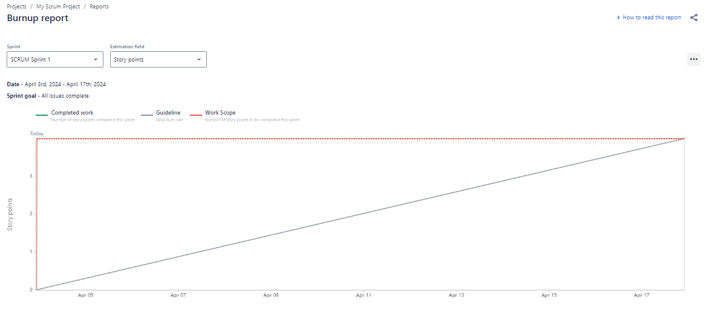

The product burndown chart is the chart that is plotted with the story points of all the user stories on the y-axis and the sprint numbers on the x-axis. It provides the product backlog visualization of completed requirements over time.

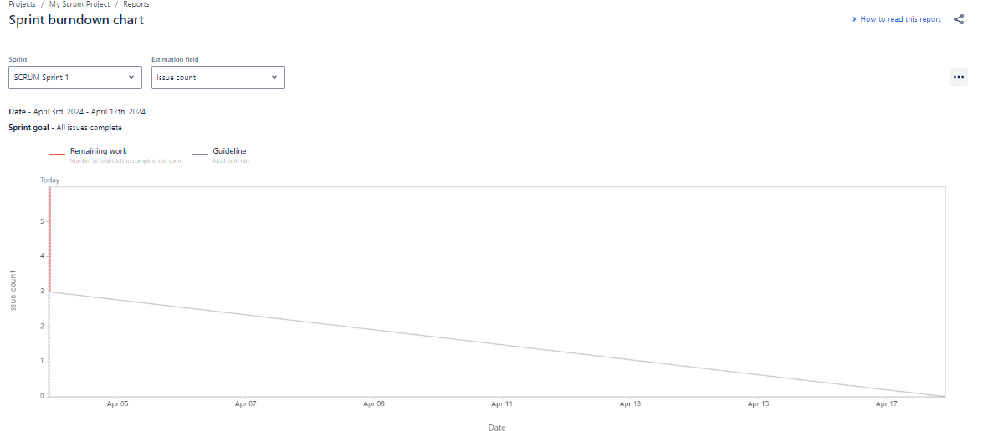

**Document 6: Sprint meetings**

Meeting Type 1: Sprint Planning meeting

|  |  |
| --- | --- |
| Date | March 2024 |
| Time | 10.00 am |
| Location | Pune |
| Prepared By | Dipti |
| Attendee | Business Analyst, Project Manager, Developers , Testers and User |

Agenda Topics

|  |  |  |
| --- | --- | --- |
| Topic | Presenter | Time allot |
| Number of user stories in each sprint | Project Manager | 30 minutes |
| Priorities of user stories | Business Analyst | 30 minutes |

Other Information

|  |  |
| --- | --- |
| Observers | SMEs |
| Resources | Team, software systems |
| Special Notes | Next meeting time and date |

Meeting Type 2: Sprint review meeting

|  |  |
| --- | --- |
| Date | March 2024 |
| Time | 10.00 am |
| Location | Pune |
| Prepared By | Dipti |
| Attendee | Business Analyst, Project Manager, Developers |

|  |  |  |  |
| --- | --- | --- | --- |
| Sprint status | Things to demo | Quick updates | What’s next |
| Number of user stories covered | DoD | Issues | Complete the user stories |

Meeting Type 3: Sprint retrospective meeting

|  |  |
| --- | --- |
| Date | March 2024 |
| Time | 10.00 am |
| Location | Pune |
| Prepared By | Dipti |
| Attendee | Business Analyst, Project Manager, Developers , Testers and User |

|  |  |  |  |  |
| --- | --- | --- | --- | --- |
| Agenda | What went well | What didn’t go well | Questions | Refer |
| Sprint cycles | Number of user stories covered as decided in sprint meeting | Time management | Utilization of resources? | Previous products |
| Product backlog | Was cleared on time | cluttered | More refinement needed | Previous products |

Meeting Type 4: Daily Stand-up meeting

|  |  |  |  |  |  |  |
| --- | --- | --- | --- | --- | --- | --- |
| Question | Name/Role | Mon | Tue | Wed | Thrus | Fri |
| What did you do yesterday? | Developer 1 | Code for user story 1--4 | Code for user story 1--4 | Code for user story 1--4 | Code for user story 1--4 | Code for user story 1--4 |
| Developer 2 | Code for user story 5-7 | Code for user story 5-7 | Code for user story 5-7 | Code for user story 5-7 | Code for user story 5-7 |
| Developer 3 | Code for user story 8-10 | Code for user story 8-10 | Code for user story 8-10 | Code for user story 8-10 | Code for user story 8-10 |
| What will you do today? | Developer 1 | Code for user story 1--4 | Code for user story 1--4 | Code for user story 1--4 | Code for user story 1--4 | Code for user story 1--4 |
| Developer 2 | Code for user story 5-7 | Code for user story 5-7 | Code for user story 5-7 | Code for user story 5-7 | Code for user story 5-7 |
| Developer 3 | Code for user story 8-10 | Code for user story 8-10 | Code for user story 8-10 | Code for user story 8-10 | Code for user story 8-10 |
| What (if any) is blocking your progress? | Developer 1 | NA |  |  |  |  |
| Developer 2 | NA |  |  |  |  |
| Developer 3 | NA |  |  |  |  |