**1 Que**.- Identify Business Process Model for Online Agriculture Store – (Goal, Inputs, Resources, Outputs, Activities, Value created to the end customer –

Ans.- BPM is a visual representation of a business process that depicts the flow of activities, task, decisions, and interactions involved in achieving a particular business objective. BPM is used to analyze, design, documentation, communication, and improve business processes within an organization.

Goal- To create an online application for farmers in remote areas to easily purchase agriculture products such as fertilizers, seeds, and pesticides.

Inputs – Payment Information, Customer orders and product details provided by manufacturers.

Resources – Mobile application or the website, IT infrastructure, and Delivery Head, Project Manager, Senior Java Developer, Network Admin, Java Developer, DB Admin, Testers.

Output – Online agriculture product store platform, order placed by farmers for desired products, delivery of purchased products to farmers locations, communication channels established between farmers and manufacturing companies.

Activities –

Development online platform and framework by using programming language led by Ms. Juhi and team (Mr. Teyson, Ms. Lucie, Mr. Tucker, Mr. Bravo)

Design the user-friendly interface of online application considering ease of navigation and accessibility for Farmers.

Gathering information from stakeholders regarding product types, features, and usage.

Database set-up and maintain data infrastructure for storing product details, transaction records, user information.

Order processing were farmers browse products, select items and place order through this online application.

Value created to the end user by convenient access to fertilizers, seeds, and pesticides from anywhere with internet connectivity. User Friendly application and direct communication with manufacturers and farmers.

**2 Que**.- Mr Karthik is doing SWOT analysis before he accepts this project. What Aspects he Should consider as Strengths, as Weaknesses, as Opportunity and as Threats.

Ans.- Strengths

Identify and evaluate opportunities in the market is important for farmers in remote areas with ease agricultural products.  
APT IT Solutions team includes experienced developers, testers, network administrator, capable of handling project requirements effectively.  
The Project is financially backed by Mr. Henry’s company, SOONY with the budget of 2 crores INR, providing financial resources of development.  
Strong stakeholders support of Mr. Henry, Mr. Pandu, Mr. Dooku who is actively involved in project for provision of support.

Weaknesses

Limited timeframe of 18 months which may enforce constraints on development and implementation of project.  
The budget of 2 crores INR may not be insufficient to cover all departmental cost and expenses.

Dependency on external factors such as internet connectivity issues in remote areas and product delivery as in Logistic factor.

Opportunities

Collaboration with agricultural organization, government agencies, industry stakeholders could enhance market visibility and opportunities.  
Market expansion by having online agriculture product store has potential to reach beyond remote areas and increased market exposure for farmers through online and revenue opportunities.  
Diversification of product offerings, the platform could explore the agricultural products or services to meet customer needs and desire.

Threats

Risks related to technology failures, data breaches or cybersecurity threats may impact the reliability of the online system.  
Regulatory compliance standards related online transactions, data privacy could pose legal and operational challenges.  
Competitive platforms requiring differentiation strategies to stand out in the market and project may face competition between online store and traditional agriculture suppliers.

**3 Que**.- Mr Karthik is trying to do feasibility study on doing this project in Technology (Java), Please help him with points (HW SW Trained Resources Budget Time frame) to consider in feasibility Study.

Feasibility study contains executive summary of project’s ability, description of product or service being developed during project, and technical consideration including technology, staffing.

Hardware   
Mr. Karthik should ensure infrastructure requirements assess the hardware requirement for developing and hosting online agriculture store including storages, networking equipment and other required hardware components.  
  
Software  
Mr Karthik need to check compatibility with existing software systems and dependencies, ensure that necessary software tools and frameworks for java development are available and compatible. Evaluate the performance capabilities of java for meeting the project’s requirement, including speed, responsiveness, and resource efficiency.

Trained Resources   
Mr Karthik should assess the availability of trained resources with expertise in Java, web development, and related technologies required for project implementation. He should also identify if any gaps in skills or knowledge among the project team members and plan for training programs or skill enhancement.

Budget  
Estimation of costs associated with java development, including salaries, training expenses, software licences and infrastructures upgrades. Also, Mr Karthik should evaluate whether the project budget of 2 crores INR is sufficient to cover all the cost and if not then how to adjust the project scope to make it feasible.   
  
Timeframe  
Mr Karthik defined key milestones and deadlines for project deliverables to ensure timely progress and alignment within 18 months duration. Estimate the time required for each phase of the project, including requirement gathering, design, development, testing and deployment.

**4 Que**.- Mr Karthik must submit Gap Analysis to Mr Henry to convince to initiate this project. What points (compare AS-IS existing process with TO-BE future Process) to showcase in the GAP Analysis

Ans.- To convince Mr Henry to initiate project Mr Karthik should conduct a gap analysis comparing current state (AS-IS) with the future state (TO-BE) process where it will be easy to identify GAP.

AS-IS Process

Currently Farmers in remote areas face challenges in procuring fertilizers, seeds, and pesticides due to manual procurement processes involving physical visits to stores.  
There is a lack of direct communication channels between farmers and manufacturing companies, product enquires, and order placement.  
Geographical constraints, including remote locations and limited transportation infrastructure all challenges are faced by farmers in accessing products and services.

TO-BE Process

The vision of online agriculture product store will provide farmers with convenient and efficient platform to search, select and purchase any agricultural products.  
Direct communication channel such as messaging systems or inquiry system will be established between manufacturing companies and farmers to facilitate product delivery and enquiries.  
The online platform will enhance accessibility by overcome with geographical constraints by providing door step delivery of purchased products to farmer’s location, efficient logistics, and distribution network.

GAP Analysis

Communication effectiveness   
Comparing lack of direct communication channels in the current process with the enhanced communication capabilities of the online platform cover up the gap by facilitation effective communication and collaboration between stakeholders.   
Process Efficiency   
The manual process of purchasing agriculture products is time-consuming and prone to errors. The online store would automate many aspects of the process, increasing efficiency and reducing the likelihood.  
Increased product availability and Better Pricing   
The online store would increase the availability of agriculture products to farmers in remote areas, because in local markets farmers face availability of few products.  
By reducing number of intermediaries and providing direct contacts of companies and farmers, the online store could help better pricing for the products when they need.

**5 Que**.- List down different risk factors they may be involved (BA risks and process/Project Risks)

Ans.- BA Risks  
Unclear requirements gathering and Incomplete requirement   
Inadequate requirements may lead to misunderstandings, rework, and delays in project deliverables. Incomplete gathering may result in missing critical functionalities or deliverables, impacting project success.  
Communication Challenges   
Poor communication between stakeholders, BA, and Project team could lead to misunderstandings, delays, and project disruptions.

Scope Creep  
Unauthorized changes or additions to project scope without proper approval can results in resource overruns, timelines expectations, and project failure.  
Unwilling changes in project   
Changes in requirements or stakeholder’s expectations during the project could results in delays or additional cost will apply at certain level.

Project Risks

Budget overruns  
Exceeding the allocation budget due to unforeseen expenses, cost escalations, or resource shortage can impact project and financial sustainability.  
Technical challenges  
Technical complexities, such as integration issues, compatibility issues, or performance congestion can pose risks to project quality and delivery timelines.  
Resources constraints  
Inadequate availability of resources, including skilled personnel, infrastructure, or budget may difficult to project execution.  
Quality Assurance failures  
Inefficient quality assurance processes, including inadequate testing coverage can lead to defects, bugs, and system failure in the deployed solution.  
  
Identifying and mitigation these risks is essential for project success, requiring proactive risk management strategies, stakeholder engagement and proper planning throughout the project lifecycle.

**6 Que**.- Perform stakeholder analysis (RACI Matrix) to find out the key stakeholders who can take Decisions and Who are the influencers

Ans.- RACI Matrix   
RACI matrix is a useful tool for clarifying roles and responsibilities among stakeholders in a project. RACI stands for Responsible, Accountable, Consulted, and Informed. To identify key decision makers and influencers.

|  |  |
| --- | --- |
| Responsible | Mr Karthik (Delivery Head, APT IT Solutions) |
| Mr Vandanam (Project Manager, APT IT Solutions) |
| Ms Juhi (Senior Java Developer, APT IT Solutions) |
| Mr Teyson, Mr Lucie, Mr Tucker, Mr Bravo (Java Developer) |
| Mr Mike (Network Admin, APT IT Solutions) |
| John (DB Admin) |
| Mr Jason and Ms Alekya (Tester) |
| Accountable | Mr Henry (Client, SOONY Company) |
| Mr Pandu (Financial Head, SOONY Company) |
| Mr Dooku (Project Coordinator, SOONY Company) |
| Consulted | Peter, Kevin, and Ben (Stakeholders and Farmers form village) |
| Informed | Farmers and Companies (Manufacturing of fertilizers, seeds, and pesticides |

**7 Que**.- Help Mr. Karthik to prepare a Business Case Document

Ans.- Business Case documents are prepared by Senior BA, Senior Business Manager. Business Case Documents will be help to solve some following open-ended Questions.

**Project Definition** -  
This project is going to built upon an online platform which will be developed by our developers and will be delivered to the client. This project will be completed in phases, the developers will write the codes, once the coding is completed, Testers will finally test the codes to confirm, the product working perfectly. Once tested, the product will be delivered to the clients with product instructions and trainings will also be provided to use the project.

**Why is this Project initiated?**

In case study Mr. Henry is wealthiest person in the city and he wants to help few people who wants to fulfil their desire. Mr Henry meet his childhood friends Peter, Kevin and Ben who were farmers. In this Meeting Peter, Kevin and Ben told to Mr. Henry about their farmer’s problems which solve by IT solutions. And the Mr. Henry plan is to develop online agriculture store to solve farmers problem.

**What is the current problem?**

1. Farmers are facing problems in procuring fertilizers. They are buying fertilizers from their nearby stores which may be far from their places to visit.
2. Some crops are also not available with those places, where they are buying seeds.
3. Due to lack of options in pesticides, farmers have to buy the low-quality pesticides every year.
4. Lack of information on seeds, pesticides, and fertilizers.

**With this project how many problems could be solved?**

1. Farmers will be able to go online agriculture product store to buy fertilizers, seeds, and pesticides.
2. This new application should be able to accept the product (fertilizers, seeds, pesticides) details from the manufacturers and should be able to display them to the Farmers.
3. There is available of home delivery facility.
4. Farmers should able to choose agricultural product from large product segment.

**What are the resources required?**

1. Mobile application of online agriculture product store.
2. Agriculture web store.

**Time frame to recover ROI?**

This project is initiate under CSR activity. Budget for this project is 2 crore INR and 18 months duration.

**How much organizational change is required to adopt this technology?**

The online product store is new to organization and agriculture industry. Then organization required to build total new team to handle all activity organization also unaware about industry.

**How to identify stakeholders?**

Direct stakeholders – Mr. Henry, Mr. Pandu, and Mr. Dooku and Farmers

**8 Que**.- The committee of Mr. Henry, Mr. Pandu, Mr. Dooku and Mr. Karthik are having a discussion on Project Development approach.  
Mr Karthik explained to Mr. Henry about SDLC. And Four methodologies like Sequential Iterative Evolutionary and Agile. Please share your thoughts and clarity on Methodologies.

Ans.- **SDLC – Software Development Life Cycle**

SDLC is a process used by the software industry to design, develop and test high quality software’s. It consists of a detailed plan describing how to develop, maintain, replace, and alter or enhance specific software.

**Stages of SDLC**-

Planning and Requirement Analysis  
Defining Requirement   
Designing the Product Architecture  
Building or Development the Product  
Testing the Product  
Deployment in the Market and Maintenance

**Waterfall (Sequential) Model**

Waterfall methodology is a development process where all the phases flow like a waterfall. Each phases need to be completed before the next phase begins. There are 5 stages in waterfall methodology.

1. Requirement – Waterfall model depends on all the requirements gathered and understood upfront.
2. Design – Once the requirement is gathered, the technical team designs the requirement into layouts, data models, prototypes etc.
3. Implementation – One the design is completed; the technical team starts coding as per the design or prototypes.
4. Testing – Before the product is delivered to the customer, the product/software needs to be tested.
5. Deployment/Maintenance – Once the software is tested, it gets released to the customer and with that maintenance phase begins.

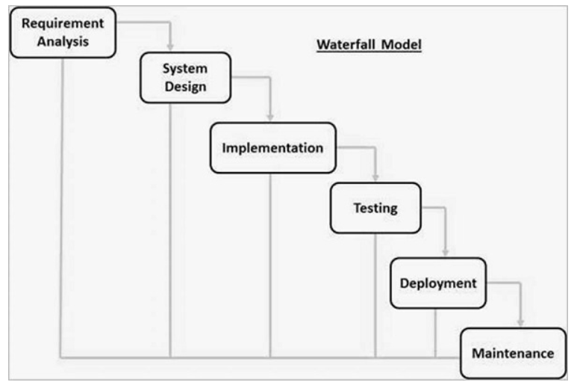

**Advantages** –

1. Simple and easy to understand and use, Phases are processed and completed one at a time.
2. Easy to manage due to the rigidity of the model. Each phase has specific deliverables and a review process.
3. Works well for smaller projects where requirement is very well understood.
4. Clearly defined stages and easy to arrange tasks.

**Iterative Model**

In this development process, each phase builds on the previous one. The development takes place in iterations and in small parts at a time. It’s a process of gradual improvement and learning from previous iterations, as how to improve the next. There are 4 phases in this methodology:

1. Requirement -  
   The goal needs to set accordingly, as every iteration is different from later ones and there are no previous iterations to work form.
2. Design –  
   In this phase, design needs to be created to solve the requirements, which includes technical designs, process flow diagrams etc.
3. Implementation or Development –
4. The technical team will create the first iteration which will be informed by analysis and design.
5. Testing –  
   After the iteration, it will be tested to find out the improvement. It can also be checked with project stakeholders.
6. Review -  
   Team will evaluate the success of the iteration and align on anything that need to be charged.

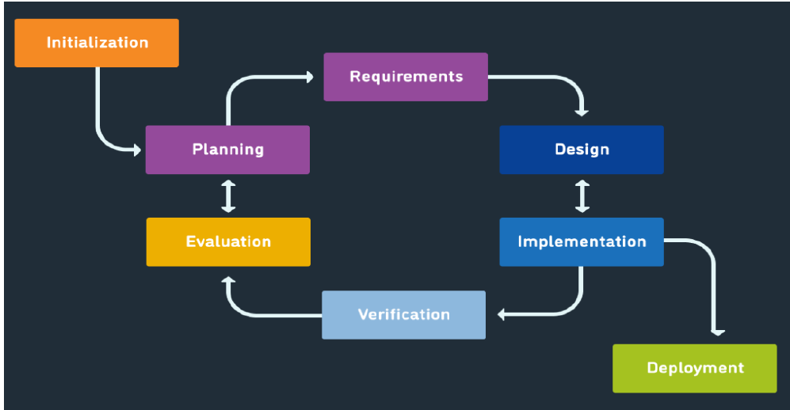

**Advantages** –

1. Some working functionality can be developed quickly and early in the life cycle.
2. Results are obtained early and periodically. Parallel development can be planned.
3. Progress can be measured. Easier to manage risk – High risk part is done first.
4. It supports change requirement. Better suited for large and mission-critical projects.

**Spiral Model** –

Spiral model is an SDLC methodology which combines iterative development and waterfall model. It is used for Risk Management. This SDLC model is mostly used for large and complicated projects. The spiral model enables gradual releases and refinement of a product through each phase of the spiral as well as the ability to build prototypes at each phase. It can manage unknown risks once the project is started.

Every phase can be broken into four quadrants –

Identifying and understanding requirement –  
Every phase can be broken into four quadrants: identifying and understanding requirements, performing risk analysis, building prototype and evaluation of software performance.

Performing risk analysis –  
Risk analysis should be performed on all possible solutions to find any faults, such as running over budget or areas within the software.

Building prototype -  
Prototype is built and tested. This step includes architectural design, design of modules, physical product design and the final design.

Evaluation of the software’s performance -  
In the final quadrant, test results of the newest version are evaluated. This analysis allows programmers to stop and understand what worked and didn’t work before progressing with a new build. At the end of the whole spiral, the software is finally deployed in its respective market.

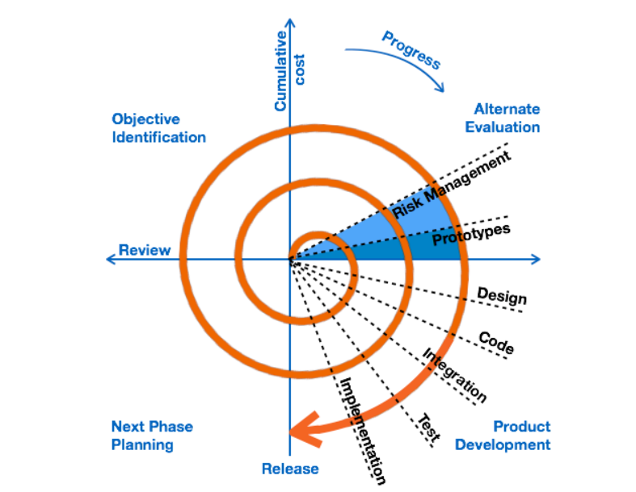

**Advantages** –

1. Changing requirements can be accommodated and allows extensive use of prototype.
2. Requirements can be captured more accurately and users see the system early.
3. Development can be divided into smaller parts and the risky parts can be developed earlier which helps in better risk management.

**Agile Model** –

The agile methodology is way to manage a project by breaking it up into several phases. It’s a process for managing a project that involves constant collaboration and working in iterations. Agile project management work off the basis that a project can be continuously improved upon throughout its life cycle, with changes being made quickly and responsively.

Agile’s four main values are:

* Individuals and interactions over processes and tools.
* Working software over compressive documentation.
* Customer collaboration over contract negotiation.
* Responding to change over following plan.

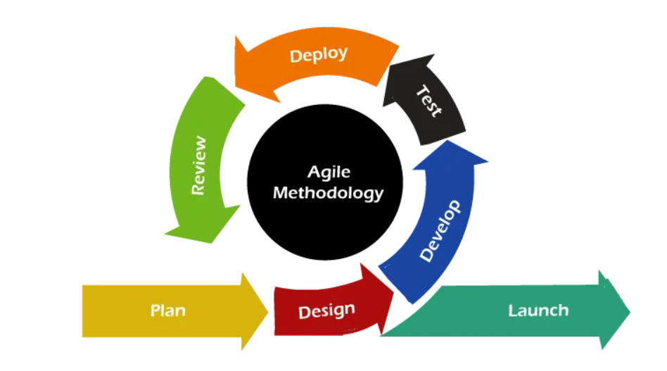

**Advantages** –

1. It is a very realistic approach to software development and promotes teamwork and cross training.
2. Functionality can be developed rapidly and demonstrated.
3. Resources requirements are minimum and gives flexibility to developers.
4. Delivers early partial working solutions and minimum rules, documentation easily employed.

**9 Que**.- They discussed models in SDLC like waterfall RUP Spiral and Scrum. You put forth you are understanding on these models

When the APT IT SOLUTIONS company got the project to make this online agriculture product store, there is a difference of opinion between a couple of SMEs and the project team regarding which methodology would be more suitable for this project. SMEs are stressing on using the V model and the project team is leaning more onto the side of waterfall model. As a business analyst, which methodology do you think would be better for this project?

Ans. **Waterfall Model** -   
This model is a traditional model in IT company, the waterfall model is a classical model used in system development life cycle to create a system with linear and sequential approach.  
In this model software development done form one phase to another phase in downward manner, output of one phase is used as a input for next phase, every phase has to completes before next phase starts and here is no overlapping of the phases.  
It is progressive implementation of the project which is divided into different phases of SDLC. As waterfall model have few limitations, still it was used earlier on wide range.

**RUP Model** -   
Rational Unified Model is a software development process from rational, a division of IBM, it divides the development process into four distinct phases that each involve business modelling, analysis and design, implementation, testing and deployment. In RUP there are four project life cycles –  
-Inception  
-Elaboration  
-Construction  
-Transaction

**Spiral Model** -  
This phase starts with gathering of business requirements in the subsequent spirals as the product matures identification of system requirement are done in this phase.   
This includes understanding of system requirement by continual communication between customer and the analyst at the end of the spiral the product is deployed.

Design – This phase starts with the design in the baseline of spiral and involves architectural, logical design of modules, physical product design and final design in the successive spirals.

Construct – This Phase refers to development of the final software product at every spiral. In the spiral when the product is just thought and the design is being developed, a proof of concept (POC) is developed in this phase to get user’s feedback.

Evaluation and Risk analysis – Risk analysis includes identifying, estimating, and observing technical feasibility such as schedule slippage and cost overrun.  
After testing the build, at the end of first iteration, user evaluate the software and provides the feedback. Based on the customer assessment, development process enters the next iteration and afterwards follows the linear approach to implement the feedback provided by the user.

**Scrum** -  
It is not a process technique or definitive method, rather it is framework within which you can employ various processes and technique.   
It is three roles and every role has clear accountability. The product owner is responsible for maximizing the products value resulting from the development team work.  
The scrum model suggests that projects progress via a series of sprints. In keeping with an agile methodology, sprints are time boxed to no more that a month log, most commonly two weeks.  
Scrum is lightweight agile process framework used primarily for managing software development.

The scrum models have steps also called phases in scrum  
1. Product backlog creation  
2. Sprint planning and creating backlog  
3. Working on sprint  
4. Retrospective and next sprint planning

Since as BA and in this project, I supposed to use a V-Model methodology is to be better for this project. As V-model is the most important model that is used in the process of software testing. It is also known as Validation and verification. V-model is a sequential process in which the next phase begins only after the completion of the present phase.   
In this model, steps do not move in a linear way while the steps are bent upwards. It is similar to waterfall model because we follow V-model form left to right as well as follow a sequential path of execution of processes like as in waterfall model.

10 Que.- Write down the difference between waterfall model and V Model

Ans.-

|  |  |
| --- | --- |
| Waterfall Model | V Model |
| Approach  It follows a sequential approach, where the project progresses through linear sequence of phases (requirement, design, implementation, testing, deployment), with phase dependent on the completion of the previous one. | It is a variation of the waterfall model, where each phase of development is associated a corresponding testing phase. It emphasizes verification and validation activities, with testing activities mirroring development activities in a V-shape manner. |
| Testing  Testing is performed at the end of the development process, after the completion of implementation. It follows a test-lane approach, where testing starts only after the development phase is complete. | Testing is integrated throughout the development process, the testing activities planned and conducted in parallel with development activities. |
| Phases  This model consists of distinct, non-overlapping phases, with each phase representing a stage of the project lifecycle. Progression from one phase to the next is strictly linear and sequential. | This model organizes development and testing activities into corresponding pairs of phases, forming a V-shaped structure. |
| Flexibility  This model is less flexible and adaptable to changes in requirements, as modifications to project scope or objectives may require revisiting and repeating earlier phases. | This model offers some degree of flexibility through its iterative and parallel development and testing activities. Changes or enhancements can be incorporated into subsequent phases, about some coordination and efforts. |
| Risk Management  Its typically addressed at the beginning of the project, with risk identified and mitigated upfront. However, the sequential nature of the model may limit the ability to adapt to unforeseen risk or changes. | Its integrated throughout the project lifecycle, with risk identification, analysis, and mitigation activities conducted in parallel with development and testing. |

11 Que. As a BA, state your reason for choosing one model for this project

Ans.- As a BA, my recommendation would be to use waterfall model for this project.

The waterfall model is a linear sequential approach where each phase pf the software development process is completed before moving onto next phase.  
This model is suitable for project with clear and well-defined requirements, which is the case for the online agriculture products store project.  
The Project has clear objective of developing an e-commerce platform for farmers to buy agriculture products, and the requirements for the project have been shared by the stakeholders.

Therefore, based on the project’s clear requirements, recommend is to use waterfall model.

12 Que. The Committee of Mr. Henry, Mr. Pandu, and Mr. Dooku discussed with Mr. Karthik and finalised the V Model approach (RG, RA, Design, D1, T1, D2, T2, D3, T3, D4, T4 and UAT)  
Mr Vandanam is mapped as a PM to this project. He studies this project and prepares a Gantt Chart with (RG, RA, Design, D1, T1, D2, T2, D3, T3, D4, T4 and UAT) as development process and the Resources are PM, BA, Java Developers, Testers, DB Admin, NW Admin.

Ans.

|  |  |  |  |
| --- | --- | --- | --- |
| TASK | START DATE | END DATE | DURATION |
| Requirement Gathering | 01-07-2022 | 25-08-2022 | 55 |
| Requirements Analysis | 16-08-2022 | 20-09-2022 | 35 |
| Design | 10-09-2022 | 05-11-2022 | 56 |
| Development 1 | 20-10-2022 | 01-01-2022 | 73 |
| Testing 1 | 01-12-2022 | 15-02-2023 | 76 |
| Development 2 | 25-01-2023 | 10-04-2023 | 75 |
| Testing 2 | 01-03-2023 | 15-05-2023 | 75 |
| Development 3 | 01-05-2023 | 15-07-2023 | 75 |
| Testing 3 | 01-07-2023 | 20-09-2023 | 81 |
| Development 4 | 01-09-2023 | 01-11-2023 | 61 |
| Testing 4 | 15-10-2023 | 15-12-2023 | 61 |
| UAT | 01-12-2023 | 01-01-2024 | 31 |

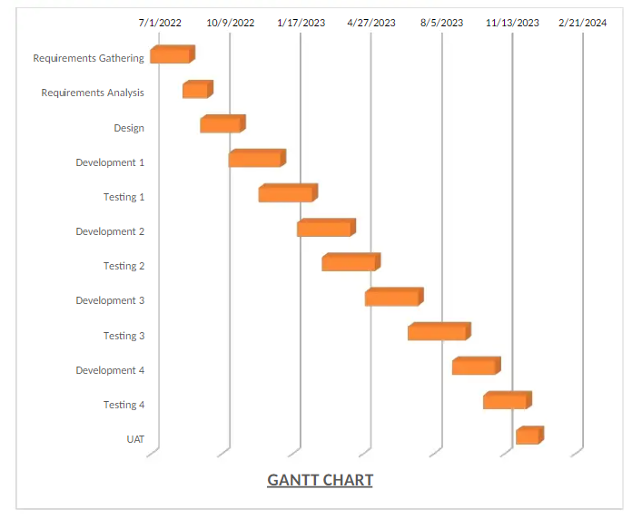

13 Que. Fixed Bid Vs Billing

Design Timesheet of a BA  
Development Timesheet of a BA  
Testing Timesheet of a BA  
UAT Timesheet of a BA  
Deployment and Implementation Timesheet of a BA

Ans. Fixed Bid – In a Fixed bid contract, the project cost is agreed upon upfront, and the client pays a fixed amount for the entire project, regardless of the actual time and resources spent. This places the risk on the service provider to deliver within the agreed budget.

Billing – Billing typically involves invoicing the client for services rendered based on actual hours worked or milestones achieved. This could be on an hourly basis, daily rate, or other agreed-upon terms. Billing allows for greater flexibility and transparency, as clients are billed based on the actual effort expended.

Timesheet for BA  
Design Timesheet – Records time spent by the BA on designing project requirements, workflows, wireframes, and other design-related activities.

|  |  |  |  |  |
| --- | --- | --- | --- | --- |
| Date worked | In time | Out time | Total Hours worked | Information |
| 10-09-2022 | 06:00 | 07:00 | 1 | User Testing |
|  | 07:00 | 08:00 | 1 | Technical elaboration |
|  | 08:00 | 09:00 | 1 | data analysis |
|  | 10:00 | 13:00 | 3 | Showcase |
|  | 13:30 | 17:00 | 4 | Business designs |
|  | 17:00 | 19:00 | 2 | Solution on Architect |

Development Timesheet – Tracks time allocated to BA involvement during the development phase, including clarifying requirements, providing feedback, and supporting development efforts.

|  |  |  |  |  |
| --- | --- | --- | --- | --- |
| Date worked | In time | Out time | Total Hours worked | Information |
| 20-10-2022 | 06:00 | 07:00 | 1 | Analysis of domain |
|  | 07:00 | 08:00 | 1 | documentation |
|  | 08:00 | 09:00 | 1 | Outlines of Business req |
|  | 10:00 | 13:00 | 3 | Outlines of Business req |
|  | 13:30 | 17:00 | 4 | Analysis of Business req |

Testing Timesheet – Logs time spent by the BA on reviewing test plans, test cases, and participating in testing activities such as user acceptance testing (UAT) or quality assurance.

|  |  |  |  |  |
| --- | --- | --- | --- | --- |
| Date worked | In time | Out time | Total Hours worked | Information |
| 01-12-2022 | 06:00 | 07:00 | 1 | Work with testing team |
|  | 07:00 | 08:00 | 1 | Create and execute the system test case |
|  | 08:00 | 09:00 | 1 | Review system test case |
|  | 10:00 | 13:00 | 3 | Provide requirement |
|  | 13:30 | 17:00 | 4 | Review requirement |

UAT Timesheet – Documents time spent by the BA on facilitating user acceptance testing sessions, gathering feedback, and coordinating with stakeholders to ensure successful UAT completion.

|  |  |  |  |  |
| --- | --- | --- | --- | --- |
| Date worked | In time | Out time | Total Hours worked | Information |
| 01-12-2023 | 06:00 | 07:00 | 1 | Develop the detailed UAT plan |
|  | 07:00 | 08:00 | 1 | Develop the test case |
|  | 08:00 | 09:00 | 1 | Create UAT test case |
|  | 10:00 | 13:00 | 3 | Data preparation |
|  | 13:30 | 17:00 | 4 | Run test case |

Deployment and Implementation Timesheet – Captures time dedicated to BA involvement during deployment and implementation phases, including co-ordinating release activities, user training, and post-implementation support.

|  |  |  |  |  |
| --- | --- | --- | --- | --- |
| Date worked | In time | Out time | Total Hours worked | Information |
| 01-01-2024 | 06:00 | 07:00 | 1 | Design RTM |
|  | 07:00 | 08:00 | 1 | Co-ordinate to complete manual |
|  | 08:00 | 09:00 | 1 | Training session |
|  | 10:00 | 13:00 | 3 | Prepare lessons |