# Use case diagram for I vehicle value mobile application:

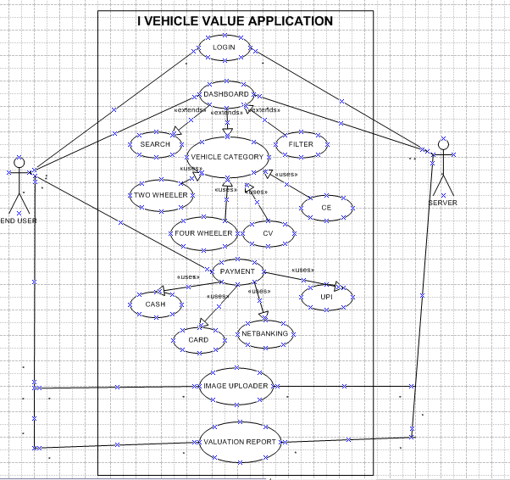

* 1. **Use case specification**:

The purpose of use case specification is to describe the flow of events in detail including how use case starts, ends and modify the system and interact with the actors.

Use case name: **LOGIN**

Description: Username and password Actor: vehicle owner

Pre-condition: active internet connection, User need to download the app

Post condition: After Login the app stores the login credential securely, Home page has to display Basic Flow: Username and password are correct

Alternate flow: Any one of the credentials are wrong, both username and password are wrong Exceptional Flow: Forget Username or Forget Password

Assumption: The app uses reliable data storage to store user profile and other data Constraints: Username cannot be Names

Dependencies: Registration process should complete before login Input: Username and Password

Output: Error Message (any of the credentials is wrong)

Business Rule: Username should be some mail id and password Should have minimum of 8 letters which include some special character.

Use case name**: VIEW DASHBOARD**

Description: To access the mobile application and to view relevant information about vehicle ‘s data Actor: vehicle owner

Pre-condition: active internet connection, User need to Login the app with proper credentials Post condition: The vehicle owner has accessed their dashboard and viewed relevant information Basic Flow: The dashboard screen displays a summary of the vehicle's information.

Alternate flow: user can take alert on notification

Exceptional Flow: If there are technical issues with the app the app displays an error message Assumption: The app has a backup plan in place in case of server errors or other technical issues. Constraints: The app must load within the 3 secs of opening

Dependencies: The dashboard depends on vehicle information system Input: Data resource

Output: viewing relevant information.

Use case name: **VEHICLE CATEGORY**

Description: To view and select the vehicle category in the application Actor: vehicle owner

Pre-condition: User need to select category based on the vehicle he owns Post condition: Need to Display the selected vehicle category

Basic Flow: The app has to display the parameter which user selects Alternate flow: user can take alert on notification

Exceptional Flow: If user selects invalid category need to display an error message

Assumption: The app has a backup plan in place in case of server errors or other technical issues. Constraints: Dashboard should provide accurate and reliable data

Dependencies: The app uses a secure communication protocol to retrieve data from the server Input: Input Data given

Output: Displaying key performance metrics.

Use case: **PAYMENT GATEWAY**

Description: Payment option, card details Actor: Debit card, credit card

Pre-condition: Vehicle category must have assigned

Post Condition: User should make the payment through card or COD, Net banking Basic Flow: It should display the payment page

Alternate Flow: Not displaying the payment page Expectational Flow: Unable to read the card data, card blocked

Assumption: User has to know how to make payment through cards Dependencies: The card should be valid

Constraints: Product should be purchased and Cards should have valid money Input: Purchased product and card details

Output: Payment gateway page or error message display Business Rule: card should be valid.

Use case: **IMAGE UPLOAD**

Description: Upload the vehicle image in mobile application Actor: Vehicle and Mobile camera

Pre-condition: Access to the camera to take vehicle image

Post condition: The vehicle owner has successfully upload the image in mobile application. Basic flow: The app uploads the image to the server and Displaying the progress bar Alternate Flow: If network error occurs during uploading it will save the image in web service Exceptional Flow: If uploaded image is invalid, an error message has to displayed Assumption: The app uses a reliable data storage mechanism to store uploaded image

Dependencies: The app uses a secure communication protocol to transfer images between devices and servers.

Constraints: The app should have a minimum and maximum resolution limit for images Input: Vehicle image

Output: The system saves the image file to the designated storage location

Business Rule: Only images with valid formats (e.g. JPEG, PNG, GIF) can be uploaded.

1.2. **Activity Diagram**:

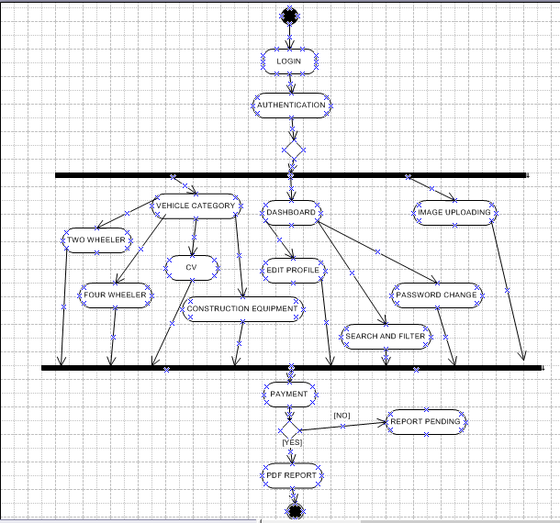

1. Screens and Pages:

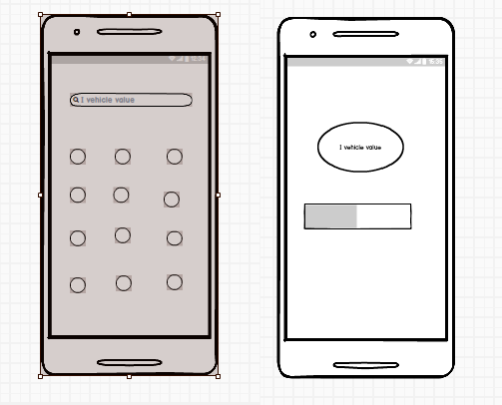

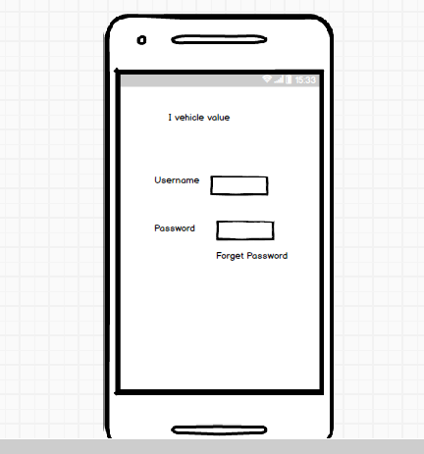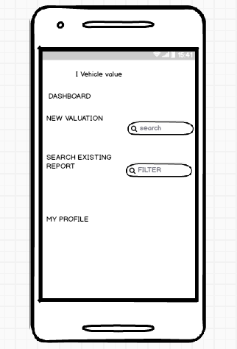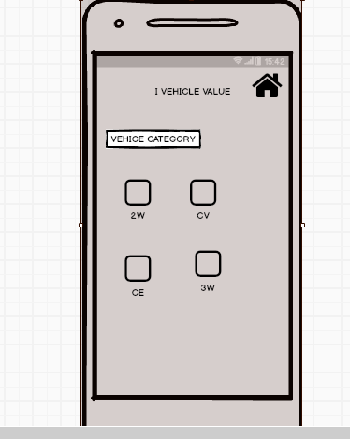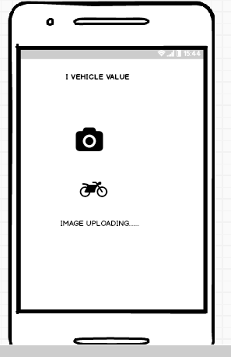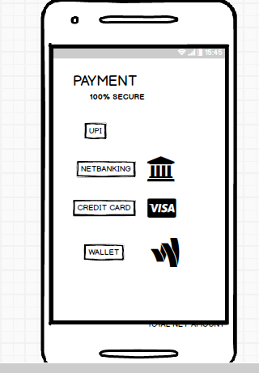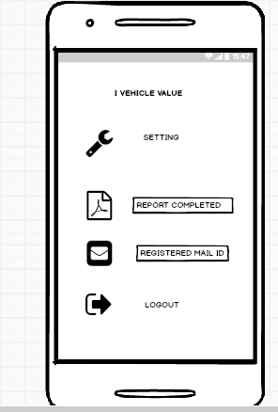

# Tools:

During the development of the vehicle value mobile application, I had the opportunity to utilize Visio and Axure, Balsamic to create wireframes, prototypes, and user flow diagrams. Visio proved to be an excellent tool for creating detailed wireframes and prototypes of the application's user interface, allowing me to quickly and easily arrange and reorganize elements on the screen. I used Visio to design the application's login screen, dashboard, and various feature pages, ensuring that they were visually appealing and user-friendly. Balsamic, on the other hand, enabled me to create interactive prototypes of the application, allowing me to test and validate assumptions about user interactions with the application. I used Axure to create a prototype of the application's search feature, where users can search for vehicles by make, model, and year. By testing the prototype with real users, I was able to identify areas for improvement and make data-driven design decisions. Overall, both Visio and Axure were invaluable tools in helping me design and test the vehicle value mobile application, enabling me to create a high-quality user experience that meets the needs of our target audience.

# My experience as BA in following phases:

Requirement gathering:

As a Business Analyst, played a crucial role in the requirement gathering phase of the vehicle value mobile application project. I worked closely with stakeholders to understand their needs and goals, conducting interviews, surveys, and workshops to gather requirements. I used tools such as questionnaires, sticky notes, and whiteboards to facilitate open communication and collaboration. Through these sessions, I identified key points and opportunities for improvement in the current process of determining vehicle values. I also gathered insights on the target audience's needs, preferences, and behaviours, which informed the design of the application's features and user interface. By actively listening to stakeholders' concerns and asking clarifying questions, I ensured that all requirements were thoroughly understood and documented. Additionally, I created a comprehensive requirements document that outlined the functional and non-functional requirements of the application, serving as a foundation for subsequent development phases.

# Requirement Analysis:

As a Business Analyst on the Vehicle Value mobile application project, I was responsible for leading the Requirements Analysis phase. In this phase, I worked closely with stakeholders, including the development team, product managers, and customers, to gather and document the functional and non-functional requirements of the application. I employed various techniques, such as interviews, surveys, and workshops, to elicit requirements and ensure that they were clear, concise, and unambiguous. I also conducted stakeholder analysis to identify the needs and expectations of each group and prioritized requirements based on their importance and feasibility. I created detailed

requirement documents, including use cases, user stories, and acceptance criteria, which were reviewed and validated by the stakeholders. Throughout the Requirements Analysis phase, I ensured that the requirements were aligned with the project's goals and objectives, and that they were testable and measurable. My primary goal was to create a comprehensive set of requirements that would serve as a foundation for the development of the mobile application.

# Design:

From the use case diagrams, we prepare test cases Communicate with client on design and solution documents Write negative test cases as well along with positive test cases. Do not miss a single test case. It might have huge impact on project development in later stages Prepare test data for testing Update RTM. This is just as we need to make sure that all the requirements are met.

**Developmen**t: I worked closely with the development team to ensure that the application was developed according to the requirements gathered during the first phase. I reviewed code reviews, provided feedback on technical implementation details, and ensured that any technical issues were addressed promptly. My involvement in this phase ensured that any technical debt or issues were identified early on, allowing for timely resolution.

# Test Planning Phase:

In the test planning phase, I worked closely with the QA team to develop test cases and scenarios that would validate the application's functionality. I reviewed and provided feedback on test cases, ensuring that they were thorough and covered all aspects of the application's functionality. I also worked with the QA team to identify test data and test environments required for testing. My involvement in this phase ensured that we had a comprehensive testing strategy that would ensure high-quality testing of the application.

# Deployment Phase:

In the deployment phase, I worked with the operations team to ensure a smooth deployment of the application. I reviewed deployment scripts, provided feedback on deployment procedures, and ensured that all necessary infrastructure was in place. My involvement in this phase ensured that the application was deployed successfully and met all necessary security and compliance requirements.



LOGIN

AUTHENTICATION

VEHICLE CATEGORY

DASHBOARD

IMAGE UPLOADING

TWO WHEELER

CONSTRUCTION EQUIPMENT

EDIT PROFILE

PASSWORD CHANGE

FOUR WHEELER

CV

SEARCH AND FILTER

PAYMENT

[NO]

REPORT PENDING

[YES]



PDF REPORT