**Document 6- Please prepare a use case diagram, activity diagram and a use case specification document.**

1. Use case Name

2. Use case Description

3. Actors Primary Actors Secondary actors

4. Basic Flow

5. Alternative Flow

6. Exceptional flows

7. Pre- Conditions

8. post-conditions

9. Assumptions

10. Constraints

11. Dependencies

12. Inputs and Outputs

13. Business Rules

14.Miscellaneous Information

**Ans: USE CASE DIAGRAM**



**Activity Diagram**



**Use Case Specification Document**

**Use case 1**

|  |  |
| --- | --- |
| **Use case name** | User registration/login |
| **Use case description** | This use case allows a user to create a new account or log in to the system to access its features. |
| **Actors** | Customer |
| **Basic flow** | 1. The user enters registration details or login credentials. 2. The system validates the information. 3. The system grants access to the user dashboard. |
| **Alternative flow** | If registration details are incomplete, the system prompts the user to fill all fields. |
| **Exceptional flow** | If login credentials are incorrect, the system displays an error message and allows retry. |
| **Preconditions** | The user must have a valid email address. |
| **Post conditions** | The user is successfully registered or logged in. |
| **Business rules** | Password must be at least 8 characters long. |
| **Requirements** | R001, R002 |

**Use case 2**

|  |  |
| --- | --- |
| **Use case name** | Browse tours |
| **Use case description** | This use case describes how a user searches and filters tours based on preferences |
| **Actors** | Customer |
| **Basic flow** | The user search for specific tour (destination, date, package)  The system displays the matching tours |
| **Alternative flow** | If no tours are matched for the customer preferences then system shows the similar tours |
| **Exceptional flow** | None |
| **Preconditions** | Tour data must be up to date |
| **Post conditions** | A list of tours displayed to the visitors |
| **Business rules** | The system must display results with in 5 seconds |
| **Requirements** | R004 |

**Use case 3**

|  |  |
| --- | --- |
| **Use case name** | Book tour |
| **Use case description** | This use case allows user to book selected tour package |
| **Actors**  **Primary actors**  **Secondary actors** | Customer  Payment gateway |
| **Basic flow** | 1. The user selects a tour and enters booking details. 2. The system calculates the total cost and redirects to the payment gateway. 3. Payment is processed and confirmed. 4. A confirmation email is sent to the user |
| **Alternative flow** | If payment fails the system allows retry a different method |
| **Exceptional flow** | Tour availability may change during booking |
| **Preconditions** | The user must be login |
| **Post conditions** | User receives the confirmation of tour booking |
| **Business rules** | Payment must be processed securely |
| **Requirements** | R006, R007, R008 |

**Use case 4**

|  |  |
| --- | --- |
| **Use case name** | Cancel booking |
| **Use case description** | This use case allows the user to cancel the trip and receive refund |
| **Actors**  Primary actors  Secondary actors | Customer  Payment gateway |
| **Basic flow** | 1. The user selects a booking to cancel. 2. The system confirms the cancellation and processes a refund (if applicable). 3. A confirmation email is sent to the user. |
| **Alternative flow** | If the cancellation time has expired, the system informs the user and denies the request. |
| **Exceptional flow** | None |
| **Preconditions** | The user must have an active booking |
| **Post conditions** | The booking is canceled and refund is initiated |
| **Business rules** | Cancellation of trip is allowed up to 72hours before the tour date |
| **Requirements** | R009 |

**Use case 5**

|  |  |
| --- | --- |
| **Use case name** | View travel details |
| **Use case description** | This use case allows the users to view the details of their booked tour |
| **Actors** | Customers |
| **Basic flow** | The system navigates to My Bookings section  The system displays the details of their booked tour |
| **Alternative flow** | If no bookings are there the system suggest the users to book a tour |
| **Exceptional flow** | None |
| **Preconditions** | The user must have an active booking |
| **Post conditions** | The tour details are viewed |
| **Business rules** | Only booked tours can be viewed |
| **Requirements** | R003 |

**Document 7- Screens and pages Please follow the following steps to create the mock-ups**

1. Kindly use balsamic or Axure.

2. Always start with a home page of an application.

3. Take a feature and follow it to the end

a. Eg: Home page of SCRUM Foods

b. Select Login- Create a login page

c. Let’s assume, you want to search a restaurant

d. Search page- Type the restaurant name and select the dish

e. Add to cart page

f. Payment Page

g. Log out page

ANS:

Home page



**Login page**

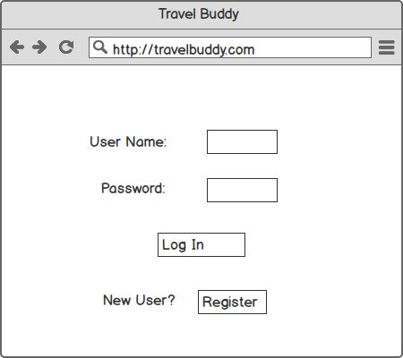

**Search page**

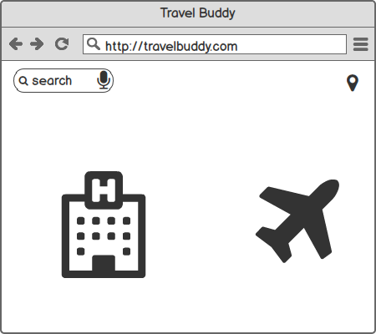

**Add to cart:**

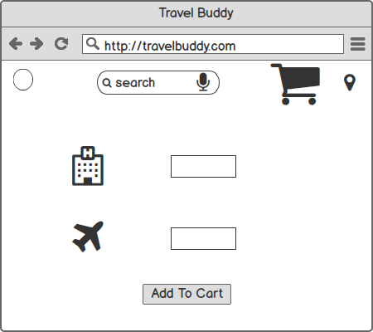

**Payment page:**

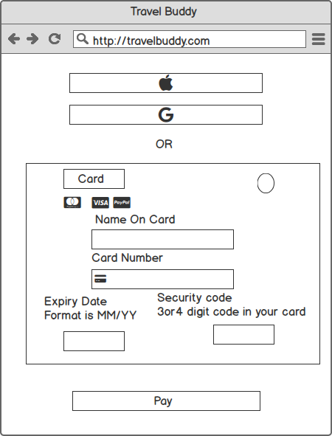

**Logout Page**

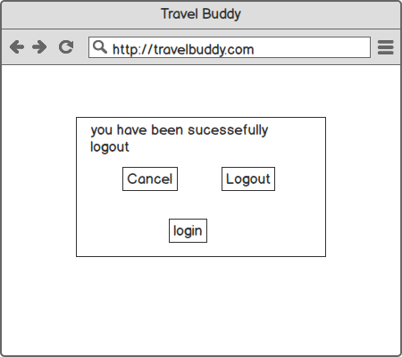

**Document8- Tools-Visio and Axure**

**Write a paragraph on your experience using Visio and Axure for the project.**

**Ans:**

**Visio:** I have used Microsoft Visio to draw use case diagram and activity diagram. In Visio, there are various static and dynamic diagrams. For drawing use case diagram, select UML use case where we can find various diagrams such as use case, actor, uses, communication lines, extends etc. For drawing activity diagram, select UML activity where we can find various diagrams such as initial state, final state, action state, control flow, decision box etc.

**Axure:** I have used Axure for prototyping the website. In Axure, we can create multiple webpages as per requirement. There are various icons for various purposes. We can select suitable icons/images to represent various activities. Once prototype is ready same can be used to represent to the stakeholder

**Document9- BA experience**

**1.Requirement Gathering:**

As a BA Conducted interviews with the stakeholders(client) to gather the requirements. By organizing focus group sessions to understand the visitor’s needs and preferences.

Review existing system and documents to gather additional information. Conduct surveys and questionnaire to gather the customer perspective.

Used MOSCOW technique to prioritize the requirements based on their importance and urgency

For validating the requirements FURPS technique used

By grouping the requirements removed the duplicated or repeated requirements

Using prototypes to filter and clarify requirements enhances the accuracy and alignment with stakeholder expectations.

**2. Requirement Analysis:**

By using MS VISIO created the USECASE diagram and ACTIVITY diagram

Where use case diagram gives the visual representation of the system and activity diagrams are give represents the process flow of system

Shared the use case and activity diagrams with the team members and gather their feedback and made the changes based on the discussion with them

Created a requirement document (RD) to outline the functional and Non-functional requirements of the project. Later created the BRD document to provide detailed description of the project objectives, scope and deliverables

**3.Design**

After the requirements are cleared, Design phase starts. This has a detailed design document that outlines the software architecture, user interface, and system components’, ADD and solution document will be generated here. [High-level Design Doc.] As a BA Collaborate with designers, architects, and developers to translate requirements into system design. Ensure that the design aligns with the documented requirements and addresses stakeholder needs.

Defined the overall architecture of the system including major components, modules and their interactions. Developed high level diagrams like data flow diagrams and system flow charts

Communicated with the client to review the design and solution document for the system

Prepared the both positive and negative test cases to ensure no test case was missed otherwise it might have huge impact on project development in later stages

Prepared the data for testing and used RTM matrix to track the requirements whether the requirements completed or not and the requirements met the project goals

**4.Development:**

Conducted the JAD session with stakeholders in development process to extract high inputs and minimize the errors.

The Development phase include implementation. It involves coding the software based on the design specifications. Programmers or developer are involved in this phase. Here as a BA, acts as a mediator between the development team and the stakeholders and clarifies the requirements, checks if the development is going on right track or not and also participates in scrum meetings.

**5.Testing:**

In the testing phase, the software is tested as a whole to ensure that it meets the requirements and is free from defects. Testers are involved in this phase

Test case documents are created from use case diagrams. BA works with the testing team to ensure that the solution meets the requirements.BA facilitate UAT.BA helps the users to know the functionality of the system and also helps them to use the system.

After the completion of testing obtained signoff from the client that the project meets all preferences of the client. Based on the changes updated the RTM

**6.Deployment:**

Plan the release of the software, considering factors such as the deployment schedule, potential downtime, and communication strategies for informing stakeholders about the release

**RTM Forwarding:** Sharing the RTM with clients as part of the project closure document ensures transparency**.**

**End-User Manuals:** Coordinating the creation and distribution of end-user manuals aids in user adoption**.**

**Training Sessions:** Planning and organizing training sessions ensures users are equipped to utilize the system effectively.

**Attendance Assurance:** Ensuring all candidates attend training sessions is crucial for effective knowledge transfer.

**Post-Deployment Testing:**

Conduct post-deployment testing to ensure that the software functions as expected in the production environment. This may include additional testing to verify performance, security, and overall system stability.

**Feedback Collection:**

Gather feedback from end-users and stakeholders after deployment. This feedback is valuable for identifying any unforeseen issues and for making further improvements in future releases