Capstone Project 2

**Question 1** – Audits - 5 Marks

4 Quarterly Audits are planned Q1, Q2, Q3, Q4 for this Project What is your knowledge on how these Audits will happen for a BA ?

**Answer:**

Audits are more focused on the status at the end of each stage of the project. These help us to ensure we are in compliance to the projects we are committed to.

|  |  |  |  |  |
| --- | --- | --- | --- | --- |
| **Audit Quarter** | 1 |  | **Audit Quarter** | 2 |
| **Stage** | Requirement Gathering |  | **Stage** | Requirement Analysis |
|  |  |  |  |  |
| **Completion Status** | Completed |  | **Completion Status** | Completed |
| **Time Period** | 4 Weeks |  | **Time Period** | 8 Weeks |
| **Check Lists** | Objective of the scope Confirmation from Client |  | **Check Lists** | Analysing the documented requirements |
| BRD Document Completion |  | Identifying any conflicts or gaps |
| Elicitation report |  | Creation of UML |
| Duplicate requirement if any |  | schedule meeting with all stakeholder |
| **Signoff** | Email Communication and confirmation on requirement gathering |  | Client signoff |
|  |  |  | **Signoff** | Email Communication and confirmation |

|  |  |  |  |  |
| --- | --- | --- | --- | --- |
| **Audit Quarter** | 3 |  | **Audit Quarter** | 4 |
| **Stage** | Design Phase |  | **Stage** | Development & Testing |
|  |  |  |  |  |
| **Completion Status** | Completed |  | **Completion Status** | Completed |
| **Time Period** | 4 Weeks |  | **Time Period** | 32 Weeks |
| **Check Lists** | Design the process/flow including the tools being used |  | **Check Lists** | Development the project based on the objective |
| Produce the prototype to client |  | Documentation on the stages of development |
| Schedule the meeting with all the stake holders to present the deign |  | End user manual preparation and MOM after completion of development stage |
| accept the CRs if any or send the MOM |  | Test case document and summary |
| **Signoff** | Email Communication and confirming the signoff from client |  | MOM with BA on development and testing stage completion |
|  |  |  | **Signoff** | Email Communication and confirmation from DV and Testing team |

**Question 2** – BA Approach Strategy - 6 Marks

Before the Project is going to Kick Start, The Committee asked Mr Karthik to submit BA Approach Strategy

Write BA Approach strategy (As a business analyst, what are the steps that you would need to follow to complete a project – What Elicitation Techniques to apply, how to do Stakeholder Analysis RACI/ILS, What Documents to Write, What process to follow to Sign off on the Documents, How to take Approvals from the Client, What Communication Channels to establish n implement, How to Handle Change Requests, How to update the progress of the project to the Stakeholders, How to take signoff on the UAT- Client Project Acceptance Form )

Your Team:

Project Manager - Mr Vandanam & Senior Java Developer - Ms. Juhi

Java Developers - Mr Teyson, Ms Lucie, Mr Tucker, Mr Bravo

Network Admin - Mr Mike

DB Admin - Mr John.

Testers - Mr Jason and Ms Alekya

BA - You

Technical Team have assembled to discuss on the Project approach and have finalised to follow 3-tier architecture for this project.

**Answer:**

**What Elicitation Techniques to apply**

We have multiple Elicitation Techniques to gather the requirements like brainstorm, prototyping, observation, document analysis, reverse engineering, survey, workshops, JAD, Focus Groups, Interview. We will be using workshop elicitation technique for this project specifically as that one would be more suitable.

**How to do Stakeholder Analysis**

Stake holder analysis is done using RACI matrix. These are simple to understand as it clearly defines who is responsible, Accountable, Consultant and who to be informed about the project/process in each stage. We can identify the stakeholders, define their roles and assign them to the RACI matrix

**What Documents to Write**

We have multiple documents here on the requirements. Some of them are BRD, SRD, FRD/FRS, SRS, use case, test case documents etc. each have their own specifics as per the requirement is defined.

**What process to follow to Sign off on the Documents**

Documents sign off are crucial for any projects to proceed especially on BRD and SRS. Hence, we follow traditional way for signoff on any documents which ever is required thru email from the client.

**How to take Approvals from the Client**

at first, we shall fix a formal meeting to communicate on the importance of the process and its approval. Post which we will shall write MOM along with all the documents for a formal signoff via email as approval process.

**What Communication Channels to establish and implement**

1. Weekly status update on the process via email
2. Monthly stake holder updates on project

**How to Handle Change Requests**

1. We shall send the change request form
2. Once we receive it from client, we will do impact analysis in terms of time, resource and costs
3. We shall formally send for an approval via email for signoff and document it
4. We will imply the CRs to the project

**How to update the progress of the project to the Stakeholders**

1. Weekly status reports
2. Monthly review meetings

**How to take signoff on the UAT- Client Project Acceptance Form**

1. Preparating of UAT
2. Conduct UAT
3. Accept any CRs/Issues
4. Complete / Fix the CRs/Issues
5. UAT acceptance sign off
6. Final Review meeting
7. Final Signoff on UAT

**Question 3** – 3-Tier Architecture - 5 Marks

Explain and illustrate 3-tier architecture?

**Answer:**

3 Tier architecture is simple and have 3-layered architecture with the top layer as presenting layer which is the GUI of the website and bottom layer is the data base layer usually the data base with an intermediate layer called logic layer.

**Application Layer** – this is the top layer or GUI which is also called as presenting layer. This shows us the design of the page or products.

E.g., product pictures and design, click buttons, etc.

**Intermediate layer** – this is the page where it takes action on the click whenever end user does. It acts as an intermediator from application layer to data base layer and hence it is also called as business logic layer.

E.g., clicking on payment gateway, checking the product availability or the number of stocks, etc.

**Database Layer** – this layer is the bottom most layer which has ability to store the data and retrieving the data based on the product search.

E.g., database layer usual deal with coding programs like SQL etc.

**Question 4** – BA Approach Strategy for Framing Questions – 10 Marks

Business Analyst should keep What points in his/her mind before he frames a Question to ask to the Stakeholder (5W 1H – SMART – RACI – 3 Tier Architecture – Use Cases, Use case Specs, Activity Diagrams, Models, Page designs)

**Answer:**

1. 5W1H – these are crucial yet simple way of asking question on a specific project initiation to gather requirement. 5W1H stands for Who, What, When, Where, Why and How. These are type of question we ask stakeholder as below:

Who – initiated the project

What – is the purpose of the project

When – does the project require / time line of the project

Where – will the project takes place

Why – this project is initiated

How – the project will be implemented

1. SMART – is a type of technique which can be useful to achieve a meaningful goal. SMART stands for Specific, Measurable, attainable, Relevant and Timebound. These can be used as below:

Specific – on the accomplishment in this project

Measurable – on the progress towards the goal

Attainable – using the resource and other constraints

Relevant – to the specific goal we want to achieve ultimately

Timebound – time duration of the project

1. RACI – Stake holder analysis is done using RACI matrix. We can identify the stakeholders, define their roles and assign them to the RACI matrix. These are simple to understand as it clearly defines who is responsible, Accountable, Consultant and who to be informed about the project/process in each stage.
2. 3 Tier Architecture – this was explained in the question number 3
   1. Use case: It describes how a user interacts with the system to achieve a specific goal right from searching of a product to the successful order placements.
   2. Use case Specs: use case specification is a detailed document that describes how a user interacts with a system to achieve a specific goal step by step. A typical use case specification includes Name, ID, Pre condition, actors, assumptions, post condition, etc.
   3. An activity diagram is a type of UML (Unified Modelling Language) diagram that represents the flow of a system/website/application. Example, a end user search a product > then views it > adds to cart > checkout > payment > finally order confirmation.
   4. Models represents the flow of a project like waterfall, V model, Spiral, Scrum/Agile, RUP.
   5. Page designs – how does a website/application page must be visualised. Where to keep what options like login buttons top right or middle or top left of a webpage. These require client confirmation as well.

**Question 5** – Elicitation Techniques - 6 Marks

As a Business Analyst, What Elicitation Techniques you are aware of? (BDRFOWJIPQU)

**Answer:**

Elicitation Techniques is a technique for gathering the requirement of a project. We have multiple Elicitation Techniques here called BDRFOWJIPQU which stands as below:

B – Brainstorming

D – Document analysis

R – Reverse Engg.

F – Focus Groups

O – Observations

W – Workshops

J – JAD

I – Interview

P – Prototype

Q – Questionnaire

U – Use case Specs

**Question 6** – This project Elicitation Techniques - 5 Marks

Which Elicitation Techniques can be used in this Project and Justify your selection of Elicitation Techniques?

Prototyping

Use case Specs

Document Analysis

Brainstorming

Fertilizers, seeds, pesticides details from the manufacturers and should be able to display them to the Farmers.

To gather the business requirements from the client, you went to SOONY and met Mr. Henry. When Mr. Henry was asked about the project and what are they expecting from the project, Mr. Henry stated that he is expecting to have a login for all its users (fertilizers, seeds, pesticides manufacturers and Farmers) , a product catalog of fertilizers, seeds, pesticides, a search option to search for products, payment process, and delivery tracking.

After doing the stakeholder analysis, you have found out that Peter, Kevin, Ben are the key stakeholders and you have scheduled an appointment to meet them. After meeting with them and trying to gather the stakeholder requirements, Kevin said that, a Farmer should be able to browse through the products catalog once they visit the website and need to have a search option so that they can search for any product they need. Peter said that, if a farmer wants to buy any product or add them to buy-later list, they need to login first using their email id and password. If it is a new user, then they can create a new account by submitting their email ID and creating a secure password. Ben added saying that, Farmers needs to have an easy-to-use payment gateway which should include cash-on-delivery (COD), Credit/Debit card and UPI options so that the user’s experience should be better. Kevin mentioned that, a user gets an email confirmation regarding their order status. A delivery tracker to track the whereabouts of their order.

Identify Business Requirements (which includes Stakeholder Requirements)

BR001 – Farmers should be able to search for available products in fertilizers, seeds, pesticides BR002 – Manufacturers should be able to upload and display their products in the application

**Answer:**

**we can implement with** **use case Specs elicitation technique** for this project. The only reason is because we have the flow of the application basis how to search a product, buy the product by clicking add to cart, user login flow etc. per the stakeholder analysis input/requirement.

BR001 – Farmers should be able to search for available products in fertilizers, seeds, pesticides BR002 – Manufacturers should be able to upload and display their products in the application

Both of the above is Stakeholder Requirements

**Question 7** – 10 Business Requirements- 10 Marks

Make suitable Assumptions and identify at least 10 Business Requirements.

**Answer:**

Business Requirements are those conditions which has to be achieved/fulfilled for the project objectives/scope. In this case, Peter, Kevin and Ben have given us some lists of requirements that this project must be fulfilled for a successive scope of the project such as

BR001 – search option so that they can search for any product they need through the products catalog once they visit the website

BR002 – Login Using Email Id and Password

BR003 – If it is a new user, then farmers can create a new account by submitting their email ID and creating a secure password

BR004 – Buy Later cart for future purchase

BR005 – Farmers needs to have an easy-to-use payment gateway which should include cash-on-delivery (COD), Credit/Debit card and UPI options

BR006 – once order placed, the user gets an email confirmation regarding their order status

BR007 – A delivery tracker to track the whereabouts of their order

BR008 – Manufacturers should be able to upload and display their products in the application

BR009 – Product catalog should have product description in detail along with the manufacture date and date of expiry

BR010 – Manufacturers can update if they give any additional discounts to farmers

BR011 – add products to cart when farmer wants to buy the product

**Question 8** –Assumptions- 5 Marks

List your assumptions

**Answer:**

Assumptions are those which we assume the basic knowledge or facility available before using the website/mobile application for a successive project. Like,

1. Farmers must have desktop/smart mobile phone to use the Online Agriculture Products Store along with the high-speed internet facility
2. Farmers must have the technology knowledge
3. Have a valid email ID for login/signup
4. Have bank account and cash balance to use payment gateways
5. Have a furnished address to delivery the product without difficulties
6. End to end supply chain connectivity even in remote villages

**Question 9** – This project Requirements Priority - 8 Marks

Give Priority 1 to 10 numbers (1 being low priority – 10 being high priority) to these Requirements

after discussions with the stakeholders

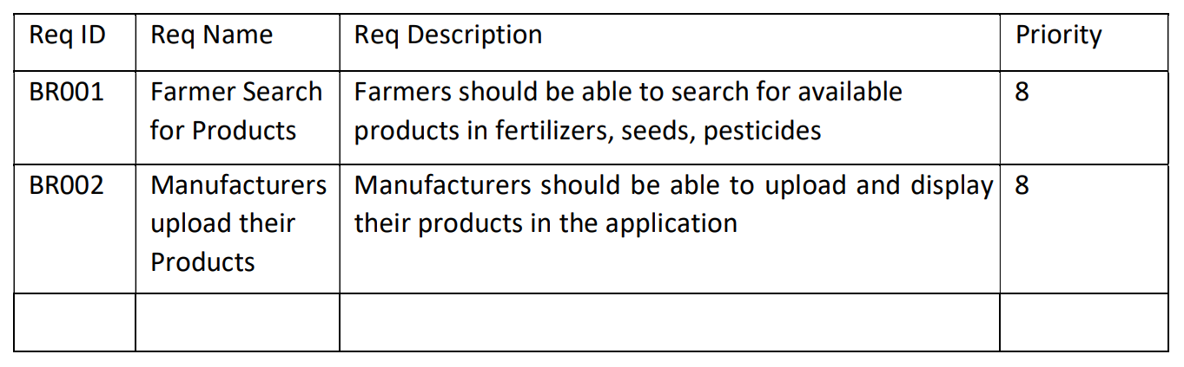

Once the requirements are finalized, as a business analyst, one of the major roles is to act as a liaison between the client and the project team. To gather the requirements correctly from the client side and then to deliver those requirements to the project team in a way they understand.

To make the project team understand the requirements, you need to convert those requirements into UML diagrams and screen mock-ups.

**Answer:**

|  |  |  |  |
| --- | --- | --- | --- |
| **Req IDs** | **Requirement Name** | **Requirement Description** | **Priority** |
| BR001 | User Search Option | Search option so that they can search for any product they need through the products catalog once they visit the website | 3 |
| BR002 | User Login | Login Using Email Id and Password | 1 |
| BR003 | User Signup | If it is a new user, then farmers can create a new account by submitting their email ID and creating a secure password | 1 |
| BR004 | User Wishlist | Buy Later cart for future purchase | 5 |
| BR005 | Payment Gateway | Farmers needs to have an easy-to-use payment gateway which should include cash-on-delivery (COD), Credit/Debit card and UPI options | 6 |
| BR006 | Email confirmation | Once order placed, the user gets an email confirmation regarding their order status | 7 |
| BR007 | Product Delivery Tracking | A delivery tracker to track the whereabouts of their order | 8 |
| BR008 | Manufacturer Product Uploads | Manufacturers should be able to upload and display their products in the application | 2 |
| BR009 | Manufacturer Product Upload Description | Product catalog should have product description in detail along with the manufacture date and date of expiry | 2 |
| BR010 | Manufacturer Product Discounts | Manufacturers can update if they give any additional discounts to farmers. | 5 |
| BR011 | User Cart | add products to cart when farmer wants to buy the product | 5 |

**Question 10** – Use Case Diagram - 10 Marks

Draw use case diagram

**Answer:**

Use case diagram represents the interaction between actor (user) with system and data base.

The below use case diagram covers the below 5 processes:

1. Registration
2. Login
3. Search product
4. Add cart
5. Payment

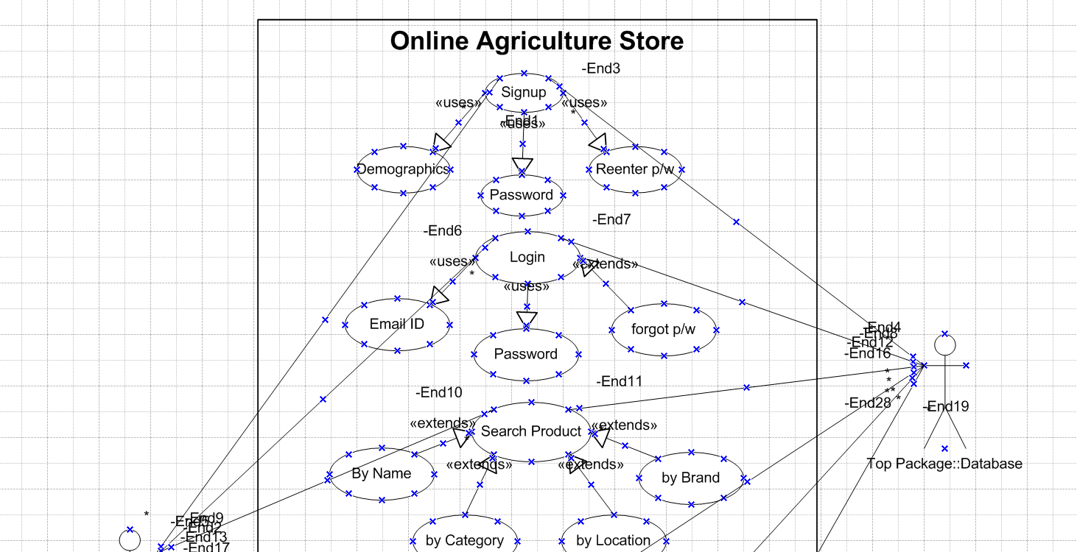

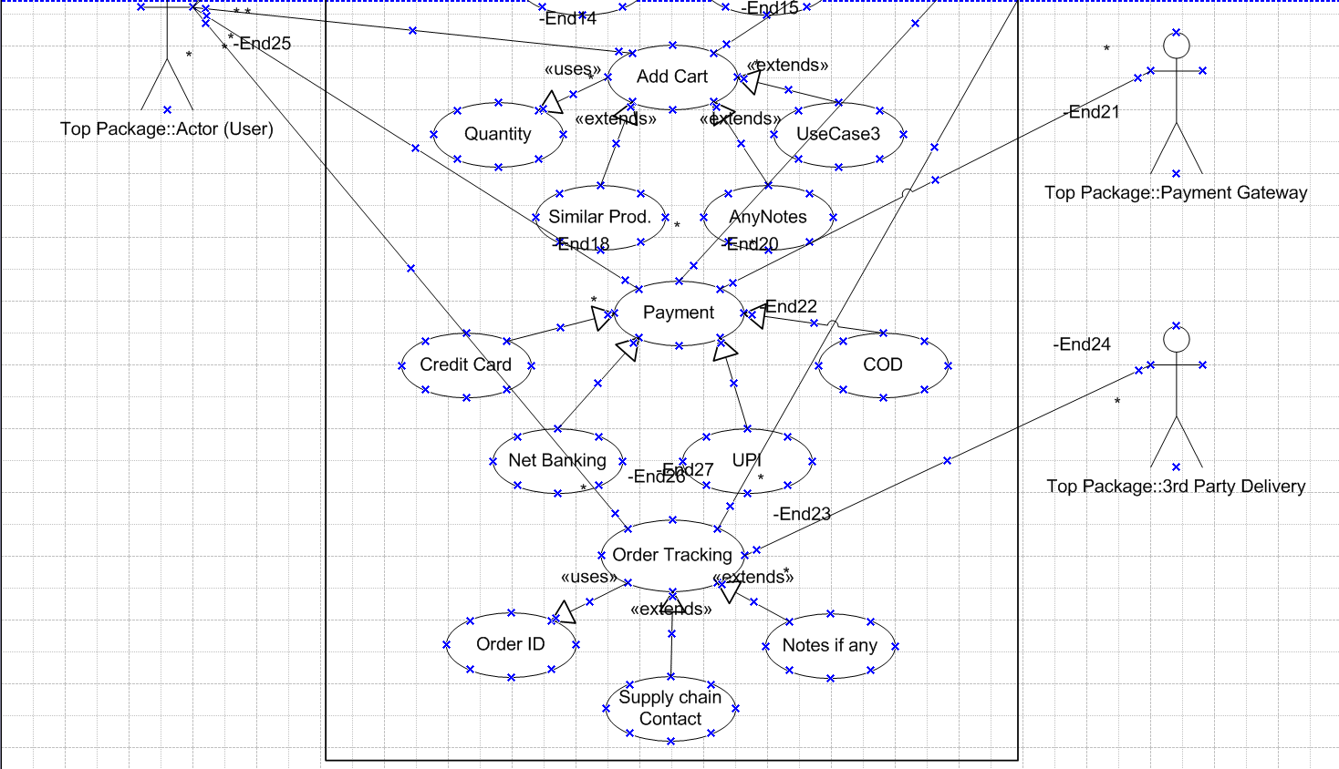

**Question 11** – (minimum 5) Use Case Specs - 15 Marks

Prepare use case specs for all use cases

**Answer:**

a use case specification represents a detailed representation on the user or actor on how they can navigate thru each of the pages/screens from online product store.

|  |  |  |  |
| --- | --- | --- | --- |
| Use Case ID | UC 01 | | |
| Use Case Name | User SignUp Process Flow | | |
| Created by | Mr. XXX | Created on | 2-4-2024 |
| Last Updated By | Mr. XYZ | Last Updated on | 12-30-2024 |
| Actor | Customer | | |
| Description | End user should be able to signup new account | | |
| Pre Condition | New or first time User to the website/application, Valid email ID | | |
| Post Condition | Successfully registers to the online store for purchase | | |
| Normal process flow/Basic Flow/Happy Path | Step 1: Customer should go to www.XYZ.com website from Google Chrome/Edge. Step 2: On top right of the home page user can click on Signup button Step 3: User Should enter all the required information like name, address, pincode, valid email ID and enter information as requested and click next. Step 4: user should update password 2 times, the 2nd one is to confirm the password and click on submit. Step 5: User will get successful user ID creation upon all valid details along with a popup message and email confirming the signup or system will redirect to check the information entered and resubmit. | | |
|  |
|  |
|  |
|  |
|  |
|  |
|  |
|  |
|  |
|  |
|  |
| Alternate Flow | Step 1: User can download application from Apple's app store or Google Play store. Step 2: User to Click on Signup button seen at the bottom of the application 1st screen. Step 3: User can follow the basic flow above from Step 3 and 4 Step 4: User will get successful user ID creation upon all valid details along with a popup message and email confirming the signup or system will redirect to check the information entered and resubmit. | | |  |
|  |
|  |
|  |
|  |
|  |
|  |
|  |
|  |
| Exceptions | If user enters existing email ID, then system to popup message as "existing user, kindly login" and redirect to login page | | |  |
| Frequency | High | | |  |
| Assumptions | User should have Laptop or smart cell phone with stable internet connection | | |  |

|  |  |  |  |
| --- | --- | --- | --- |
| Use Case ID | UC 02 | | |
| Use Case Name | User Login Process Flow | | |
| Created by | Mr. XXX | Created on | 2-4-2024 |
| Last Updated By | Mr. XYZ | Last Updated on | 12-30-2024 |
| Actor | Customer | | |
| Description | End user should be able to login to their existing account and reset the password if he/she forgets | | |
| Pre Condition | must be a existing user with valid email and password | | |
| Post Condition | Successfully login to the online store for purchase or reset the password | | |
| Normal process flow/Basic Flow/Happy Path | Step 1: Customer should go to www.XYZ.com website from Google Chrome/Edge. Step 2: User to click login from the home page Step 3: User Should enter valid email ID and Password and click on submit Step 4: User will be logged in successful with valid credentials and screen will be redirected to the home screen for purchase of products. Step 5: User can also click on forgot UserID/Password button available at the bottom of the login screen if he forgets password. Step 6: User should give mobile number/ registered email ID to generate OTP for password reset Step 7: Upon successful OTP, user can enter new password 2 times (2nd time to confirm the password entered) and click on submit. Step 8: User will be redirected to login screen to enter the email ID and the new password. Step 9: User will be logged in successful with valid credentials and screen will be redirected to the home screen for purchase of products. | | |
|  |
|  |
|  |
|  |
|  |
|  |
|  |
|  |
|  |
|  |
|  |
|  |
|  |
|  |
|  |
|  |
|  |
|  |
|  |
|  |
| Alternate Flow | Step 1: User can download application from Apple's app store or Google Play store. Step 2: User to click login from the home page Step 3: User can follow the basic flow above from Step 3 and 8 Step 4: User will be logged in successful with valid credentials and screen will be redirected to the home screen for purchase of products. | | |  |
|  |
|  |
|  |
|  |
| Exceptions | 1. If user enter's incorrect email ID then system to popup message as "Incorrect email, please check again" and redirect to login page 2. If user enter's incorrect Password then system to popup message as "Incorrect Password, please try again" and redirect to login page | | |  |
| Frequency | High | | |  |
| Assumptions | User should have Laptop or smart cell phone with stable internet connection | | |  |

|  |  |  |  |
| --- | --- | --- | --- |
| Use Case ID | UC 03 | | |
| Use Case Name | Buying Of a Product in online Store | | |
| Created by | Mr. XXX | Created on | 2-4-2024 |
| Last Updated By | Mr. XYZ | Last Updated on | 12-30-2024 |
| Actor | Customer, Manufacturer | | |
| Description | End user should be able to search and add the products to cart | | |
| Pre Condition | Must have logged in to the portal, Products availability in the website | | |
| Post Condition | a product to be added in the cart for purchase | | |
| Normal process flow/Basic Flow/Happy Path | Step 1: User can type the product they are searching for in the search tab bar Step 2: User can also see the products auto populates while they type of the product and can directly click on it to view the product Step 3: User can also click on description button to read the product related description along with the date and expiry of manufacturing, Quantity details, Manufacturer details, price of the product etc. Step 4: User can swipe left or right to view more images or details of the product they are looking into Step 5: Once user decides buying a specific product, they can click on add to cart button just below the product description Step 6: User get 1 quantity by default for 1 click on add to cart Step 7: User can click "+" or "-" button just available before and after add to cart button to get their required number of quantities. minimum will be 1 quantity to add in the cart Step 8: after all purchase, user can click "Go To Cart" to view the summary of the products | | |
|  |
|  |
|  |
|  |
|  |
|  |
|  |
|  |
|  |
|  |
|  |
|  |
|  |
|  |
|  |
|  |
|  |
|  |
|  |
|  |
| Alternate Flow | Step 1: User can click on Mic Symbol to voice out to product he/she is searching for clearly Step 2: system will auto populate the product lists in the GUI for customer to shop for Step 3: User can follow the step 3 to 8 as above mentioned in the basic flow. | | |  |
|  |
|  |
|  |
|  |
| Exceptions | 1. If user enter's a product which is not available then system to popup message as "Searched product is currently not in stock, please check again Later" 2. If user enter's too many products then system to popup message as "maximum 5 quantities allowed" and add the maximum quantity to the cart. and vice versa for minimum purchase for other products 3. if user clicks "go to Cart" without adding products in cart hen system to popup message as " Add products to cart to show" and redirect to search tab | | |  |
|  |
|  |
|  |
|  |
| Frequency | High | | |  |
| Assumptions | User should have Laptop or smart cell phone with stable internet connection and products in the cart | | |  |

|  |  |  |  |
| --- | --- | --- | --- |
| Use Case ID | UC 04 | | |
| Use Case Name | Placing a order in online Store | | |
| Created by | Mr. XXX | Created on | 2-4-2024 |
| Last Updated By | Mr. XYZ | Last Updated on | 12-30-2024 |
| Actor | Customer, Manufacturer, 3rd party payment gateway | | |
| Description | End user should be able to successfully place order and get order ID | | |
| Pre Condition | Must have logged in to the portal, Products availability in the website and products in the cart with payment details | | |
| Post Condition | Successful Placement of the order along with the Order ID | | |
| Normal process flow/Basic Flow/Happy Path | Step 1: From the products in the cart, user to verify the lists and amounts and can click on place order button. User can also check on minimum order amount Step 2: Popup will appear with confirmation button for address confirmation for delivery. User must confirm accordingly. Step 3: After clicking Place Order button, the end user to select any one of the payment options like cash on delivery, UPI, Net Banking or credit card payment Step 4: if user selects Net Banking or Credit card payment, then the page will redirect to 3rd party website for the payment Step 5: User to enter banking / CC related details and complete the payment process.  Step 6: Post successful payment, it will redirect to online product store along with the order ID and its summary. Step 7: An order tracking option also be generated to see the status of the order | | |
|  |
|  |
|  |
|  |
|  |
|  |
|  |
|  |
|  |
|  |
|  |
|  |
|  |
|  |
|  |
|  |
|  |
|  |
|  |
|  |
| Alternate Flow | Step 1: If user selects COD, then order should be placed directly along with the order ID and its summary Step 2: An order tracking option also be generated to see the status of the order | | |  |
|  |
|  |
|  |
|  |
| Exceptions | 1. If user orders small Amount or says lesser than 500 INR, then system will popup "Small Cart fee of 100INR will be charged for delivery". 2. Any products become out of stock after adding to cart and before confirming the order, then system popups " Item XXX is currently unavailable at the moment, can we proceed further placing order excluding the Item XXX". Upon user confirmation system will also adjust INR value from the cart. | | |  |
|  |
|  |
|  |
|  |
| Frequency | Medium | | |  |
| Assumptions | User should have Laptop or smart cell phone with stable internet connection and products in the cart and valid banking details and cash | | |  |

|  |  |  |  |
| --- | --- | --- | --- |
| Use Case ID | UC 05 | | |
| Use Case Name | Change of Address | | |
| Created by | Mr. XXX | Created on | 2-4-2024 |
| Last Updated By | Mr. XYZ | Last Updated on | 12-30-2024 |
| Actor | Customer | | |
| Description | Change of address to be updated successfully | | |
| Pre Condition | must be an existing customer with address updated to his/her account | | |
| Post Condition | Successful change of address for delivery | | |
| Normal process flow/Basic Flow/Happy Path | Step 1: User should login with email ID and Password Step 2: User can click on edit profile Step 3: User will be navigated to new page with all the demographics Step 4: User can click edit button and update the address along with the valid pincode and submit Step 5: After successful address updated, system popups "Address details updated successfully". | | |
|  |
|  |
|  |
|  |
|  |
|  |
| Alternate Flow | Step 1: Call to the helpline number and can update the address accordingly Step 2: email confirmation will be sent upon successful address change | | |  |
|  |
|  |
|  |
|  |
| Exceptions | 1. for any active orders while changing address, the system can popup as "The address change cannot happen for existing order. Your future orders can be delivered to your new address". | | |  |
|  |
|  |
|  |
|  |
| Frequency | Low | | |  |
| Assumptions | Must have an existing address to change | | |  |

**Question 12** – (minimum 5) Activity Diagrams - 15 Marks

Activity diagrams

**Answer:**

Activity diagrams is a Type of UML which helps us to identify the flow of the system at each stage.

1. User Registration

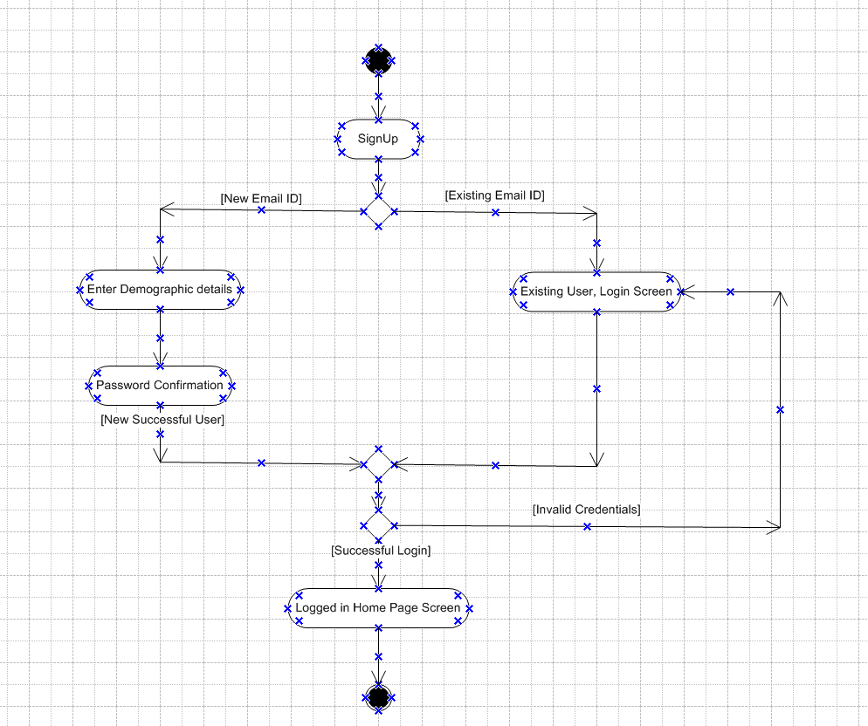

1. User Login

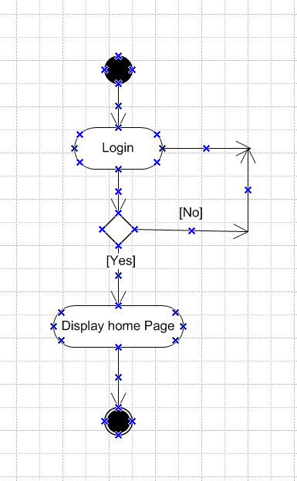

1. Adding product to the cart

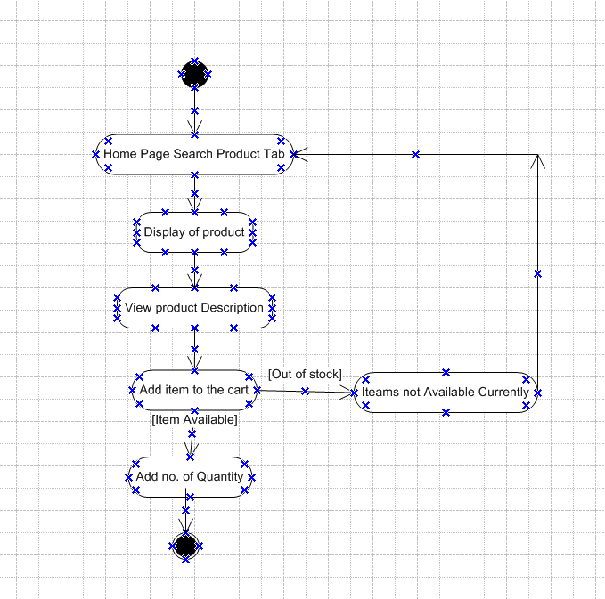

1. Place the order with successful payment along with Order ID

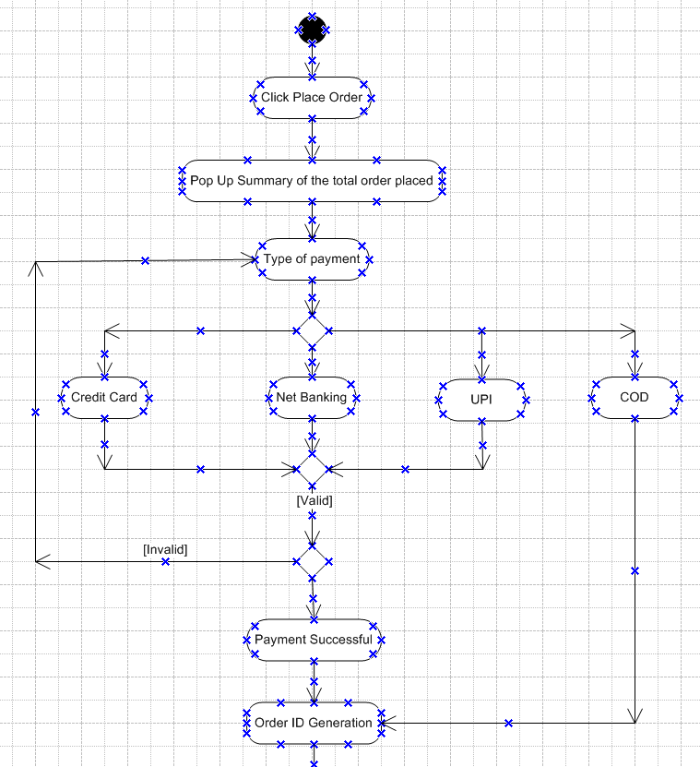

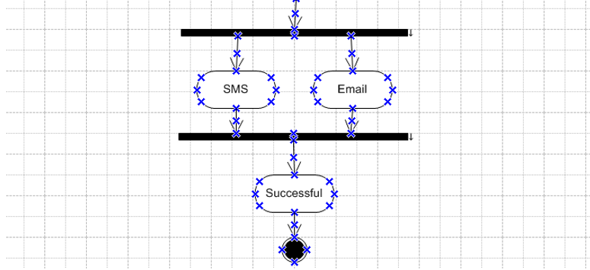

1. Change of Address

