**Capstone Project1 – Part -3**

**Q1) Identify minimum 20 functional requirements?**

**Example: Functional requirement: When an order is fulfilled, the local printer shall print a packing slip.**

**Non-Functional Requirement: Packing slips shall be printed on both sides of 4”x 6” white paper, the standard size for packing slips used by local printers.**

These below are the functional requirements which cover various aspects of the online agriculture application store,

including user registration, Product recommendation, shopping cart, Manufacturer registration, Wishlist etc.

These below are the functional requirements which cover various aspects of the online agriculture application store,

including user registration, Product recommendation, shopping cart, Manufacturer registration, Wishlist etc.

**Ans) These below are the functional requirements which cover various aspects of the online agriculture application store.**

These below are the functional requirements which cover various aspects of the online agriculture application store,

including user registration, Product recommendation, shopping cart, Manufacturer registration, Wishlist etc.

**These below are the functional requirements which cover various aspects of the online agriculture application store,**

**Including user registration, Product recommendation, shopping cart, Manufacturer registration, Wish list etc.**

**Functional requirement:**

|  |  |  |  |
| --- | --- | --- | --- |
| **Req ID** | **Requirement Name** | **Requirement Description** | **Priority** |
| FR001 | Farmers Registration | Application should allow to register with and login to the application | 8 |
| FR002 | Product Catalogue | Farmers should be able to search for the products available (Fertilizers, seeds,  pesticides) | 8 |
| FR003 | Shopping Cart | Should allow farmers after logging in to add the products to the shopping cart (buy  now /buy later) | 9 |
| FR004 | Payment Processing | Application should be able to manage  multiple payment gateways to facilitate  secure and convenient transactions | 10 |
| FR005 | Order quantity placement | Farmers should be able to place order for  specifying quantity for selected address  and selected products. | 8 |
| FR006 | Order History | Should allow to view the past history  including the orders list, and status of the order. | 9 |
| FR007 | Tracking Details | Users getting an email confirmation with a  delivery tracker to track the status of the  order in real time | 5 |
| FR008 | Order Confirmation | Users should get confirmation details like  order quality, colour, delivery timeline on  the specified ordered products | 9 |
| FR009 | Customer Service | support to either  Should allow customer chat, phone, call option | 9 |
| FR0010 | Inventory Control | Should have update on the inventory  needed if required | 8 |
| FR0011 | Product Reviews | Allow users to provide ratings to the products  they have purchased | 10 |
| FR0012 | Return and refund policy | Should allow user to avail for a refund or a return  if the product is damaged or doesn’t meet the  criteria. | 8 |
| FR013 | Manufacturer registration | Allow manufacturers to register and login | 9 |
| FR0014 | Product Recommendations Application | should provide personalized product  recommendations according to user history and  order history | 5 |
| FR0015 | Social Sharing Application | hould allow users to share the  products socially to anyone on social media platform | 7 |
| FR0016 | Product Filtering | Should allow users to filter the product according  to their needs | 3 |
| FR0017 | Account Management | Should allow users to manage their account via/  profile settings, password changes and email preferences | 3 |
| FR0018 | Order Confirmation | Should allow users to select the mode of  confirmation either via(email/phone number, SMS,  what’s app etc) | 8 |
| FR0019 | Manufacturer Product Listing | Should allow manufacturers to able to list their products | 8 |
| FR0020 | Wish list show | allows customers to add the products to  Wishlist to buylater | 5 |
| FR0021 | Auto Order | Should allow users to enable auto order  according to the flexibility of time/month or days  Frequency. | 3 |

**Non-Functional Requirement:**

|  |  |  |  |
| --- | --- | --- | --- |
| **Req ID** | **Requirement Name** | **Requirement Description** | **Priority** |
| NFR001 | Page loading time | Each page should load within 2 seconds of time | 9 |
| NFR002 | WCAG 2.1. | The system must meet Web Content Accessibility Guidelines WCAG 2.1 | 10 |
| NFR003 | Internet Speed | Required Internet speed to run the application | 7 |
| NFR004 | Maintenance | Maintenance of the application | 8 |
| NFR005 | Compliance | Adherence of law, regulations, industry standards etc., | 8 |

**Q2. Make wireframe and prototypes**

Ans. Creating 5-page designs for reference to online agriculture store.

1. Login page

2. Search page

3. Add to cart page

4. Payment page

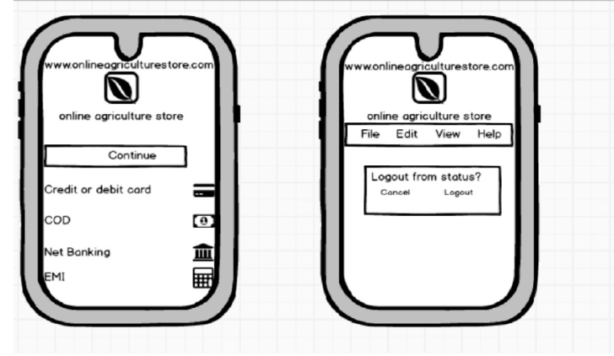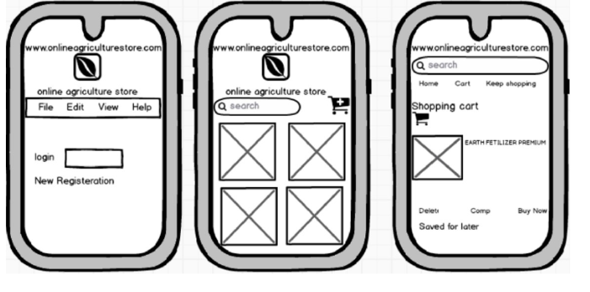5. Logout page

**Q3) Make a note of the Tools, which you are using for above concepts.**

Ans. Some commonly used tools for the concepts you mentioned: -

1. **Microsoft Visio:** Microsoft Visio is a popular tool for creating diagrams, flowcharts, and wireframes. It offers a wide range of templates and shapes to create visual representations of processes and systems. It is also commonly used for scenarios such as Process Mapping and Visual Collaboration. The latest version of Visio also has data visualization that allows users to create diagrams from Excel data and also embed Visio diagrams in Power Dashboards.
2. **Balsamiq**: Balsamiq is a wire framing tool that allows you to create low-fidelity wireframes quickly. It has a simple and intuitive interface, making it easy to sketch out ideas and concepts
3. **Axure RP**: Axure RP is a powerful prototyping and wire framing tool that enables you to create interactive and dynamic prototypes. It offers advanced features for creating complex interactions and user flows.
4. **Mock-ups**: - Mock-ups is a web-based design tool that provides a comprehensive set of features for wire framing and prototyping. It allows you to create interactive wireframes and prototypes with a user-friendly interface. These tools can assist you in visualizing and prototyping your design concepts effectively. It's important to explore their features and determine which tool best fits your specific needs and preferences. These tools can assist you in visualizing and prototyping your design concepts effectively. It's important to explore their features and determine which tool best fits your specific needs and preference.

**Q4: A business analyst’s key responsibilities are to keep track of the requirements and make sure that no requirement is missed.**

**Mr. Henry and peter have approached you regarding the current status of the project. How will you tackle this situation?**

**Prepare RTM**

**Ans.** RTM requirement traceable Matrix pals a vital role as it showcases the progress and the status of the project, it contains high level documents which shows us the information on the project data.

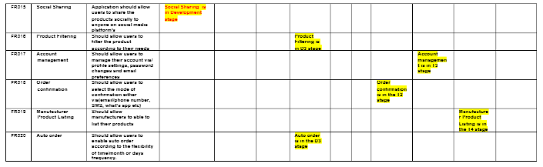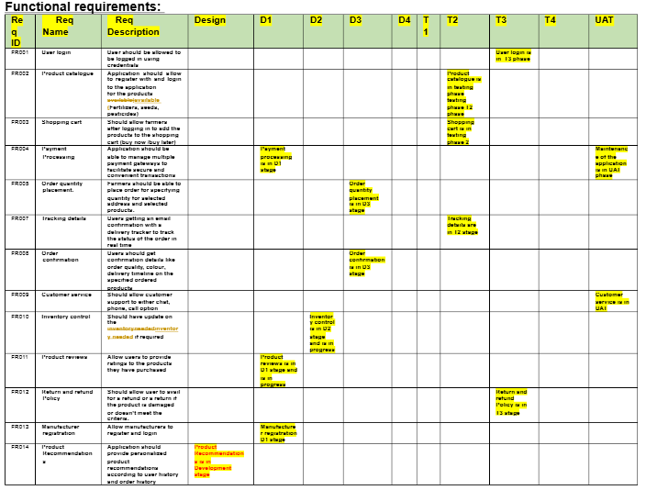

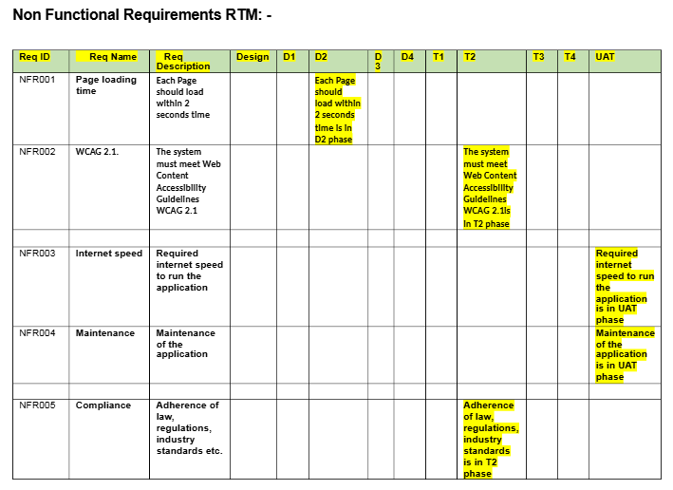**Q5) Prepare 10 Test Case Documents**

**Ans: Test case for Login page:**

|  |  |  |  |
| --- | --- | --- | --- |
| **Test case ID** | **TC001** |  |  |
| **Project Name** | **Online agriculture application** | **Tested by** | **Samatha** |
| **Document** | **User login** | **Testing date** | **05-Jan-25** |
| **Model** | **Login** | **Test implemented by** | **Samatha** |
|  |  | **Test implementation date:** | **05-Jan-25** |

Pre condition’s: - User needs to valid user name and password to login to the portal

Post condition’s: - Successfully logged in to the portal

Dependencies: - Internet Connectivity

|  |  |
| --- | --- |
| Input Data | *User ID *Password *Captcha *OTP |
| Excepted Behaviour | Home page / Pop up error page |
| Actual Behaviour | Home page / Pop up error page |
| Comments | Test was successful |
| Results Pass/ Fail | Pass |

Scenario: website for online shopping of farm products, in that we have login we have 4inputs, 3compulsory and 1 optional after that results are being shown.

**2. Test Case 2 :- (New User)**

|  |  |  |  |
| --- | --- | --- | --- |
| **Test case ID** | **TC002** |  |  |
| **Project Name** | **Online agriculture application** | **Tested by** | **Samatha** |
| **Document** | **New User** | **Testing date** | **06-Jan-25** |
| **Model** |  | **Test implemented by** | **Samatha** |
|  |  | **Test implementation date:** | **06-Jan-25** |

Pre condition’s: - User needs to register with email id and create a secure password.

Post condition’s: - Successfully created a user name and password

Dependencies: - Internet Connectivity

|  |  |
| --- | --- |
| Input Data | *Username *Password set  *Email authentication *Captcha *OTP |
| Excepted Behaviour | Registered and logged in home page shows |
| Actual Behaviour | Home page pops up |
| Comments | Test was successful |
| Results Pass/ Fail | Pass |

Scenario: website for online shopping of farm products, in that we have login we have 4 compulsory, 1 optional after that results are being shown.

**3. Test Case 3 :- (Website Ordering)**

|  |  |  |  |
| --- | --- | --- | --- |
| **Test case ID** | **TC003** |  |  |
| **Project Name** | **Online agriculture application** | **Tested by** | **Samatha** |
| **Document** | **Online ordering** | **Testing date** | **06-Jan-25** |
| **Model** |  | **Test implemented by** | **Samatha** |
|  |  | **Test implementation date:** | **06-Jan-25** |

Pre condition’s: - User needs to login and open and have access to the portal.

Post condition’s: - Successfully have access to portal

Dependencies: - Internet Connectivity/ Valid username and password

|  |  |
| --- | --- |
| Input Data | *Product name * Product details |
| Excepted Behaviour | After login to the portal  user has multiple products  to choose |
| Actual Behaviour | Options to select from  Products |
| Comments | Test was successful |
| Results Pass/ Fail | Pass |

Scenario: website for online shopping of farm products, in that we perform website purchasing we have 1 compulsory 1 optional and after that results being shown.

**4. Test Case 4 :- (Online products purchase)**

|  |  |  |  |
| --- | --- | --- | --- |
| **Test case ID** | **TC004** |  |  |
| **Project Name** | **Online agriculture application** | **Tested by** | **Samatha** |
| **Document** | **Online purchasing** | **Testing date** | **06-Jan-25** |
| **Model** |  | **Test implemented by** | **Samatha** |
|  |  | **Test implementation date:** | **06-Jan-25** |

Pre condition’s: - User needs to login and open and have access to the portal.

Post condition’s: - Can purchase products online

Dependencies: - Internet Connectivity/ Valid username and password

|  |  |
| --- | --- |
| Input Data | *Product name *Manufacturing code *Captcha * Password |
| Excepted Behaviour | After login to the portal  user has products / stocks information |
| Actual Behaviour | After login to the portal  user has products / stocks information |
| Comments | Test was successful |
| Results Pass/ Fail | Pass |

Scenario: website for online shopping of farm products, in that we perform online purchasing we have 3 inputs & 3 are compulsory and after that results being shown.

**5. Test Case 4 :- (Payment Gateway)**

|  |  |  |  |
| --- | --- | --- | --- |
| **Test case ID** | **TC005** |  |  |
| **Project Name** | **Online agriculture application** | **Tested by** | **Samatha** |
| **Document** | **Online purchasing** | **Testing date** | **06-Jan-25** |
| **Model** |  | **Test implemented by** | **Samatha** |
|  |  | **Test implementation date:** | **06-Jan-25** |

Pre condition’s: - User needs to login and select a product and check out using COD/CARD OR UPI

Post condition’s: - Product Ordered

Dependencies: - Internet Connectivity/ Have payment details

|  |  |
| --- | --- |
| Input Data | *User Name  *Card number *Expiry  * CVV *OTP |
| Excepted Behaviour | After proceeding to buy the products  leads to transactions/ Payments page |
| Actual Behaviour | After proceeding to buy the products  leads to transactions/ Payments page |
| Comments | Test was successful |
| Results Pass/ Fail | Pass |

Scenario: website for online shopping of farm products, in that we perform payment gateway we have 4 inputs & 4 are compulsory and after that results being shown.

**6. Test Case 6 :- (Browse Product)**

|  |  |  |  |
| --- | --- | --- | --- |
| **Test case ID** | **TC006** |  |  |
| **Project Name** | **Online agriculture application** | **Tested by** | **Samatha** |
| **Document** | **Browse products** | **Testing date** | **06-Jan-25** |
| **Model** |  | **Test implemented by** | **Samatha** |
|  |  | **Test implementation date:** | **06-Jan-25** |

Pre condition’s: - User needs to login by using user name and password

Post condition’s: - User can now be able to browse the products

Dependencies: - Internet Connectivity

|  |  |
| --- | --- |
| Input Data | *Category  *Size  *Price  *Availability |
| Excepted Behaviour | After login to page user will have options to browse according to needs |
| Actual Behaviour | After login to page user will have options to browse according to needs |
| Comments | Test was successful |
| Results Pass/ Fail | Pass |

Scenario: website for online shopping of farm products, in that we perform browse products we have 4 inputs & 4 are compulsory and after that results being shown.

**7. Test Case 7 :- (User experience)**

|  |  |  |  |
| --- | --- | --- | --- |
| **Test case ID** | **TC007** |  |  |
| **Project Name** | **Online agriculture application** | **Tested by** | **Samatha** |
| **Document** | **User experience** | **Testing date** | **06-Jan-25** |
| **Model** |  | **Test implemented by** | **Samatha** |
|  |  | **Test implementation date:** | **06-Jan-25** |

Pre condition’s: - User needs to buy products

Post condition’s: - User can now be able to rate the products accordingly to the use.

Dependencies: - Should be valid customer and brought a product

|  |  |
| --- | --- |
| Input Data | *Name  *Order ID  *Contact number  *Rating |
| Excepted Behaviour | After user brought a product,  he can rate the product usage  whether the product has met the expectations |
| Actual Behaviour | After user brought a product,  he can rate the product usage  whether the product has met the expectations |
| Comments | Test was successful |
| Results Pass/ Fail | Pass |

Scenario: website for online shopping of farm products, in that we perform user experience we have 4 inputs & 3 are compulsory and after that results being shown.

**8. Test Case 8 :- (Order Cancellation)**

|  |  |  |  |
| --- | --- | --- | --- |
| **Test case ID** | **TC008** |  |  |
| **Project Name** | **Online agriculture application** | **Tested by** | **Samatha** |
| **Document** | **Order Cancellation** | **Testing date** | **06-Jan-25** |
| **Model** |  | **Test implemented by** | **Samatha** |
|  |  | **Test implementation date:** | **06-Jan-25** |

Pre condition’s: - User needs to buy product or cancel the delivery when the product is (out for delivery)

Post condition’s: - User can avail for a return on a replacement/refund

Dependencies: - Should be valid customer and brought a product

|  |  |
| --- | --- |
| Input Data | *Name  *Order ID/ details *Reason for cancelling the order |
| Excepted Behaviour | After user brought a product,  he can return the product for  replacement or a refund if the user wants |
| Actual Behaviour | After user brought a product,  he can return the product for  replacement or a refund if the user wants |
| Comments | Test was successful |
| Results Pass/ Fail | Pass |

Scenario: website for online shopping of farm products, in that we perform order cancellation we have 3 inputs after clicking on submit results are being shown.

**9. Test Case 9 :- (Customer Service)**

|  |  |  |  |
| --- | --- | --- | --- |
| **Test case ID** | **TC009** |  |  |
| **Project Name** | **Online agriculture application** | **Tested by** | **Samatha** |
| **Document** | **Customer Service** | **Testing date** | **06-Jan-25** |
| **Model** |  | **Test implemented by** | **Samatha** |
|  |  | **Test implementation date:** | **06-Jan-25** |

Pre condition’s: - User needs to be registered customer and might or might not buy a product

Post condition’s: - User can connect with customer service and enquire about the needs

Dependencies: - Should be valid customer

|  |  |
| --- | --- |
| Input Data | *Name  *Order ID  *Contact number |
| Excepted Behaviour | User have to be registered customer with valid user id and password (ordered the product or not doesn’t matter) |
| Actual Behaviour | User have to be registered customer with valid user id and password (ordered the product or not doesn’t matter) |
| Comments | Test was successful |
| Results Pass/ Fail | Pass |

Scenario: website for online shopping of farm products, in that we perform customer service we have 3 inputs, 2 are compulsory and 1 is optional after that results are being shown.

**10. Test Case 10 :- (Delivery Tracking)**

|  |  |  |  |
| --- | --- | --- | --- |
| **Test case ID** | **TC010** |  |  |
| **Project Name** | **Online agriculture application** | **Tested by** | **Samatha** |
| **Document** | **Delivery Tracking** | **Testing date** | **06-Jan-25** |
| **Model** |  | **Test implemented by** | **Samatha** |
|  |  | **Test implementation date:** | **06-Jan-25** |

Pre condition’s: - User should buy the product

Post condition’s: - User shared with a tracking number through which customer can track the product live

Dependencies: - Should be valid customer & should order a product

|  |  |
| --- | --- |
| Input Data | *Name  *Order ID  *Tracking number |
| Excepted Behaviour | User shared with a tracking number through which customer can track the product live |
| Actual Behaviour | User have to place an order & tracking number is shared |
| Comments | Test was successful |
| Results Pass/ Fail | Pass |

Scenario: website for online shopping of farm products, in that we perform delivery tracking we have 3 inputs, 3 are compulsory and 1 is optional after that results are being shown.

**Q6) After the requirements are thoroughly explained to the entire project team by business analyst, the Database architects have decided to do the database design and also to represent the in-flow and out-flow of data. Draw database schema and ER diagram**

**Ans:** Database design has **2** approach:

* Top to bottom approach
* Bottom to Top approach

All table + entities = DB Schema

Products (Table name)

|  |  |  |
| --- | --- | --- |
| Product name | Product category | Remarks |
| 30 | 40 | 20 |
| 60 | 50 | 1 |

Entities

Data records

**DB SCHEMA+ER DIAGRAM = DB DESIGN**

**Database Schema Diagram for ONLINE AGRICULTURE APPLICATION**

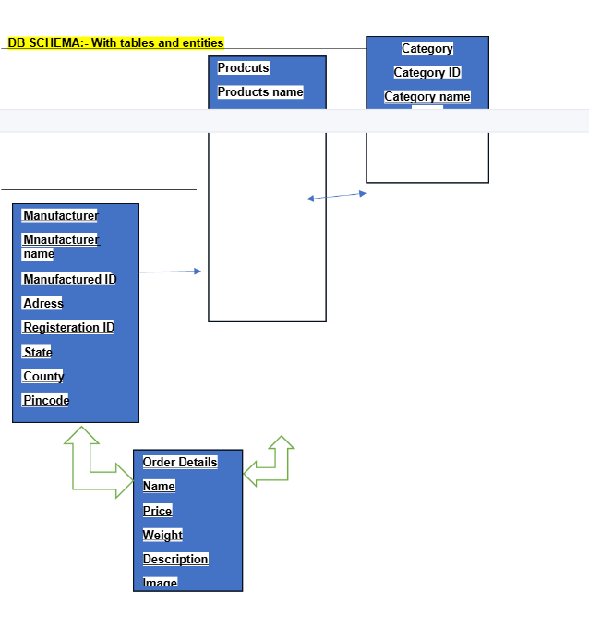

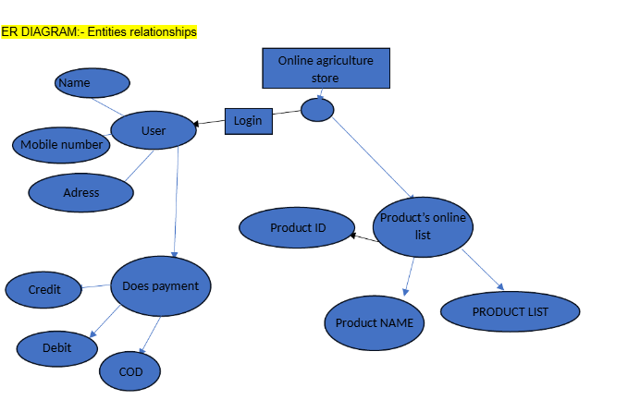

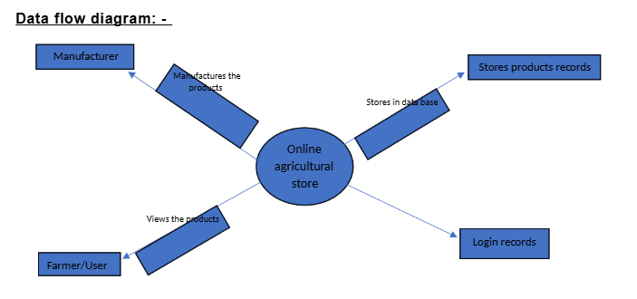**Q7. What is a data flow diagram? Draw a data flow diagram to represent the in-flow and out-flow of data when a farmer is placing order for the product.   
Ans:** The data flow diagram also provides Information about the outputs and inputs of each entity and the process itself. A dataflow diagram has no control flow there are no decision rules and no loops.

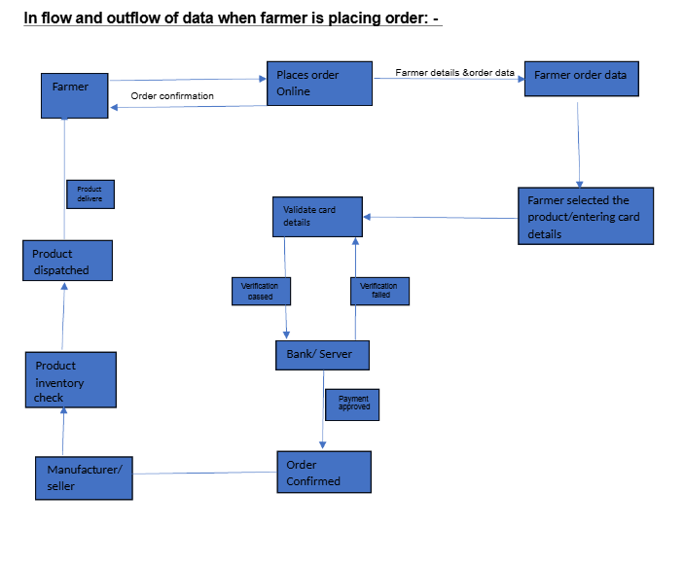

**Q8. Due to change in the Government Taxation structure. We should change the Tax structure how do you handle change requests in a project?**

**Ans:** What is a Change request - Change requests are when a stakeholder, either a client or an internal team or department, requests a change to the processes or deliverables that had already been decided upon the project scope. However, in this scenario, this change request has come up due to change in the Govt.Taxation structure.

As a BA, I would analyse the request and clarify the stakeholders exactly what the request is asking us to do in the Online Agriculture Product Store. In a normal scenario, as a BA, I would first do the Feasibility Test, to check, how feasible it is to change the current ongoing project with the new change request.

However, in this case, Feasibility study is not required, as it’s a Govt structure which needs to be updated and followed.

Therefore, as a BA the below steps to change the project as per the client’s requirements: **-**

Document the Change request.

oLook for any Supporting materials to help in adding this Change.

oNeed to assess, whether the Change is an Inside or Outside scope. As it’s an outside scope, the

Budget and time will get impacted.

oBA and PM should ensure whether the change is a minor or a major change. Policy changes

by Govts a major change request and we need to ensure that the change should be done according

to the Govt. instruction.

oFill the Change request Form (CRL) and get the approval from the Project Manager.

oWe also need to ensure that our Team understands the priority of this change request.

oWe also need to discuss the change with Change Control Board (CCB) who will recommend the

necessary change on the Project.

oOnce this change is approved, the project deliverables will need to be updated. This can include

plans and schedules, business process documents, and the requirements documents.

oOnce these updates have been made, the project manager can communicate the new course of

action to everyone who will be impacted. Now you can delegate the necessary tasks to the people

in charge of implementing these new changes

* Document the Change request.
* Look for any Supporting materials to help in adding this Change.
* Need to assess, whether the Change is an Inside or Outside scope. As it’s an outside scope, the Budget and time will get impacted.
* BA and PM should ensure whether the change is a minor or a major change. Policy changes by Govts a major change request and we need to ensure that the change should be done according to the Govt. instruction.
* Fill the Change request Form (CRL) and get the approval from the Project Manager.
* We also need to ensure that our Team understands the priority of this change request.
* We also need to discuss the change with Change Control Board (CCB) who will recommend the necessary change on the Project.
* Once this change is approved, the project deliverables will need to be updated. This can include plans and schedules, business process documents, and the requirements documents.
* Once these updates have been made, the project manager can communicate the new course of action to everyone who will be impacted. Now you can delegate the necessary tasks to the people in charge of implementing these new changes.

**Q9) Change Request Vs an Enhancement?**

**Ans:** The request from Ben and Kevin is an Enhancement request, as they want to add another feature in the Online store which acts as an application upgrade, which will also help the Farmers to sell the yields directly in the online store, apart from buying products. Hence my response would a positive response to them. Therefore, as a BA, I should analyse the request and provide a project plan, requirement, design, and testing plans for this request. I must prepare an enhancement request form and decide how much man-power and man-hours required for this enhancement request

**Q10) Come up with estimations – How many Man hours required?**

**Ans:** Man-hours Required= Total hours working per day x Total number of members x Total numbers of days worked over the specific period.

Number of Working Hours a day = 8 hours

Number of Resources = 12

Time period provided = 18 months = 547 days = 78 weeks (Including Weekends and Public Holidays)

Assuming Weekends = 156

Assuming Public Holidays = 10

Total = 166

547-166 = 381 working days

Hence, Estimated Man-hours = 8 hours * 12 resources * 381 days = 36,576 hours required.

**Q11) Explain the UAT process?**

**Ans.** **User Acceptance Testing (UAT)** is a phase in the software development life cycle where the users of the Online Agriculture Product Store participate in validating that if its meets their needs.

As a BA, I will verify all the validations prior to design the UAT Test cases, which will cover the functionality of the product, System environment, any possible defects which could arise and how to deal with these defects.

**Steps for UAT**

**Analysis of Business Requirements**: One of the most important activities in the UAT is to identify and develop test scenarios. These test scenarios are derived from the following documents:

* Business Use Cases
* Process flow diagrams
* Business Requirements Document (BRD)
* System Requirements Specification (SRS)

**Creation of UAT Plan:** The UAT test plan outlines the strategy that will be used to verify and ensure an application meets its business requirements. It documents entry and exit criteria for UAT, Test scenarios and test cases approach and timelines of testing.

**Identify Test Scenarios and Test Cases:** Identify the test scenarios with respect to high-level business process and create test cases with clear test steps. Test Cases should sufficiently cover most of UAT scenarios. Business Use cases are input for creating the test cases.

**Preparation of Test Data**: It is best advised to use live data for UAT. Data should be scrambled for privacy and security reasons. Tester should be familiar with the database flow.

**Run and record the results:** Execute test cases and report bugs if any. Re-test bugs once fixed. Test Management tools can be used for execution.

By the above steps UAT acceptance process is taken care.

**Q12. Project closure document?**

**Ans:** A project closure document is a document that summarizes the results of a project. It documents all phases of project management into one report. It includes the team’s accomplishments, lessons learned, and recommendations for improving upon future projects. A project closure document is created at the end of a project.

**Project closure Document**

**Online agriculture product store**

**Version 1.1**

**Revision Date: - MM/DD/YYYY**

Submit the document to the Project Sponsor, Business Owner, and PPMO/PMO Division Director; and archive this closure document with the project artifacts once completed**.**

|  |  |  |  |
| --- | --- | --- | --- |
| **Approver Name** | **Title/Role** | **Signature** | **Date** |
| Peter and Ben | Project Stakeholders | ok | MM/DD/YYYY |
| Henry | Sponsor | ok | MM/DD/YYYY |
| Pandu | Financial Head | ok | MM/DD/YYYY |
| Vandanam | Project Manager | ok | MM/DD/YYYY |
| Karthik | Delivery-Head | ok | MM/DD/YYYY |
| Dooku | Project Co-ordinator | ok | MM/DD/YYYY |

By authorizing this Project Closure, the Project Stakeholder(s), and Executive Sponsor agree to all terms within this document

By authorizing this Project Closure, the Project Stakeholder(s), and Executive Sponsor agree to all terms within this document

**Revision History: Identify Document Changes**

|  |  |  |  |
| --- | --- | --- | --- |
| **Version** | **Date** | **Name** | **Description** |
| 1.0 | MM/DD/YYYY | Mr.Henry | Passed |

**Section-1 General Information:**

|  |  |
| --- | --- |
| **Project Activity** | **Date** |
| Project Start | 05th Jan 2025 |
| Project Closure | 06th Jan 2025 |

Date of project closure refers to the project finish date, meaning all the task must be completed

**Section-2 Business Objective:**

|  |  |  |  |
| --- | --- | --- | --- |
| **Business Case Reference** | **Business Objective** | **Met/Not Met** | **Comments** |
| B1001 | Farmers should be able to purchase products online | Met | Passed |

**Section-3 Customer Expectation Management:**

|  |  |  |  |
| --- | --- | --- | --- |
| **Item** | **Question** | **Description** | **Comments** |
| 1 | How does expected benefits and business outcomes realized? | Yes | Passed |
| 2 | Were all expected outcomes satisfied | Yes | Passed |

**Section-4 Issues Identified:**

|  |  |  |  |
| --- | --- | --- | --- |
| **Item** | **Issues identified** | **Met/ Not Met** | **Comments** |
| 1 | Farmers should be able to purchase products online | Met | Passed |

**Section-5 Project Checklist:**

|  |  |
| --- | --- |
| **Deliverable** | **Description** |
| Business case completed and posted on suitable shared shortage | Yes No |
| Risk assessment completed and posted on suitable shared shortage | Yes No |
| Meeting notes completed and posted on suitable shared shortage | Yes No |
| Project charter completed and posted on suitable shared shortage | Yes No |
| Lessons learned documented Yes No  Lessons learned documented | Yes No |
| Project folder moved completed on suitable shared shortage | Yes No |
| Additional project docs and artifacts posted on shared storage, including project change, change requests, budget, timeline etc. | Yes No |
| Support handover document completed | Yes No |
| Comments Application passes |  |

The above format would generally require for project closure