Document 1- Business case document template
➢ Why is this project initiated?
This project was initiated to make marketing people more accountable for their job, increase productivity, control reimbursement claims and manage leads effectively
➢ What are the current problems?
Marketing executives are not visiting resellers or project site often and making hefty claims while the sales numbers are not encouraging. To maximise the sales even if the company signed up with the india mart portal but the marketing people are not showing active participation
➢ With this project how many problems could be solved?
- Leads will be managed properly with proper follow ups as an open lead will be displayed as a remainder in the notification
- Leads conversion analysis can be done with the feedback.
- Reimbursement claims can be verified against actual travel (kilometres and duration)
- Executives will be able to mark attendance and dealer/project visits on the android app itself
- Backend team will get attendance data, visits data, reimbursement data, Real time end user tracking and leads status feedback
Note : above info was not available prior to this project implementation
➢ What are the resources required?
Android platform account creation and hosting of application
PHP portal for adding data and assigning it to users on android, a functional API between portal and android application
SAAS model opted with application ownership with the developer
Development team
Testing team
BA
Sponsor

➢ How much organizational change is required to adopt this technology?
- Existing system lot of papers are being printed and signed approved and sent
- Going forward we will get all data on the app and portal itself for backend users
- Marketing people will have to use the app to mark attendance instead of hard copy
- Marketing people have to use app for any claims and reimbursement instead of sending hard copy
➢ Time frame to recover ROI?
- Existing system there are no expenditure for the process apart from the stationary usage
- Claims of upto 12 lacs were claimed prior to the system go live
- Now after system golive we are easily saving 2-3 lacs per month
- And sales and collections have gone up drastically and non performing resources are replaced after 2-3 warnings opportunity cost and reaping results
- ROI at the end of 30days

➢ How to identify Stakeholders?
Internal stakeholders:-
These individuals or organizations are involved in the project from within the organization. They are The project team, The project manager, The sponsor, Internal teams
External stakeholders
External stakeholders:-
Are affected by the project’s outcome even though they are not involved in the project directly. They are The external clients, The end-user, The subcontractors, The government, The supplier, The community
- Project Charter:- This document normally identifies the project head, key sponsors, clients, and influencers. Stake holders also are identified
- Reviewing the enterprise environmental factors (EEF) may involve factors such as competition, the company’s structure, and industry standards. Helps in stake holder identification
- Interviewing the influencers
- Brainstorming sessions and asking questions between the project team members and experts are a great way of getting an idea of the stakeholders

Document 2: BA Strategy
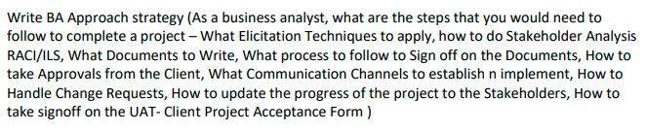
- A business case is prepared with a point of view on the return on investment.
- I prepares a feasibility analysis and cost benefit analysis
- Tangible and non tangible benefits which can be easily measured or difficult all are considered and pushed for a sign off for a project from project sponsor
- Once the requirements are finalized a brd document is prepared and a sign off from stake holders is taken either by a mailor physical copy sign
- Post design and development
- Testing team tests the product for all the features and prepare test cases fot the same to prove product working as expected
- UAT is planned before a product handover to ensure end users are also satisfied and a sign off from client/end user is taken
- Deployment and implementation is done and a sign off is taken again for billing
We basically follow software development life cycle
Reverse engineering is used to gather information on requirements
- Requirement Gathering:- Reverse engineering is used to gather information on requirements and BRD document is prepared
- Requirement analysis:- Functional non functional and Business value etc
- Designing:- In this phase Architect will design the system based on BRD and BA inputs. Since this is a saas model the product is already perceived it can be moderately customised for our requirements
- Coding:- Development team will design the product BA should ensure requirements are clearly understood
- Testing:- Here testers will test the product which has been developed. Testers will prepare test cases to ensure that all the functionalities are being met. BA must ensure that the test case is covering entire functionality
- Deployment:-Once product is developed and tested it is ready for deployment. BA has to verify that the product is delivered as per the BRD and it meets the business needs.
- Maintainence:- Once the implementation is completed the product goes under continous improvement by keeping in mind the ever changing market trends. These changes will be applied to the system as patch upgrades. BA will evaluate these changes and communicate to the stakeholders as he is invested in the project from the scratch
Document 3- Functional Specifications

Project name | Marketing team tracker & lead management
Customer name | Paint manufacturing firm
Project Version | 3.0 (previous 2 attempts failed)
Project Sponsor | Paint company management
Project Manager | BA myself
Project Initiation date | December 31st

Functional Requirement specifications:
Req ID | Req Name | Req Description | Priority
FR0001 | Android app Login | Marketing user should be able to login to the application to use the app | 10
FR0002 | Portal login | Backend user should be able to login to the portal | 10
FR0003 | Backend users view and download report | In the portal login all reports viewing and download option is required | 10
FR0004 | Front end users add attendance | Mark attendance + selfie  Sign out for the day without any photo requirement | 8
FR0005 | Front end users add reimbursement | Add travel claims, Dearness allowance, hotel bills in case of overnight stay, food expenses | 8
FR0006 | Front end users add feedback on leads assigned | Open the leads list(name, ph no, requirement details). After speaking to the customer status needs to be updated | 9
FR0007 | Front end users add dealer/project visit | Add the dealer name if first time, for repeat customer select the corresponding dealer/project. SIGN IN with shop or site photo. After work. SIGN OUT with discussion details(order received, payment collected, followup etc) | 8
FR0008 | Back end users need to create leads | Create lead with customer name, ph no, and product required, quantity required and address | 10
FR0009 | Back end users need to assign leads | Against the lead id with respect to the location/pincode assign the lead to the respective location marketing representative | 10
FR0010 | Backend users view leads status | Completed leads are closed, not interested leads are also closed, will buy later leads are assigned with a date and reminder | 9

Document 4- Requirement Traceability Matrix
C – completed
P – pending ie half done
NY - not yet started
Req ID | Req Name | Req description | Design | D1 | T1 | D2 | T2 | UAT
FR0001 | Android app Login | Marketing user should be able to login to the application to use the app | C | C | C | C | C | C
FR0002 | Portal login | Backend user should be able to login to the portal | C | C | C | C | C | C
FR0003 | Backend users view and download report | In the portal login all reports viewing and download option is required | C | C | C | C | C | C
FR0004 | Front end users add attendance | Mark attendance + selfie  Sign out for the day without any photo requirement | C | C | C | C | C | C
FR0005 | Front end users add reimbursement | Add travel claims, Dearness allowance, hotel bills in case of overnight stay, food expenses | C | C | C | C | C | C
FR0006 | Front end users add feedback on leads assigned | Open the leads list(name, ph no, requirement details). After speaking to the customer status needs to be updated | C | C | C | C | C | C
FR0007 | Front end users add dealer/project visit | Add the dealer name if first time, for repeat customer select the corresponding dealer/project. SIGN IN with shop or site photo. After work. SIGN OUT with discussion details(order received, payment collected, followup etc) | C | C | C | C | C | C
FR0008 | Back end users need to create leads | Create lead with customer name, ph no, and product required, quantity required and address | C | C | C | C | C | C
FR0009 | Back end users need to assign leads | Against the lead id with respect to the location/pincode assign the lead to the respective location marketing representative | C | C | C | C | C | C
FR0010 | Backend users view leads status | Completed leads are closed, not interested leads are also closed, will buy later leads are assigned with a date and reminder | C | C | C | C | C | C

Document 5- BRD Template


Marketing Application
MAR065
Ver 3.04
Dhanoop

Contents
1. Document Revisions 9
2. Approvals 9
3. RASCI Chart for This Document 9
Codes Used in RASCI Chart 10
RASCI Chart 10
4. Introduction 10
4.1. Business Goals 10
4.2. Business Objectives 10
4.3. Business Rules 11
4.4. Background 11
4.5. Project Objective 11
4.6. Project Scope 11
4.6.1. In Scope Functionality 11
4.6.2. Out Scope Functionality 12
5. Assumptions 12
6. Constraints 12
7. Risks 12
Technological Risks 12
Skills Risks 13
Political Risks 13
Business Risks 13
Requirements Risks 13
Other Risks 13
8. Business Process Overview 13
8.1. Legacy System (AS-IS) 14
8.2. Proposed Recommendations (TO-BE) 15
9. Business Requirements 16
10. Appendices 17
10.1. List of Acronyms 17
10.2. Glossary of Terms 17
10.3. Related Documents 17

Document Revisions
Date | Version Number | Document Changes
15/12/2024 | 0.1 | Initial Draft
22/12/2024 | 0.2 | Changes in reports format and reporting structure
29/12/2024 | 0.3 | Changes in required quantity of licences so pricing revision
1/1/2025 | 0.4 | Portal access restriction for HR and accounts

Approvals

Role | Name | Title | Signature | Date
Project Sponsor | Prashanth | MD
Business Owner | Dhanoop | Basis consultant & IT operations
Project Manager | Vignesh | SPOC and project head
System Architect | Subcontract | -
Development Lead | Subcontracted | -
User Experience Lead | Subcontract | -
Quality Lead | Subcontracted | -
Content Lead | Subcontract | -

RACI Chart for This Document
The RACI chart identifies the persons who need to be contacted whenever changes are made to this document. RACI stands for responsible, accountable, consulted, and informed. These are the main codes that appear in a RACI chart, used here to describe the roles played by team members and stakeholders in the production of the BRD. They are adapted from charts used to assign roles and responsibilities during a project.( RACI Can be made for IT side[Project stakeholder] as mentioned above, apart from that Can also Be made for Client side[Business Stakeholder]).
The following describes the full list of codes used in the table:

Codes Used in RACI Chart
* Authorize Has ultimate signing authority for any changes to the document.
R Responsible Responsible for creating this document.
A Accountable Accountable for accuracy of this document
(for example, the project manager)
S Supports Provides supporting services in the production of this document
C Consulted Provides input (such as an interviewee).
I Informed Must be informed of any changes.

RACI Chart
Name | Position | * | R | A | S | C | I
Lystloc team | Development team |  | * | *
Dhanoop | Project manager/BA |  |  | * | *
MD | sponsor |  |  |  |  | *
Marketing managers/ executives | Stake holder |  |  |  |  | *
HR | Stake holder |  |  |  |  |  | *
Accounts | Stake holder |  |  |  |  |  | *

Introduction

Business Goals
[This should describe the organization goals& Organization Need]
Need: As a paint manufacturing firm we need to monitor our on field marketing executives real time, along with monitoring leads

Business Objectives
To provide an IT solution for:
List what the functionalities are going to develop in software
- Mobile application for android and for ios so that all the marketing executives can login and perform(attendance, dealer/site visits, attending to leads)
- Portal login for backend monitoring and leads creation and assigning.

Business Rules
[List Organization Policies, Procedures, and Rules& Regulations]
- Login before 11am
- Minimum 8hrs work
- Minimum 5-6 visits
- Per kilometre 3.25 rupees

Background
[Provide a brief history of how the project came to be proposed and initiated, including the business issues/problems identified, and expected benefit of implementing the project/developing the product.]
There was no growth and all the marketing people were stagnating with some amount of work being done and not putting in the right kind of effort. Also people were not visiting either office or stores or site for weeks together and lot of complaints were coming in from customers and dealers while the salaries were also high . india mart leads were not attended to correctly while we were getting false updates

Project Objective
[These should describe the overall goal in developing the product, high level descriptions of what the product will do, how they are aligned to business objectives, and the requirements for interaction with other systems]
Daily activities of marketing executives are tracked
Leads are created and assigned realtime
Reimbursements are tracked and validated

Project Scope
[What we are going to develop in the current project]
An android app is to be developed to address the objective
Portal access for backend monitoring and lead management

In Scope Functionality
[List what functionalities we are going to do with in the project in bullets]
- Attendance
- Dealer/project visits
- Leads addressing and feedback system
- Reimbursement track and validation

Out Scope Functionality
[List of functionality what is not included in the current project]
- Leads which are not completed posted as reminder 1 ..2...3...4

Assumptions
[List all assumptions requirements are based on]
- We will get attendance report
- We will get visits report
- We will get reimbursement report
- We will get leads status report

Constraints
[List all Constraints]
- The data that is made available is on a select format as this is a existing product customised to our business requirements, since they work on SAAS model this product cannot be heavily customized
- If attendance end is not marked then post work in the evening where ever the executive travels that distance also gets calculated
- Autolog out is set for 1130 pm

Risks
In this section of the BRD, you describe risks. A risk is something that could affect the success or failure of a project. Analyze risks regularly as the project progresses. While you may not be able to avoid every risk, you can limit each risk’s impact on the project by preparing for it beforehand. For each risk, you’ll note the likelihood of its occurrence, the cost to the project if it does occur, and the strategy for handling the risk. Strategies include the following:
- Avoid: Do something to eliminate the risk.
- Mitigate: Do something to reduce damage if risk materializes.
- Transfer: Pass the risk up or out to another entity.
- Accept: Do nothing about the risk. Accept the consequences.

Technological Risks
This subsection of “Risk Analysis” specifies new technology issues that could affect the project.
Software platform is android which is widely used and successful only issue is continuous update due to version change. Portal i do not see any issue as it is HTML

Skills Risks
This subsection of “Risk Analysis” specifies the risk of not getting staff with the required expertise for the project.
Right now we have a good team but going forward this issue will not come up as the management is hands on experts themselves and not dependent

Political Risks
This subsection of “Risk Analysis” identifies political forces that could derail or affect the project.
This occurs if we have many hierarchy within the organisation but this is not a issue as we have managements commitment for this project

Business Risks
This subsection of “Risk Analysis” describes the business implications if the project is canceled.
Marketing executives will have an opposition and may work half heartedly for a while after some time they will realise they have to accept

Requirements Risks
This subsection of “Risk Analysis” describes the risk that you have not correctly described the requirements. List areas whose requirements were most likely to have been incorrectly captured.
Management and myself are actively involved in this project from the beginning and this is our 3rd attempt so requirements are sorted

Other Risks
In this subsection of “Risk Analysis,” document any other risks not covered in the prior subsections.
I don’t foresee anything as such

Business Process Overview
[This describes the overall process flow from each phase]
Attendance will be sent to HR dept for salary calculation
Reimbursement will be sent to accounts dept for disbursement

Legacy System (AS-IS)
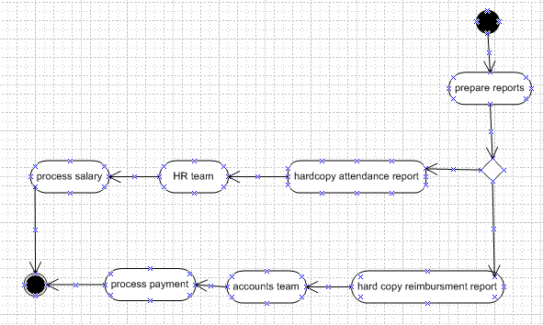
[Brief Explanation about the process in legacy system and draw process flow diagrams]
- Marketing personel will write attendance in the provided hard copy format and get it attested by the reporting manager and send it across to corporate office
- Similarly reimbursement document is written in the given format as a hardcopy and the same is attested by reporting manager
Note:- Lead management is not available

Proposed Recommendations (TO-BE)

[Describe the recommended process and how the proposed system will address the challenges in legacy system]
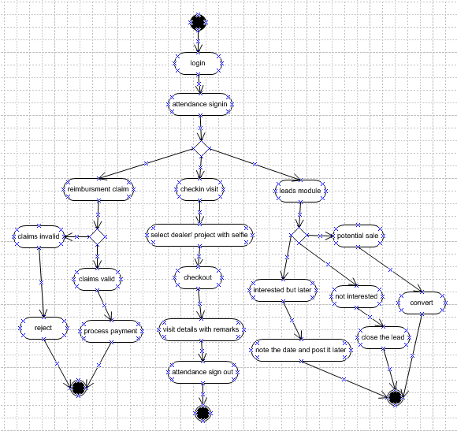

- Attendance report is available in a downloadable format and realtime tracking is possible
- Reimbursement is available as a report and it can be verified against actual travel data which is available
- Lead management is a new functionality introduced for better handling of leads

Business Requirements
[The specific business requirements elicited from stakeholders should be listed, categorized by both priority and area of functionality to smooth the process of reading and tracking them. Include links to use case documentation, and other key reference material as needed to make the requirements as complete and understandable as possible. You may wish to incorporate the functional and non-functional requirements into a traceability matrix that can be followed throughout the project]
Sl No | Req ID | Req Category | Description | Priority
1 | BRQ01 | Android app Login | Marketing user should be able to login to the application to use the app | 10
2 | BRQ02 | Portal login | Backend user should be able to login to the portal | 10
3 | BRQ03 | Backend users view and download report | In the portal login all reports viewing and download option is required | 10
4 | BRQ04 | Front end users add attendance | Mark attendance + selfie  Sign out for the day without any photo requirement | 10
5 | BRQ05 | Front end users add reimbursement | Add travel claims, Dearness allowance, hotel bills in case of overnight stay, food expenses | 10
6 | BRQ06 | Front end users add feedback on leads assigned | Open the leads list(name, ph no, requirement details). After speaking to the customer status needs to be updated | 10
7 | BRQ07 | Front end users add dealer/project visit | Add the dealer name if first time, for repeat customer select the corresponding dealer/project. SIGN IN with shop or site photo. After work. SIGN OUT with discussion details(order received, payment collected, followup etc) | 10
8 | BRQ08 | Back end users need to create leads | Create lead with customer name, ph no, and product required, quantity required and address | 10
9 | BRQ09 | Back end users need to assign leads | Against the lead id with respect to the location/pincode assign the lead to the respective location marketing representative | 10
10 | BRQ10 | Backend users view leads status | Completed leads are closed, not interested leads are also closed, will buy later leads are assigned with a date and reminder | 10

Appendices

List of Acronyms
BRD- business requirement document
RTM Requirement traceability matrix
CR Change Request
RACI responsible accountable consulted informed

Glossary of Terms

Related Documents
BRD
RTM
CR
RACI

