**Assignment 1:**

**Business Requirements Document (BRD)**

Project Title: Inventory Management and Quick Delivery System for Dairy Products

Date: [11/JAN/2025]

Prepared By: [Rutuja Madnoorkar]

1. Executive Summary:

The company manufactures ice cream and milk products and operates multiple manufacturing plants and warehouses across the country. To optimize operations and meet customer demands efficiently, the proposed software aims to achieve two primary objectives:

* Inventory Management: Streamlining stock levels, tracking inventory across all locations, and reducing wastage.
* Quick Delivery: Ensuring the fastest possible delivery of products to customers by leveraging an optimized logistics solution.

2. Objectives:

-Provide real-time visibility into inventory levels at manufacturing plants and warehouses.

-Optimize inventory restocking to prevent overstocking or stock outs.

-Implement an intelligent order routing system to ensure the quickest delivery to customers.

-Enable integration with existing systems, including ERP and CRM.

-Provide detailed reporting and analytics for better decision-making.

3. Scope of Work:

In-Scope:

-Development of an inventory management system.

-Implementation of a delivery optimization module.

-Integration with existing ERP systems.

-Web and mobile interface for user access.

-User roles and permissions for different stakeholders (e.g., managers, warehouse staff).

-Reporting and analytics dashboard.

Out-of-Scope:

-Hardware procurement (e.g., barcode scanners, IoT devices).

-Third-party logistics services.

4. Functional Requirements:

1. Inventory Management

2. Delivery Optimization

3. Reporting and Analytics

5. Non-Functional Requirements:

1. Performance

2. Scalability

3. Security

4. Usability

5. Availability

6. Development Plan:

Phase 1: Requirement Gathering (2 weeks)

Phase 2: System Design (3 weeks)

Phase 3: Development (12 weeks)

Phase 4: Testing (4 weeks)

Phase 5: Deployment and Training (2 weeks)

7. Resource Plan:

Team Structure:

Project Manager: 1

Business Analyst: 1

UI/UX Designers: 2

Back-end Developers: 3

Frontend Developers: 2

QA Engineers: 2

DevOps Engineer: 1

Technical Support Staff: 2

Key Tools and Technologies:

Front-end: React.js or Angular.

Backend: Node.js, Python (Django/Flask).

Database: PostgreSQL.

Cloud Platform: Azure.

Integration Tools: API s for GPS and mapping services.

Testing Tools: JIRA.

8. Risks and Mitigation:

Risk: Delays in requirement finalization.

Mitigation: Early stakeholder alignment and iterative reviews.

Risk: Integration challenges with existing systems.

Mitigation: Detailed API documentation and sandbox testing.

Risk: Data security concerns.

Mitigation: Regular security audits and compliance adherence.

9. Success Criteria:

Reduction in inventory wastage by 20% within the first six months.

Improved delivery time by 30% within the first year.

Positive user feedback with a satisfaction score of 85% or higher.

Accurate real-time reporting with minimal errors.

10. Appendix:

Glossary of terms.

Reference documents (if any).

Contact details of project stakeholders.

1. **Prepare process flow diagram using your imagination.**

Process flow diagram is a visual representation of a process or system that uses shapes & lines to show the steps involved. PFD,s are used in many fields to help people understand, plan, & improve processes.

Process Flow Description for Inventory Management and Delivery System:

1.Customer Order Placement

Input: Customer places an order via the web/mobile app or through customer support.

Output: Order details are captured and forwarded to the Order Processing System.

2.Order Processing System

Action: Validates the order (e.g., availability of items, payment confirmation).

Decision: If inventory is insufficient, notify the customer; else, proceed to inventory allocation.

3.Inventory Management System

Input: The system retrieves real-time stock levels from the database.\n

Action: Updates inventory records to reserve stock for the order.

Output: Sends updated stock data to the ERP system and initiates a delivery request.

4.Delivery Optimization Module

Input: Receives delivery request along with customer details and location.

Action:

Calculate the best route using GPS/mapping services.

Prioritize the order based on proximity and urgency.

Assign delivery personnel or vehicles.\n

Output: Updates the delivery schedule and notifies the customer.

5.ERP System Integration

Synchronizes inventory data, order status, and delivery updates for enterprise-level reporting.

6.Customer Notifications

Real-time updates about order status (e.g., packed, shipped, out for delivery, delivered).

7.Feedback Loop

Captures delivery performance metrics (e.g., time taken, delays).

Logs customer feedback for service improvement.

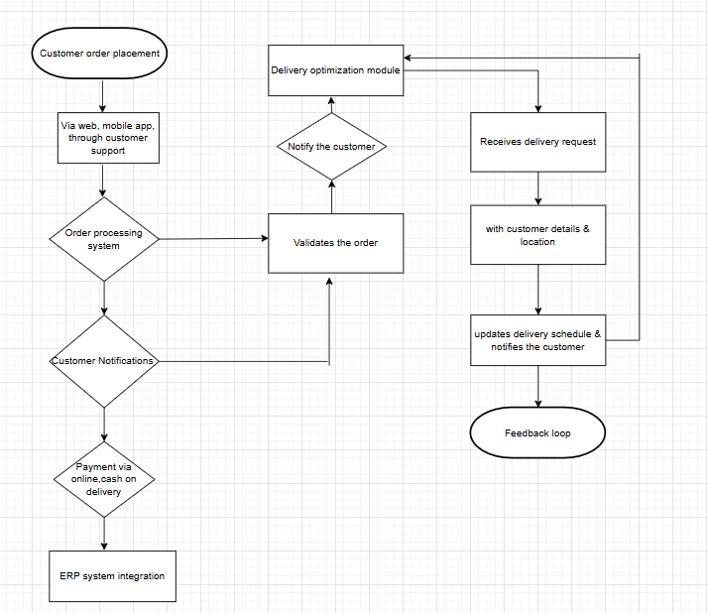

**Assignment 2:**

**1. Write an introduction letter to a client introducing you as a business analyst in charge of Working with the client and his team to start the business understanding process.**

Mrs. Rutuja Madnoorkar

Business Analyst

Herald Logic

7559315328

Date: 11/JAN/2024

Sushant Thakur

Industrial Innovators

91 spring road Godrej & Boyce,

Gate no. 2, plant no. 6

Lal Bahadur Shastri Marg

Mumbai, Maharashtra 400079

Subject: Introduction as Business Analyst

Dear Sushant,

I hope this message finds you well. My name is Rutuja Madnoorkar, and I am the Business Analyst assigned to work closely with you and your team on to build software to manage the inventory & quickest delivery to customer. It is both a pleasure and a privilege to collaborate with you in starting the business understanding process for this exciting initiative.

My primary role will be to act as the liaison between your team and ours, ensuring that your vision and requirements are effectively captured and translated into actionable solutions. I will be focusing on understanding your business needs, identifying potential challenges, and recommending strategies to optimize outcomes.

As we embark on this journey together, I aim to:

-Develop a thorough understanding of your business goals and objectives.

-Facilitate discussions to gather requirements and insights from your team.

-Provide detailed documentation and analysis to guide the project.

-Maintain clear and open communication throughout the process.

I look forward to our initial discussions and the opportunity to learn more about your organization’s operations, priorities, and expectations. Please feel free to reach out to me at rutuja.madnoorkar18@gmail.com or 7559315328 should you have any questions or require additional information prior to our first meeting.

Thank you for entrusting us with this project. I am confident that our collaboration will yield successful outcomes, and I am excited to begin working with you and your team.

Warm regards,

Mrs. Rutuja Madnoorkar

Business Analyst

Herald Logic

1. **Prepare a brief BRD and SRS for a project- Horoscope or Ticketing system or online store.**

BRD Document: A Business requirement document is a formal document that outlines a projects goals, scope, & requirements. It is used by project managers & business analysts to manage business requirements in an organized way.

SRS Document: A software requirements specification document is a detailed description of a software products requirements, expectations, & design. It’s a blueprint for the software being developed. & is used by software developers throughout the product development process.

**Business Requirement Document (BRD)**

**1. Introduction:**

**Project Title: Online Ticketing System**

**Description:The Online Ticketing System is a web-based platform designed to simplify the process of booking tickets for events such as movies, concerts, and sports. Users can browse available events, select seats, and make payments seamlessly. The system ensures real-time updates on ticket availability and secure payment processing.**

1. **Goals and Objectives:**

**Goals:**

* **To create a user-friendly platform for ticket booking.**
* **To provide real-time updates on ticket availability and pricing.**
* **To ensure secure and efficient payment processing.**

**Objectives:**

* **Develop a responsive web interface accessible via desktop and mobile devices.**
* **Integrate payment gateways for multiple payment options.**
* **Enable users to manage bookings and view their purchase history.**

1. **Use case Diagram:**

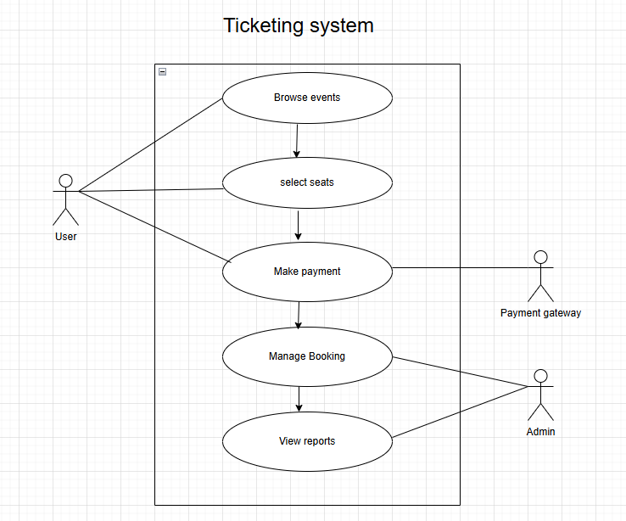

1. **Use case specification:**

**Use Case 1: Browse Events**

**Actors: User**

**Description: The user browses available events by category, date, or location.**

**Precondition: The user has access to the system.**

**Post condition: The user views a list of events and their details.**

**Main Flow:**

**User logs into the system.**

**User selects the browse events option.**

**The system displays available events.**

**Use Case 2: Select Seats**

**Actors: User**

**Description: The user selects preferred seats for an event.**

**Precondition: The user has chosen an event.**

**Post condition: The selected seats are reserved temporarily.**

**Main Flow:**

**User selects an event.**

**System displays seating availability.**

**User selects desired seats.**

Use Case 3: Make Payment

Actors: User, Payment Gateway

Description: The user completes payment for tickets.

Precondition: The user has selected seats.

Post condition: The booking is confirmed and payment is processed.

Main Flow:

User proceeds to checkout.

System redirects to the payment gateway.

User completes payment.

System confirms booking.

Use Case 4: Manage Booking

Actors: User

Description: The user can view, modify, or cancel bookings.

Precondition: The user has a confirmed booking.

Post condition: The changes are reflected in the system.

Main Flow:

User navigates to the booking management section.

User views booking details.

User modifies or cancels the booking.

Use Case 5: View Reports

Actors: Admin

Description: The admin generates reports on ticket sales and system performance.

Precondition: The admin has logged into the system.

Post-condition: Reports are generated successfully.

Main Flow:

Admin logs in.

Admin navigates to the reports section.

Admin selects the report type and time-frame.

System generates the report.

5. Functional Requirements:

-User registration and login functionality.

-Event browsing by category, date, and location.

-Real-time seat availability updates.

-Secure payment gateway integration.

-Booking management features.

-Admin dashboard for managing events and generating reports.

6. Non-Functional Requirements:

-Scalability

-Security

-Performance

-Availability

-Usability

**Software Requirements Specification (SRS) for Ticketing System**

1. Introduction:

1.1 Purpose:

The purpose of this document is to define the functional and non-functional requirements for an online ticketing system. The system will facilitate users in purchasing tickets for events, concerts, movies, or transportation. It ensures a user-friendly experience with secure payment and efficient management of ticket sales.

1.2 Scope:

The ticketing system will allow users to browse events, view details, and purchase tickets through a secure platform. The system will also support administrators in managing events, tickets, and users.

1.3 Stakeholders:

End Users: Individuals purchasing tickets.

Event Organizers: Managing events and ticket availability.

Administrators: Overseeing platform operations.

2. Goals and Objectives:

Goals:

-Simplify the ticket-purchasing process.

-Provide a centralized platform for event management.

-Ensure a secure and reliable transaction system.

Objectives:

-Enable users to search and filter events.

-Provide a smooth checkout process with multiple payment options.

-Offer real-time availability updates for tickets.

-Ensure the scalability of the platform to handle high traffic.

1. Use case Diagram:

A use case is a description of a system’s behavior as it responds to a request from one of its users or another system. It defines a sequence of actions that the system performs to achieve a particular goal or provide a specific service to the user. Use cases are often used in systems analysis & design to capture the functional requirements of a system.

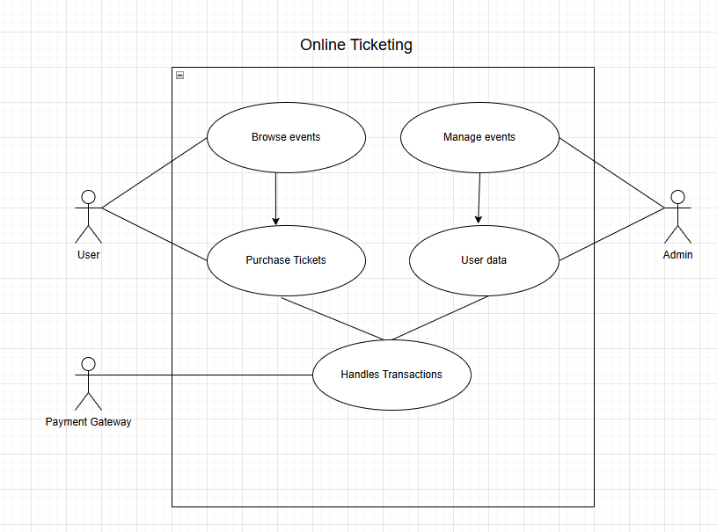

4. Use Case Specifications:

4.1 Browse Events:

Actor: User

Description: User searches and filters events based on location, date, or category.

Preconditions: User has access to the platform.

Post conditions: List of relevant events is displayed.

4.2 View Event Details:

Actor: User

Description: User views detailed information about a selected event.

Preconditions: Event exists in the database.

Postconditions: Event details are displayed.

4.3 Purchase Tickets:

Actor: User

Description: User selects tickets, proceeds to checkout, and completes payment.

Preconditions: Tickets are available, and payment gateway is functional.

Post conditions: Payment is processed, and ticket confirmation is sent.

4.4 Manage Events:

Actor: Admin

Description: Admin adds, updates, or removes events.

Preconditions: Admin is logged in.

Post conditions: Event database is updated.

4.5 Generate Reports:

Actor: Admin

Description: Admin generates sales and user activity reports.

Preconditions: Data exists for the selected period.

Post conditions: Reports are generated and available for download.

5. Functional Requirements:

-User Registration: Users can sign up and manage their profiles.

-Event Browsing and Filtering: Users can search for events by category, location, or date.

-Ticket Purchase: Secure transaction process with multiple payment options.

-Real-Time Availability: Tickets are updated in real-time.

-Admin Management: Admins can add, edit, or delete events.

6. Non-Functional Requirements:

-Scalability

-Security

-Performance

-Reliability

-Usability

1. **Make an ERD of creating a support ticket/Ticketing life cycle.**

Entity relationship diagram is a visual representation of how entities relate to each other in a database or information system. An ERD is a flowchart like diagram that uses symbols like rectangles,ovals,& diamonds to show how entities are connected.

How its used:

-Design databases

-Maintain databases

-Troubleshoot issues

-Train new team members

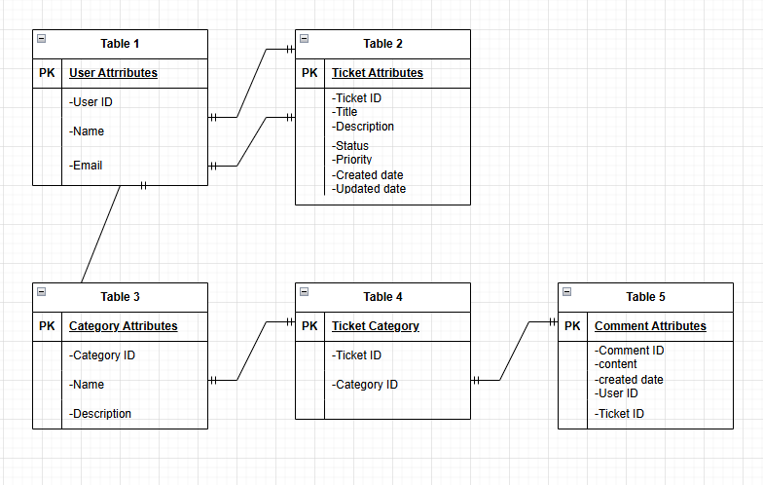

**4. User story of shopping from e-commerce.**

User stories: User story is a brief description of software feature or functionality written from the perspective of the end user of a system. In software development & product management. A user story is an informal, natural language description of features of a software system. They facilitate sense making & communication; & may help software teams document their understanding of the system & its context.

|  |  |  |  |
| --- | --- | --- | --- |
| User story No. 1 | Task: 2 | | Priority-HIGHEST |
| As a user,  I want to create an account so that  I can save my preferences. | | | |
| BV:08 | | CP:05 | |
| Acceptance Criteria:  User can sign up,  verify email, and log in successfully. | | | |

|  |  |  |  |
| --- | --- | --- | --- |
| User story No. 2 | Task: 3 | | Priority-HIGHEST |
| As a user,  I want to log in securely using my credentials. | | | |
| BV:10 | | CP:04 | |
| Acceptance Criteria:  User can log in with valid credentials  and see an error for invalid attempts. | | | |

|  |  |  |  |
| --- | --- | --- | --- |
| User story No. 3 | Task: 2 | | Priority-HIGHEST |
| As a user,  I want to browse products by category. | | | |
| BV:09 | | CP:06 | |
| Acceptance Criteria:  Categories are displayed,  and products load correctly  when a category is selected. | | | |

|  |  |  |  |
| --- | --- | --- | --- |
| User story No. 4 | Task: 2 | | Priority-HIGHEST |
| As a user,  I want to search for products using keywords. | | | |
| BV:10 | | CP:07 | |
| Acceptance Criteria:  Search results are relevant to the entered keywords. | | | |
| User story No. 5 | Task: 2 | | Priority-HIGHEST |
| As a user,  I want to view product details,  including images and reviews. | | | |
| BV:09 | | CP:06 | |
| Acceptance Criteria:  Product page shows image carousel,  descriptions, and customer reviews. | | | |

|  |  |  |  |
| --- | --- | --- | --- |
| User story No. 6 | Task: 2 | | Priority-HIGHEST |
| As a user,  I want to add products to my cart for later purchase. | | | |
| BV:10 | | CP:07 | |
| Acceptance Criteria:  Products added to the cart  appear in the cart page and  persist during the session. | | | |

|  |  |  |  |
| --- | --- | --- | --- |
| User story No. 7 | Task: 1 | | Priority-HIGHEST |
| As a user,  I want to update quantities of products in my cart. | | | |
| BV:08 | | CP:05 | |
| Acceptance Criteria:  Quantity updates reflect in the cart total immediately. | | | |

|  |  |  |  |
| --- | --- | --- | --- |
| User story No. 8 | Task: 1 | | Priority-HIGHEST |
| As a user,  I want to remove products from my cart. | | | |
| BV:09 | | CP:04 | |
| Acceptance Criteria:  Products removed are no longer displayed in the cart. | | | |

|  |  |  |  |
| --- | --- | --- | --- |
| User story No. 9 | Task: 1 | | Priority-HIGHEST |
| As a user,  I want to see the total cost of my cart, including tax. | | | |
| BV:08 | | CP:06 | |
| Acceptance Criteria:  Cart displays subtotal, tax, and total accurately. | | | |

|  |  |  |  |
| --- | --- | --- | --- |
| User story No. 10 | Task: 3 | | Priority-HIGHEST |
| As a user,  I want to save items to a wish-list for future reference. | | | |
| BV:07 | | CP:05 | |
| Acceptance Criteria:  Wish-list functionality allows adding, removing,  and viewing saved items. | | | |

|  |  |  |  |
| --- | --- | --- | --- |
| User story No. 11 | Task: 2 | | Priority-HIGHEST |
| As a user,  I want to apply discount codes during checkout. | | | |
| BV:08 | | CP:06 | |
| Acceptance Criteria:  Discount code field accepts valid codes  and updates totals correctly. | | | |

|  |  |  |  |
| --- | --- | --- | --- |
| User story No. 12 | Task: 1 | | Priority-HIGHEST |
| As a user,  I want to select a shipping method for my purchase. | | | |
| BV:08 | | CP:05 | |
| Acceptance Criteria:  Shipping options are displayed with costs  and estimated delivery times. | | | |

|  |  |  |  |
| --- | --- | --- | --- |
| User story No. 13 | Task: 1 | | Priority-HIGHEST |
| As a user,  I want to securely enter my payment details during checkout. | | | |
| BV:10 | | CP:08 | |
| Acceptance Criteria:  Payment gateway processes payments securely  and shows confirmation. | | | |

|  |  |  |  |
| --- | --- | --- | --- |
| User story No. 14 | Task: 1 | | Priority-HIGHEST |
| As a user,  I want to track my order status post-purchase. | | | |
| BV:09 | | CP:07 | |
| Acceptance Criteria:  Order tracking page shows current status  and expected delivery date. | | | |

|  |  |  |  |
| --- | --- | --- | --- |
| User story No. 15 | Task: 1 | | Priority-HIGHEST |
| As a user,  I want to view my order history. | | | |
| BV:08 | | CP:05 | |
| Acceptance Criteria:  User dashboard displays previous orders with details and status. | | | |

|  |  |  |  |
| --- | --- | --- | --- |
| User story No. 16 | Task: 1 | | Priority-HIGHEST |
| As a user,  I want to view my order history | | | |
| BV:09 | | CP:04 | |
| Acceptance Criteria:  Order confirmation email is sent immediately after purchase. | | | |

|  |  |  |  |
| --- | --- | --- | --- |
| User story No. 17 | Task: 1 | | Priority-HIGHEST |
| As a user,  I want to filter products by price range. | | | |
| BV:07 | | CP:06 | |
| Acceptance Criteria:  Price filter shows relevant products within the selected range. | | | |

|  |  |  |  |
| --- | --- | --- | --- |
| User story No. 18 | Task: 1 | | Priority-HIGHEST |
| As a user,  I want to filter products by customer ratings. | | | |
| BV:08 | | CP:05 | |
| Acceptance Criteria:  Products displayed match the selected rating filter. | | | |

|  |  |  |  |
| --- | --- | --- | --- |
| User story No. 19 | Task: 1 | | Priority-LOWEST |
| As a user,  I want to sort products by  relevance, price, and popularity. | | | |
| BV:08 | | CP:06 | |
| Acceptance Criteria:  Sorting options display products correctly based on selected criteria. | | | |

|  |  |  |  |
| --- | --- | --- | --- |
| User story No. 20 | Task: 1 | | Priority-LOWEST |
| As a user,  I want to receive recommendations  based on my browsing history. | | | |
| BV:09 | | CP:07 | |
| Acceptance Criteria:  Recommendations on the homepage are relevant to recent activities. | | | |

|  |  |  |  |
| --- | --- | --- | --- |
| User story No. 21 | Task: 1 | | Priority-LOWEST |
| As a user,  I want to compare products side-by-side. | | | |
| BV:08 | | CP:06 | |
| Acceptance Criteria:  Comparison tool displays selected products with specifications and features. | | | |

|  |  |  |  |
| --- | --- | --- | --- |
| User story No. 22 | Task: 1 | | Priority-LOWEST |
| As a user,  I want to read customer reviews before purchasing a product. | | | |
| BV:10 | | CP:04 | |
| Acceptance Criteria:  Review section displays user feedback with ratings and comments. | | | |

|  |  |  |  |
| --- | --- | --- | --- |
| User story No. 23 | Task: 1 | | Priority-LOWEST |
| As a user,  I want to see a "recently viewed" section for quick navigation. | | | |
| BV:07 | | CP:05 | |
| Acceptance Criteria:  Recently viewed items appear on the homepage or sidebar. | | | |

|  |  |  |  |
| --- | --- | --- | --- |
| User story No. 24 | Task: 1 | | Priority-LOWEST |
| As a user,  I want to pay using multiple payment methods. | | | |
| BV:09 | | CP:07 | |
| Acceptance Criteria:  Payment gateway supports credit/debit cards, PayPal,  and digital wallets. | | | |

|  |  |  |  |
| --- | --- | --- | --- |
| User story No. 25 | Task: 1 | | Priority-LOWEST |
| As a user,  I want to track my delivery  on a map in real time. | | | |
| BV:08 | | CP:09 | |
| Acceptance Criteria:  Real-time map tracking shows driver location  and estimated delivery time. | | | |

|  |  |  |  |
| --- | --- | --- | --- |
| User story No. 26 | Task: 1 | | Priority-LOWEST |
| As a user,  I want to return or exchange products if needed. | | | |
| BV:08 | | CP:07 | |
| Acceptance Criteria:  Return/exchange process is accessible from the order details page. | | | |

|  |  |  |  |
| --- | --- | --- | --- |
| User story No. 27 | Task: 1 | | Priority-LOWEST |
| As a user,  I want to contact customer support for any issues. | | | |
| BV:09 | | CP:06 | |
| Acceptance Criteria:  Customer support page provides chat, email, and phone options. | | | |

|  |  |  |  |
| --- | --- | --- | --- |
| User story No. 28 | Task: 1 | | Priority-LOWEST |
| As a user,  I want to receive notifications for sales and special offers. | | | |
| BV:08 | | CP:05 | |
| Acceptance Criteria:  Notifications are sent via email or app push based on user preferences. | | | |

|  |  |  |  |
| --- | --- | --- | --- |
| User story No. 29 | Task: 1 | | Priority-HIGHEST |
| As a user,  I want to pre-order upcoming products. | | | |
| BV:07 | | CP:06 | |
| Acceptance Criteria:  Pre-order option is available for eligible products with estimated release dates. | | | |

|  |  |  |  |
| --- | --- | --- | --- |
| User story No. 30 | Task: 1 | | Priority-HIGHEST |
| As a user,  I want to view product availability at nearby stores. | | | |
| BV:08 | | CP:07 | |
| Acceptance Criteria:  Store locator shows inventory for selected products in nearby locations. | | | |

|  |  |  |  |
| --- | --- | --- | --- |
| User story No. 31 | Task: 1 | | Priority-HIGHEST |
| As a user,  I want to have my address autofilled using location services. | | | |
| BV:08 | | CP:06 | |
| Acceptance Criteria:  Location autofill suggests accurate address options during checkout. | | | |

|  |  |  |  |
| --- | --- | --- | --- |
| User story No. 32 | Task: 1 | | Priority-HIGHEST |
| As a user,  I want to upload images for product reviews. | | | |
| BV:07 | | CP:06 | |
| Acceptance Criteria:  Review form accepts image uploads and displays them in the review section. | | | |

|  |  |  |  |
| --- | --- | --- | --- |
| User story No. 33 | Task: 1 | | Priority-HIGHEST |
| As a user,  I want to share products with friends via social media. | | | |
| BV:07 | | CP:05 | |
| Acceptance Criteria:  Share button generates sharable links for social platforms. | | | |

|  |  |  |  |
| --- | --- | --- | --- |
| User story No. 34 | Task: 1 | | Priority-HIGHEST |
| As a user,  I want to view deals of the day prominently. | | | |
| BV:09 | | CP:05 | |
| Acceptance Criteria:  Homepage highlights daily deals with countdown timers and discounts. | | | |

|  |  |  |  |
| --- | --- | --- | --- |
| User story No. 35 | Task: 1 | | Priority-HIGHEST |
| As a user,  I want to pay using installment plans for expensive products. | | | |
| BV:08 | | CP:08 | |
| Acceptance Criteria:  Eligible products display installment options during checkout. | | | |

|  |  |  |  |
| --- | --- | --- | --- |
| User story No. 36 | Task: 1 | | Priority-HIGHEST |
| As a user,  I want to gift wrap items during checkout. | | | |
| BV:06 | | CP:04 | |
| Acceptance Criteria:  Gift wrap option is available with additional charges and custom messages. | | | |

|  |  |  |  |
| --- | --- | --- | --- |
| User story No. 37 | Task: 1 | | Priority-HIGHEST |
| As a user,  I want to receive loyalty points for purchases. | | | |
| BV:09 | | CP:07 | |
| Acceptance Criteria:  Points are credited to the user account immediately after the purchase. | | | |

|  |  |  |  |
| --- | --- | --- | --- |
| User story No. 38 | Task: 1 | | Priority-HIGHEST |
| As a user,  I want to use voice search to find products. | | | |
| BV:07 | | CP:08 | |
| Acceptance Criteria:  Voice search accurately recognizes commands and displays relevant products. | | | |

|  |  |  |  |
| --- | --- | --- | --- |
| User story No. 39 | Task: 1 | | Priority-HIGHEST |
| As a user,  I want to schedule my delivery at a convenient time. | | | |
| BV:08 | | CP:07 | |
| Acceptance Criteria:  Delivery scheduler allows selecting specific dates and time slots during checkout. | | | |

|  |  |  |  |
| --- | --- | --- | --- |
| User story No. 40 | Task: 1 | | Priority-LOWEST |
| As a user,  I want to see trending products based on user interests. | | | |
| BV:08 | | CP:06 | |
| Acceptance Criteria:  Homepage displays trending products based on user preferences and popular items. | | | |