**Waterfall Model Documents - Part -2/2**

**Document 6- Please prepare a use case diagram, activity diagram and a use case specification document.**

**Use Case Diagram**

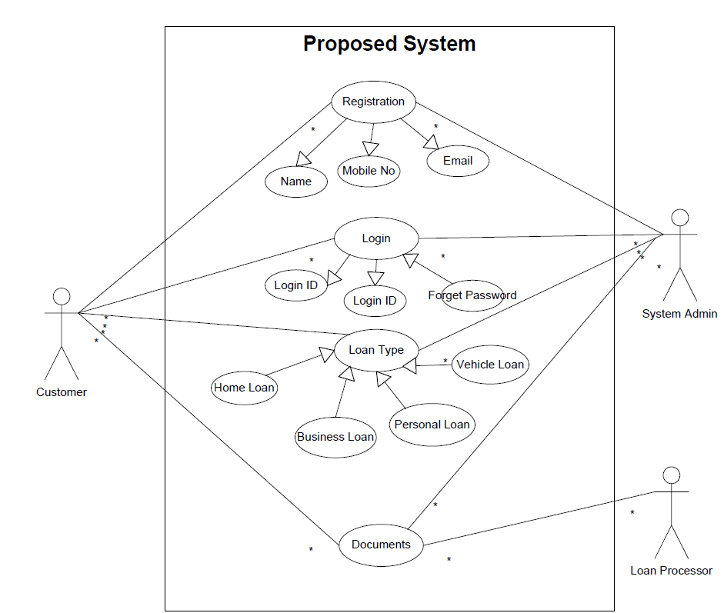

**Activity Diagram**

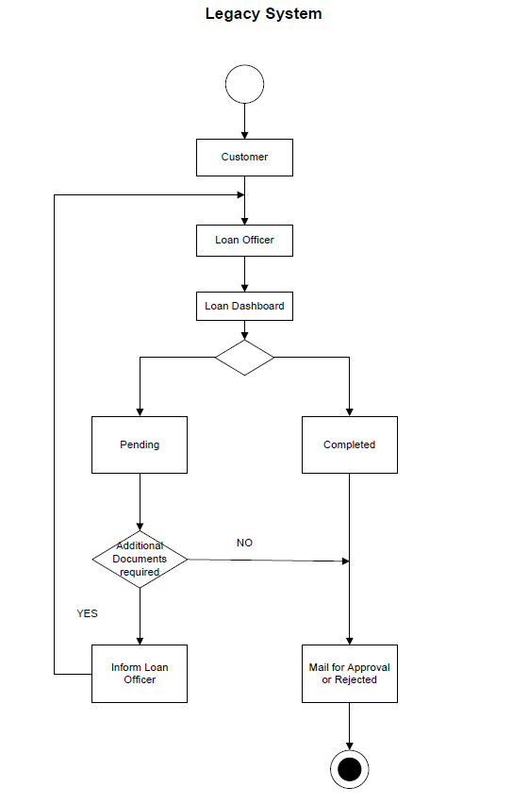

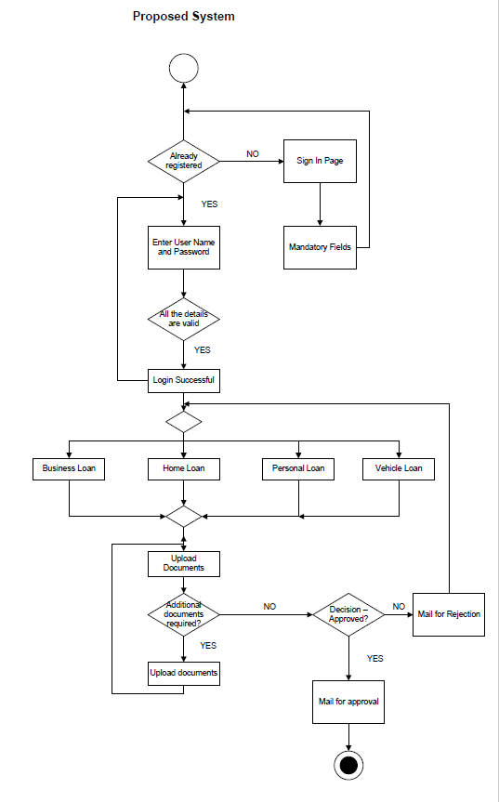

**Use Case Specification Document**

* **Use Case ID:** UCD001
* **Use Case Name:** Registration
* **Primary Actors:** Customers
* **Secondary Actors:** Database Admin
* **Use Case Description:** This use case describes how users will register to use the app/web page
* **Pre-Conditions:** Users are not registered previously
* **Post-Conditions:** Successful login page
* **Basic Flow:** Username and Password are entered correctly,mobile number and email entered correctly, click on submit, successful login page appears
* **Alternate Flow:** Password is wrong, Username is wrong, error page appears
* **Exceptional Flow:** Forgot username, forgot password, reset page appears
* **Frequency of Use:** High
* **Assumptions:** There is internet connectivity, users have basic mobile knowledge
* **Use Case ID:** UCD002
* **Use Case Name:** Login
* **Primary Actors:** Customers
* **Secondary Actors:** Database Admin
* **Use Case Description:** This use case describes how users will login to use the app/web page
* **Pre-Conditions:** Customers are already registered
* **Post-Conditions:** Successful login page
* **Basic Flow:** Username and Password are entered correctly,click on submit, successful login page appears
* **Alternate Flow:** Password is wrong, Username is wrong, error page appears
* **Exceptional Flow:** Forgot username, forgot password, reset page appears
* **Frequency of Use:** High
* **Assumptions:** There is internet connectivity, users have basic mobile knowledge
* **Use Case ID:** UCD003
* **Use Case Name:** Search loans
* **Primary Actors:** Customers
* **Secondary Actors:** Database Admin
* **Use Case Description:** This use case describes how users will choose the loan type from home loan, business loan, personal loan and vehicle loan
* **Pre-Conditions:** Users should select any one type of loan
* **Post-Conditions:** Loan application page appears
* **Basic Flow:** Click on the loan type, fill all the details of application form, save and proceed option appears
* **Alternate Flow:** Any field left blank
* **Exceptional Flow:** If any information is not in the prescribed format, system displays error message
* **Frequency of Use:** High
* **Assumptions:** Users have all the required documents and information in pdf or jpeg format

**Document 7- Screens and pages**

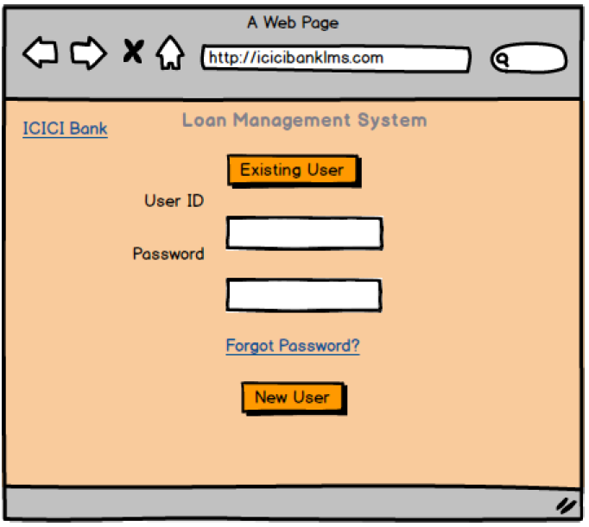

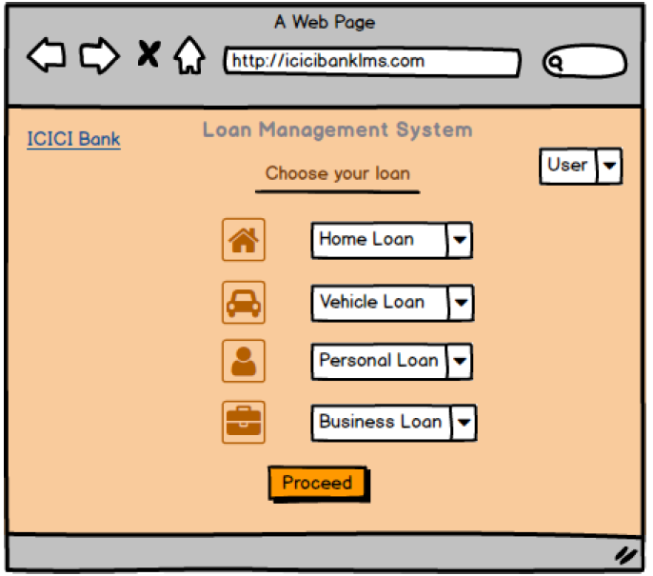

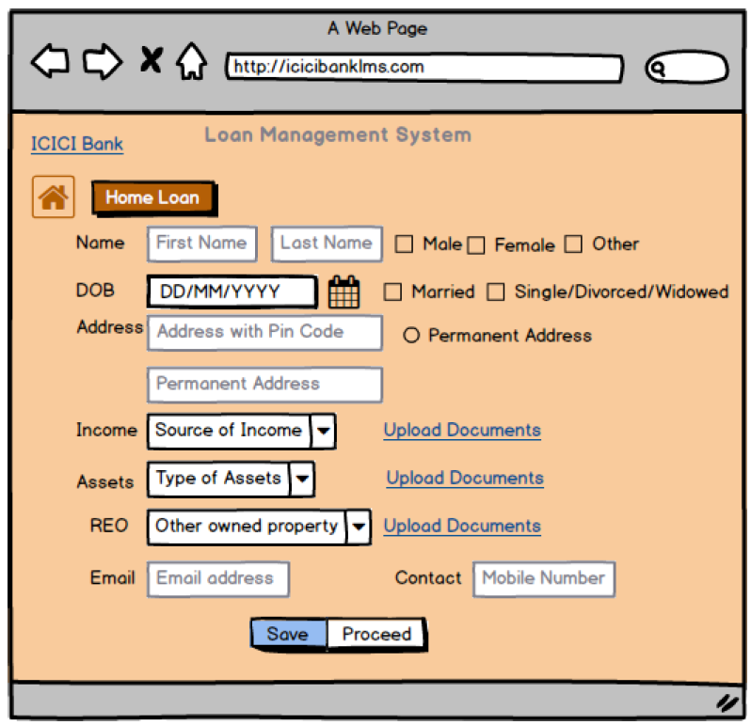

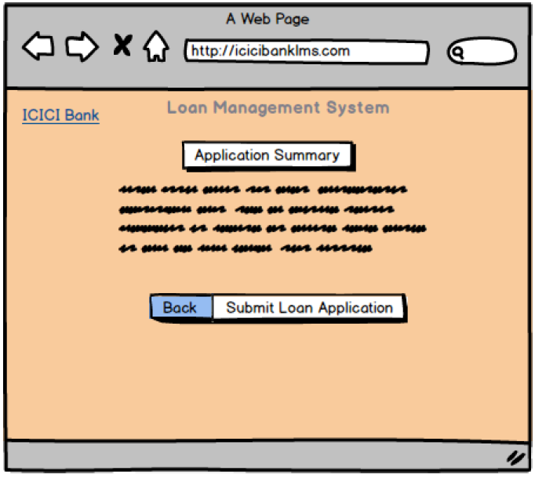

**Document 8- Tools-Visio and Axure**

**MS Visio:** Microsoft Visio is a diagramming and vector graphics application that allows users to create a wide variety of diagrams, charts, and visuals. It can be used for Diagram Creation, Customization, Drawing Use Cases, Templates & Shapes. It is commonly used by IT professionals, BA, Architects etc.

It offers a comprehensive and satisfactory experience for diagram creation and visualization tasks. The main highlights are its interface which makes it easy for us to start creating diagrams, regardless of their skill level.

MS Visio provides a user-friendly diagramming platform with a bunch of templates and shapes as per the user requirement. The nice intuitive drag and drop interface simplifies the creation of flowcharts, diagrams, and process maps.

**Axure:** Axure is an advanced prototyping tool used to create high-fidelity, interactive wireframes and prototypes for web and mobile applications.

It is Valuable for creating interactive prototypes. It is a valuable tool for creating interactive prototypes that closely resemble the finished product. It is easy to demonstrate ideas to clients using Axure's features.

**Document 9- BA experience**

**My experience as BA in following phases:**

**Requirement gathering:**

* We Identified the Stakeholders and gathered the requirement by doing Document Analysis and conducting Observation session with the employees and Interview session with the stakeholders to get more information about the Project.
* Once requirements were gathered, requirement sorting was done and we removed the duplicate and repeated requirements then validated the requirement using FURPS.
* Once the required requirements were validated, we prioritized the requirements according to the stakeholder needs using MoSCoW technique.

**Requirement Analysis:**

* In this phase we prepared UML diagram and Activity diagram.
  + Use case specifications was prepared with the help of Use Case diagram and we conducted meeting with the stakeholders to get information on the Use Case Specification.
  + BRD document was prepared by me and the same was shared with the Stakeholders for approval.
  + Functional specification Document and Non function document was merged and SRS document was prepared and was sent to client for sign off.
  + Once we got sign off on the SRS document, we prepared the RTM.

**Design:**

* In this phase we regularly provided update to the client about the progress of the project.
* Using the use case specification, I also prepared test cases for Testing.
* Training session was organized for the employees and end users.
* I also updated the RTM as per the designing of the requirements.

**Development:**

* JAD session was conducted to clear the technical team doubts.
* We made sure that there are no technical doubts so that there is no problem while coding.
* Client was updated regularly about the Project progress.

**Testing:**

* Test cases were prepared using the Use Case Diagram.
* Training sessions were conducted for employees and end users and the manual was shared.
* We prepared client and the end user for UAT.
* Weekly meetings were conducted and sign off was taken from the client after the UAT.

**Deployment:**

* RTM along with Project Closure document was shared with the Client and Project Manager
* The project went Go Live and for few days, latency system ad proposed system was working simultaneously.