**Project Name: I-Connect**

**6. Use Case Diagram**

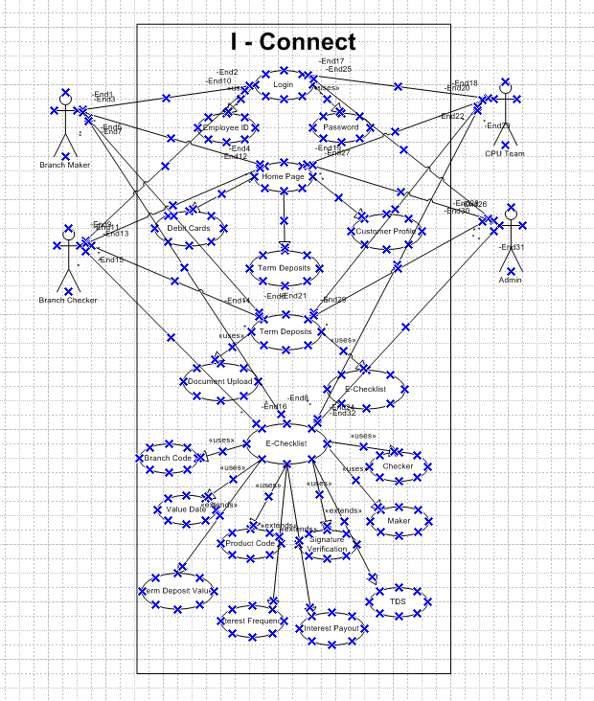

**Activity Diagram**

**Activity - Login**

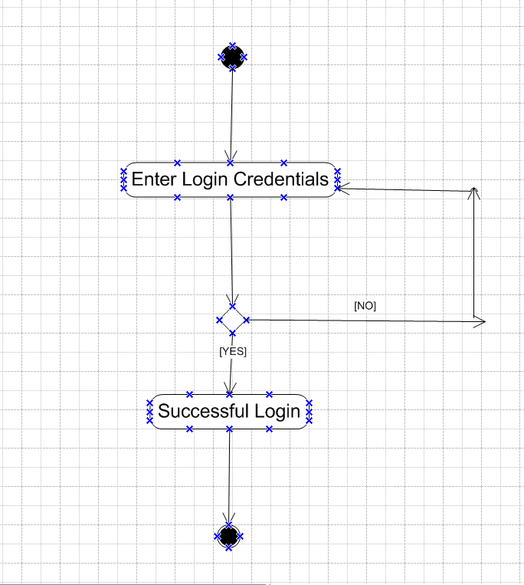

**Activity - Home Page Browsing**

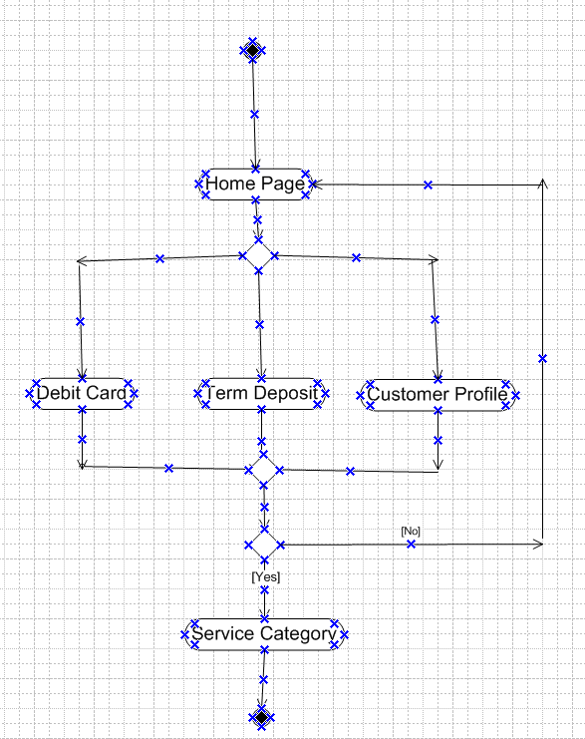

**Activity - Term Deposit**

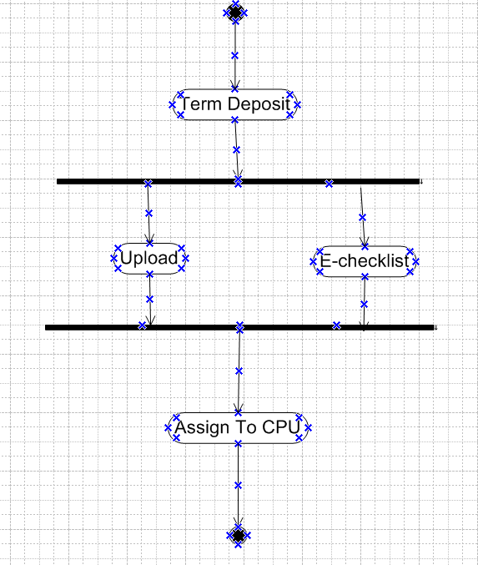

**Use Case Specs**

|  |  |
| --- | --- |
| **Use case Id** | **UC001** |
| **Use Case Name** | Employee Login |
| **Created By** | Rohit |
| **Date Created** | 31.12.2024 |
| **Actors** | Bank Employees |
| **Description** | How user will login in to the application |
| **Pre-Condition** | User will need to login into application using employee id and password |
| **Post-Condition** | Successful login post registration |
| **Normal flow of event** | Step 1. User registers on portal using his employee id  Step 2. User Sets a password |
| **Alternative flow of event** | Incase user forgets the password; user would get an option to reset the password. The new password would be generated with a new password reset page |
| **Assumptions** | Customer is tech savvy |

|  |  |
| --- | --- |
| **Use case Id** | **UC002** |
| **Use case Name** | Browsing the I –Connect Service Category Page |
| **Created By** | Rohit |
| **Date Created** | 31.12.2024 |
| **Actors** | Bank Employees |
| **Description** | How employee will browse various service categories on the application |
| **Pre-Condition** | User has logged into the system  User will need to view the service category requirements |
| **Post-Condition** | Various service category will be displayed on the application |
| **Normal flow of event** | Step 1. User logged into the application  Step 2. User sets filter for service category  Step 3. User browse service category as per his requirements.  Step 4. User selects service category |
| **Alternative flow of event** | Incase service category is not visible user will search the service category in browse option |
| **Assumptions** | All service categories are available on the application |

|  |  |
| --- | --- |
| **Use case Id** | **UC003** |
| **Use case Name** | Term Deposit E-checklist updation |
| **Created By** | Rohit |
| **Date Created** | 31.12.2024 |
| **Actors** | Bank Employees |
| **Description** | How employee will update Term Deposit E-checklist |
| **Pre-Condition** | User has logged into the application  User will select Term Deposit Category |
| **Post-Condition** | E-check list updated in application |
| **Normal flow of event** | Step 1. User logged into the application  Step 2. User updates Term Deposit E-checklist  Step 3. Use saves and assigns Term Deposit E-checklist. |
| **Alternative flow of event** | Incase E-check list is not updated, user will need to re-login and proceed with E-checklist updation |
| **Assumptions** | E-checklist is available on the application |

**7. Screens and Pages**

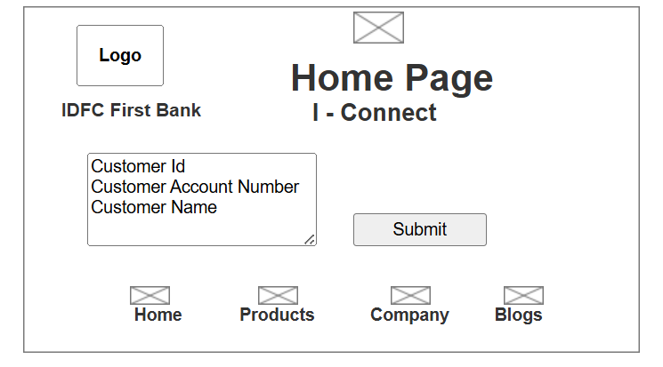

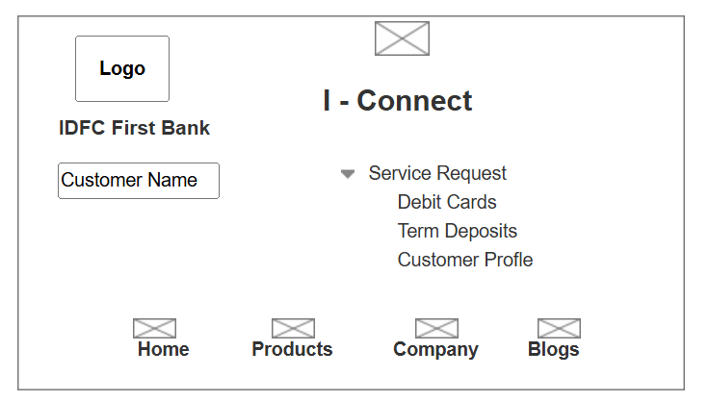

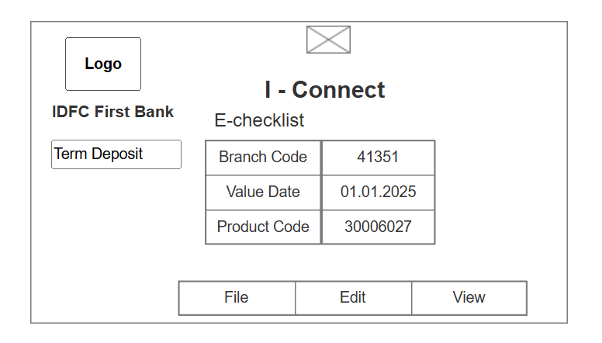

**8. Tools Visio and Axure**

* **Microsoft Visio -** Microsoft Visio is diagramming and vector graphics tool used to create diagrams, flowcharts and other visual representation of complex requirements. It consists of Use Case Diagram (User Perspective) and Activity Diagram (System Perspective).
* **Axure** – is a more advanced prototyping tool used to create high fidelity (designs with high / minute details) interactive wireframes and prototypes. In axure Graphical representation / Navigation is more better and more realistic.