**Online Agriculture Store. Cap 1st. Part 3.**

**Q.1.Functional Requirements  
Answer**

|  |  |  |  |
| --- | --- | --- | --- |
| **Req ID** | **Req Name** | **Req Description** | **Priority** |
| FR0001 | Farmer Registration | Farmers should be able to register with the application. | 8 |
| FR0002 | Farmer Search for Products | Farmers should be able to search for available products in fertilizers, seeds, pesticides. | 8 |
| FR0003 | Manufacturer Registration | Manufacturers should be able to register with the application. | 7 |
| FR0004 | Product Listing | Manufacturers should be able to upload and display their products. | 8 |
| FR0005 | Product Catalog | A structured and comprehensive listing of all available products should be provided. | 7 |
| FR0006 | Product Details | Farmers should be able to view detailed information about each product. | 7 |
| FR0007 | Add to Cart | Farmers should be able to add products to their shopping cart. | 7 |
| FR0008 | Buy-Later List | Farmers should be able to add products to a buy-later list after logging in. | 6 |
| FR0009 | Checkout | Farmers should be able to proceed to checkout and complete their purchase. | 7 |
| FR0010 | Payment Processing | The platform should support multiple payment options including COD, Credit/Debit card, and UPI. | 9 |
| FR0011 | Order Confirmation | Farmers should receive an email confirmation upon successful purchase. | 5 |
| FR0012 | Order Tracking | Farmers should be able to track the status of their orders in real-time. | 9 |
| FR0013 | Profile Management | Users (both farmers and manufacturers) should be able to manage their profiles. | 6 |
| FR0014 | Password Recovery | Users should be able to recover their password if forgotten. | 5 |
| FR0015 | User Login | Users should be able to log in using their email ID and password. | 8 |
| FR0016 | Social Media Login | Users should be able to log in using their Google or Facebook accounts. | 5 |
| FR0017 | Feedback Submission | Farmers should be able to provide feedback on products they have purchased. | 6 |
| FR0018 | Manufacturer Response to Feedback | Manufacturers should be able to respond to feedback from farmers. | 5 |
| FR0019 | Delivery Notification | Farmers should receive notifications about the delivery status of their orders. | 6 |
| FR0020 | Customer Support | A dedicated customer support system should be available to assist users with any issues or queries. | 8 |
| NFR0101 | Page Loading Time | Each page should load within 2 seconds. | 9 |
| NFR0102 | WCAG 2.1 | The system must meet Web Content Accessibility Guidelines WCAG 2.1. | 8 |
| NFR0103 | Data Encryption | All user data should be encrypted to ensure security. | 9 |
| NFR0104 | System Availability | The platform should have an uptime of 99.9%. | 9 |
| NFR0105 | Scalability | The system should be scalable to handle an increasing number of users. | 7 |
| NFR0106 | Data Backup | Regular data backups should be conducted to prevent data loss. | 8 |
| NFR0107 | Cross-Browser Compatibility | The platform should be compatible with major web browsers (Chrome, Firefox, Safari, Edge). | 6 |
| NFR0108 | Mobile Responsiveness | The platform should be fully responsive and accessible on mobile devices. | 9 |
| NFR0109 | User Interface Consistency | The user interface should be consistent across different pages and features. | 7 |
| NFR0110 | Load Testing | The system should undergo load testing to ensure it can handle peak usage. | 8 |

**Q.2. Create 5 Wireframe and Prototype**

**Answer -**

**1.Home Page, 2. User Log in, 3.Registration Page, 4. Product Catlog, 5.Payments.**

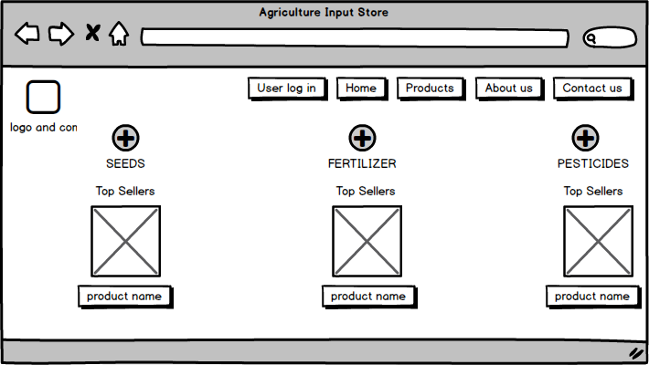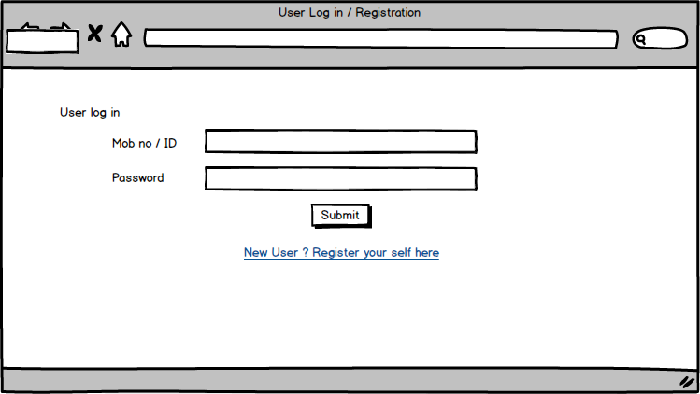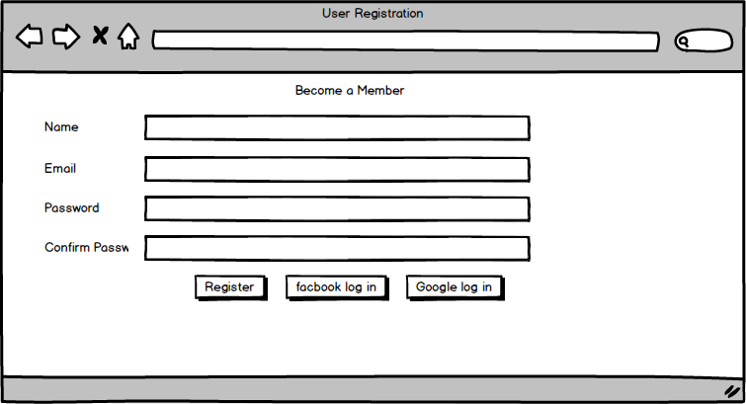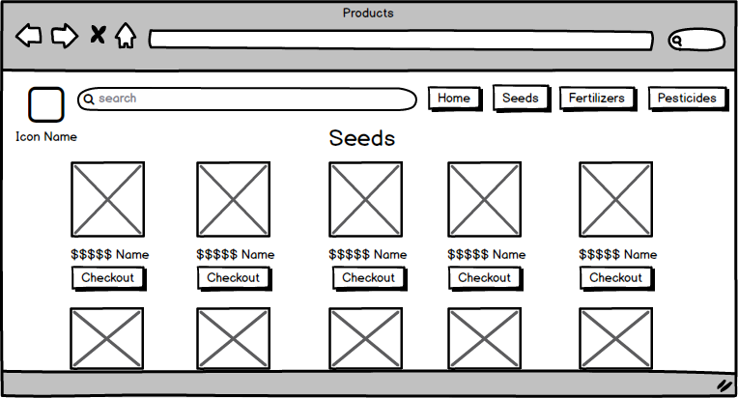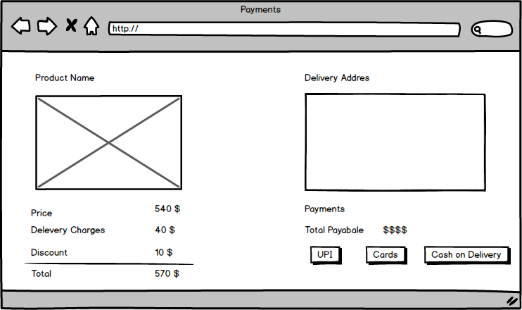

**Q.3. Make a note of the Tools, which you are using for above concepts.  
Answer -**

**Balsamiq**

**Balsamiq** is a low fidelity wireframing tool designed to help teams quickly create mockups that focus on structure and flow rather than detailed design. It's user-friendly and ideal for brainstorming and early-stage design1.

**For the case study:**

* **Home Page:** Quickly sketch the layout with placeholders for the header, search bar, featured products, and categories.
* **User Registration/Login Page:** Design simple forms for user registration and login.
* **Product Catalog Page:** Create a grid layout for product listings with filters and sorting options.
* **Product Details Page:** Detail the product information layout with images, descriptions, and reviews.
* **Checkout Page:** Outline the cart summary, delivery information, and payment options.

**Microsoft Visio**

**Microsoft Visio** is a diagramming and vector graphics application used to create flowcharts, organizational charts, and other diagrams. It's great for visualizing processes and workflows.

**For the case study:**

* **Flowcharts:** Map out the user journey from landing on the home page to completing a purchase.
* **Process Diagrams:** Illustrate the steps involved in the product registration and checkout process.
* **Network Diagrams:** Design the backend system architecture for handling user data and transactions.

**Axure**

**Axure RP** is a powerful tool for creating interactive prototypes and specifications. It allows for high-fidelity prototypes with realistic interactions and conditional logic3.

**For the case study:**

* **Interactive Prototypes:** Build clickable prototypes for the home page, product catalog, and checkout process.
* **User Testing:** Create interactive elements like forms, buttons, and dynamic content to test user interactions.
* **Collaboration:** Share prototypes with stakeholders and gather feedback directly on the design.

**Q.4. RTM  
Answer -**

|  |  |  |  |  |  |  |  |  |  |
| --- | --- | --- | --- | --- | --- | --- | --- | --- | --- |
| **Req ID** | **Req Name** | **Req Description** | **Design (Completed/Not)** | **Code** | **Unit Testing** | **Component Testing** | **System Testing** | **SIT** | **UAT** |
| FR0001 | Farmer Registration | Farmers should be able to register with the application. | Completed | incomplete | incomplete | incomplete | incomplete | incomplete | incomplete |
| FR0002 | Farmer Search for Products | Farmers should be able to search for available products in fertilizers, seeds, pesticides. | Completed | incomplete | incomplete | incomplete | incomplete | incomplete | incomplete |
| FR0003 | Manufacturer Registration | Manufacturers should be able to register with the application. | Completed | incomplete | incomplete | incomplete | incomplete | incomplete | incomplete |
| FR0004 | Product Listing | Manufacturers should be able to upload and display their products. | Completed | incomplete | incomplete | incomplete | incomplete | incomplete | incomplete |
| FR0005 | Product Catalog | A structured and comprehensive listing of all available products should be provided. | Completed | incomplete | incomplete | incomplete | incomplete | incomplete | incomplete |
| FR0006 | Product Details | Farmers should be able to view detailed information about each product. | Completed | incomplete | incomplete | incomplete | incomplete | incomplete | incomplete |
| FR0007 | Add to Cart | Farmers should be able to add products to their shopping cart. | Completed | incomplete | incomplete | incomplete | incomplete | incomplete | incomplete |
| FR0008 | Buy-Later List | Farmers should be able to add products to a buy-later list after logging in. | Completed | incomplete | incomplete | incomplete | incomplete | incomplete | incomplete |
| FR0009 | Checkout | Farmers should be able to proceed to checkout and complete their purchase. | Completed | incomplete | incomplete | incomplete | incomplete | incomplete | incomplete |
| FR0010 | Payment Processing | The platform should support multiple payment options including COD, Credit/Debit card, and UPI. | Completed | incomplete | incomplete | incomplete | incomplete | incomplete | incomplete |
| FR0011 | Order Confirmation | Farmers should receive an email confirmation upon successful purchase. | Completed | incomplete | incomplete | incomplete | incomplete | incomplete | incomplete |
| FR0012 | Order Tracking | Farmers should be able to track the status of their orders in real-time. | Completed | incomplete | incomplete | incomplete | incomplete | incomplete | incomplete |
| FR0013 | Profile Management | Users (both farmers and manufacturers) should be able to manage their profiles. | Completed | incomplete | incomplete | incomplete | incomplete | incomplete | incomplete |
| FR0014 | Password Recovery | Users should be able to recover their password if forgotten. | Completed | incomplete | incomplete | incomplete | incomplete | incomplete | incomplete |
| FR0015 | User Login | Users should be able to log in using their email ID and password. | Completed | incomplete | incomplete | incomplete | incomplete | incomplete | incomplete |
| FR0016 | Social Media Login | Users should be able to log in using their Google or Facebook accounts. | Completed | incomplete | incomplete | incomplete | incomplete | incomplete | incomplete |
| FR0017 | Feedback Submission | Farmers should be able to provide feedback on products they have purchased. | Completed | incomplete | incomplete | incomplete | incomplete | incomplete | incomplete |
| FR0018 | Manufacturer Response to Feedback | Manufacturers should be able to respond to feedback from farmers. | Completed | incomplete | incomplete | incomplete | incomplete | incomplete | incomplete |
| FR0019 | Delivery Notification | Farmers should receive notifications about the delivery status of their orders. | Completed | incomplete | incomplete | incomplete | incomplete | incomplete | incomplete |
| FR0020 | Customer Support | A dedicated customer support system should be available to assist users with any issues or queries. | Completed | incomplete | incomplete | incomplete | incomplete | incomplete | incomplete |
| NFR0101 | Page Loading Time | Each page should load within 2 seconds. | Completed | incomplete | incomplete | incomplete | incomplete | incomplete | incomplete |
| NFR0102 | WCAG 2.1 | The system must meet Web Content Accessibility Guidelines WCAG 2.1. | Completed | incomplete | incomplete | incomplete | incomplete | incomplete | incomplete |
| NFR0103 | Data Encryption | All user data should be encrypted to ensure security. | Completed | incomplete | incomplete | incomplete | incomplete | incomplete | incomplete |
| NFR0104 | System Availability | The platform should have an uptime of 99.9%. | Completed | incomplete | incomplete | incomplete | incomplete | incomplete | incomplete |
| NFR0105 | Scalability | The system should be scalable to handle an increasing number of users. | Completed | incomplete | incomplete | incomplete | incomplete | incomplete | incomplete |
| NFR0106 | Data Backup | Regular data backups should be conducted to prevent data loss. | Completed | incomplete | incomplete | incomplete | incomplete | incomplete | incomplete |
| NFR0107 | Cross-Browser Compatibility | The platform should be compatible with major web browsers (Chrome, Firefox, Safari, Edge). | Completed | incomplete | incomplete | incomplete | incomplete | incomplete | incomplete |
| NFR0108 | Mobile Responsiveness | The platform should be fully responsive and accessible on mobile devices. | Completed | incomplete | incomplete | incomplete | incomplete | incomplete | incomplete |
| NFR0109 | User Interface Consistency | The user interface should be consistent across different pages and features. | Completed | incomplete | incomplete | incomplete | incomplete | incomplete | incomplete |
| NFR0110 | Load Testing | The system should undergo load testing to ensure it can handle peak usage. | Completed | incomplete | incomplete | incomplete | incomplete | incomplete | incomplete |

**Q.5. 10 Test Case Documents  
Answer -**

|  |  |  |  |  |  |  |  |  |  |  |  |
| --- | --- | --- | --- | --- | --- | --- | --- | --- | --- | --- | --- |
| **Test Case ID** | **Project ID** | **Test Strategy ID** | **Test Plan ID** | **Test Schedule ID** | **Scenarios** | **Link to Pages (Various Sets)** | **Input Data** | **Expected Behavior** | **Actual Behavior** | **Comments** | **Result (Pass/Fail)** |
| TC-001 | OAPS-001 | TS-01 | TP-01 | TS-001 | User Registration | Registration Page | Name, Email, Password | User should receive a confirmation email and account should be created | [To be filled after execution] | [To be filled after execution] | [To be filled after execution] |
| TC-002 | OAPS-001 | TS-01 | TP-01 | TS-002 | User Login | Login Page | Email, Password | User should be successfully logged in and redirected to the dashboard | [To be filled after execution] | [To be filled after execution] | [To be filled after execution] |
| TC-003 | OAPS-001 | TS-01 | TP-01 | TS-003 | Product Search | Home Page | Product Name | Relevant products should be displayed | [To be filled after execution] | [To be filled after execution] | [To be filled after execution] |
| TC-004 | OAPS-001 | TS-01 | TP-01 | TS-004 | Product Listing | Product Listing Page | Product Details | Product should be successfully listed and visible in the catalog | [To be filled after execution] | [To be filled after execution] | [To be filled after execution] |
| TC-005 | OAPS-001 | TS-01 | TP-01 | TS-005 | Add to Cart | Product Details Page | Product Selection | Product should be added to the cart and displayed in the cart summary | [To be filled after execution] | [To be filled after execution] | [To be filled after execution] |
| TC-006 | OAPS-001 | TS-01 | TP-01 | TS-006 | Checkout | Checkout Page | Delivery Info, Payment Details | Order should be successfully placed, and the user should receive an order confirmation | [To be filled after execution] | [To be filled after execution] | [To be filled after execution] |
| TC-007 | OAPS-001 | TS-01 | TP-01 | TS-007 | Payment Processing | Checkout Page | Payment Details | Payment should be processed successfully, and the order should be placed | [To be filled after execution] | [To be filled after execution] | [To be filled after execution] |
| TC-008 | OAPS-001 | TS-01 | TP-01 | TS-008 | Order Tracking | Order Tracking Page | Order ID | Order status should be displayed accurately | [To be filled after execution] | [To be filled after execution] | [To be filled after execution] |
| TC-009 | OAPS-001 | TS-01 | TP-01 | TS-009 | Feedback Submission | Feedback Page | Feedback Details | Feedback should be submitted successfully and displayed on the product page | [To be filled after execution] | [To be filled after execution] | [To be filled after execution] |
| TC-010 | OAPS-001 | TS-01 | TP-01 | TS-010 | Delivery Notification | Delivery Notification Page | Order ID | User should receive notifications about the delivery status of their orders | [To be filled after execution] | [To be filled after execution] | [To be filled after execution] |

**Q.6.Draw database schema and ER diagram  
Answer –**

**Database Schema**

A database schema is the structure that defines how data is organized in a database. It includes all the tables, the fields in those tables, the relationships between the fields, and other components like views, indexes, and stored procedures. Think of it as a blueprint for the database, showing how all the pieces of data fit together. There are two main types of database schemas:

1. Logical Schema: Describes the data model, including entities, attributes, and the relationships between them, without regard to how they are physically stored.
2. Physical Schema: Describes how data is stored on physical storage devices, including details like file structures, indexes, and partitions.

**Entity-Relationship (ER) Diagram**

An ER Diagram (Entity-Relationship Diagram) is a visual representation of the database schema. It shows how entities (things) in the database relate to each other. Each entity represents a table in the database, and the relationships show how these tables are connected. Here's a quick breakdown:

* Entity: An object or concept that can have data stored about it. For example, in a database for a school, entities might include Student, Teacher, and Course.
* Attribute: A property or characteristic of an entity. For example, a Student entity might have attributes like StudentID, Name, and DateOfBirth.
* Relationship: A connection between entities. For example, a Student entity might have a relationship with a Course entity, indicating that students enroll in courses

|  |
| --- |
| Users |
| User id |
| Name |
| Email |
| Password |
| User type (farmer/Manufacturer) |
| Created at |

|  |
| --- |
| Products |
| Product ID |
| Name |
| Category (seed/fertilizer/pesticide) |
| Price |
| Quantity |
| users id |
| Created at |

|  |
| --- |
| Orders |
| Order id |
| User id |
| Total amount |
| Order status |

|  |
| --- |
| Order items |
| Order item id |
| Order id |
| Product id |
| Quantity |
| Price |

|  |
| --- |
| Payments |
| Payment id |
| Order id |
| Payment method |
| Payment status |
| Payment date |

**Explanation of Relationships**

1. **Users to Products**: One manufacturer (user) can list multiple products (one-to-many relationship).
2. **Users to Orders**: One user (farmer) can place multiple orders (one-to-many relationship).
3. **Orders to Order_Items**: One order can contain multiple order items (one-to-many relationship).
4. **Products to Order_Items**: One product can be included in multiple order items (one-to-many relationship).
5. **Orders to Payment**: One order has one payment (one-to-one relationship).

This flowchart-based ER diagram and database schema provide a clear understanding of how the data is structured and the relationships between different entities in the Online Agriculture Products Store system.

**Q.7.What is a data flow diagram? Draw a data flow diagram to represent the in-flow and out-flow of data when a Farmer is placing an order for the product.**

**Answer -**

A Data Flow Diagram (DFD) is a graphical representation that depicts the flow of data within a system. It shows how data is processed, transferred, and stored within a system, highlighting the inputs and outputs, data sources, destinations, and processes involved. DFDs are useful for understanding and analyzing how information flows through a system and identifying areas for improvement.

**Data Flow Diagram for Placing an Order**

Below is a simplified Data Flow Diagram (DFD) representing the in-flow and out-flow of data when a Farmer place an order for a product in the Online Agriculture Products Store

**USER**

Product catalog

Search Item

User Data

Registration

Product Catalog

Product Details

Product Catalog

Add to Cart

User Data

User details

Product catalog

Order details

User Data

Payment confirmation

Order confirmation

Product catalog

Update inventory

Inventory

**Explanation of the Flow:**

1. **Search Products:** The farmer searches for a product in the product catalog.
2. **Product Details:** The product catalog sends the product details back to the farmer.
3. **Add to Cart:** The farmer adds the product to their shopping cart.
4. **Cart Information:** The shopping cart sends the cart information back to the farmer for review.
5. **Checkout:** The farmer proceeds to checkout, entering user details and reviewing the order.
6. **User Details:** The checkout process retrieves and verifies user details from the user data store.
7. **Order Details:** The checkout process sends the order details to the orders data store.
8. **Payment Info:** The checkout process sends payment information to the payments data store.
9. **Payment Confirmation:** The payments data store sends a payment confirmation back to the checkout process.
10. **Order Confirmation:** The checkout process generates an order confirmation and sends it to the farmer.
11. **Update Inventory:** The orders data store updates the inventory to reflect the purchased items.

This DFD provides a clear view of how data flows within the system when a farmer places an order, including the interactions between different processes and data stores.

**Q.8.Due to change in the Government Taxation structure. We should change the Tax structure How do you handle change requests in a project?**

**Answer -**

Handling change requests in a project involves a systematic process to ensure that changes are effectively managed while minimizing disruption to the project's scope, timeline, and resources. Here are the steps typically followed to handle change requests

1. Change Request Identification: Identify and document the change request, including the specific details of the requested change, the reason for the change, and its potential impact on the project.

2. Change Impact Analysis: Assess the impact of the change on various aspects of the project, such as scope, timeline, cost, resources, and risks. Evaluate the feasibility and implications of implementing the change.

3. Change Evaluation: Review the change request with key stakeholders, including project sponsors, clients, and relevant team members. Discuss the potential benefits, risks, and trade-offs associated with the change. Consider the project’s objectives, constraints, and priorities in the evaluation process.

4. Change Prioritization: Prioritize the change request based on its urgency, impact, and alignment with project goals. Determine whether the change is critical and

must be implemented immediately or can be scheduled for a future phase or release.

5. Change Approval: Obtain formal approval from the appropriate stakeholders, such as project sponsors or change control boards. Ensure that all stakeholders are in agreement regarding the change and its implications.

6. Change Implementation: Incorporate the approved change into the project plan, including any necessary adjustments to the scope, schedule, budget, or resources. Communicate the change to the project team and other relevant stakeholders. Update project documentation, such as requirements, design, and test plans, to reflect the approved change.

7. Change Communication: Communicate the approved change to all relevant parties, including team members, clients, and other stakeholders. Clearly explainthe reasons for the change, its impact on the project, and any adjustments to expectations or deliverables.

8. Change Tracking and Documentation: Track and document all approved changes, including the rationale, approvals, and implemented modifications. Maintain a change log or change register to ensure transparency and accountability throughout the project.

9. Change Control and Monitoring: Continuously monitor the impact of implemented changes on the project's progress, risks, and quality. Maintain open lines of communication with stakeholders to address any concerns or issues related to the approved changes. Monitor the project's overall alignment with the revised scope, timeline, and objectives.   
  
By following these steps, a project can effectively manage change requests, ensuring that changes are evaluated, approved, and implemented in a controlled manner, while minimizing disruptions and maintaining project success.

**Q.9. As the project is in process, Ben and Kevin have contacted you. The reason is to inform you that they want the Farmers to sell their crop yields through this application i.e. Farmers should be able to add their crop yields or products and display to public and should be able to sell them. They also want to introduce an Auction system for their Crop yields. As a BA, what will be your response?**

**Answer –**

 As a business analyst, my response to Ben and Kevin's request would be to classify it as an enhancement rather than a change request. A change request typically involves modifications to existing functionality or requirements, while an enhancement introduces new features or capabilities that were not initially specified. In this case, the request to allow farmers to add their crop yields, display them to the general public, and enable selling through the application represents an enhancement because it introduces new functionality that goes beyond the initial scope of the project. Additionally, the introduction of an auction system for crop yields adds another layer of functionality to the application. To address this enhancement request, I would follow the standard process for handling new requirements:

1. Requirement Gathering: I will meet with Ben and Kevin to gather detailed requirements for the new functionality. This would involve understanding the specific features they envision, such as the process for farmers to add and manage their crop yields, the display of products to the public, and the implementation of the auction system.

2. Impact Analysis: I would analyze the impact of these enhancements on the existing project scope, timeline, budget, and resources. This assessment would help determine the feasibility and potential implications of incorporating the requested features.

3. Stakeholder Analysis: I would identify and involve relevant stakeholders, such as the project sponsor, development team, and other key personnel, to assess their perspectives and gather their inputs on the potential enhancements.

4. Documentation and Communication: I would document the detailed requirements and changes in the project scope, and communicate them to the project team, stakeholders, and any other parties involved. This would ensure everyone is aware of the proposed enhancements and their implications.

5. Evaluation and Prioritization: I would work with the project team and stakeholders to evaluate the value and priority of the requested enhancements. This evaluation would consider factors such as the potential benefits, impact on project goals, alignment with business objectives, and available resources.

6. Planning and Execution: If the enhancements are deemed feasible and approved, I would update the project plan, schedule, and resources accordingly .I would collaborate with the development team and other stakeholders to incorporate the new features into the application, ensuring proper testing and quality assurance. By treating this request as an enhancement, the project can effectively manage the additional requirements and deliver the desired functionality while considering the impact on the ongoing project.

**Q.10.Come up with estimations – How many Man-hours required.  
Answer -**  
Estimating the number of man-hours required for the requested enhancements (adding crop yields, displaying them to the public, and implementing an auction system) would depend on various factors, including the complexity of the features, the size of the existing system, the development team's expertise, and the development methodology used. Without specific details about the project, it's challenging to provide an accurate estimation.  
  
 However, I can offer a general guideline based on industry standards and experience:  
  
1. Requirement Gathering and Analysis: 10-20 man-hours  
2. This includes meetings with stakeholders, gathering detailed requirements, analyzing the impact, and documenting the enhancements.  
3. Design and Architecture: 20-40 man-hours  
4. This involves designing the system components, database structure, and user interface for the new features. It also includes identifying the necessary changes to accommodate the enhancements.  
5. Development and Coding: 40-80 man-hours  
6. The actual development of the new features, including backend and frontend coding, integration with existing modules, and implementation of the auction system.  
7. Testing and Quality Assurance: 20-40 man-hours  
8. This phase involves writing test cases, performing unit testing, integration testing, and ensuring the proper functioning and stability of the added features.  
9. Deployment and User Acceptance Testing (UAT): 10-20 man-hours  
10.Deploying the updated system to a testing environment, conducting user acceptance testing, and resolving any issues identified during UAT.  
11.Documentation and Training: 10-20 man-hours  
12.Documenting the new features, updating user manuals or guides, and providing training or support materials for farmers and users.   
  
It’s important to note that these estimations are rough figures and can vary significantly depending on the complexity and scale of the enhancements, the team's productivity, and other project-specific factors. It's recommended to involve the development team in the estimation process to get a more accurate assessment based on their expertise and knowledge of the project.

**Q.11. Project has finally completed all the stages i.e., design, development, testing etc. Now, it is the role of a business analyst to contact the client for testing the final product and have to successfully complete it. How are you going to handle this situation? And once it is done, what will be the process to close the project?  
Explain UAT Acceptance process  
Answer –**

To handle the situation of testing the final product and successfully completing it, the business analyst can follow these steps:  
  
1. UAT Planning: Prepare a plan for User Acceptance Testing (UAT) in consultation with the client. This plan should include the scope of testing, test scenarios, test data, and timelines.  
2. Test Environment Setup: Ensure that the required test environment is set up and available for the client to perform testing. This may include providing access to the testing environment, necessary test accounts, and any additional resources needed for testing.  
3. Test Execution: Coordinate with the client to execute the planned test scenarios. Monitor the testing progress, provide support for any questions or issues that arise, and track the test results.  
4. Defect Management: If any defects are identified during UAT, work closely with the client to understand the issues, document them, and track their resolution. Collaborate with the development team to address the reported defects and verify their fixes.  
5. UAT Sign-off: Once the client has completed testing and is satisfied with the product’s functionality, obtain their formal sign-off or approval. This indicates that the client has accepted the final product and is ready to move forward with its deployment.   
  
Regarding the process to close the project, it typically involves the following steps:  
1. Final Documentation: Ensure that all project-related documentation is complete, including requirements, design documents, test cases, and user manuals. Review and update these documents to reflect the final product.  
2. Project Review: Conduct a project review meeting with key stakeholders, including the client, to discuss the overall project performance, achievements, and lessons learned. Gather feedback and suggestions for improvement.  
3. Project Closure Report: Prepare a project closure report summarizing the project’s objectives, deliverables, timeline, budget, and overall success. Include any important metrics or performance indicators.  
4. Handover or Deployment: Coordinate with the necessary teams, such as deployment or operations, to ensure a smooth transition of the final product to the production environment. Provide any necessary training or documentation to support the deployment process.  
5. Post-Project Evaluation: After the product is deployed and operational, conduct post-project evaluation to assess its performance, gather user feedback, and identify any areas for further improvement.

UAT Acceptance Process: The User Acceptance Testing (UAT) Acceptance process involves the following steps:  
1. Test Planning: Define the scope of UAT and identify the key features or functionalities to be tested. Prepare test scenarios and test cases based on user requirements.  
2. Test Execution: Perform the planned test scenarios, following the test cases provided. Validate the system's behavior against the expected outcomes and verify that it meets the user's acceptance criteria.  
3. Defect Reporting: If any issues or defects are identified during UAT, document them in a structured manner, including detailed steps to reproduce the problem. Communicate the issues to the development team for resolution.  
4. Defect Resolution: Collaborate with the development team to address the reported defects. Verify the fixes provided by the development team and retest the affected areas.  
5. Sign-off: Once all test scenarios have been executed, defects have been resolved, and the system meets the user's acceptance criteria, provide formal sign-off or approval. This signifies that the client accepts the product as meeting their requirements.  
6. UAT Closure: Document the UAT results, including the test execution summary, any outstanding issues, and the overall assessment of the product. Communicate the closure of UAT to all stakeholders involved in the testing process.  
  
The UAT Acceptance process ensures that the final product meets the client’s expectations and is ready for deployment. It serves as a final validation before the project is considered complete and ready for closure

**Q.12. Project Closure Document  
Answer -**

A project closure document is a comprehensive report that summarizes the entire project’s lifecycle, outcomes, and lessons learned. It serves as a formal record of the project’s completion and provides important information for future reference. The document typically includes the following sections:

1. Project Overview: This section provides an overview of the project, including its objectives, scope, and stakeholders involved. It summarizes the project’s purpose and sets the context for the closure report.

2. Project Achievements: Here, the document highlights the key achievements and deliverables of the project. It outlines the successful completion of milestones, tasks, and any significant accomplishments that were achieved.

3. Project Timeline and Budget: This section provides an overview of the timeline, highlighting the start and end dates, major phases, and milestones. It also includes information on the project's budget, including any significant deviations or changes.

4. Lessons Learned: The lessons learned section reflects the project successes and challenges. It includes a comprehensive analysis of what worked well and what could have been improved. It highlights valuable insights and recommendations for future projects.

5. Stakeholder Feedback: This section gathers feedback from key stakeholders involved in the project. It includes their opinions, suggestions, and any concerns they may have expressed. The feedback helps in assessing the overall satisfaction and identifying areas for improvement.  
6. Risks and Issues: The closure document discusses the risks and issues encountered throughout the project. It outlines the actions taken to mitigate these risks and resolve any issues that arose during the project's lifecycle.  
7. Project Performance: This section evaluates the project's performance against the defined objectives and success criteria. It assesses factors such as scope adherence, timeline adherence, budget performance, quality of deliverables, and customer satisfaction.  
8. Project Sign-off: The closure document includes formal sign-off or approval from key stakeholders, indicating their acceptance and satisfaction with the project’s outcomes. This signifies the official closure of the project.  
9. Project Documentation: This section provides an overview of the project documentation, including the list of documents produced, their location, and accessibility for future reference.  
10.Next Steps and Recommendations: The closure document outlines any recommended actions or next steps following the project's closure. It may include suggestions for further improvements, additional tasks, or follow-up activities.   
  
The project closure document serves as a final report that captures the project's journey, outcomes, and key learnings. It provides references for future projects, helps in evaluating project success, and facilitates knowledge transfer to stakeholders involved in the project.