Capstone Project1 – Part -3/3

Online Agriculture Products Store

Mr. Henry, after being successful as a businessman and has become one of the wealthiest persons in the city. Now, Mr. Henry wants to help others to fulfil their dreams. One day, Mr. Henry went to meet his childhood friends Peter, Kevin and Ben. They live in a remote village and do farming. Mr. Henry asked his friends if they are facing any difficulties in their day-to-day work.

Peter told Mr. Henry that he is facing difficulties in procuring fertilizers which are very important for farm. Kevin said that he is also facing the same problem in-case of buying seeds for farming certain crops. Ben raised his concern on lack of pesticides which could help in greatly reducing pests in crops.

After listening to all his friends’ problems, Mr. Henry thought that this is a crucial problem faced not only by his friends but also by so many other farmers. So, Mr. Henry decided to make an online agriculture product store to facilitate remote area farmers to buy agriculture products. Through this Online Web / mobile Application, Farmers and Companies (Fertilizers, seeds and pesticides manufacturing Companies) can communicate directly with each other.

The main purpose to build this online store is to facilitate farmers to buy seeds, pesticides, and fertilizers from anywhere through internet connectivity. Since new users are involved, Application should be user friendly.

This new application should be able to accept the product (fertilizers, seeds, pesticides) details fromthe manufacturers and should be able to display them to the Farmers. Farmers will browse throughthese products and select the products what they need and request to buy them and deliver them to farmers location.

Mr. Henry has given this project through his Company SOONY. In SOONY Company, Mr Pandu is Financial Head and Mr Dooku is Project Coordinator. Mr. Henry , Mr Pandu , and Mr Dooku formed one Committee and gave this project to APT IT SOLUTIONS company for Budget 2 Crores INR and

18 months Duration under CSR initiative. Peter, Kevin and Ben are helping the Committee and can be considered as Stakeholders share requirements for the Project.

Mr Karthik is the Delivery Head in APT IT SOLUTIONS company and he reached out to Mr Henry through his connects and Bagged this project. APT IT SOLUTIONS company have Talent pool Available for this Project. Mr Vandanam is project Manager, Ms. Juhi is Senior Java Developer, Mr Teyson, Ms Lucie, Mr Tucker, Mr Bravo are Java Developers. Network Admin is Mr Mike and DB Admin is John. Mr Jason and Ms Alekya are the Tester. And you joined this team as a BA.

Your Team

|  |  |  |
| --- | --- | --- |
|  | Project Manager - Mr VandanamSenior Java Developer - Ms. Juhi |  |
| Java Developers - Mr Teyson, Ms Lucie, Mr Tucker, Mr Bravo  Network Admin - Mr Mike | | |
|  | DB Admin - Mr John. |  |
| Testers - Mr Jason and Ms Alekya |
| BA - You |

Fertilizers, seeds, pesticides details from the manufacturers and should be able to display them to the Farmers.

To gather the business requirements from the client, you went to SOONY and met Mr. Henry. When Mr. Henry was asked about the project and what are they expecting from the project, Mr. Henry stated that he is expecting to have a login for all its users (fertilizers, seeds, pesticides manufacturers and Farmers) , a product catalog of fertilizers, seeds, pesticides, a search option to search for products, payment process, and delivery tracking.

After doing the stakeholder analysis, you have found out that Peter, Kevin, Ben are the key stakeholders and you have scheduled an appointment to meet them. After meeting with them and trying to gather the stakeholder requirements, Kevin said that, a Farmer should be able to browse through the products catalog once they visit the website and need to have a search option so that they can search for any product they need. Peter said that, if a farmer wants to buy any product or add them to buy-later list, they need to login first using their email id and password. If it is a new user, then they can create a new account by submitting their email ID and creating a secure password. Ben added saying that, Farmers needs to have an easy-to-use payment gateway which should include cash-on-delivery (COD), Credit/Debit card and UPI options so that the user’s experience should be better. Kevin mentioned that, a user gets an email confirmation regarding their order status. A delivery tracker to track the whereabouts of their order.

Identify Business Requirements (which includes Stakeholder Requirements)

BR001 – Farmers should be able to search for available products in fertilizers, seeds, pesticides BR002 – Manufacturers should be able to upload and display their products in the application

Make suitable Assumptions and identify at least 10 Business Requirements.

List your assumptions

Give Priority 1 to 10 numbers ( 1 being low priority – 10 being high priority) to these Requirements after discussions with the stakeholders

|  |  |  |  |
| --- | --- | --- | --- |
| Req ID | Req Name | Req Description | Priority |
| BR001 | Farmer Search for Products | Farmers should be able to search for available products in fertilizers, seeds, pesticides | 8 |
| BR002 | Manufacturers upload their Products | Manufacturers should be able to upload and display their products in the application | 8 |
|  |  |  |  |

Once the requirements are finalized, as a business analyst, one of the major roles is to act as a liaison between the client and the project team. To gather the requirements correctly from the client side and then to deliver those requirements to the project team in a way they understand.

To make the project team understand the requirements, you need to convert those requirements into UML diagrams and screen mock-ups. You will draw use case diagram

Prepare use case specs for all use cases

And you will all Activity diagrams required

Question 1 – Functional Requirements -

Identify minimum 20 functional requirements

Answer 1

|  |  |  |  |
| --- | --- | --- | --- |
| Req ID | Req Name | Req Registration | Priority |
| FR0001 | User registration and login | Allows customer to create an account and login to the application | 10 |
| FR0002 | Product catalog | Display all the available products and it's details to the customer | 10 |
| FR0003 | Search | Allows customer to search for the desired products | 10 |
| FR0004 | Shopping Cart | Allows customer to add products to the cart | 10 |
| FR0005 | Wishlist | Allows customer to add products they are interested in | 8 |
| FR0006 | Orders | Customer should be able to view the orders he has made in the past and the status of purchases made | 10 |
| FR0007 | Coupons | Allow customers to view the discount coupons available to them | 6 |
| FR0008 | Payment processing | Provide secure payment processing to customers | 10 |
| FR0009 | Customer care contact info | Allow customers to view the customer support details like phone number | 9 |
| FR0010 | Feedback form | Allow customers to provide feedback about the products purchased | 6 |
| FR0011 | Confirmation mail | Customers should be able to receive mails when an order is made or cancelled or returned | 7 |
| FR0012 | Offer information | Customer should be able to receive information about any offers or discounts through mail | 6 |
| FR0013 | Cancel order | Allows customer to cancel an order he/she has made | 10 |
| FR0014 | Return order | Allows customer to return a product he/she has purchased | 10 |
| FR0015 | Sort list | Customer should be able to sort the products according the price range like low to high or high to low | 9 |
| FR0016 | Product details | Customer should be allowed to view the details of the product | 10 |
| FR0017 | Add to cart | Customer should be able to add the products to cart | 10 |
| FR0018 | Delete from cart | Customer should be able to delete/remove the product added to cart | 10 |
| FR0019 | Return and refund policy | Outline the return and refund policy to customer to ensure positive customer experience | 9 |
| FR0020 | Shipping and delivery | Provide customer with shipping options and estimated delivery | 9 |

|  |  |  |  |
| --- | --- | --- | --- |
| Req ID | Req Name | Req Description | Priority |
| NFR0101 | Page Loading Time | Each page should load within 2 seconds | 9 |
| NFR0102 | WCAG 2.1 | The system must meet Web Content Accessibility Guidelines WCAG 2.1 | 8 |
| NFR0103 | Scalability | The system should handle up to 10,000 concurrent users | 8 |
| NFR0104 | Data Security | Sensitive data like passwords and payment details should be encrypted | 10 |
| NFR0105 | Backup and Recovery | The system should have daily backups and disaster recovery mechanisms | 7 |

Question 2 – Minimum 5page designs –

Make wireframes and Prototypes

Answer 2

Login Page

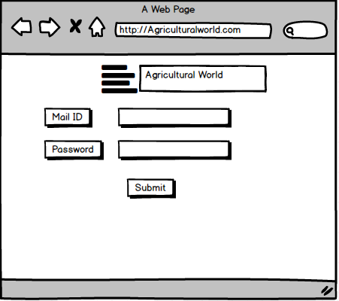

Search Page

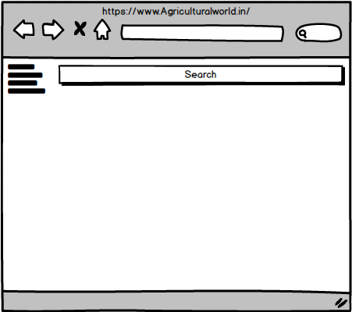

Cart

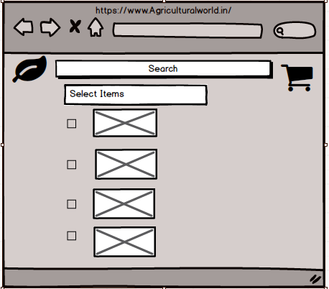

Proceed to Booking

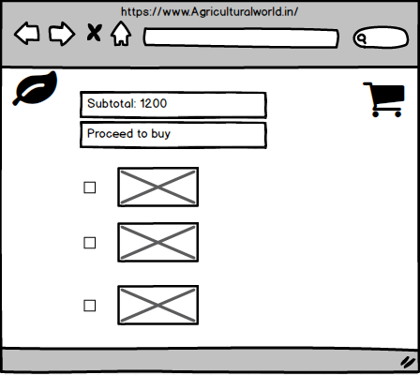

Delivery Adress Screen

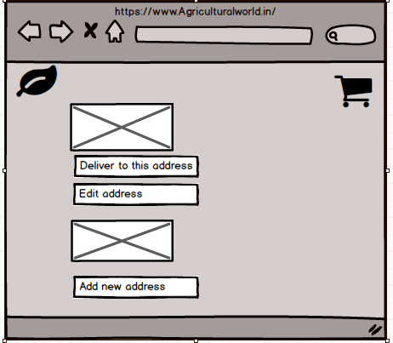

Question 3 – Tools (Visio, Balsamiq) –

Make a note of the Tools, which you are using for above concepts.

Answer 3

Microsoft Visio:

Microsoft Visio is software for drawing a variety of diagrams. These include flowcharts, org charts, building plans, floor plans, data flow diagrams, process flow diagrams, business process modeling, swimlane diagrams, 3D maps, and many more.

**Balsamiq**:

Balsamiq is a user interface design tool for creating wireframes. You can use it to generate digital sketches of your idea or concept for an application or website, to facilitate discussion and understanding before any code is written.

Axure:

Axure RP is a leading wireframing and prototyping software that allows designers, developers, and product managers to create detailed wireframes, mockups, and prototypes.

Question 4 –RTM –

A business analyst’s key responsibilities are to keep track of the requirements and make sure that no requirement is missed.

Mr. Henry and peter have approached you regarding the current status of the project. How will you tackle this situation?

Prepare RTM

Answer 4

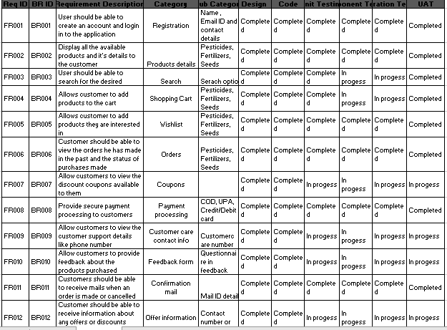

Question 5 –10 Test Case Documents –

Prepare 10 Test Case Documents

Answer 5

|  |  |  |  |
| --- | --- | --- | --- |
| **Test case ID** | ABCD0001 | **Test Case Name** | Search Query |
| **Project ID** | ABCD | **Project Name** | Online Agricultural Shop |
| **Test Strategy** | ABCD0001 | **Tester ID** | T12345 |
| **Test Plan ID** | ABCD00P1 | **Date of Test** |  |
| **Test Schedule ID** | ABCD0S1 |  |  |

|  |  |  |
| --- | --- | --- |
|  | **Set 1** | **Set 2** |
| **Input Data** | Pesticides | Seeds |
|  | Organic pesticides | Soyabean |
|  | 1 quantity | 1kg |
|  | 200Rs is the cost | 500rs/kg |
| **Expected Behaviour** | 100 Farmers should visit & oder for the above data |  |
| **Actual Behaviour** | 75 farmers visited & ordered successfully |  |
| **Comment** | Tested and UAT done, document updated |  |
| **Result: Pass/Fail** | PASS |  |

**2.**

|  |  |  |  |
| --- | --- | --- | --- |
| **Test case ID** | ABCD0002 | **Test Case Name** | Registration & Login |
| **Project ID** | ABCD | **Project Name** | Online Agricultural Shop |
| **Test Strategy** | ABCD0002 | **Tester ID** | T12345 |
| **Test Plan ID** | ABCD00P2 | **Date of Test** |  |
| **Test Schedule ID** | ABCD0S2 |  |  |

|  |  |  |
| --- | --- | --- |
|  | **Set 1** | **Set 2** |
| **Input Data** | Mail ID | First Name |
|  | Mobile Number | Last Name |
|  | Password | Password |
|  |  |  |
| **Expected Behaviour** | Mandatory field are marked with * against field and password Masking |  |
| **Actual Behaviour** | After filling all the mandatory fields register button will appear below then press register yourself |  |
| **Comment** | You have been successfully registered |  |
| **Result: Pass/Fail** | PASS |  |

**3.**

|  |  |  |  |
| --- | --- | --- | --- |
| **Test case ID** | ABCD0003 | **Test Case Name** | Product Details Page |
| **Project ID** | ABCD | **Project Name** | Online Agricultural Shop |
| **Test Strategy** | ABCD0003 | **Tester ID** | T12345 |
| **Test Plan ID** | ABCD00P3 | **Date of Test** |  |
| **Test Schedule ID** | ABCD0S3 |  |  |

|  |  |  |
| --- | --- | --- |
|  | **Set 1** | **Set 2** |
| **Input Data** | Images of Products | Reviews |
|  | Price of the product | Payment options |
|  | Product Specification | Available/out of stock |
|  |  |  |
| **Expected Behaviour** | Select the required product |  |
| **Actual Behaviour** | After selecting the product, the page should take user to payment page to select the mode of payment |  |
| **Comment** | Oder places |  |
| **Result: Pass/Fail** | PASS |  |

|  |  |  |  |
| --- | --- | --- | --- |
| **Test case ID** | ABCD0004 | **Test Case Name** | Selection of Payment mode |
| **Project ID** | ABCD | **Project Name** | Online Agricultural Shop |
| **Test Strategy** | ABCD0004 | **Tester ID** | T12345 |
| **Test Plan ID** | ABCD00P4 | **Date of Test** |  |
| **Test Schedule ID** | ABCD0S4 |  |  |

|  |  |  |
| --- | --- | --- |
|  | **Set 1** | **Set 2** |
| **Input Data** | Check different payment options | Receives OTP |
|  | Enter card details | Check total amount |
|  | Payment details |  |
|  |  |  |
| **Expected Behaviour** | Text Confirmation with Oder number generated |  |
| **Actual Behaviour** | While making payment, farmer can select their preferred mode of payment, after entering the valid payment details, press the pay button |  |
| **Comment** | Payment done, order successfully placed |  |
| **Result: Pass/Fail** | PASS |  |

|  |  |  |  |
| --- | --- | --- | --- |
| **Test case ID** | ABCD000 | **Test Case Name** | Tracking Oder Status |
| **Project ID** | ABCD | **Project Name** | Online Agricultural Shop |
| **Test Strategy** | ABCD0005 | **Tester ID** | T12345 |
| **Test Plan ID** | ABCD00P5 | **Date of Test** |  |
| **Test Schedule ID** | ABCD0S5 |  |  |

|  |  |  |
| --- | --- | --- |
|  | **Set 1** | **Set 2** |
| **Input Data** | Check if the placed order is reflected in Page | Check the order status |
|  | Name and Delivery Address is correct | Check Delivery status |
|  | Item ordered is same as showing in order page |  |
| **Expected Behaviour** | Item is shipped and delivered on date |  |
| **Actual Behaviour** | We have input that is selection of one order ID at a time after selecting order Id press track button |  |
| **Comment** | Page will display the shipment status |  |
| **Result: Pass/Fail** | PASS |  |

|  |  |  |  |
| --- | --- | --- | --- |
| **Test case ID** | ABCD0006 | **Test Case Name** | Delivery Partner Tracking Link |
| **Project ID** | ABCD | **Project Name** | Online agriculture Shop |
| **Test Strategy** | ABCD0006 | **Tester ID** | T12345 |
| **Test Plan ID** | ABCD00P6 | **Date of Test** |  |
| **Test Schedule ID** | ABCD0S6 |  |  |

|  |  |  |
| --- | --- | --- |
|  | **Set 1** | **Set 2** |
| **Input Data** | Link provided by delivery partner is correct or not | Tracking Id number Page |
|  | Testing of tracking ID link | Link can be viewed in any browser |
|  | Link is reachable or no |  |
|  |  |  |
| **Expected Behaviour** | If the farmer clicks on the tracking Link provided by the delivery partner it should be able to open the tracking page |  |
| **Actual Behaviour** | Page should display the correct tracking details |  |
| **Comment** | Page will display the delivery status |  |
| **Result: Pass/Fail** | PASS |  |

|  |  |  |  |
| --- | --- | --- | --- |
| **Test case ID** | ABCD0007 | **Test Case Name** | Post Order Page Test |
| **Project ID** | ABCD | **Project Name** | Online agriculture Shop |
| **Test Strategy** | ABCD0007 | **Tester ID** | T12345 |
| **Test Plan ID** | ABCD00P7 | **Date of Test** |  |
| **Test Schedule ID** | ABCD0S7 |  |  |

|  |  |  |
| --- | --- | --- |
|  | **Set 1** | **Set 2** |
| **Input Data** | Cancel the order | Replacement of product |
|  | Return the product |  |
| **Expected Behaviour** | Testing of relevant option after the order is placed change the order |  |
| **Actual Behaviour** | In this tab farmer can select any one option at a time to modify the order details as per their requirement |  |
| **Comment** | If any option is selected then next page will display the text confirmation |  |
| **Result: Pass/Fail** | PASS |  |

|  |  |  |  |
| --- | --- | --- | --- |
| **Test case ID** | ABCD0008 | **Test Case Name** | FAQ Page |
| **Project ID** | ABCD | **Project Name** | Online agriculture Shop |
| **Test Strategy** | ABCD0008 | **Tester ID** | T12345 |
| **Test Plan ID** | ABCD00P8 | **Date of Test** |  |
| **Test Schedule ID** | ABCD0S8 |  |  |

|  |  |  |
| --- | --- | --- |
|  | **Set 1** | **Set 2** |
| **Input Data** | Have all the questions and Answers covered | Search option is working or not |
|  | Alphanumeric keywords can be entered in the search bar |  |
| **Expected Behaviour** | Testing of questions & Answers available relate to product or service can be searched or not |  |
| **Actual Behaviour** | Farmers are searching for different types of questions and answers |  |
| **Comment** | When any question or answer is searched then FAQ page should be able to display the result on the same page |  |
| **Result: Pass/Fail** | PASS |  |

9.

|  |  |  |  |
| --- | --- | --- | --- |
| **Test case ID** | ABCD0009 | **Test Case Name** | Contact Us Page |
| **Project ID** | ABCD | **Project Name** | Online agriculture Shop |
| **Test Strategy** | ABCD0009 | **Tester ID** | T12345 |
| **Test Plan ID** | ABCD00P9 | **Date of Test** |  |
| **Test Schedule ID** | ABCD0S9 |  |  |

|  |  |  |
| --- | --- | --- |
|  | **Set 1** | **Set 2** |
| **Input Data** | Email & Ph.no of customer care team | Registered office address |
|  | Escalation team contact details |  |
| **Expected Behaviour** | Testing of have all the questions and answers has been covered in this example |  |
| **Actual Behaviour** | Any escalation or any query farmer will contact to the customer care team through this page |  |
| **Comment** | This page will display available option to contact customer care team |  |
| **Result: Pass/Fail** | PASS |  |

**10.**

|  |  |  |  |
| --- | --- | --- | --- |
| **Test case ID** | ABCD00010 | **Test Case Name** | Invoice Generation |
| **Project ID** | ABCD | **Project Name** | Online agriculture Shop |
| **Test Strategy** | ABCD00010 | **Tester ID** | T12345 |
| **Test Plan ID** | ABCD00010 | **Date of Test** |  |
| **Test Schedule ID** | ABCD0S10 |  |  |

|  |  |  |
| --- | --- | --- |
|  | **Set 1** | **Set 2** |
| **Input Data** | Product name and other details | Total amount |
|  | Amount Paid | Bill is prepared or COD |
|  | Delivery Address of farmer |  |
|  | Seller address & GST number |  |
| **Expected Behaviour** | Testing of invoice generation process |  |
| **Actual Behaviour** | Amount paid by farmer and invoice generation |  |
| **Comment** | This page will display the invoice & there is an option to download the invoice |  |
| **Result: Pass/Fail** | PASS |  |

Question 6 –DB Design –

After the requirements are thoroughly explained to the entire project team by business analyst, the Database architects have decided to do the database design and also to represent the in-flow and out-flow of data.

Draw database schema and ER diagram

Answer 6

1. Database Schema is a combination of tables and all the records. It is a blueprint of a database which describes how the data in the tables may relate to each other.
2. Relationship between tables and records is called entity relationship diagram.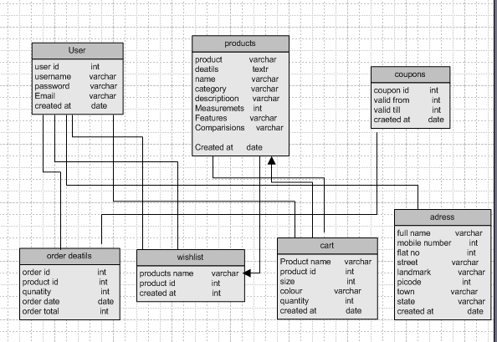

Question 7 –Data Flow Diagram –

What is a data flow diagram? Draw a data flow diagram to represent the in-flow and out-flow of data when a Farmer is placing an order for the product

Answer 7

A **Data Flow Diagram (DFD)** is a visual representation of how data flows within a system. It shows the processes, data stores, data flows, and external entities involved in a system. DFDs are commonly used in system analysis and design to model and understand the movement and transformation of data.

Provides even more detailed breakdowns of specific processes.

Used for complex systems.

Advantages of Data Flow Diagrams

Clarity: Offers a clear, visual way to understand how data moves through a system.

Communication: Helps stakeholders and developers understand system requirements.

Problem Identification: Highlights inefficiencies, redundancies, or bottlenecks in processes.

Documentation: Serves as a reference for system design and maintenance.

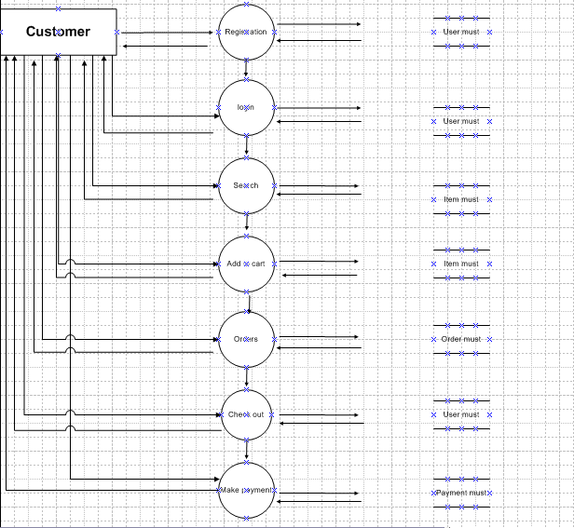

Question 8 –Change Request–

Due to change in the Government Taxation structure . we should change the Tax structure. How do you handle change requests in a project?

Answer 8

**1. Understand the Change Request**

Understand the specifics of the new government taxation rules.

Identify the changes needed in the existing tax structure.

Consult legal, compliance, and finance teams for clarity on the regulation.

Document the Request:

Note details such as who requested the change, why it’s required, and its expected impact.

**2. Analyze the Impact**

Determine how the new tax structure affects business operations, pricing, invoices, and reporting.Identify affected systems, modules, and processes (e.g., ERP, accounting software) Review how this change affects the project’s scope, timeline, and budget.

Risk Assessment: Identify risks such as compliance failures, delayed project timelines, or increased costs. Assess how the change aligns with organizational goals and priorities.

**3.Collaborate with Stakeholders:**

Engage relevant teams, including finance, legal, IT, and operations. Ensure all stakeholders understand the change and its implications. Secure formal approval from decision-makers to proceed with the change.

**4. Update Project Documentation**

Document the revised tax requirements in the project requirements documentation.

Include use cases, business rules, and scenarios related to the new tax structure.

Update project schedules, resource allocations, and budgets to reflect the change.

**5. Implement the Change**

Collaborate with the development team to implement the new tax calculations, reports, and compliance checks. Update databases, workflows, and integrations as needed.

Perform rigorous testing, including unit, system, and user acceptance testing (UAT), to ensure the change works correctly.Validate compliance with legal requirements.

Deploy the updated system in a controlled environment. Use phased or pilot

deployment if the changes are complex.

**6. Communicate with Stakeholders**

Train end-users and stakeholders on the new tax structure.Update user guides and documentation.Keep Stakeholders Informed. Provide regular updates on progress, challenges, and resolutions.

**7. Monitor and Validate**

Monitor the system for any issues or deviations.Collect feedback from users to ensure the system meets expectations. Conduct an audit to ensure that the new system adheres to the updated taxation regulations.

**8. Lessons Learned**

Document challenges, solutions, and best practices to improve the process for future change requests.

As a BA, first I will document the change request.

Further analyse the change request.

Then I will take approval from the Project Manager.

Here the change request is changes in the Government Taxation structure, so I will inform and discuss this with stakeholders that we have to change our own taxation structure that our budget to complete this project may be changed.

Question 9 –Change Request vs an Enhancement–

As the project is in process, Ben and Kevin have contacted you. The reason is to inform you that they want the Farmers to sell their crop yields through this application i.e. Farmers should be able to add their crop yields or products and display to general public and should be able to sell them. They also want to introduce Auction system for their Crop yields.

As a BA, what will be your response? Is this a change request or an enhancement???

Answer 9

Change Request vs an Enhancement

|  |  |  |
| --- | --- | --- |
| **Aspect** | **Change Request** | **Enhancement** |
| Scope Impact | Changes the agreed-upon project scope. | Stays within the project scope. |
| Timing | Occurs during the project lifecycle. | Can be planned post-implementation. |
| Reason | Driven by external requirements or missed needs. | Driven by opportunities for improvement. |
| Approval Process | Requires formal approval and potential reprioritization. | Often part of planned updates or optimizations. |
| Complexity | May involve significant design and development changes. | Generally involves minor updates or additions. |
| Cost and Effort | Likely increases both significantly. | Usually involves manageable adjustments. |

Question 10 –Estimations–

Come up with estimations – How many Manhours required

Answer 10

There are 12 members who are actually working on this project, so, total 2320 Man hours are required.

BA – 480 Hours

PM – 160 Hours

Senior Team &amp; Java Developer – 800 Hours

Network Admin &amp; DB Team – 320 Hours

Tester – 640 Hours

Java Developer – 120 Hours

PM – 120 Hours

BA – 320 Hours

Question 11 –UAT–

Project has finally completed all the stages i.e., design, development, testing etc. Now, it is the role of a business analyst to contact the client for testing of the final product and have to successfully complete it. How are you going to handle this situation? And once it is done, what will be the process to close the project?

Explain UAT Acceptance process

Answer 11

**Planning** : For UAT BA plans and communicate with client for UAT and provides new version of software

for UAT.

**Team** : Team will provide good support as server and product to run software smoothly and buffer free.

**Designing**: We provide test cases for every scenario so client will understand every step of that software.

Test cases gives flow of software and provide accurate information. If any bug or error is there team will work on that error and test it. If problem is solved client will sign off on test case document.

After removing all the bugs testing team will indicate completion of work and all stack holder will come and confirms that software is ready to go for launch.

**UAT Acceptance Process**

**Client Involvement**: Engage stakeholders actively throughout the UAT to ensure thorough testing and alignment with expectations.

**Clear Documentation**: Maintain transparency by documenting issues, resolutions, and client approvals during the UAT phase.

**Effective Communication**: Act as the liaison between the client and the project team, ensuring seamless communication for any fixes or clarifications.

**Sign-off**: UAT is incomplete without formal client approval, which marks the transition from the development phase to deployment.

Question 12 –– Project Closure Document –

Explain Project closure document

Answer 12

Project closure document is a formal written assessment which briefly summarizes the project and its objectives. The purpose of the document is to formally close a project and authorize the handoff from the project to operations. A project closure document includes the details of project deliverables, Version information, Scope of the project, Milestones achieved, budget and as well the lessons learnt.

|  |  |  |  |
| --- | --- | --- | --- |
| **S.No** | **Points to include** | **Details** | **Reference Links** |
| 1 | **Did the client sign off on UAT testing** | Yes | Buisness Scope Document Link |
|  | Date of Signoff | 20th April 2024 |
|  | Name of resource |  |
|  |  |  |  |
| 2 | **Objective of the Project** |  |  |
|  | User friendliness | Achieved | Buisness requirement Document Link |
|  | Customer Satisfication | ROI in 1 year |
|  | Product quality | Achieved |
|  |  |  |  |
| 3 | **Functionalities worked on** |  |  |
|  | Secure payment processing | Achieved | Finance breakdown structure |
|  | Categories | Achieved |
|  |  |  |  |
| 4 | **Infrastructure** |  |  |
|  | Software installed | Achieved |  |
|  |  |  |  |
| 5 | **Funding** |  |  |
|  | Amount approved | 1 Crore |  |
|  | Amount utilized | 95 lakhs |  |
|  |  |  |  |
| 6 | **Overall project information** |  |  |
|  | Escalations | 10 |  |
|  | Customer Statisfaction | High |  |
|  |  |  |  |
| 7 | **Overall project information** |  |  |
|  | Positive Feedback | 1. Company has gained a edge over other competitors 2. Trained employees 3. New projects in pipeline 4. Increased clients 5. Overall Company growth |  |