**Document 1: Business Case Document Template**

**Project Initiation:**

The i-lens project was initiated to make the entire loan disbursal process as ease and make an system to reduce the errors, paper work and time consuming of the process. Ultimately enhancing the overall efficiency and satisfaction of customer.

**Current Problems:**

Currently RM has to onboard the customer for sanction in i-disburse application, Once login is completed case will move to credit team to make decision. Post sanction RM has to provide hard copy of sanction letter to customer and collect property document from customer and need to initiate for Legal and Technical evaluation of the property by handover the copy of property documents to respective teams. Post evaluation Legal and Technical team will provide the reports to RM. RM will get signature in disbursement form from the customer and provide the disbursement form, Legal and technical reports and property documents to credit team for disbursement process. Credit will verify and initiate FCU for the case. Once all the verification done, case will be moved to ops for fund transfer to the customer.

**Problem Solution:**

Build an single system, Where all the team can access their respective portal and preform their activity. RM can onboard the customer in i-lens application, Once login is completed case will move to credit team to make decision for sanction and if case got sanctioned customer will get notification and sanction letter through email as auto message from i-lens. Post sanction RM / customer can upload the soft copy of property document for Legal and Technical evaluation of the property in the i-lens. Post evaluation Legal and Technical team will upload the reports in i-lens application and approve the case to RM stage. RM will get digital signature from the customer and move the case to credit team for disbursement process. Once all the verification done, case will be moved to ops for fund transfer to the customer.

**Resources required :**

1. Human Resources

• **Project Manager :**  Oversees the project.

• **Business Analyst :**  Gathers and analyzes requirements.

• **Developers :** Build the portal.

• **UI/UX Designers :** Design user interfaces.

• **Testers :** Ensure functionality and reliability.

• **IT Support :** Handle deployment and support.

• **Trainers :** Provide user training.

2. Technical Resources

• Development Tools, Design Tools, Testing Tools, Hosting Infrastructure: Servers, database systems, Security Tools: Data protection software.

3. Financial Resources

• **Budget:** For salaries, software licenses, hardware, and training materials.

4. Physical Resources

• **Workspace :** Offices or remote setups.

• **Hardware :** Computers, servers, networking equipment.

5. Documentation and Training Materials

• **User Manuals :** Guides for portal use.

• **Training Programs :** Structured training sessions.

**Organizational Change:**

1. Process Changes

• **Digital system :** Internal Team need to adopt for new system.

• **E-sign :** customer signature need to be captured digitally.

2. Training and Support

• **User Training :** Comprehensive training for Internal Team members.

• **Ongoing Support :** Dedicated support team for user assistance.

3. Communication and Collaboration

• **Enhanced Communication :** Improved channels between customer and Internal Team.

• **Stakeholder Involvement :** Increased involvement in planning and rollout.

4. Technology Integration

• **Data Management :** New protocols for data entry, storage, and security.

**Return on Investment ROI Timeframe:**

The expected ROI time frame for I-lens is approximately 12 months, with tangible benefits and cost savings becoming evident within the six month and full ROI realized by the end of the year.

**Stakeholder Identification:**

1. Primary Stakeholders

• **Bank Administrators :** Oversee the implementation and ensure alignment with bank goal.

• **Staff :** Main users of the portal, responsible for entering and managing the loans details.

• **IT Staff :** Manage technical aspects, including deployment, integration, and support.

2. Secondary Stakeholders

• **Internal Staff :** Indirect beneficiaries who will experience more timely and client onboarding.

• **Customer :** Views and uploads the documents for loan process.

3. Tertiary Stakeholders

• **Government :** Ensure compliance as per financial regulations and standards.

• **Vendors :** Third-party providers involved in software development, security, and maintenance.

4. Project Team

• **Project Manager :** Leads the project, ensuring it stays on schedule and within budget.

• **Business Analyst :** Gathers requirements and ensures they meet stakeholders needs.

• **Developers :** Design and build the i-lens application

• **UI/UX Designers :** Create an intuitive and user-friendly interface.

• **Testers :** Ensure the portal is functional and free of defects.

• **Trainers :** Develop and deliver training programs for end-users.

**Document 2: Business Analyst Approach Strategy**

**1. Project Initiation:**

●Understand the project objectives, scope, and constraints.

●Identify key stakeholders and establish communication channels.

●Conduct a preliminary assessment of business needs and requirements.

1. **Elicitation Techniques:**

**Interviews**

• Conduct one-on-one interviews with Sales, Credit, legal vendor, Technical vendor and IT staff to gather detailed requirements and insights.

**Surveys and Questionnaires**

• Distribute surveys to a larger group of stakeholders, including Sales, Credit, legal vendor, Technical vendor to collect quantitative data on needs and expectations.

**Focus Groups**

• Organize focus group sessions with Credit, legal vendor, Technical vendor and administrators to discuss challenges and potential solutions collaboratively.

**Workshops**

• Facilitate workshops with key stakeholders to brainstorm ideas, define requirements, and prioritize features.

**Observation**

• Observe Sales during their loan onboarding process to understand their workflows, pain points, and areas for improvement.

**Document Analysis**

• Review existing loan documentation, such as Application documents, Property documents, current systems, and workflow diagrams, to understand the current state and identify gaps.

**Prototyping**

• Develop and present prototypes of the i-lens application to stakeholders for feedback and refinement of requirements.

**Brainstorming**

• Conduct brainstorming sessions with the project team and stakeholders to generate ideas and identify innovative solutions.

**3. Stakeholder Analysis using RACI/ILS:**

●Identify stakeholders and their roles using RACI (Responsible, Accountable, Consulted, Informed) or ILS (Influencer, Leader, Supporter) matrices.

●Determine each stakeholder's level of involvement and expectations regarding the project.

●Need to use this analysis to allocate responsibilities, manage expectations, and ensure effective communication.

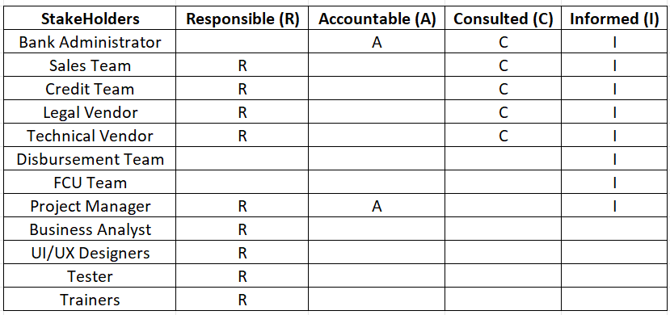

1. **Documents to Write:**

●Business Requirements Document (BRD)

●Functional Requirements Specification (FRS)

●Use Case Documents

●User Stories

●Test Plan

●User Acceptance Testing (UAT) Plan

●Training Materials

●Project Management Plan

1. **Document Sign-off Process:**

●Share draft documents with stakeholders for review and feedback.

●Incorporate feedback and revisions as necessary.

●Obtain formal sign-off from stakeholders indicating their acceptance of the documents.

●Maintain version control to track changes and updates.

**6. Client Approvals:**

●Present finalized documents to the client for approval.

●Provide explanations and clarifications as needed to ensure understanding.

●Obtain formal approval from the client through signed agreements or email confirmation.

**7. Communication Channels:**

●Establish regular meetings with stakeholders to discuss project progress, issues, and updates.

●Utilize email, project management software, and collaboration tools for asynchronous communication.

●Maintain an open-door policy for stakeholders to raise concerns or provide feedback.

**8. Change Request Handling:**

●Establish a formal change management process to capture, assess, and prioritize change requests.

●Evaluate the impact of proposed changes on scope, timeline, and budget.

**9. Progress Reporting to Stakeholders:**

●Provide regular updates on project milestones, deliverable, and risks.

●Use status reports, dashboards, and presentations to communicate progress effectively.

●Highlight achievements, challenges, and upcoming tasks to keep stakeholders informed.

**10. UAT - Client Project Acceptance:**

●Coordinate User Acceptance Testing (UAT) with the client to validate that the software meets requirements.

●Provide clear instructions and test cases for the client to execute during UAT.

●Obtain sign-off on the UAT - Client Project Acceptance Form once the client confirms satisfaction with the software functionality.

**Document 3- Functional Specifications**

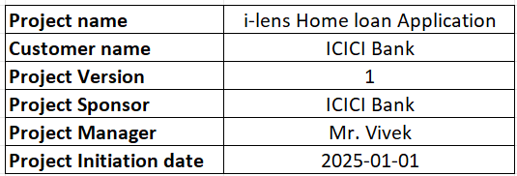

**Functional Requirement specifications:**

|  |  |  |  |
| --- | --- | --- | --- |
| **Req ID** | **Req Name** | **Req Description** | **Priority** |
| **FR0001** | User Authentication and Authorization | The system shall provide secure login functionality for Sales, Credit, legal vendor, Technical vendor and IT staff. | 10 |
| **FR0002** | Role-Based Access Control | The system shall allow role-based access control, restricting functionalities based on user roles. | 9 |
| **FR0003** | Export Reports | The system shall allow exporting reports in multiple formats (PDF, Excel). | 7 |
| **FR0004** | Data Validation | The system shall validate marks entries to ensure they are within acceptable ranges. | 10 |
| **FR0005** | Error Handling | The system shall provide error messages and prompts for invalid data entries. | 9 |
| **FR0006** | Data Encryption | The system shall encrypt sensitive data to ensure confidentiality. | 10 |
| **FR0007** | Audit Trail | The system shall maintain an audit trail of all changes made in the loan application | 9 |
| **FR0008** | User-Friendly Interface | The system shall provide a user- friendly interface for entering, viewing, and managing marks. | 10 |
| **FR0009** | Multi-Device Accessibility | The system shall be accessible via multiple devices, including desktops, tablets, and smartphones. | 8 |
| **FR0010** | Notifications | The system shall send notifications to Sales, Credit, legal vendor, Technical vendor and Customer for pending tasks or deadlines. | 7 |
| **FR0011** | Alerts | The system shall alert users of any discrepancies or errors in data entries. | 8 |
| **FR0012** | API Support | The system shall support API integration for future scalability. | 9 |
| **FR0013** | Help Section | The system shall include a help section with user guides and FAQs. | 8 |
| **FR0014** | Compliance | The system shall comply with relevant data protection and privacy regulations. | 10 |
| **FR0015** | Restricted access | The system shall allow restriceted access based on their access roles | 10 |
| **FR0016** | Interest Calculation | The system shall calculate the interest based on the loan amount and tenure | 7 |
| **FR0017** | Loan eligibility | The system shall calculate the soft eligibility of the customer based on the income details. | 7 |
| **FR0018** | Compliance Reporting | The system shall generate compliance reports for regulatory bodies. | 9 |
| **FR0019** | TAT | The system shall calulate the tat for the application pending in the tray | 7 |
| **FR0020** | User Feedback | The system shall allow users to provide feedback on the application's functionality. | 8 |
| **FR0021** | Technical Support | The system shall provide access to technical support for trouble shooting. | 8 |
| **FR0022** | Communication | The system shall sent the mail once the case has been recceived in their tray | 8 |
| **FR0023** | Loan reports | The system shall allow to extract reports of the loans | 8 |
| **FR0024** | Training Material Access | The system shall provide access to training materials for users. | 7 |
| **FR0025** | Auto Logout | The system shall automatically log out users if the portal is open for a long time and is not active. | 10 |

**Document 4- Requirement Traceability Matrix**

|  |  |  |  |  |  |  |  |  |
| --- | --- | --- | --- | --- | --- | --- | --- | --- |
| **Req ID** | **Req Name** | **Req Description** | **Design** | **D1** | **T1** | **D2** | **T2** | **UAT** |
| **FR0001** | User Authentication and Authorization | The system shall provide secure login functionality for Sales, Credit, legal vendor, Technical vendor and IT staff. | Yes | Completed | Yes | Completed | Yes | Yes |
| **FR0004** | Data Validation | The system shall validate marks entries to ensure they are within acceptable ranges. | Yes | Completed | Yes | Completed | Yes | Yes |
| **FR0006** | Data Encryption | The system shall encrypt sensitive data to ensure confidentiality. | Yes | Completed | Yes | Completed | Yes | Yes |
| **FR0008** | User-Friendly Interface | The system shall provide a user- friendly interface for entering, viewing, and managing marks. | Yes | Completed | No | Pending | No | No |
| **FR0014** | Compliance | The system shall comply with relevant data protection and privacy regulations. | Yes | Pending | No | Pending | No | No |
| **FR0015** | Restricted access | The system shall allow restriceted access based on their access roles | Yes | Pending | No | Pending | No | No |
| **FR0025** | Auto Logout | The system shall automatically log out users if the portal is open for a long time and is not active. | Yes | Completed | Yes | Yes | Yes | Yes |
| **FR0002** | Role-Based Access Control | The system shall allow role-based access control, restricting functionalities based on user roles. | Yes | Completed | Yes | Completed | Yes | Yes |
| **FR0005** | Error Handling | The system shall provide error messages and prompts for invalid data entries. | Yes | Completed | Yes | Completed | Yes | Yes |
| **FR0007** | Audit Trail | The system shall maintain an audit trail of all changes made in the loan application | Yes | Completed | Yes | Completed | Yes | Yes |
| **FR0012** | API Support | The system shall support API integration for future scalability. | Yes | Pending | No | Pending | No | No |
| **FR0018** | Compliance Reporting | The system shall generate compliance reports for regulatory bodies. | Yes | Pending | No | Pending | No | No |
| **FR0009** | Multi-Device Accessibility | The system shall be accessible via multiple devices, including desktops, tablets, and smartphones. | Yes | Completed | No | Pending | No | No |
| **FR0011** | Alerts | The system shall alert users of any discrepancies or errors in data entries. | Yes | Pending | No | Pending | No | No |
| **FR0013** | Help Section | The system shall include a help section with user guides and FAQs. | Yes | Pending | No | Pending | No | No |
| **FR0020** | User Feedback | The system shall allow users to provide feedback on the application's functionality. | Yes | Completed | No | Pending | No | No |
| **FR0021** | Technical Support | The system shall provide access to technical support for trouble shooting. | Yes | Completed | No | Pending | No | No |
| **FR0022** | Communication | The system shall sent the mail once the case has been recceived in their tray | Yes | Completed | Yes | Yes | Yes | Yes |
| **FR0023** | Loan reports | The system shall allow to extract reports of the loans | Yes | Completed | Yes | Yes | Yes | Yes |
| **FR0003** | Export Reports | The system shall allow exporting reports in multiple formats (PDF, Excel). | Yes | Completed | Yes | Completed | Yes | Yes |
| **FR0010** | Notifications | The system shall send notifications to Sales, Credit, legal vendor, Technical vendor and Customer for pending tasks or deadlines. | Yes | Completed | No | Pending | No | No |
| **FR0016** | Interest Calculation | The system shall calculate the interest based on the loan amount and tenure | Yes | Pending | No | Pending | No | No |
| **FR0017** | Loan eligibility | The system shall calculate the soft eligibility of the customer based on the income details. | Yes | Pending | No | Pending | No | No |
| **FR0019** | TAT | The system shall calulate the tat for the application pending in the tray | Yes | Pending | No | Pending | No | No |
| **FR0024** | Training Material Access | The system shall provide access to training materials for users. | Yes | Completed | Yes | Yes | Yes | Yes |

**Document 5- BRD Template**

i-lens Home loan Application

ilHLA_COEPD_2024

Version 1.0

Vignesh P

ents

1. Document Revisions ............................................................................................................8
2. Approvals..................................................................................................................8

3. RASCI Chart for This Document ................................................................................8

Codes Used in RASCI Char ...............................................................................9

RASCI Chart........................................................................................................9

4. Introduction.........................................................................................9

4.1. Business Goals .....… ......… ....................................................................................9

4.2. Business Objectives........................................................................9

4.3. Business Rules........................................................................................10

4.4. Background................................................................................................10

4.5. Project Objective...................................................................10

4.6. Project Scope ............................................................................................10

4.6.1. In Scope Functionality ....................................................................................10

4.6.2. Out Scope Functionality ...................................................................10

1. Assumptions ...................................................................................10
2. Constraints...............................................................................10

7. Risks...............................................................................................10

Technological Risks.......................................................................................11

Skills Risks.......................................................................................11

Political Risks.........................................................................................11

Business Risks..............................................................................................11

Requirements Risks ...............................................................................11

Other Risks....................................................................................................11

1. Business Process Overview .................................................................11

8.1. Legacy System (AS-IS)........................................................................11

8.2. Proposed Recommendations (TO-BE) .....................................................11

9. Business Requirements.........................................................................11

10. Appendices..................................................................................12

10.1. List of Acronyms..........................................................................12

10.2. Glossary of Terms...............................................................................12

10.3. Related Documents.........................................................................12

1. **Document Revisions :**

|  |  |  |
| --- | --- | --- |
| **Date** | **Version Number** | **Document Changes** |
| 15/06/2024 | 0.1 | Initial draft of the project documentation |
| 21/06/2024 | 0.2 | Final review and formatting adjustments |
| 26/06/2024 | 0.3 | Added project objectives and success criteria |
| 01/07/2024 | 0.4 | Included stakeholder analysis and elicitation techniques |
| 06/07/2024 | 0.5 | Completed functional requirements and requirement traceability matrix |
| 16/07/2024 | 0.6 | Updated priority and status in requirement traceability matrix |
| 21/07/2024 | 0.7 | Added Detailed Business Requirements |
| 26/07/2024 | 0.8 | Incorporated Appendices and finalized document |

1. **Approvals**

|  |  |  |  |
| --- | --- | --- | --- |
| **Role** | **Name** | **Signature** | **Date** |
| Project Sponsor | Murugan | [Signature] | 15/06/24 |
| Business Owner | Mahesh | [Signature] | 15/06/24 |
| Project Manager | Shiva | [Signature] | 15/06/24 |
| Business Analyst | Vignesh P | [Signature] | 16/06/24 |
| Technical Lead | Anand Kumar | [Signature] | 16/06/24 |
| Quality Assurance Lead | Surya | [Signature] | 17/06/24 |
| Stakeholder Representative | Ashwini | [Signature] | 18/06/24 |
| IT Department Head | Priya | [Signature] | 18/06/24 |

1. **RASCI Chart for This Document**

Codes Used in RASCI Chart:

* R: Responsible
* A: Accountable
* C: Consulted
* I: Informed

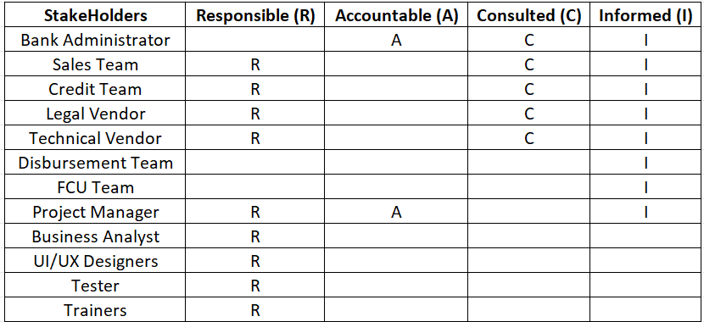

In this RASCI Chart:

Bank Administration is Accountable and has ultimate authority (Authorize) for any changes to the document.

Sales, Credit, legal vendor, Technical vendor are Responsible for their respective roles.

Project Manager is Accountable for the document.

Sales, Credit, legal vendor, Technical vendor, Bank Administration are Consulted during the document process.

**4. Introduction**

**4.1. Business Goals**

Build an single system, Where all the team can access their respective portal and preform their activity. RM can onboard the customer in i-lens application, Once login is completed case will move to credit team to make decision for sanction and if case got sanctioned customer will get notification and sanction letter through email as auto message from i-lens. Post sanction RM / customer can upload the soft copy of property document for Legal and Technical evaluation of the property in the i-lens. Post evaluation Legal and Technical team will upload the reports in i-lens application and approve the case to RM stage. RM will get digital signature from the customer and move the case to credit team for disbursement process. Once all the verification done, case will be moved to ops for fund transfer to the customer.

**4.2. Business Objectives**

Streamline loan in online: Have the system to view and process loan in online.

Enhance Data Accuracy: Reduce data entry errors by 75% through automated validation.

Facilitate Reporting: Enable quick generation of detailed performance reports.

Ensure Compliance: Maintain loan accounts and data protection regulation compliance.

Increase Accessibility: Achieve 90% user satisfaction for multi-device functionality.

Integrate Systems: Seamlessly connect with the existing loan account details.

Improve Satisfaction: Reach at least 85% user satisfaction with intuitive and efficient design.

Support Scalability: Handle double the user load and data volume over five years without performance issues.

**4.3. Business Rules**

* **Role-Based Access Control:** Users can access only the functionalities and data relevant to their roles (e.g., sales, Credit).
* **Data Validation:** All KYC, Income details must pass automated validation checks to ensure they are within acceptable ranges before being saved.
* **Automatic Logout:** Users will be automatically logged out after a specified period of inactivity to maintain security.

**4.4. Background**

Currently RM has to onboard the customer for sanction in i-disburse application, Once login is completed case will move to credit team to make decision. Post sanction RM has to provide hard copy of sanction letter to customer and collect property document from customer and need to initiate for Legal and Technical evaluation of the property by handover the copy of property documents to respective teams. Post evaluation Legal and Technical team will provide the reports to RM. RM will get signature in disbursement form from the customer and provide the disbursement form, Legal and technical reports and property documents to credit team for disbursement process. Credit will verify and initiate FCU for the case. Once all the verification done, case will be moved to ops for fund transfer to the customer.

**4.5. Project Objective**

Build a Responsive UI: Develop a responsive and user-friendly interface that works seamlessly across desktops, tablets, and smartphones.

Implement Secure Authentication: Integrate secure user authentication and role-based access control to protect user data and ensure proper authorization.

Ensure Robust Data Validation: Create and incorporate automated data validation processes to ensure the accuracy and integrity in client onboarding.

Optimize Performance and Scalability: Design the system to handle increased data volumes and user loads without compromising performance, ensuring scalability for future growth.

Implement Automated Logout: Develop functionality to automatically log out users after a specified period of inactivity to enhance security.

Conduct Thorough Testing: Ensure rigorous testing (unit, integration, system, and user acceptance testing) to deliver a high-quality, bug-free product.

Enable Multi-Language Support: Incorporate support for multiple languages to cater to a diverse user base.

**4.6. Project Scope**

Build an single system, Where all the team can access their respective portal and preform their activity. RM can onboard the customer in i-lens application, Once login is completed case will move to credit team to make decision for sanction and if case got sanctioned customer will get notification and sanction letter through email as auto message from i-lens. Post sanction RM / customer can upload the soft copy of property document for Legal and Technical evaluation of the property in the i-lens. Post evaluation Legal and Technical team will upload the reports in i-lens application and approve the case to RM stage. RM will get digital signature from the customer and move the case to credit team for disbursement process. Once all the verification done, case will be moved to ops for fund transfer to the customer.

**4.6.1. In Scope Functionality**

User Authentication and Authorization: Secure login and role-based access control.

client onboarding and Management: Functions for entering, updating, and managing loan details.

* **Data Validation:** Automated checks to ensure customer details.
* **Reporting Tools:** Customization performance and loan reports.
* **User Interface (UI):** Responsive design for desktops, tablets, and smartphones.
* **Security Measures:** Data encryption, audit trails, and automatic logout.
* **Multi-Language Support:** Support for multiple languages.
* **Training and Support:** User guides, training materials, and technical support.
* **Scalability:** Design for increased data volumes and user loads.
* **API Development:** APIs for future integrations with other educational tools.

**4.6.2. Out Scope Functionality**

* **Hardware Procurement:** No hardware for end-users.
* **Legacy System Overhaul:** New system developed with existing system integration.
* **Extended Customization:** No customizations outside predefined features.

**5. Assumptions**

* **User Readiness:** All users have basic computer literacy and are willing to adopt the new system.
* **System Integration:** The existing loan details will integrate to new system DB.

6. Constraints

* **Budget:** Project must stay within the allocated budget of 2Cr.
* **Timeline:** Project must be completed within 12 months

7.Risks

**Technological Risks:**

* • **Integration Challenges:** Difficulty in integrating i-lens with existing DB.
* • **Scalability:** Ensuring that the portal can handle large volumes of data and users simultaneously.
* • **Data Security:** Protecting sensitive customer information from breaches and unauthorized access.
* • **Reliability and Uptime:** Ensuring the system is robust and consistently available.
* • **Technology Obsolescence:** The chosen technology stack becoming outdated quickly.

**Skill Risk**

* • **Technical Expertise:** Availability of skilled developers and IT staff proficient in the required technologies.
* • **Training and Support:** Ensuring teachers and administrative staff can effectively use the new system.
* • **Project Management:** Ensuring the project managers have the necessary experience in managing large-scale IT projects.

**Political Risk**

* • **Policy Changes:** Changes in finance policies or regulations that could affect the implementation.
* • **Stakeholder Support:** Gaining and maintaining support from all stakeholders, including Sales, Credit, FCU and customer.
* • **Regulatory Compliance:** Ensuring the portal complies with all relevant local, state, and regulations regarding data privacy and educational standards.

**Business Risk**

* • **Cost Overruns:** The project exceeding budget due to unforeseen issues or scope changes.
* • **Return on Investment (ROI):** The project may not deliver the expected financial and time benefits or improvements in efficiency.
* • **Vendor Dependence:** Over-reliance on third-party vendors for critical components, which could lead to delays or additional costs.

**Requirements Risk**

* • **Changing Requirements:** Evolving needs from stakeholders leading to scope creep and potential delays.
* • **Incomplete Requirements:** Initial requirements may not fully capture the needs of all users, leading to rework.
* • **Requirement Conflicts:** Different stakeholders might have conflicting requirements, complicating the development process.

**Other Risks**

* • **Project Timeline:** Unanticipated delays extending the project timeline.
* • **User Adoption:** Resistance from staffs and customers in adopting the new system, leading to under utilization.
* • **Maintenance and Support:** Ensuring ongoing support and maintenance post-launch to address bugs, updates, and user issues.
* • **Cultural Barriers:** Differences in technology usage and acceptance across different Banks.

1. **Business Process Overview**

**8.1. Legacy System (AS-IS)**

The legacy system for loan onboarding and disbursement characterized by manual processes. This system poses several challenges, including data inconsistency, limited accessibility, security risks, and scalability issues. A transition to a modern, integrated system like i-lens aims to address these challenges by automating and streamlining the entire process, thereby improving efficiency, accuracy, and accessibility for all stakeholders.

* • **Manual Data Entry:** Loan document are maintained on paper.
* • **Report Generation:** Generation of Loan report is often done manually.
* • **Communication:** Loan status are communicated through mail.

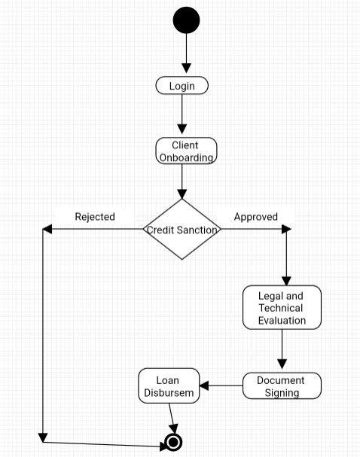

**8.2. Proposed Recommendations (TO-BE)**

To address the challenges identified in the legacy system and improve loan processes, the proposed recommendations (TO-BE) include implementing enhancements and solutions aimed at streamlining operations and maximizing efficiency. Key recommendations include:

* **Automated Data Entry:** Implement sales team to entry customer onboarding directly into the i-lens application, reducing manual errors.
* **Integrated Database:** Centralize all customer information and loan Documents in a unified database, allowing real-time access and updates.
* **Automated Report Generation:** Utilize i-lens capabilities to automatically generate report and performance analytic.
* **Regular Security Audits:** Conduct regular security assessments and audits to identify and mitigate potential vulnerabilities.
* **Mobile Access:** Develop a mobile-friendly version of i-lens to enable access from smartphones and tablets.
* **Cloud-Based Solution:** Deploy i-lens on a scalable cloud platform to handle varying loads and ensure high availability.
* **Performance Monitoring:** Implement performance monitoring tools to track system performance and address bottlenecks proactively.
* **Load Testing:** Conduct regular load testing to ensure the system can handle peak usage times without degradation in performance.
* **Training and Support:** Provide comprehensive training and support resources to ensure smooth adoption of the new system and maximize its benefits across the organization.
* **Feature Enhancements:** Regularly update the system with new features and improvements based on evolving user needs and technological advancements.

1. **Business Requirements:**

|  |  |  |  |
| --- | --- | --- | --- |
| **Req ID** | **Req Name** | **Req Description** | **Priority** |
| **BR0001** | User Authentication and Authorization | The system shall provide secure login functionality for Sales, Credit, legal vendor, Technical vendor and IT staff. | High |
| **BR0002** | Role-Based Access Control | The system shall allow role-based access control, restricting functionalities based on user roles. | High |
| **BR0003** | Export Reports | The system shall allow exporting reports in multiple formats (PDF, Excel). | Medium |
| **BR0004** | Data Validation | The system shall validate marks entries to ensure they are within acceptable ranges. | High |
| **BR0005** | Error Handling | The system shall provide error messages and prompts for invalid data entries. | High |
| **BR0006** | Data Encryption | The system shall encrypt sensitive data to ensure confidentiality. | High |
| **BR0007** | Audit Trail | The system shall maintain an audit trail of all changes made in the loan application | High |
| **BR0008** | User-Friendly Interface | The system shall provide a user- friendly interface for entering, viewing, and managing marks. | High |
| **BR0009** | Multi-Device Accessibility | The system shall be accessible via multiple devices, including desktops, tablets, and smartphones. | Medium |
| **BR0010** | Notifications | The system shall send notifications to Sales, Credit, legal vendor, Technical vendor and Customer for pending tasks or deadlines. | Medium |
| **BR0011** | Alerts | The system shall alert users of any discrepancies or errors in data entries. | Medium |
| **BR0012** | API Support | The system shall support API integration for future scalability. | High |
| **BR0013** | Help Section | The system shall include a help section with user guides and FAQs. | Medium |
| **BR0014** | Compliance | The system shall comply with relevant data protection and privacy regulations. | High |
| **BR0015** | Restricted access | The system shall allow restriceted access based on their access roles | High |
| **BR0016** | Interest Calculation | The system shall calculate the interest based on the loan amount and tenure | Medium |
| **BR0017** | Loan eligibility | The system shall calculate the soft eligibility of the customer based on the income details. | Medium |
| **BR0018** | Compliance Reporting | The system shall generate compliance reports for regulatory bodies. | High |
| **BR0019** | TAT | The system shall calulate the tat for the application pending in the tray | Medium |
| **BR0020** | User Feedback | The system shall allow users to provide feedback on the application's functionality. | Medium |
| **BR0021** | Technical Support | The system shall provide access to technical support for trouble shooting. | Medium |
| **BR0022** | Communication | The system shall sent the mail once the case has been recceived in their tray | Medium |
| **BR0023** | Loan reports | The system shall allow to extract reports of the loans | Medium |
| **BR0024** | Training Material Access | The system shall provide access to training materials for users. | Medium |
| **BR0025** | Auto Logout | The system shall automatically log out users if the portal is open for a long time and is not active. | High |

1. **Appendices**

**10.1. List of Acronyms**

* UAT - User Acceptance Testing
* BRD - Business Requirement Document
* BR - Business Requirement
* RM - Relationship manager
* DB - Database
* UI - User interference

**10.2. Glossary of Terms**

* API (Application Programming Interface)
* i-lens : The name of the project and the application developed for loan onboarding and disbursement.
* Data Validation: Procedures implemented to ensure the accuracy, consistency, and quality of data entered into the system.
* User Role: A set of permissions that define what actions a user can perform within the system.

**10.3. Related Documents**

●Functional Specifications

●Technical Design Document

●This Business Requirements Document (BRD) provides a comprehensive overview of the objectives, scope, requirements, and other relevant aspects of the i-lens project.

●Stakeholder Analysis