SALES FUNNEL

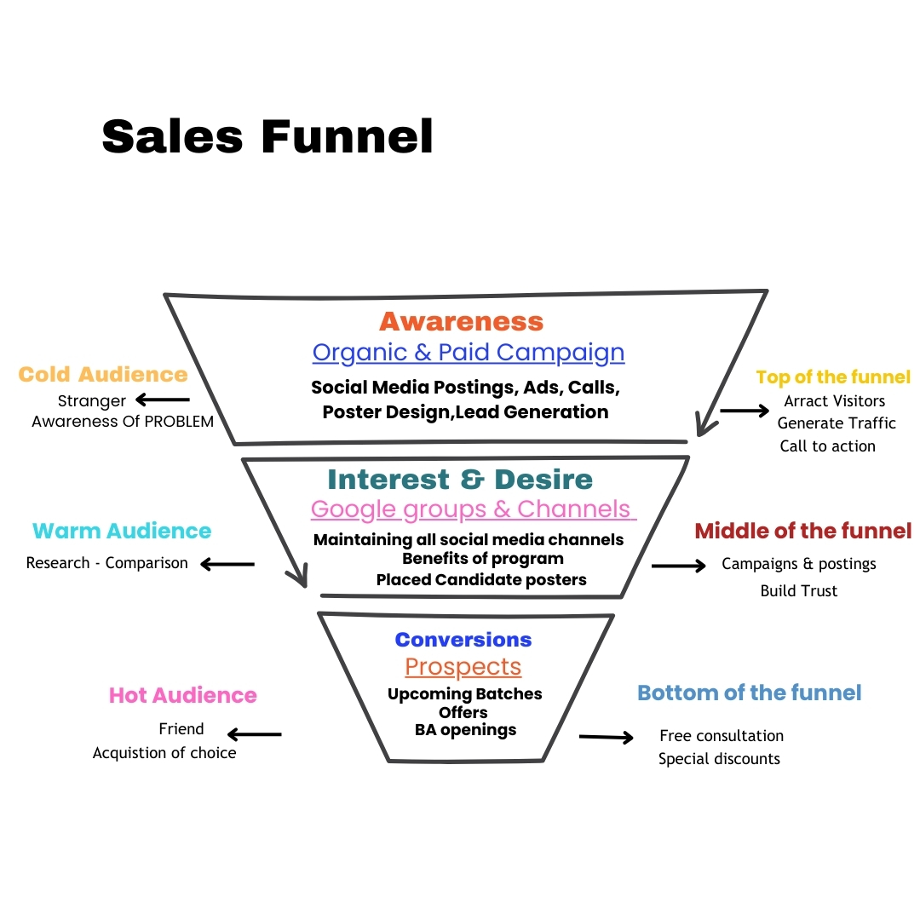

- Awareness: When a prospect becomes aware of your business
- Interest: The prospect is interested in what you have to offer
- Desire: The prospect believes your product or service is a good fit for them.
- Action: The prospect takes action to become a customer

Sales funnel Approach

Define and understand your Ideal Customer

a. Demographics:

Age 22 to 28
Gender
Location
Min Graduation,
Freshers to max 6 yrs exp in any domain like Banking, Insurance, Teaching, Sales, Healthcare,HR, Retail, Bpo Kpo etc -

CTC max 8 Lakhs and
now interested to Get into IT industry

B.Psychographics -

Potential career situations that might motivate someone to pursue BA training:
A mid-level professional looking to move into a more strategic role within their company
Someone transitioning from a technical role to a business-facing position
An individual seeking to gain a deeper understanding of business operations and data analysis
A recent graduate interested in a career path with analytical challenges

C.Needs and Pain Points
Needs and Pain Points of Professionals Seeking Career Change in Various Industries
Understanding the needs and pain points of professionals in these industries can help tailor training and career transition solutions effectively.

1. Banking Professionals
- Pain Points:
- High-pressure sales targets.
- Monotonous, repetitive tasks (e.g., data entry, customer service).
- Limited career growth in non-IT roles.
- Low work-life balance due to long hours.
- Needs:
- Transition to analytical or decision-making roles like Business Analyst (BA).
- Upskilling in data analysis, financial modeling, or IT.
- Careers with better work-life balance and flexibility.

2. Insurance Professionals
- Pain Points:
- Burnout from constant client interaction and sales-driven roles.
- Unpredictable income due to commission-based pay structures.
- Lack of technical or strategic growth opportunities.
- Needs:
- Stable and predictable roles.
- Careers in policy analysis, risk assessment, or IT-related roles.
- Opportunities to leverage industry knowledge in analytical or consulting jobs.

3. Teachers
- Pain Points:
- Limited earning potential and slow salary growth.
- Lack of professional growth and career mobility.
- High workload with limited recognition.
- Needs:
- Careers leveraging their communication and organizational skills.
- Transition to roles like instructional design, corporate training, or business analysis.
- Opportunities in industries offering financial growth and respect.

4. Healthcare Workers
- Pain Points:
- Physically and emotionally demanding jobs.
- Irregular hours, leading to burnout.
- Limited career progression without further specialized education.
- Needs:
- Transition to roles like healthcare data analysis or IT-based healthcare consultancy.
- Work environments with structured hours and mental health considerations.
- Utilization of healthcare knowledge in strategic or analytical domains.

5. Human Resources (HR) Professionals
- Pain Points:
- Saturation in HR-specific roles with limited opportunities for growth.
- Perception of HR as a non-core business function in some organizations.
- Manual processes with limited exposure to analytics or IT.
- Needs:
- Upskilling in HR analytics, process automation, or IT tools.
- Career shifts into business process analysis or project management.
- Roles offering strategic involvement and measurable impact.

6. Retail Workers
- Pain Points:
- Physically exhausting roles with long hours.
- Low job security, especially in non-managerial roles.
- Limited professional growth and upskilling opportunities.
- Needs:
- Shift to office-based roles like customer experience analytics or supply chain analysis.
- Training in technical or analytical skills.
- Careers offering stability and professional development.

7. BPO/KPO Professionals
- Pain Points:
- Burnout due to repetitive tasks and long, irregular working hours.
- Limited skill development in higher-value roles.
- Perception of low prestige and limited career growth opportunities.
- Needs:
- Transition to IT-enabled services like business analysis, data analytics, or project management.

- Roles with better work-life balance and skill utilization.
- Training to break into industries with better growth trajectories.

Common Themes
Pain Points Across Industries
- Job monotony and lack of growth.
- Stress and burnout.
- Financial instability or slow career progression.
Needs Across Industries
- Structured career paths with growth opportunities.
- Training in high-demand skills like business analysis, data analytics, and IT tools.
- Roles offering work-life balance, job security, and recognition.

By addressing these pain points and needs through tailored training programs, our company COEPD can effectively position itself as a solution provider for professionals seeking meaningful career transitions.

D.Buying Behaviour
Buying Behavior of an Ideal Customer for BA Training

Understanding the buying behavior of working professionals in banking, insurance, sales, and teaching fields transitioning to Business Analysis (BA) training involves identifying their motivations, challenges, decision-making process, and triggers.

1. Motivations for Purchase
- Career Growth: They seek to transition to roles with better career prospects, salaries, and job stability.
- Skill Enhancement: A desire to acquire IT-related skills or analytical capabilities to stay relevant in the evolving job market.
- Industry Trends: Awareness of the increasing demand for Business Analysts in IT and other sectors.
- Peer Influence: Seeing colleagues or friends successfully transition to BA roles can inspire them to take similar steps.

2. Buying Process - Stages
- Problem Recognition:
- They feel stuck in their current job roles or industries (e.g., teaching, banking) with limited growth opportunities.
- Information Search:
- Channels Used: Google searches, LinkedIn, YouTube videos, forums, and career blogs.
- Queries Searched:
- "How to become a Business Analyst?"
- "Best BA courses for career transition."
- "Business Analyst course fees and duration."
- Evaluation of Alternatives:
- Comparing course providers based on:
- Curriculum (practical vs. theoretical focus).
- Certification and industry recognition.
- Success stories and placement support.

- Purchase Decision:
- Triggers include:
- Positive testimonials.
- Free demo sessions or webinars.
- Limited-time discounts or offers.
- Post-Purchase Behavior:
- Active participation in training.
- Seeking career guidance or placement support.
- Sharing feedback and reviews.

3. Key Decision-Making Factors
- Reputation of the Training Provider:
- Proven success stories and alumni testimonials.
- Content Quality:
- Real-world projects, case studies, and industry-relevant skills.
- Cost vs. Value:
- ROI on training based on placement success and salary improvement.
- Flexibility:
- Online or hybrid options that suit working professionals.
- Placement Support:
- Direct tie-ups with companies or guaranteed interview opportunities.

4. Psychological Triggers
- Fear of Missing Out (FOMO):
- Seeing peers transition to IT roles successfully.
- Aspirations:
- Desire to break into the IT sector without technical coding skills.
- Risk Mitigation:
- Preference for training with a clear structure, certifications, and career counseling.

5. Barriers to Purchase
- Financial Constraints:
- High course fees without installment options or discounts.
- Skepticism:
- Doubts about the authenticity of certifications or placement guarantees.
- Time Management:
- Concerns about managing training alongside work schedules.

6. Customer Personas
- Persona 1: The Teacher Looking to Transition

- Pain Point: Low pay, limited growth in the teaching profession.
- Trigger: A friend transitioned to BA and doubled their salary.
- Buying Behavior: Needs assurance of a clear path to transition.

- Persona 2: The Banker Stuck in Routine
- Pain Point: Monotonous role with limited career progression.
- Trigger: Awareness of analytical roles in banking IT.
- Buying Behavior: Prefers a course with domain-specific modules.

- Persona 3: The Sales Professional Seeking Stability
- Pain Point: Burnout and lack of job security.
- Trigger: Learning about non-sales roles offering stability.
- Buying Behavior: Looks for flexible training with strong placement support.

Persona 4: The Marketing Specialist Ready for Change
- Pain Point: Overwhelmed by the fast-paced digital landscape and constant need to upskill.
- Trigger: Attending a conference where peers discuss the benefits of data-driven marketing roles.
- Buying Behavior: Interested in workshops that offer hands-on experience with analytics tools and strategies.
Persona 5: The IT Technician Seeking Advancement
- Pain Point: Limited opportunities for promotion and professional growth in current role.
- Trigger: A colleague’s success after obtaining a cloud certification.
- Buying Behavior: Prefers structured online courses that provide certifications recognized in the industry.
Persona 6: The Customer Service Representative Looking for Flexibility
- Pain Point: Rigid work hours and high-stress environment leading to burnout.
- Trigger: Learning about remote work options in tech support roles.
- Buying Behavior: Seeks training programs that emphasize remote customer service skills and offer flexible schedules.
Persona 7: The Graphic Designer Seeking New Challenges
- Pain Point: Creative stagnation due to repetitive projects and lack of innovative briefs.
- Trigger: Exposure to a design competition showcasing cutting-edge work.
- Buying Behavior: Looks for courses that encourage creative exploration and provide feedback from industry professionals.
Persona 8: The Recent Graduate Exploring Career Options
- Pain Point: Uncertainty about which career path to pursue after graduation.
- Trigger: Networking events revealing diverse career trajectories from alumni.
- Buying Behavior: Interested in mentorship programs that connect them with professionals in various fields for guidance.
Persona 9: The Insurance Agent Seeking Modernization
- Pain Point: Struggling to keep up with digital tools and changing customer expectations.
- Trigger: Attending a seminar on digital transformation in the insurance sector.
- Buying Behavior: Interested in training programs that focus on digital sales strategies and customer relationship management.
Persona 10: The Manufacturing Supervisor Aiming for Efficiency
- Pain Point: Facing challenges with outdated processes and inefficiencies on the shop floor.
- Trigger: Learning about lean manufacturing techniques at an industry conference.
- Buying Behavior: Seeks workshops that provide practical applications of lean methodologies and process optimization.

Persona 11: The BFSI Analyst Looking for a Niche
- Pain Point: Overwhelmed by the vast array of roles in the BFSI sector and unsure where to specialize.
- Trigger: Networking with professionals who have successfully transitioned into niche roles like risk management or fintech.
- Buying Behavior: Prefers specialized courses that offer insights into emerging trends and skills in specific BFSI domains.
Persona 12: The Retail Manager Transitioning to E-commerce
- Pain Point: Difficulty adapting to the fast-paced changes in consumer behavior towards online shopping.
- Trigger: Noticing a significant drop in foot traffic and sales in physical stores.
- Buying Behavior: Looks for comprehensive training on e-commerce platforms and digital marketing strategies.
Persona 13: The Healthcare Professional Seeking Administrative Roles
- Pain Point: Burnout from direct patient care and desire for a more stable work environment.
- Trigger: Learning about administrative roles that leverage clinical knowledge without direct patient interaction.
- Buying Behavior: Interested in courses that enhance management skills and provide knowledge of healthcare regulations.
Persona 14: The HR Specialist Exploring Data Analytics
- Pain Point: Limited ability to leverage data in decision-making processes within HR functions.
- Trigger: Attending a workshop on the impact of analytics in talent management.
- Buying Behavior: Seeks training programs that focus on HR analytics tools and their application in workforce planning.
Persona 15: The Sales Executive Aiming for Leadership Roles
- Pain Point: Frustration with the lack of upward mobility within the sales team.
- Trigger: Observing peers who have transitioned into managerial positions after pursuing leadership training.
- Buying Behavior: Interested in leadership development programs that emphasize strategic thinking and team management.

7. Channels They Use
- Social Media: LinkedIn, Facebook, and Instagram for ads and testimonials.
- Professional Platforms: LinkedIn Groups, forums.
- Career Websites: Naukri.com, Glassdoor.
- Word of Mouth: Recommendations from peers or alumni.

By addressing these behaviors, our BA training company, COEPD can tailor its marketing, communication, and course offerings to align with the specific needs and motivations of our target audience.

Step2: Identify Your Offer

a.Product/Service : BA Trainings
b.Pricing: 42,000/- (X)
c.Value Proposition - 3X to 10X
Key elements of a BA training company's value proposition:

Practical, industry-relevant curriculum:
Focusing on real-world scenarios and tools used by working Business Analysts to ensure graduates are prepared for immediate application.
Experienced instructors:
Providing training led by certified BAs with extensive industry experience to impart valuable insights and best practices.
Hands-on learning:
Incorporating case studies, simulations, and practical projects to develop critical thinking and problem-solving abilities.
Career support:
Including resume building workshops, interview preparation, and job placement assistance to help graduates land relevant BA roles.
Tailored learning paths:
Offering specialized tracks for different business domains (e.g., healthcare, finance, technology) to cater to specific career goals.
Example value proposition statements:
"Develop the skills to become a high-demand Business Analyst, ready to drive impactful business solutions through our comprehensive training program."
"Gain the confidence to navigate complex business challenges with our practical BA training, designed to equip you with the latest industry tools and techniques."
"Elevate your career as a Business Analyst by mastering data analysis, requirement gathering, and project management skills through our immersive training program."

Step3: Choose your Marketing Channels

a.Social Media
b. E-Mail Marketing: Target is 2500 Emails Per day.
2000 mails/ Associate in a Schedule or 500 mails / Associate
Through Mail chimp, Send Grid, Zoho Fantos, Hub Spot, Bravo , constant Contact
c. Content Marketing:
Blog Posts, Posters, Engaging Videos, Poles or Quizs
BA Content and Advantages of Taking BA trainings,the Beauty of BA Role
Facebook, LInkedin, Instagram, Telegram, Whatsapp.
d. Paid Advertising:
Google Adds, Facebook, Linkedin,

Step4: Create Compelling Lead Magnets

a.Ebooks:
- BA syllabus
- BA Job Market Trends
- BA Sample Resumes
- 10 Steps to become a Business Analyst

- BA interview preparation Checklist.

b.Webinars:
Daily Demo

c.Checklists:

d.Templates:

Step5: Build Your Landing Page

a.Clear Value Proposition Updating once a week
b.Strong Call to Action Countdown Timer to avail an Offer.
c.Optimized for Conversations -DO-

Step6: Set Up Email Automation

a.Welcome Sequence Awareness Emails
b.Nurturing Emails Interest & Desire Mails ( Placements, Job Offers, Ongoing Interviews, Daily Job Postings & Salary Hikes)
c.Promotional Emails Daily Discount Offers and Upcoming Batch Details

Step7: Integrate Your Tools

a.CRM Lead Management Tool - COEPD
b.Email Marketing Platform Previous Associates Gmails.
c.Analytics Dashboard

Step8: Track and Analyze Results
a.Conversion Rates:
Monthly Cold Leads = 42,500
Warm leads =1700
Hot leads =500
Joinings =100
Conversion Rate = 0.235%
Target Conversion Rate =1% by 31 Dec 2024
Cold leads Per Day = 42500/25 = 1700
Total No. of Associates In Hyd. & Chennai Location = 18 ( Helpdesk-10, DM-8)
Cold Leads Handled by Individual Helpdesk Associate = 1000/ 10 =100
Cold Leads Handled by Individual Helpdesk Associate 700/9 = 78

Warm Leads to be generated by the team Per day = 1700/25= 68
DM: 40 & Helpdesk: 28
Hot leads to be generated by the team Per Day = 500/25=20
DM: 9 & Helpdesk: 11
Joinings or Enrolments to be done Per Day = 100/25=4
b.Customer Acquisition Cost ( CAC):
Total expenses for salaries and Marketing = 3,60,000
Students joined = 36
Customwe Acquisition Cost = 3,60,000/36 = Rs 10,0000
Target CAC - Rs 5,000

c.Customer Lifetime Value (CLTV)
* Average Revenue Per Customer (ARPC): ₹38,000
* Customer Lifespan (L): 1 year (students engage for one year of service).

Calculation:
Since there are no additional services or engagements beyond the fees:
CLV 38,000 * 1 ‎ = 38,000

Customer Lifetime Value (CLV): ₹38,000
This means the total revenue a customer brings during their engagement with the training company is ₹38,000.

Step9: Optimize & Refine
a.A/B testing
A/B testing—also called split testing or bucket testing—compares the performance of two versions of content to see which one appeals more to visitors/viewers. It tests a control (A) version against a variant (B) version to measure which one is most successful based on your key metrics.

b.Continuous Improvement
Continuous improvement is the ongoing process of analyzing performance, identifying opportunities, and making incremental changes to processes, products, and personnel. By analyzing and fine-tuning processes, your company can save time and deliver an overall better product.

INTERVIEW QUESTIONS FOR PRESALES ROUND-I

Here are 10 questions and answers that could be asked of a Digital Marketing Executive, based on the provided data about COEPD's Business Analysis IT training program:

- Q: What is the primary goal of COEPD's digital marketing strategy, as outlined in the provided document?

- Q: What are the key customer personas identified for COEPD's BA training program?

- Q: Which marketing channels are utilized to reach the target audience?

- Q: Describe the email marketing strategy, including the types of email sequences employed.

- Q: What are some examples of lead magnets used to capture leads?

- Q: How does the provided document suggest optimizing the landing page?

- Q: What key metrics are used to track the success of the digital marketing efforts?

- Q: What is the current conversion rate, and what is the target conversion rate?

- Q: What strategies are suggested for optimizing and refining the digital marketing campaign?

- Q: What is the current Customer Acquisition Cost (CAC) and the target CAC?

